Ms Tracey Rust
TJR Planning
Suite 3 The Mansion
Wall Hall Drive
Aldenham
Hertfordshire
WD25 8BZ
Application Ref: 2015/7113/P
Please ask for: James Remmington
Telephone: 020 7974 4816
21 April 2016

Dear Sir/Madam

DECISION

Town and Country Planning Act 1990 (as amended)

Approval of Details Granted

Address:
4/4A Wadham Gardens London NW3 3DP

Proposal:
Detail of Arboricultural Method Statement in relation to condition 6 of 2015/2513/P, 25/11/2005, for excavation under front garden area with installation of underground parking lift.

Drawing Nos: SSA/4aWDM/AMS/01 ARBORICULTURAL METHOD STATEMENT

Informative(s):

The details submitted pursuant to the discharge of condition 6 of planning permission 2015/2513/P dated 25/11/2015 are considered to be sufficient to demonstrate that the trees to be retained will be adequately protected during the implementation of the proposal.

The Tree protection measures are not considered harmful to the character or appearance of the host building, street scene or the Elsworthy Conservation Area because of their temporary nature.

No objections have been received prior to making this decision. The sites planning history and relevant appeal decisions were taken into account when coming to this decision.

Considerable importance and weight has been attached to the harm and special attention has been paid to the desirability of preserving or enhancing the character or appearance of the conservation area, under s.66 (LB’s) and s.72 (CA’s) of the Listed Buildings and Conservation Areas Act 1990 as amended by the Enterprise and Regulatory Reform Act (ERR) 2013

As such, the proposed development is in general accordance with policies CS14 and CS15 of the London Borough of Camden Local Development Framework Core Strategy, and policies DP24 and DP25 of the London Borough of Camden Local Development Framework Development Policies. The proposed development also accords with policies 7.4, 7.6 and 7.8 of the London Plan 2011; and paragraphs 14, 17, 55 -66 and 126-141 of the National Planning Policy Framework.

You are advised that all conditions relating to planning permission 2015/2513/P, granted on 25/11/2005, which need details to be submitted, have been approved.

In dealing with the application, the Council has sought to work with the applicant in a positive and proactive way in accordance with paragraphs 186 and 187 of the National Planning Policy Framework.

You can find advice about your rights of appeal at:

http://www.planningportal.gov.uk/planning/appeals/guidance/guidancecontent

Yours faithfully
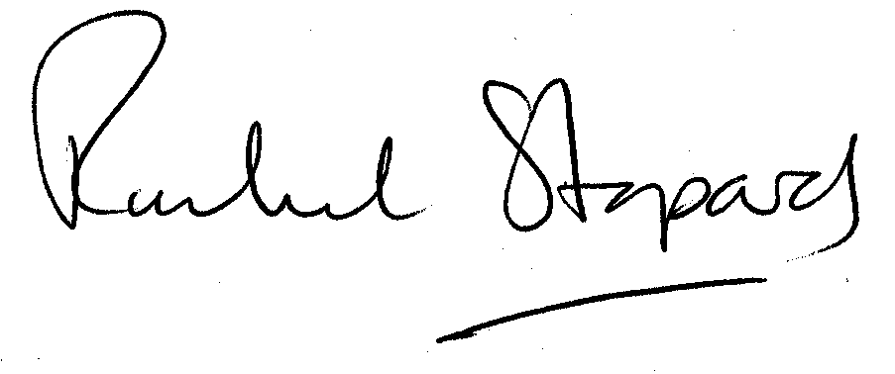
Rachel Stopard
Director of Supporting Communities

