
- Menu
- Search

What are you looking for?

Click anywhere to close (ESC)

- Listing
  - Search the List
  - Enrich the List
  - Apply for Listing
  - What is Listing?
  - Listing Guidance
  - Showcasing Designation
- Advice
  - Your Home
  - Planning
  - Latest Advice & Guidance
  - Caring for Heritage
  - Technical Guidance
  - Heritage at Risk
  - Constructive Conservation
  - Heritage Protection Guide
- Research
  - Research Approaches
  - Current Research
  - Research Results
  - Support & Collaboration
  - Inclusive Heritage
- Images & Books
  - Search All Publications
  - Buy Images
  - Books
  - The Historic England Archive
  - Aerial Photos
  - Magazines
  - Picturing England
- Services & Skills
  - Grants
  - Our Planning Services
  - Education
  - Training & Skills
  - Archive Services
  - Heritage Action Zones
- Get Involved
  - Be a Volunteer
  - Protect Your Heritage
  - Help Write History
  - Visit Your Heritage
- News & Features
  - News
  - Statements
  - Newsletter
  - First World War
  - The Second World War and the Blitz
  - Angel Awards
  - Exhibitions

  - What We Do
  - How We Are Run
  - Jobs
  - Contact Us
  - Volunteer with Historic England

  - Website Terms and Conditions
  - Data Protection
  - Privacy and Cookies
  - Links Policy
  - Historic England Blog: House Rules
  - Gormley’s ROOM Competition Terms and Conditions
This browser is not fully supported by Historic England.
We use cookies to give you the best possible experience online. By using this website, you consent to cookies being used in accordance with our Cookie Policy.
- Home
- ...
- Listing
- Search the List
- List Entry
- Section Navigation
  - Minor Amendments
  - Download Designation Data
  - Non-Listed Sites

CAMDEN TOWN HALL

List Entry Summary
This building is listed under the Planning (Listed Buildings and Conservation Areas) Act 1990 as amended for its special architectural or historic interest.
Name: CAMDEN TOWN HALL
List entry Number: 1379162

Location
CAMDEN TOWN HALL, EUSTON ROAD
CAMDEN TOWN HALL, JUDD STREET
The building may lie within the boundary of more than one authority.
County: Greater London Authority
District: Camden
District Type: London Borough
Parish:
National Park: Not applicable to this List entry.
Grade: II
Date first listed: 19-Apr-1996
Date of most recent amendment: Not applicable to this List entry.

Legacy System Information
The contents of this record have been generated from a legacy data system.
Legacy System: LBS
UID: 478529

Asset Groupings
This list entry does not comprise part of an Asset Grouping. Asset Groupings are not part of the official record but are added later for information.

List entry Description

Summary of Building
Legacy Record - This information may be included in the List Entry Details.

Reasons for Designation
Legacy Record - This information may be included in the List Entry Details.

History
Legacy Record - This information may be included in the List Entry Details.

Details
CAMDEN
TQ3082NW EUSTON ROAD 798-1/90/1752 Camden Town Hall 19/04/96
GV II
See under: Camden Town Hall JUDD STREET.
CAMDEN
TQ3082NW JUDD STREET 798-1/90/1752 (East side) 19/04/96 Camden Town Hall
GV II
Includes: Camden Town Hall EUSTON ROAD. Town hall. 1934-7. By AJ Thomas. Exterior clad in Portland stone ashlar over a steel frame on all 4 fronts. EXTERIOR: 3 main storeys. Channelled base, with plinth. Keystones over entrances carved by WCH King. Judd Street front: wings of 5 windows width, each with central aedicule and windows with alternating rhythm of channelled and unchannelled surrounds on first floor; projecting centre over entrances of three windows width with giant Corinthian order consisting of outer pilasters and inner attached columns rising to a full pediment embedded in raised attic with pitched roof. Euston Road front: 23 windows width, with wings of 5 windows width as in Judd Street and centre on the model of the Place de la Concorde with projecting pedimented pavilions as in centre of Judd Street front over subsidiary entrances flanking seven bays with giant Corinthian columns, and raised attic with pitched roof over whole centre. Tonbridge Street front: 23 windows width, with slightly recessed centre and raised attic of 13 windows width with pitched roof. East front: with single-storey ground-floor projection including side entrances on flanks, 3 round-arched windows on first floor in centre rising through second storey, and raised central attic of 3 windows width with pitched roof. INTERIOR: Judd Street entrance with black and white marble floor and deep-beamed ceiling. Main balustraded toplit staircase of white marble with dark marble pilasters and variegated marble panels on walls, branching and leading to Members' Lobby on first floor with polished marble Corinthian columns and variegated marble panels. First-floor corridors panelled throughout to impost level and plaster-vaulted in manner of London County Hall (qv Lambeth). Council Chamber in centre of building toplit, rectangular with side lobbies under galleries and giant Corinthian pilasters, oak-panelled to high level with plain frieze over and horseshoe arrangement of oak seating. Along Euston Road front at first-floor level, Mayor's Parlour oak-panelled to full height, lugged and pedimented doorcases and fine marble fireplace with burnished steel grate; Chief Executive's Room panelled to full height in Norfolk cedar with good fireplace; good panelled committee rooms. Assembly Hall on ground floor entered from Tonbridge Street, with foyer at south end, stage at north end with proscenium arch, deep south gallery and narrower west gallery communicating with Council Chamber. Light-fittings, fixtures and furniture throughout of a high standard, especially on first floor, and presumably largely designed by AJ Thomas. HISTORICAL NOTE: Camden Town Hall was designed as St Pancras Town Hall by AJ Thomas, a former assistant of EL Lutyens, the influence of whose Classical style pervades the building. Thomas designed several housing schemes for St Pancras Borough Council from 1924 onwards. (Architect and Building News: 25 June 1937: London; The Builder: 9 July 1937: London; The Building: July 1937).
Listing NGR: TQ3013982795

Selected Sources
Books and journals
'The Builder' in The Builder, (1937)
'The Building' in July, (1937)
'Architect and Building News' in 25 June, (1937)
National Grid Reference: TQ 30139 82795

Map
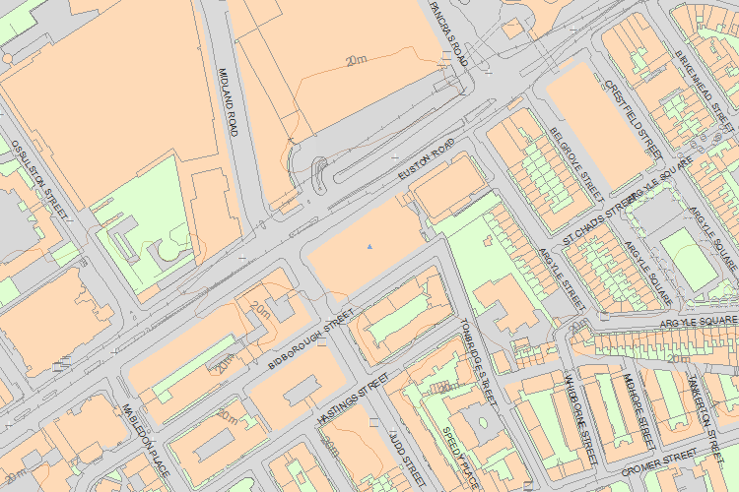© Crown Copyright and database right 2016. All rights reserved. Ordnance Survey Licence number 100024900.
© British Crown and SeaZone Solutions Limited 2016. All rights reserved. Licence number 102006.006.
Use of this data is subject to Terms and Conditions.
The above map is for quick reference purposes only and may not be to scale. For a copy of the full scale map, please see the attached PDF - 1379162 .pdf
The PDF will be generated from our live systems and may take a few minutes to download depending on how busy our servers are. We apologise for this delay.
This copy shows the entry on 21-Apr-2016 at 11:34:38.
End of official listing

Your

