
- Menu
- Search

What are you looking for?

Click anywhere to close (ESC)

- Listing
  - Search the List
  - Enrich the List
  - Apply for Listing
  - What is Listing?
  - Listing Guidance
  - Showcasing Designation
- Advice
  - Your Home
  - Planning
  - Latest Advice & Guidance
  - Caring for Heritage
  - Technical Guidance
  - Heritage at Risk
  - Constructive Conservation
  - Heritage Protection Guide
- Research
  - Research Approaches
  - Current Research
  - Research Results
  - Support & Collaboration
  - Inclusive Heritage
- Images & Books
  - Search All Publications
  - Buy Images
  - Books
  - The Historic England Archive
  - Aerial Photos
  - Magazines
  - Picturing England
- Services & Skills
  - Grants
  - Our Planning Services
  - Education
  - Training & Skills
  - Archive Services
  - Heritage Action Zones
- Get Involved
  - Be a Volunteer
  - Protect Your Heritage
  - Help Write History
  - Visit Your Heritage
- News & Features
  - News
  - Statements
  - Newsletter
  - First World War
  - The Second World War and the Blitz
  - Angel Awards
  - Exhibitions

  - What We Do
  - How We Are Run
  - Jobs
  - Contact Us
  - Volunteer with Historic England

  - Website Terms and Conditions
  - Data Protection
  - Privacy and Cookies
  - Links Policy
  - Historic England Blog: House Rules
  - Gormley’s ROOM Competition Terms and Conditions
This browser is not fully supported by Historic England.
We use cookies to give you the best possible experience online. By using this website, you consent to cookies being used in accordance with our Cookie Policy.
- Home
- ...
- Listing
- Search the List
- List Entry
- Section Navigation
  - Minor Amendments
  - Download Designation Data
  - Non-Listed Sites

NUMBERS 12-36 AND ATTACHED RAILINGS

List Entry Summary
This building is listed under the Planning (Listed Buildings and Conservation Areas) Act 1990 as amended for its special architectural or historic interest.
Name: NUMBERS 12-36 AND ATTACHED RAILINGS
List entry Number: 1244679

Location
NUMBERS 12-36 AND ATTACHED RAILINGS, 12-36, ARGYLE STREET
The building may lie within the boundary of more than one authority.
County: Greater London Authority
District: Camden
District Type: London Borough
Parish:
National Park: Not applicable to this List entry.
Grade: II
Date first listed: 14-May-1974
Date of most recent amendment: Not applicable to this List entry.

Legacy System Information
The contents of this record have been generated from a legacy data system.
Legacy System: LBS
UID: 476615

Asset Groupings
This list entry does not comprise part of an Asset Grouping. Asset Groupings are not part of the official record but are added later for information.

List entry Description

Summary of Building
Legacy Record - This information may be included in the List Entry Details.

Reasons for Designation
Legacy Record - This information may be included in the List Entry Details.

History
Legacy Record - This information may be included in the List Entry Details.

Details
CAMDEN
TQ3082NW ARGYLE STREET 798-1/90/51 (West side) 14/05/74 Nos.12-36 (Even) and attached railings
GV II
Terrace of 13 houses, now mostly small hotels. c1833-9. Yellow stock brick; Nos 16 & 18 stuccoed. No.22, painted; Nos 24-28, painted ground floors. Plain stucco 1st floor sill bands. Nos 20-28 and 32 & 36 with slated mansard roofs and dormers. 3 storeys, Nos 20-28 and 32 & 36 attics, and basements. 2 windows each. Round-arched ground floor openings. Doorways with stucco architraves, pilaster-jambs carrying cornice-heads, fanlights (some patterned) and some panelled doors. Most ground floor windows with margin lights. Gauged brick flat arches to recessed sashes; 1st floor in shallow, round-arched recesses with cast-iron balconies. Parapets. INTERIORS: not inspected. SUBSIDIARY FEATURES: attached cast-iron railings with knob and disc finials to areas. (Survey of London: Vol. XXIV, King's Cross Neighbourhood, Parish of St Pancras IV: London: -1952: 106).
Listing NGR: TQ3022882816

Selected Sources
Books and journals
'Survey of London' in Survey of London - Kings Cross neighbourhood The Parish of St Pancras Part 4: Volume 24 , (1951), 106
National Grid Reference: TQ 30228 82816

Map
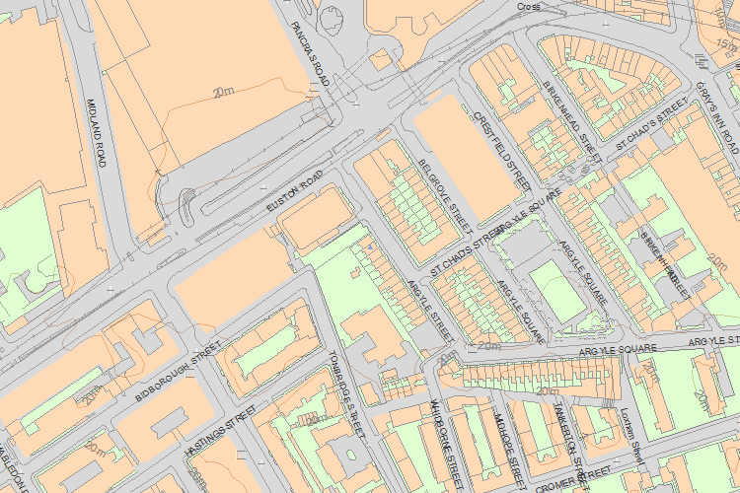© Crown Copyright and database right 2016. All rights reserved. Ordnance Survey Licence number 100024900.
© British Crown and SeaZone Solutions Limited 2016. All rights reserved. Licence number 102006.006.
Use of this data is subject to Terms and Conditions.
The above map is for quick reference purposes only and may not be to scale. For a copy of the full scale map, please see the attached PDF - 1244679 .pdf
The PDF will be generated from our live systems and may take a few minutes to download depending on how busy our servers are. We apologise for this delay.
This copy shows the entry on 21-Apr-2016 at 11:24:09.
End of official listing

