
- Menu
- Search

What are you looking for?

Click anywhere to close (ESC)

- Listing
  - Search the List
  - Enrich the List
  - Apply for Listing
  - What is Listing?
  - Listing Guidance
  - Showcasing Designation
- Advice
  - Your Home
  - Planning
  - Latest Advice & Guidance
  - Caring for Heritage
  - Technical Guidance
  - Heritage at Risk
  - Constructive Conservation
  - Heritage Protection Guide
- Research
  - Research Approaches
  - Current Research
  - Research Results
  - Support & Collaboration
  - Inclusive Heritage
- Images & Books
  - Search All Publications
  - Buy Images
  - Books
  - The Historic England Archive
  - Aerial Photos
  - Magazines
  - Picturing England
- Services & Skills
  - Grants
  - Our Planning Services
  - Education
  - Training & Skills
  - Archive Services
  - Heritage Action Zones
- Get Involved
  - Be a Volunteer
  - Protect Your Heritage
  - Help Write History
  - Visit Your Heritage
- News & Features
  - News
  - Statements
  - Newsletter
  - First World War
  - The Second World War and the Blitz
  - Angel Awards
  - Exhibitions

  - What We Do
  - How We Are Run
  - Jobs
  - Contact Us
  - Volunteer with Historic England

  - Website Terms and Conditions
  - Data Protection
  - Privacy and Cookies
  - Links Policy
  - Historic England Blog: House Rules
  - Gormley’s ROOM Competition Terms and Conditions
This browser is not fully supported by Historic England.
We use cookies to give you the best possible experience online. By using this website, you consent to cookies being used in accordance with our Cookie Policy.
- Home
- ...
- Listing
- Search the List
- List Entry
- Section Navigation
  - Minor Amendments
  - Download Designation Data
  - Non-Listed Sites

KINGS CROSS STATION

List Entry Summary
This building is listed under the Planning (Listed Buildings and Conservation Areas) Act 1990 as amended for its special architectural or historic interest.
Name: KINGS CROSS STATION
List entry Number: 1078328

Location
KINGS CROSS STATION, EUSTON ROAD
The building may lie within the boundary of more than one authority.
County: Greater London Authority
District: Camden
District Type: London Borough
Parish:
National Park: Not applicable to this List entry.
Grade: I
Date first listed: 10-Jun-1954
Date of most recent amendment: Not applicable to this List entry.

Legacy System Information
The contents of this record have been generated from a legacy data system.
Legacy System: LBS
UID: 477247

Asset Groupings
This list entry does not comprise part of an Asset Grouping. Asset Groupings are not part of the official record but are added later for information.

List entry Description

Summary of Building
Legacy Record - This information may be included in the List Entry Details.

Reasons for Designation
Legacy Record - This information may be included in the List Entry Details.

History
Legacy Record - This information may be included in the List Entry Details.

Details
CAMDEN
TQ3083SW EUSTON ROAD 798-1/85/420 (North side) 10/06/54 King's Cross Station
GV I
Railway terminus. 1850-52. By Lewis Cubitt (architect), and Sir William and Joseph Cubitt (engineers). Yellow stock brick. 2 train sheds (originally 1 for arrivals, the other for departure) closed by monumental plain brick screen of 2 glazed semicircular openings, framed with recessed arches (echoing the train sheds behind) with central and flanking towers; ground storey obscured by late C20 additions. Central tower with rectangular clock turret with pyramidical roof, eaves cornice and weather vane. To the west, 3 storey 3 window office block with booking hall and service rooms at rear; 1st floor with thin, debased Venetian windows, cornice at 2nd floor level, 2nd floor segmental-arched sashes (flanking bays tripartite), cornice. On east side, an extension with archway to the cab drive (now bricked up); rusticated surround to arch and quoins; cornice above which 3 tripartite sashes and parapet. INTERIOR: train sheds separated by round-arched brick colonnade. Originally, train shed roofs of laminated wood, inspired by the Crystal Palace, but these rapidly deteriorated and were replaced by the present iron-ribbed roofs to the eastern shed 1869-70, to the western 1886-7. (Laminated wood trusses successfully used at 26 Pancras Road (qv). HISTORICAL NOTE: when opened as the terminus of the Great Northern Railway, was the largest station in England and is the earliest great London terminus still intact. The contrast of its functional simplicity with St Pancras Station next door (qv) is powerful. (Hunter M and Thorne R: Change at King's Cross: London: -1990: 59-64).
Listing NGR: TQ3026983130

Selected Sources
Books and journals
Hunter, M, Thorne, R, Change at Kings Cross, (1990), 59-64
National Grid Reference: TQ 30269 83130

Map
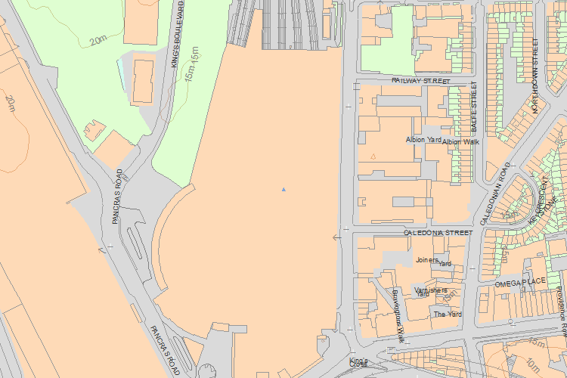© Crown Copyright and database right 2016. All rights reserved. Ordnance Survey Licence number 100024900.
© British Crown and SeaZone Solutions Limited 2016. All rights reserved. Licence number 102006.006.
Use of this data is subject to Terms and Conditions.
The above map is for quick reference purposes only and may not be to scale. For a copy of the full scale map, please see the attached PDF - 1078328 .pdf
The PDF will be generated from our live systems and may take a few minutes to download depending on how busy our servers are. We apologise for this delay.
This copy shows the entry on 21-Apr-2016 at 11:18:34.
End of official listing

