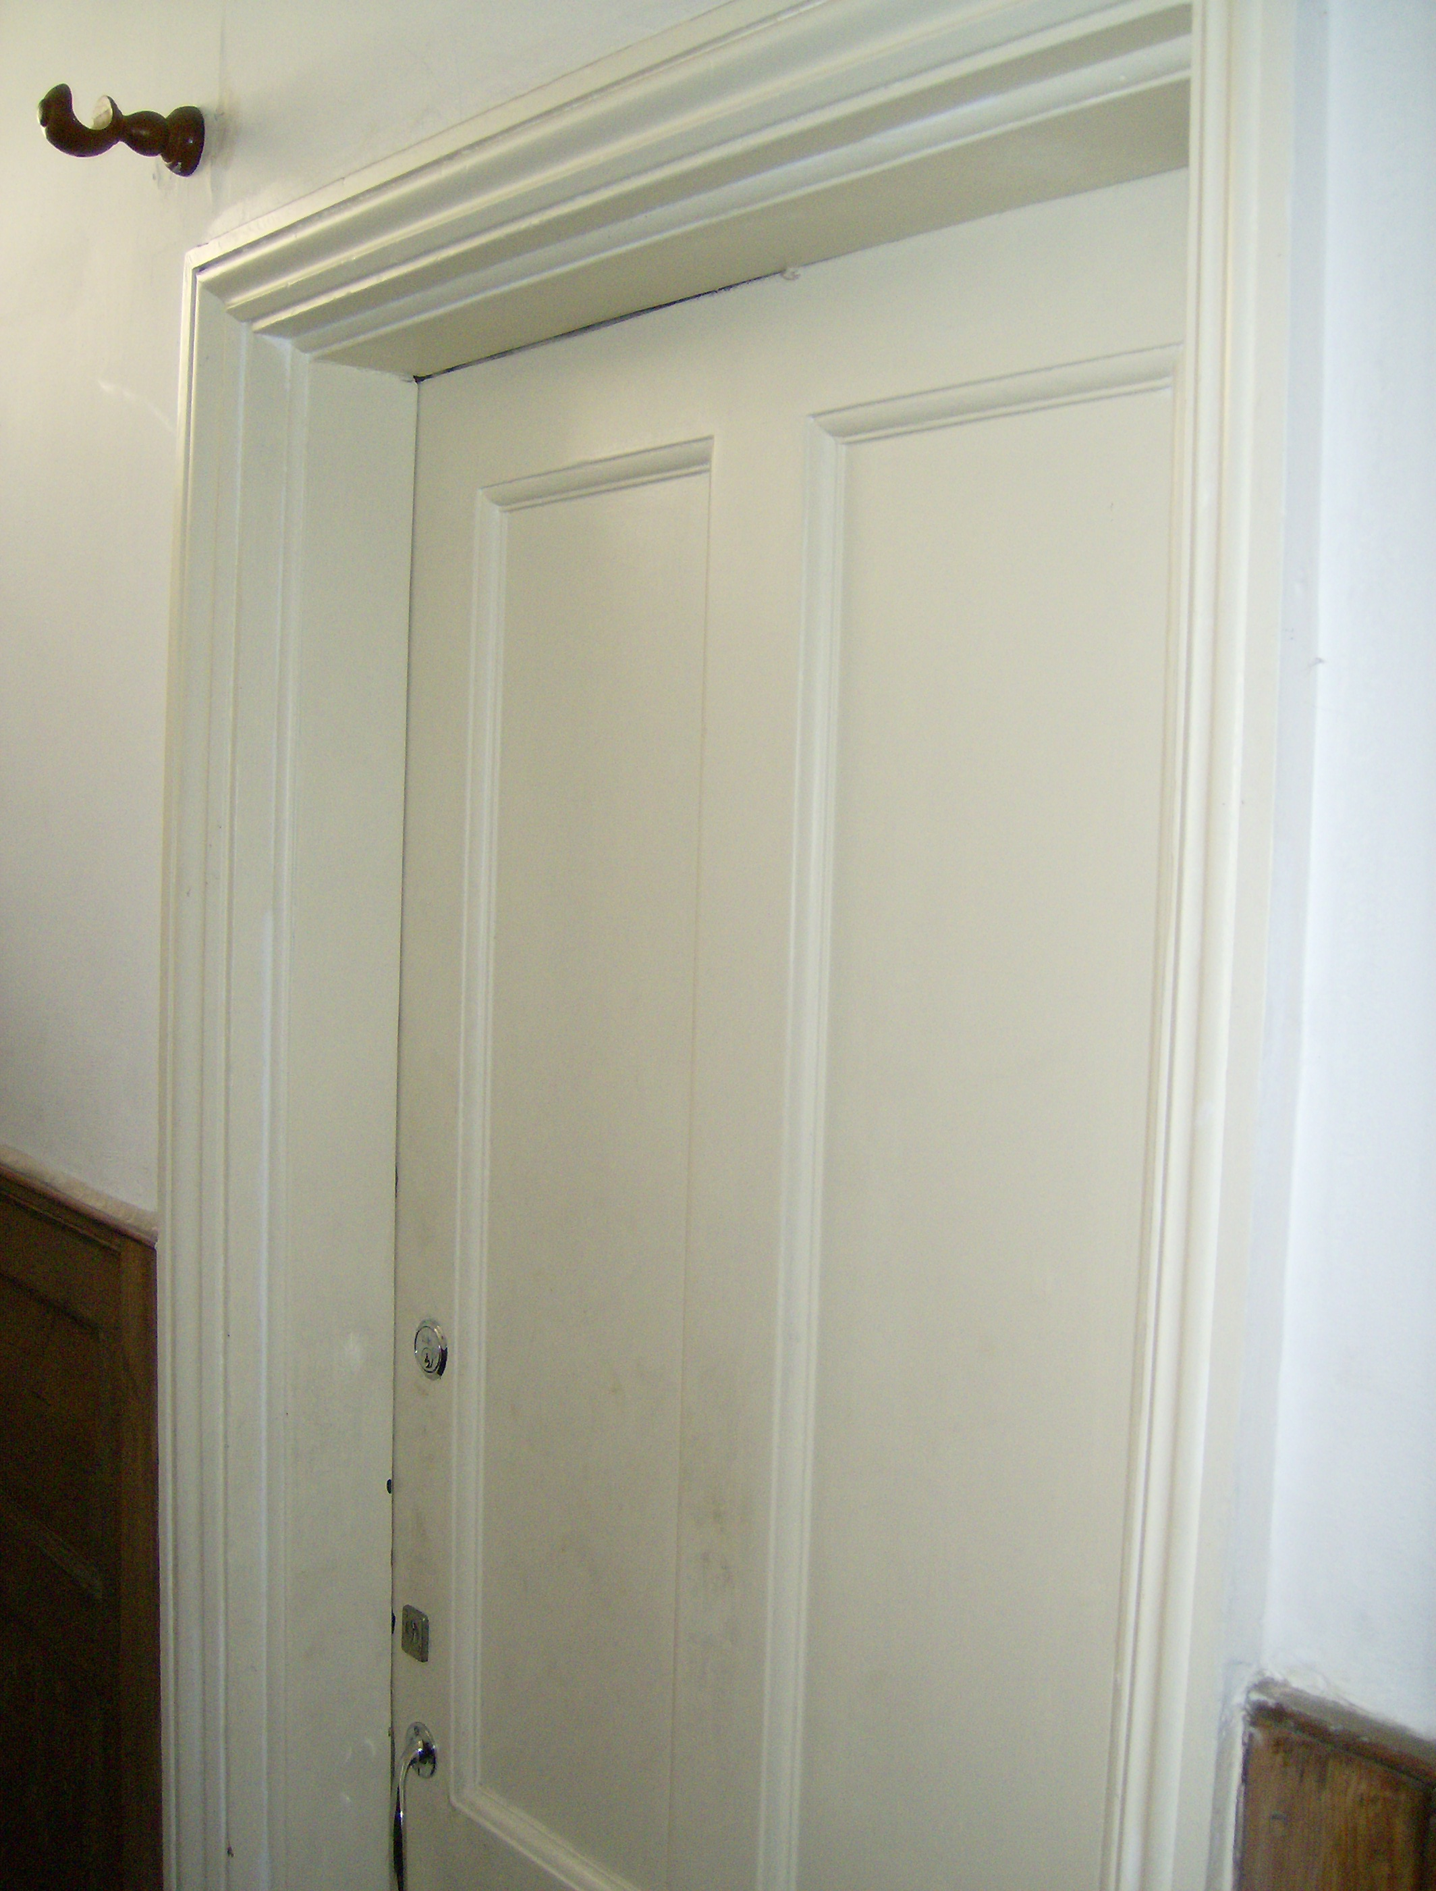
Third floor Door

Not of Period and design is not correct

Door not fire rated

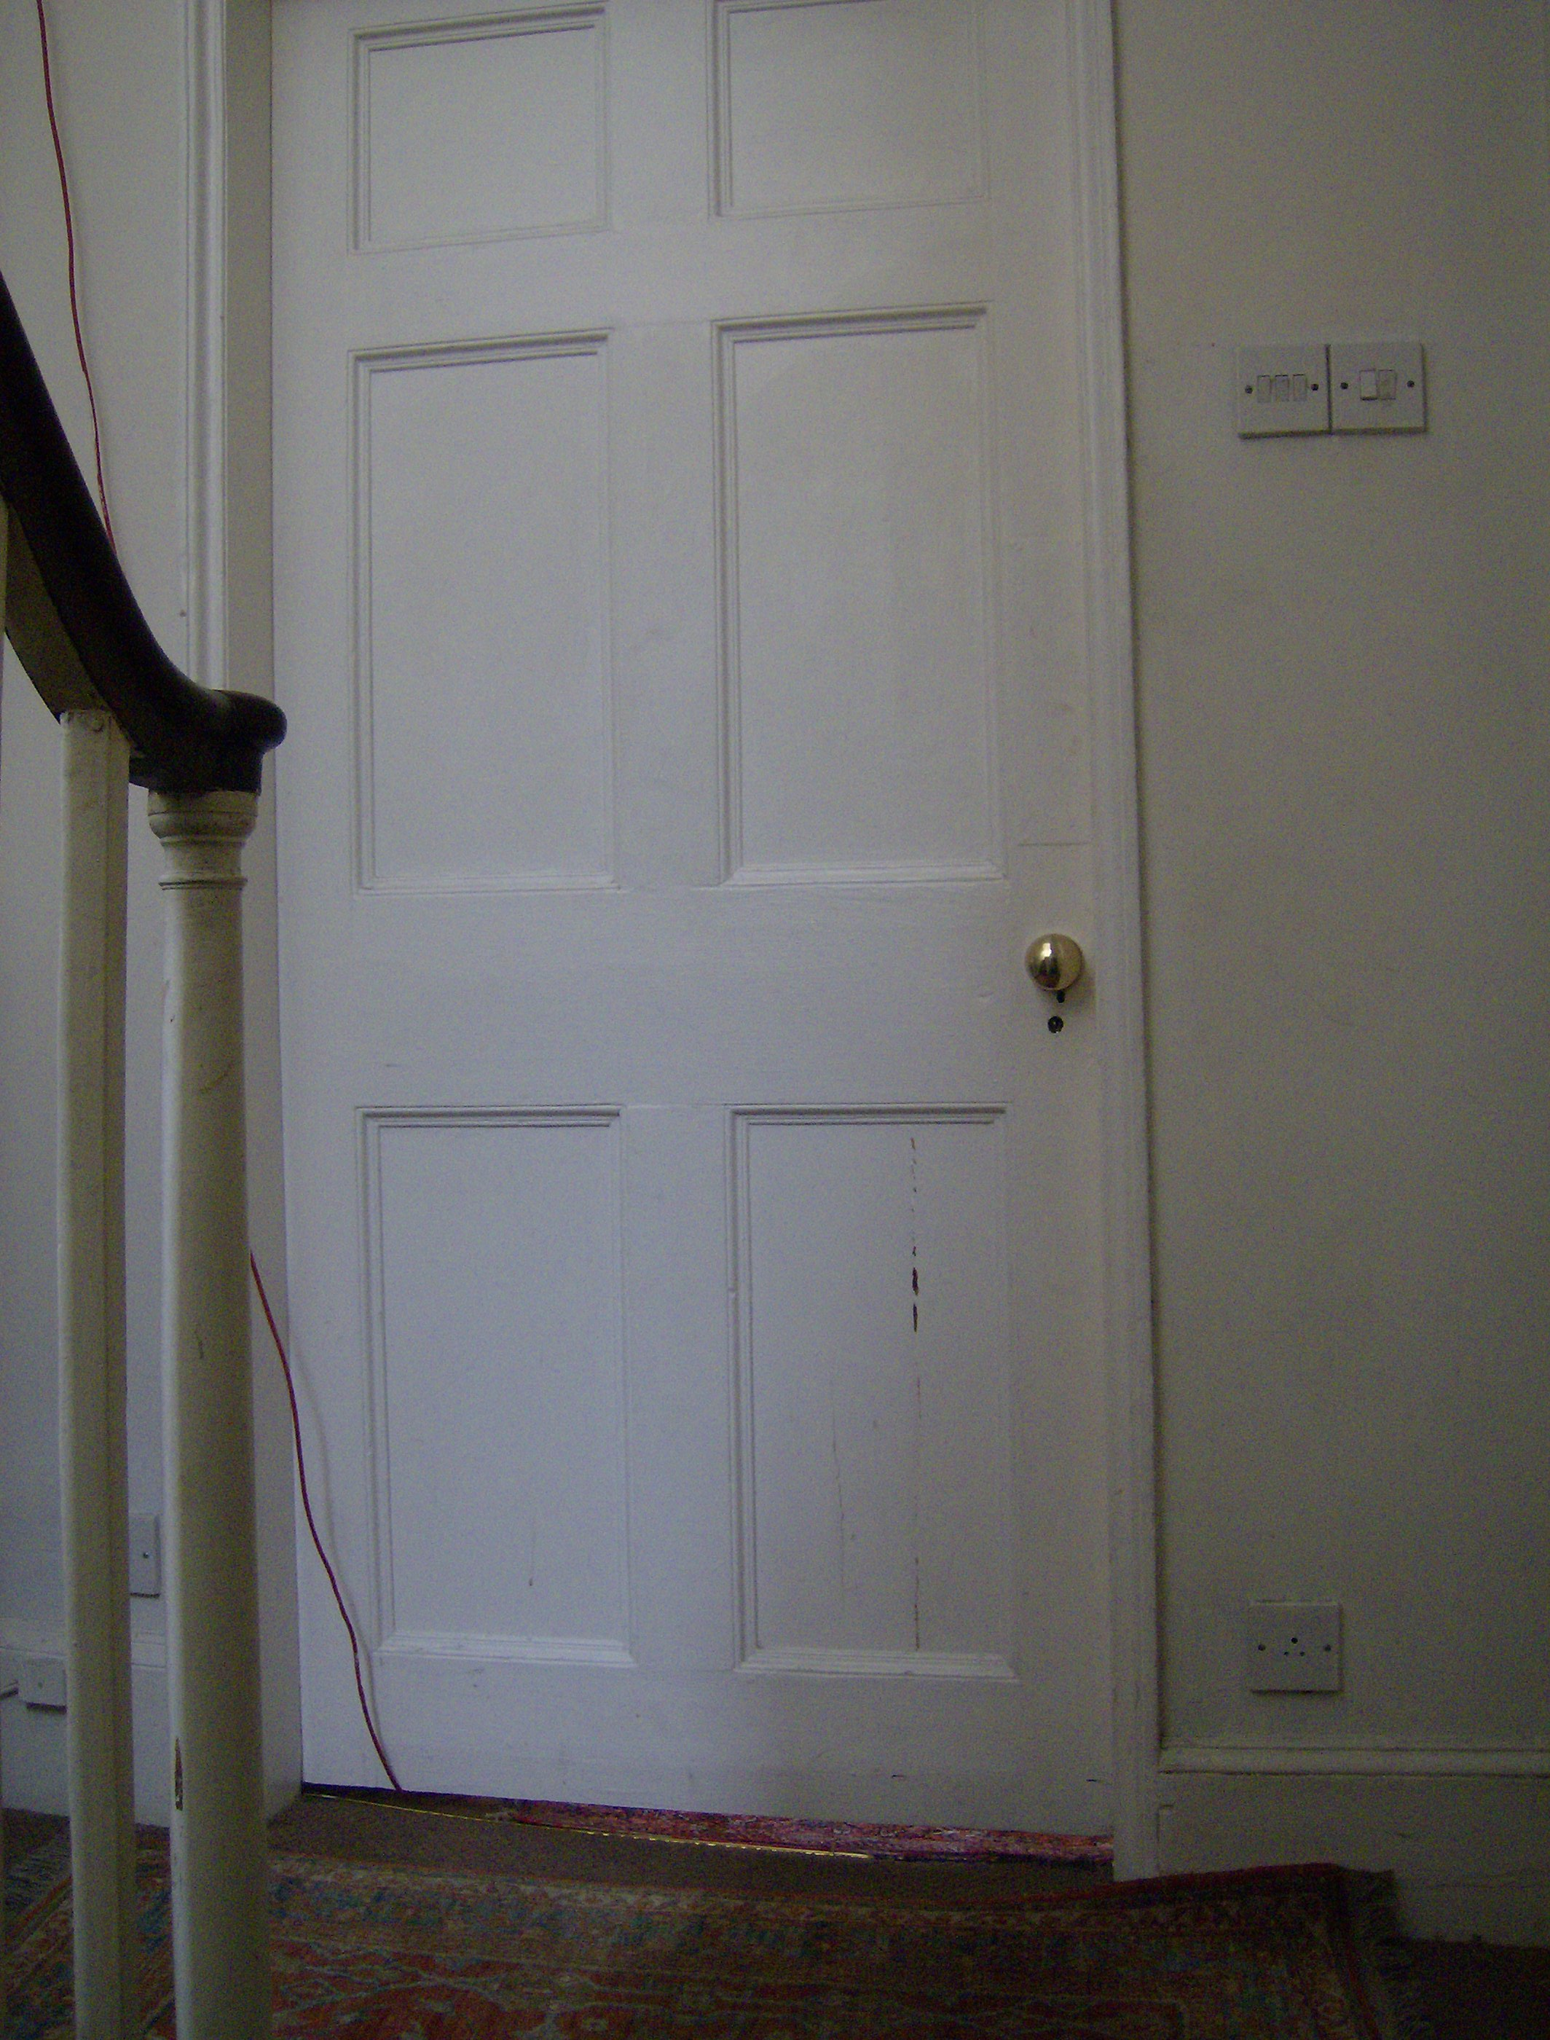

First Floor not of period

Design is not of period

Also door is damaged

Door not fire rated

