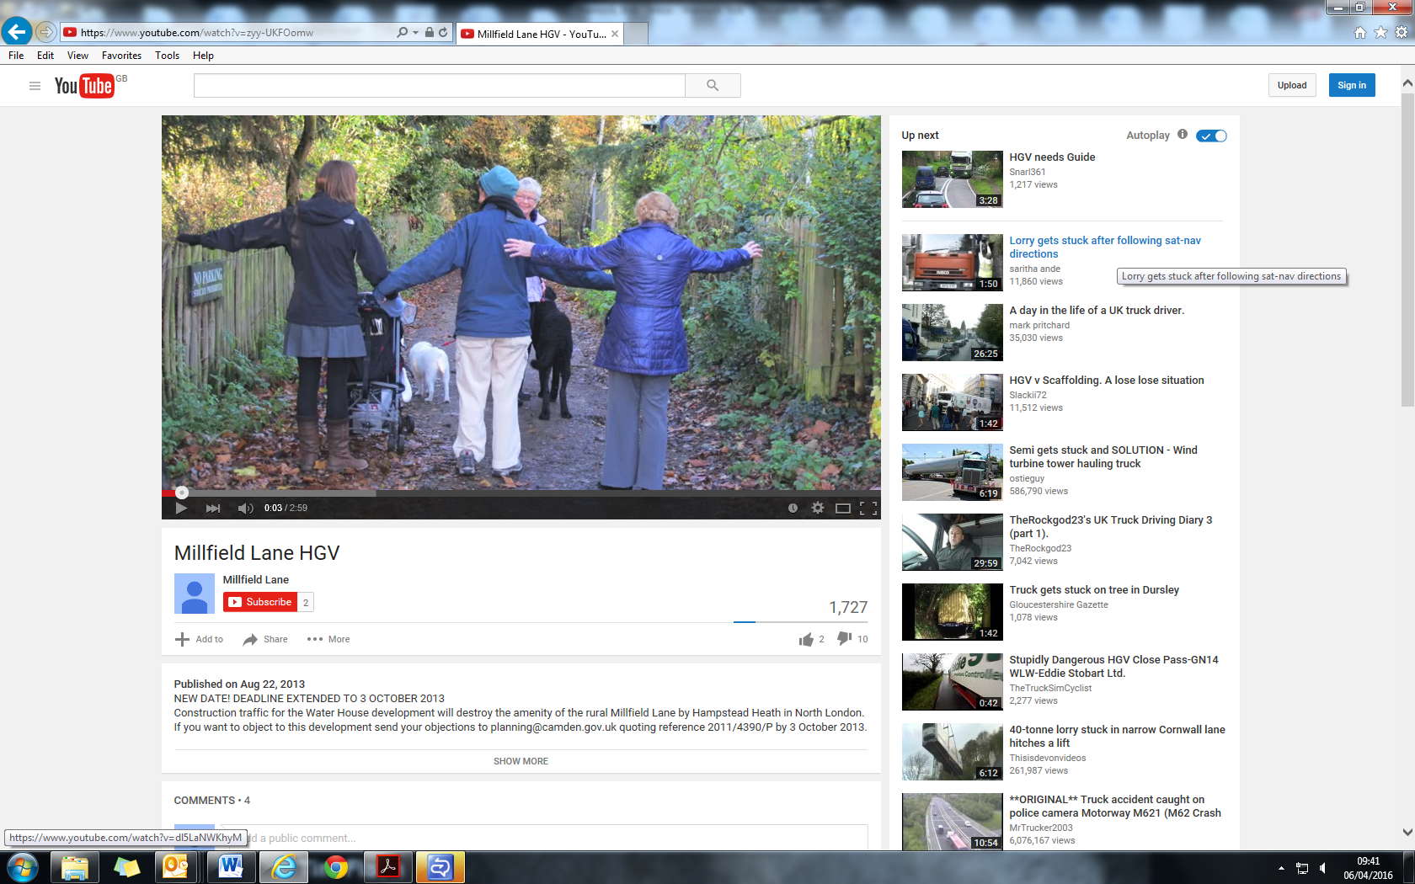

Figure 1: Illustration of the width of the Lane.

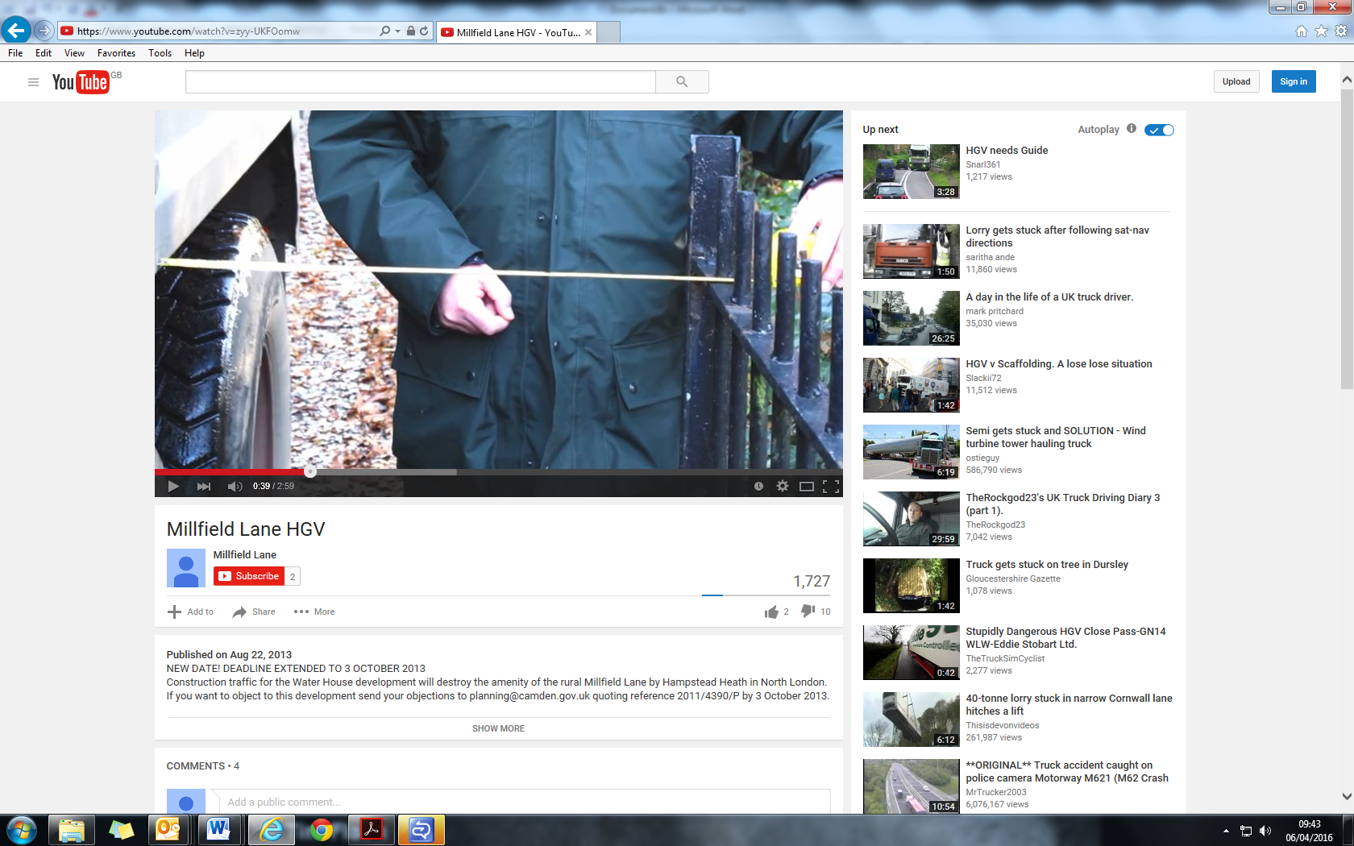

Figure 2: Illustration of lack of pedestrian passing room.
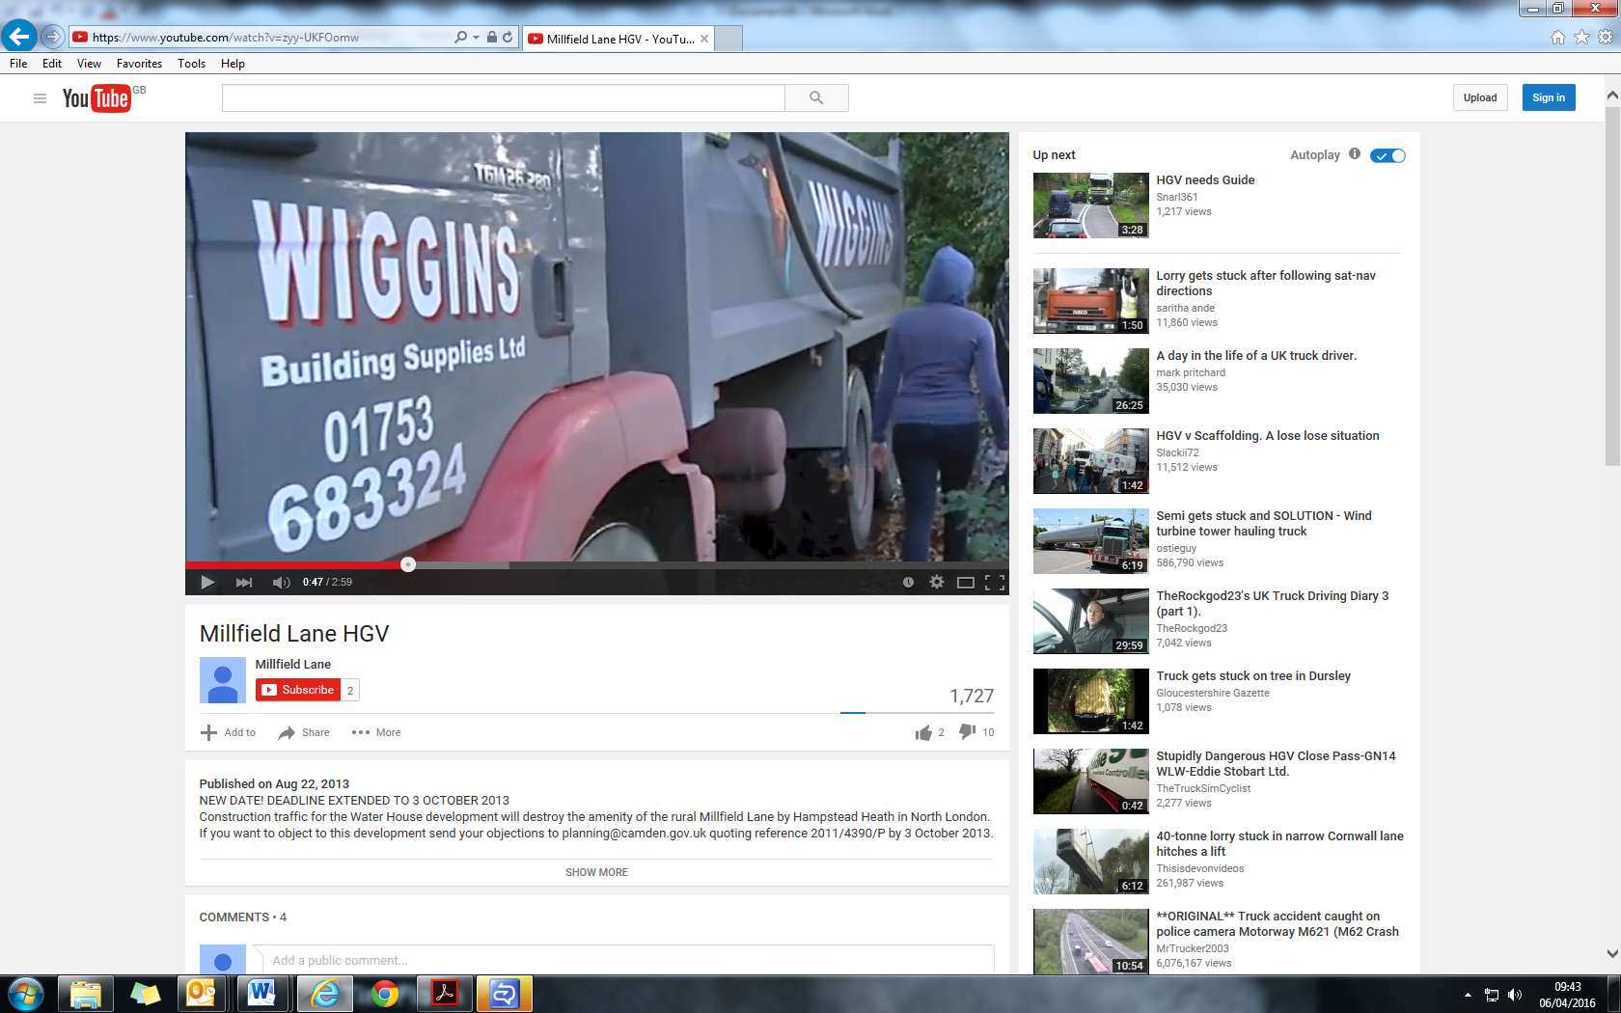

Figure 3: Illustration of lack of pedestrian passing room.

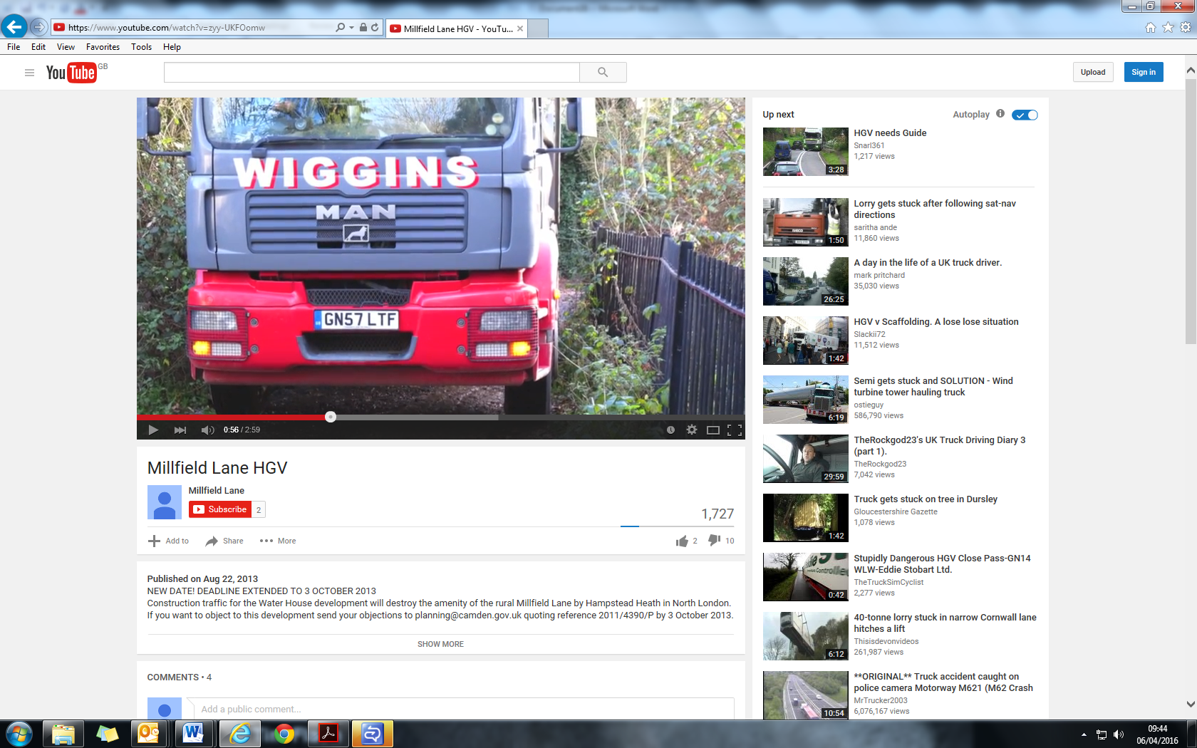

Figure 4: Illustration of lack of pedestrian passing room.

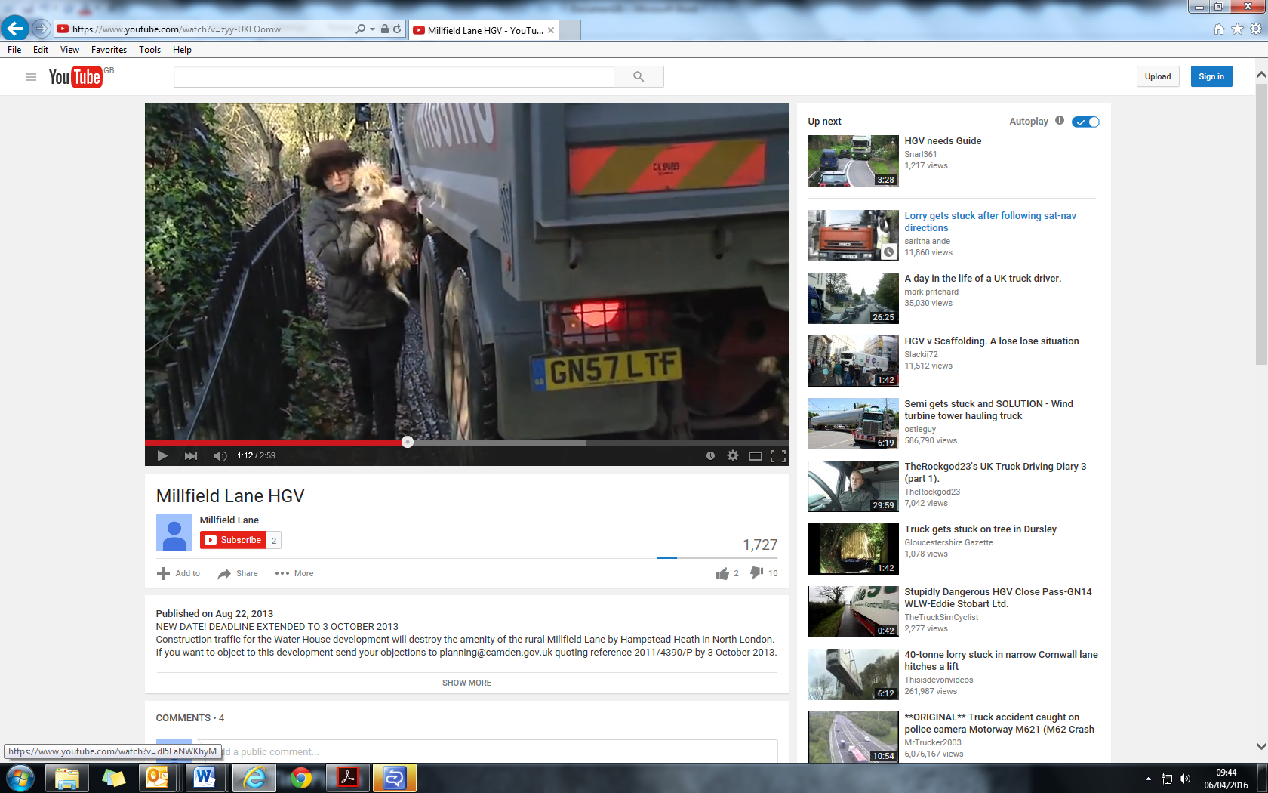

Figure 5: Illustration of lack of pedestrian passing room.

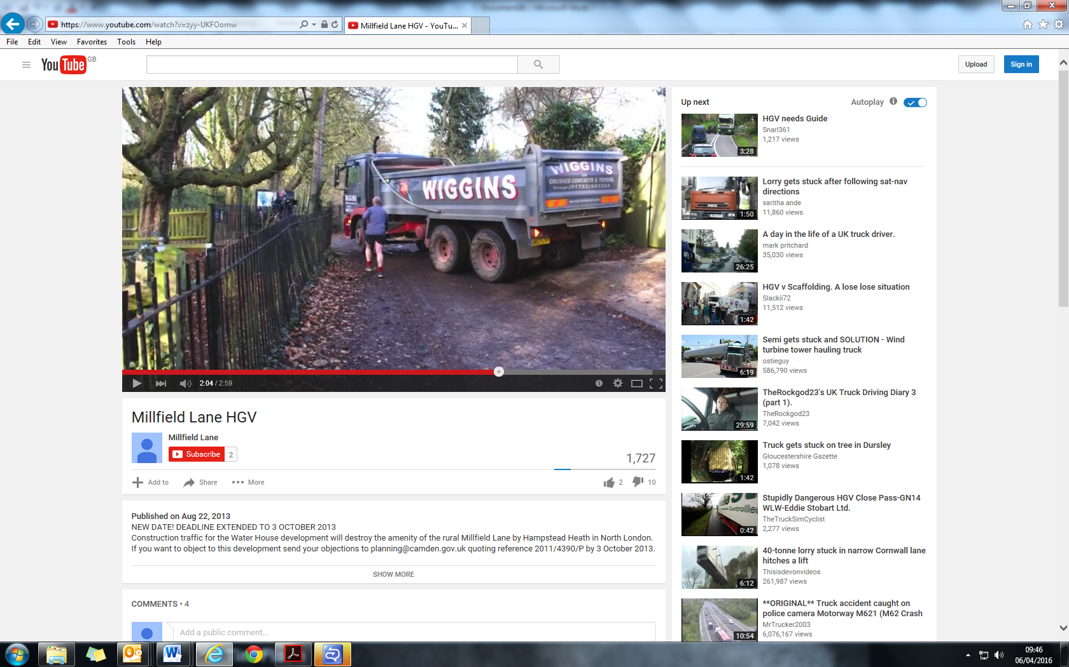

Figure 6: Illustration of lack of pedestrian passing room, and inability of vehicle to turn into the proposed access gate.

.
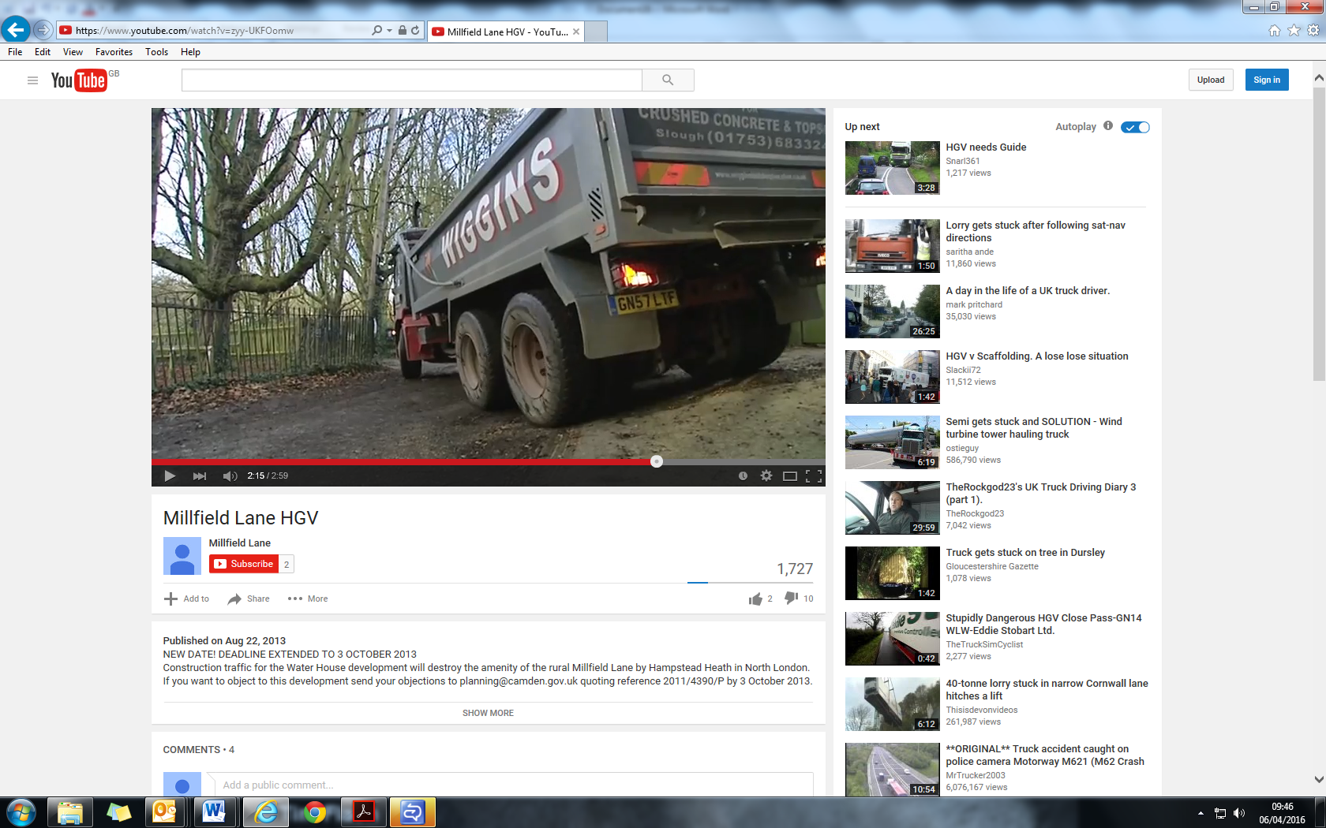

Figure 7: Illustration of lack of pedestrian passing room, and inability of vehicle to turn into the proposed access gate.

