April 2016

**DESIGN, ACCESS AND HERITAGE STATEMENT**

Alterations to The Old Bull and Bush, North End Way, London, NW3 7HE

This Statement has been prepared in accordance with the requirements of Section 42 of the Planning and Compulsory Purchase Act 2004 and the guidance set out at Section 3 of Circular 01/2006: Guidance on Changes to the Development Control System.

As set out at paragraph 77 of Circular 01/2006, Design and Access Statements should be concise and their length and content “*should be directly proportional to the scale and complexity of the proposals*”.

The scheme before the Council concerns the modification of the above site with the addition of a new pergola to the south west elevation, new signage affixed the front facade and various improvements internally, particularly to the kitchen entrance, secondary bar counter and toilets.

BACKGROUND

The applicant is Mitchells & Butlers PLC who operate many of the UK’s leading licensed retail brands including Vintage Inns, Toby Carvery and Ember Inns, as well as some of the most famous pubs in Britain.

The Old Bull & Bush public house is located on the west side of Hampstead Heath on North End Way. The site is surrounded by local shops and residential housing. A terrace of three storey townhouses, also listed, lie immediately behind the building. The northern parts of the site are laid to car parking for the pub’s staff and customers. The building is Grade II listed (APPENDIX 3) and was originally built as a farmhouse in 1721 and extended in 1923-24. Later additions were added in 1971 by Roderick Gradidge.

The building comprises a number of different elements which have been considerably altered and adapted. The building facing North End Way is brick-faced with a pitched roof. Behind this lies a second rendered building with a pitched roof behind parapet walls. These two storey buildings are linked by a two storey flat roof infill which probably dates back to the refurbishments carried out in the 1920’s (APPENDICES 1 & 2).

In addition, there is a single storey flat roof structure to the north, also from the 1920’s re-build. A third two storey building, presumably a former outhouse, links to the main structure via a single storey structure with a flat roof behind a parapet wall.

The North End Way elevation was significantly rebuilt in brick in the 1920’s. The two central bay windows and window pattern above were retained. This part of the façade was extended above eaves level to create a large arched parapet.

The doorways and windows in the bays to either side of the central section are much altered and more formal and ornate. The North End façade retains more of its original character with the arrangement of windows and doors reflecting the origins of the outbuildings.

Internal refurbishments carried out in the 1920’s opened up the front part of the building to create a saloon and public bars. The bar area has subsequently been extended into the ground floor of the former outbuilding and into the rear two storey structure.

A hallway which runs the depth of the building (front to back) survives virtually intact.

The first floor remains practically unaltered from the 1920’s layout.

DESIGN

Externally, the proposal will include removal of a jumbrella, with an open sided pergola installed in its place. The pergola is an aluminium structure, finished in anthracite grey with white aluminium rotating louvres. There will be three warm white LED light strips integrated within the roof louvres and two heaters, one on each cross beam. Please see Appendix 3 for more details.

ACCESS

The works do not affect access to the pub or to the patio. They provide a sheltered area for customers to sit while dining.

SUMMARY

In summary, the proposals have been designed to improve the external dining experience on the patio and in a way that is sympathetic to the character of the listed building. The works will be completed to a high standard maintaining the premium offer currently provided by the public house.

This Design and Access Statement is proportionate to the scale and complexity of the matters that require planning permission. It covers all the issues set out in Circular 01/2006 and is fully consistent with the requirements of Deposit Draft Local Plan and, in particular, Policies D5 & BH2.

APPENDICES

APPENDIX 1

Plan of old public house from 1920’s

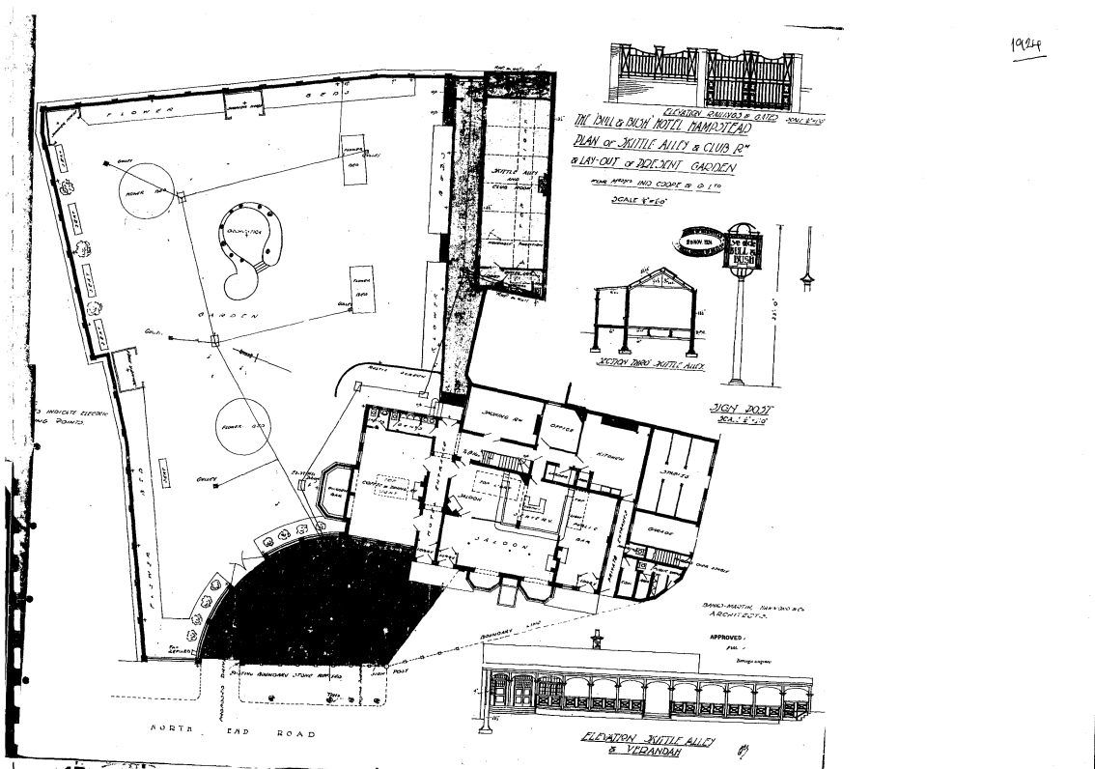

APPENDIX 2

Photo of The Old Bull & Bush front façade from 1924:

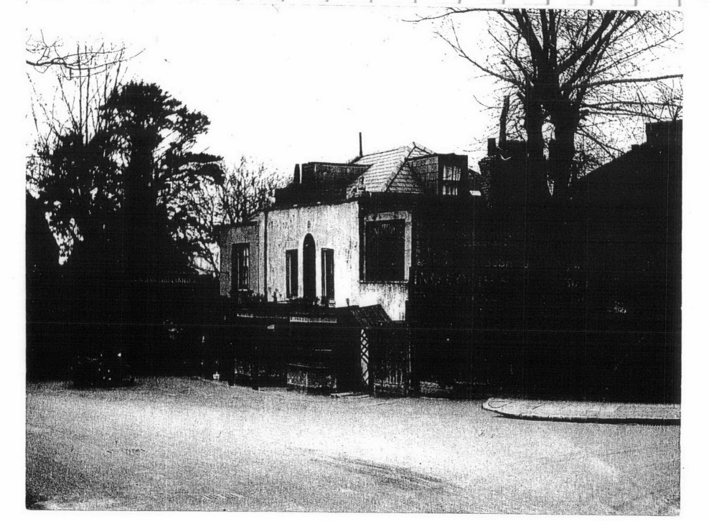

Photo of The Old Bull & Bush front façade from 1930:

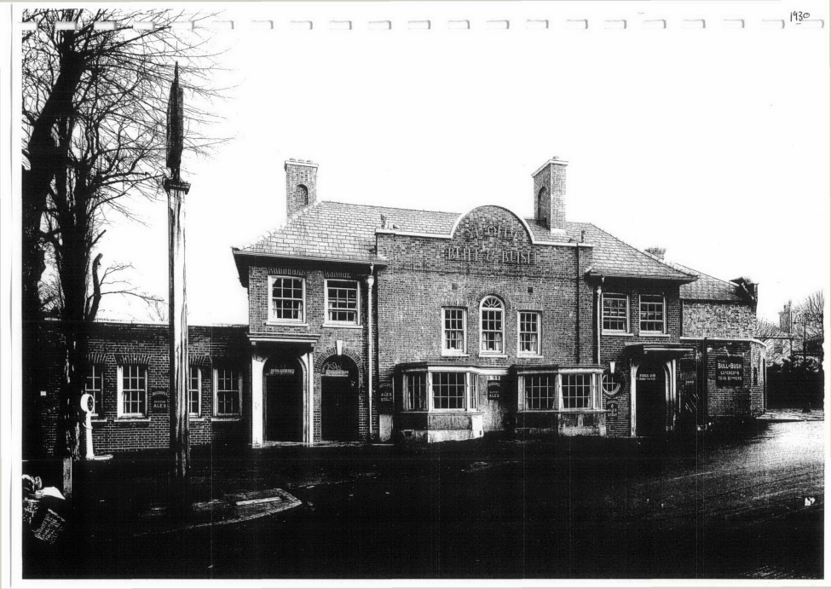

APPENDIX 3

**PERGOLA DETAILS: CARIBBEAN BLINDS PRODUCT**

**OUTDOOR LIVING POD – Louvred Roof Patio Canopy**

TECHNICAL DRAWINGS

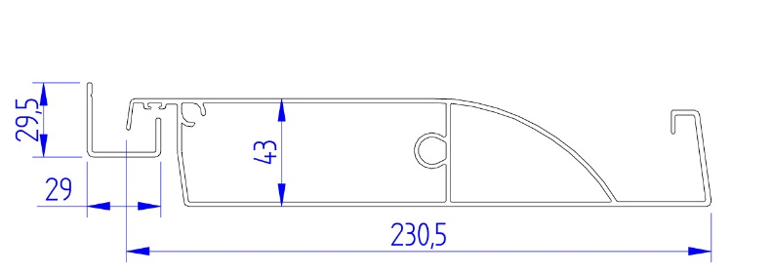

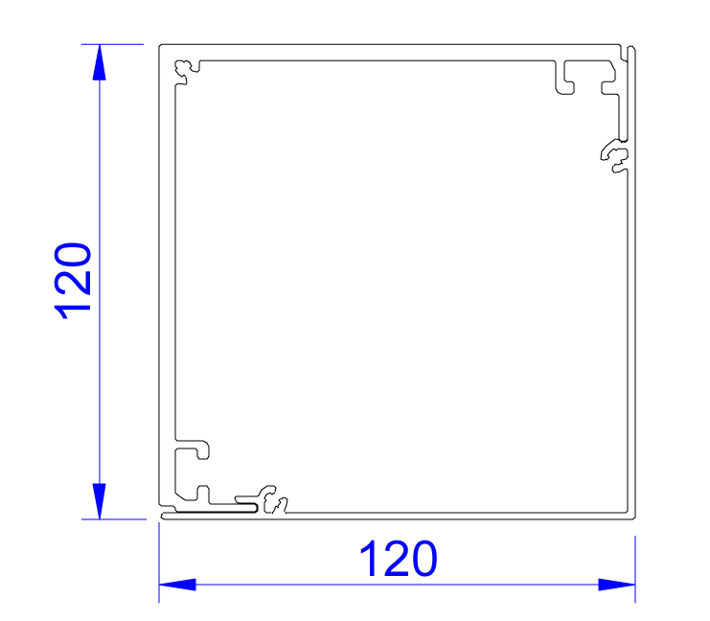

Roof Louvre Post Upright

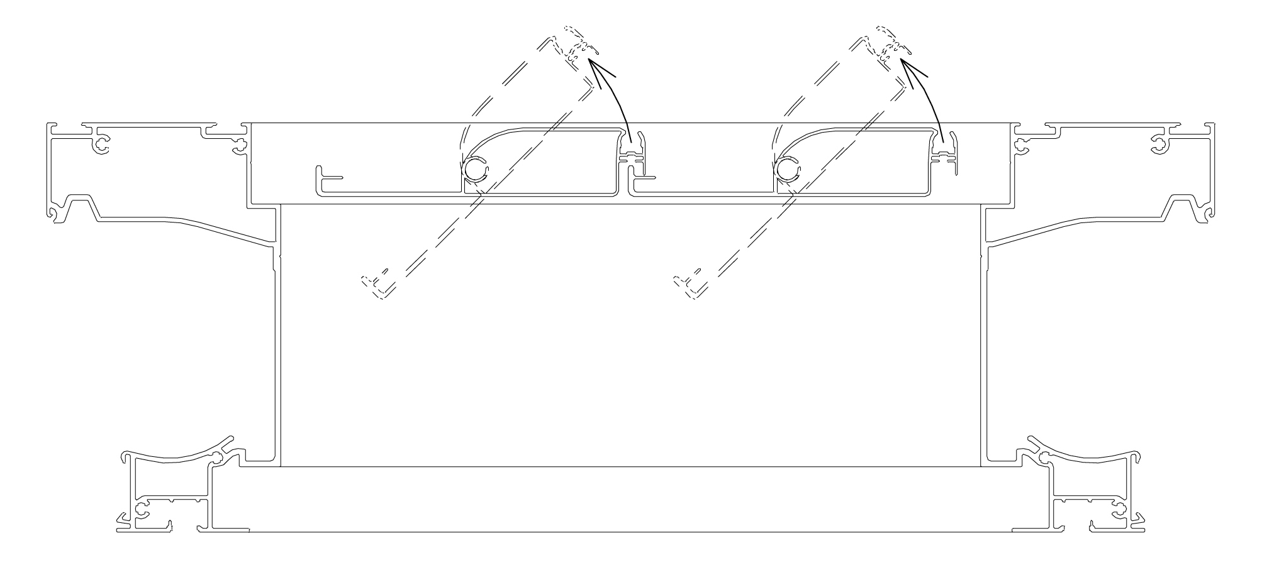

Section Through Frame

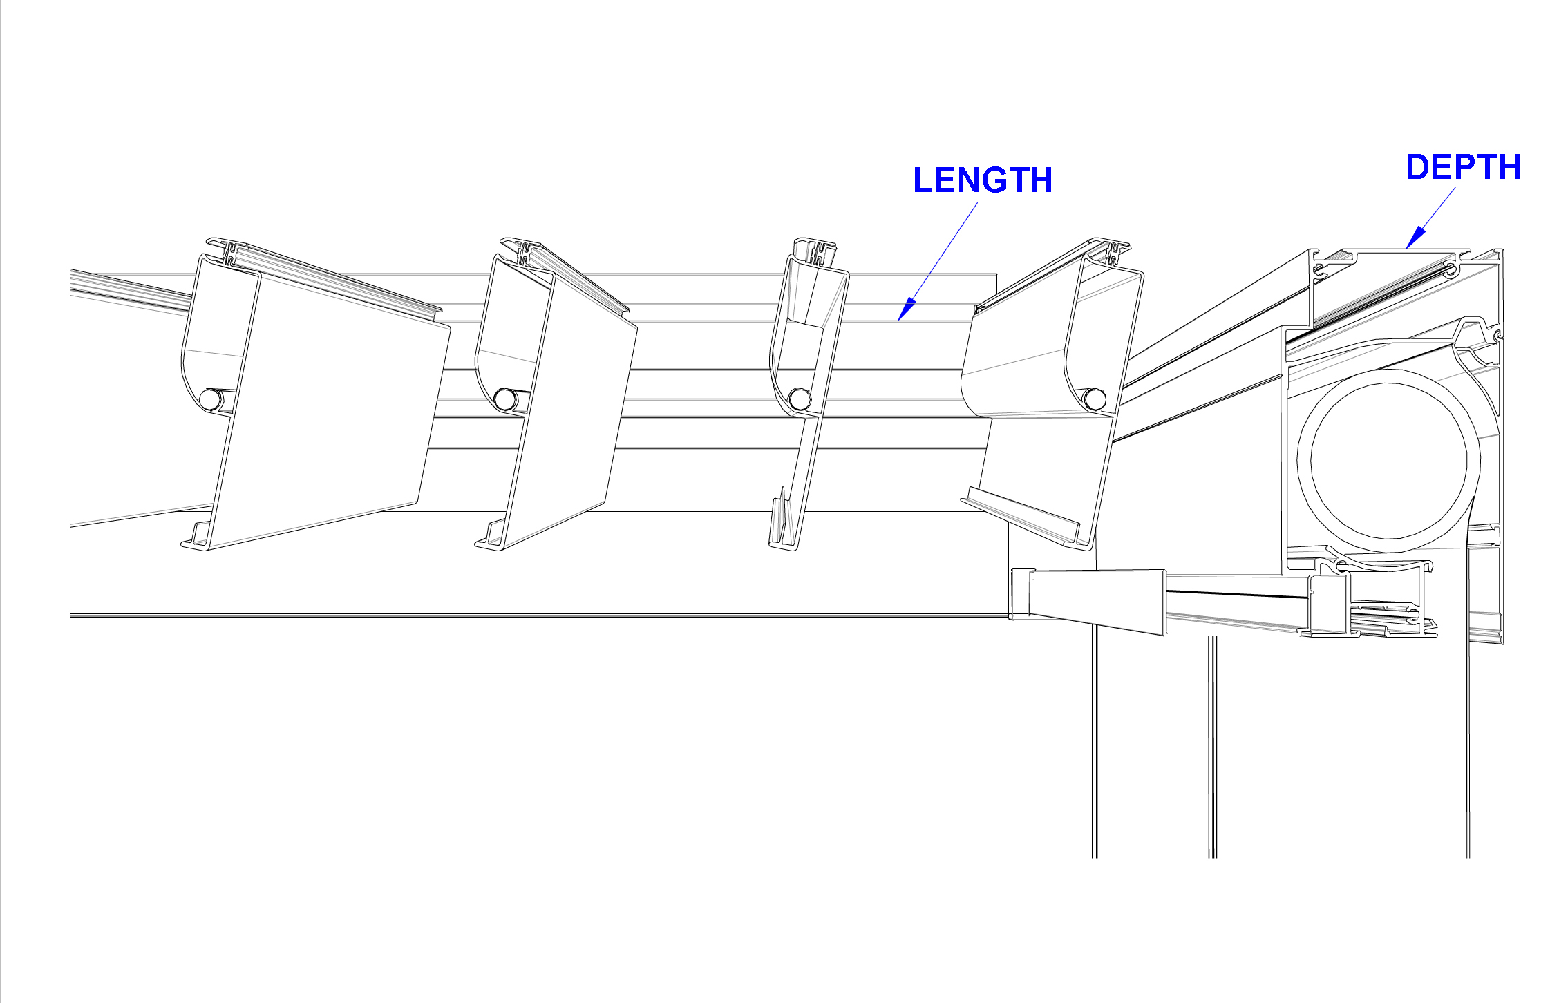

Cross Section of Pergola

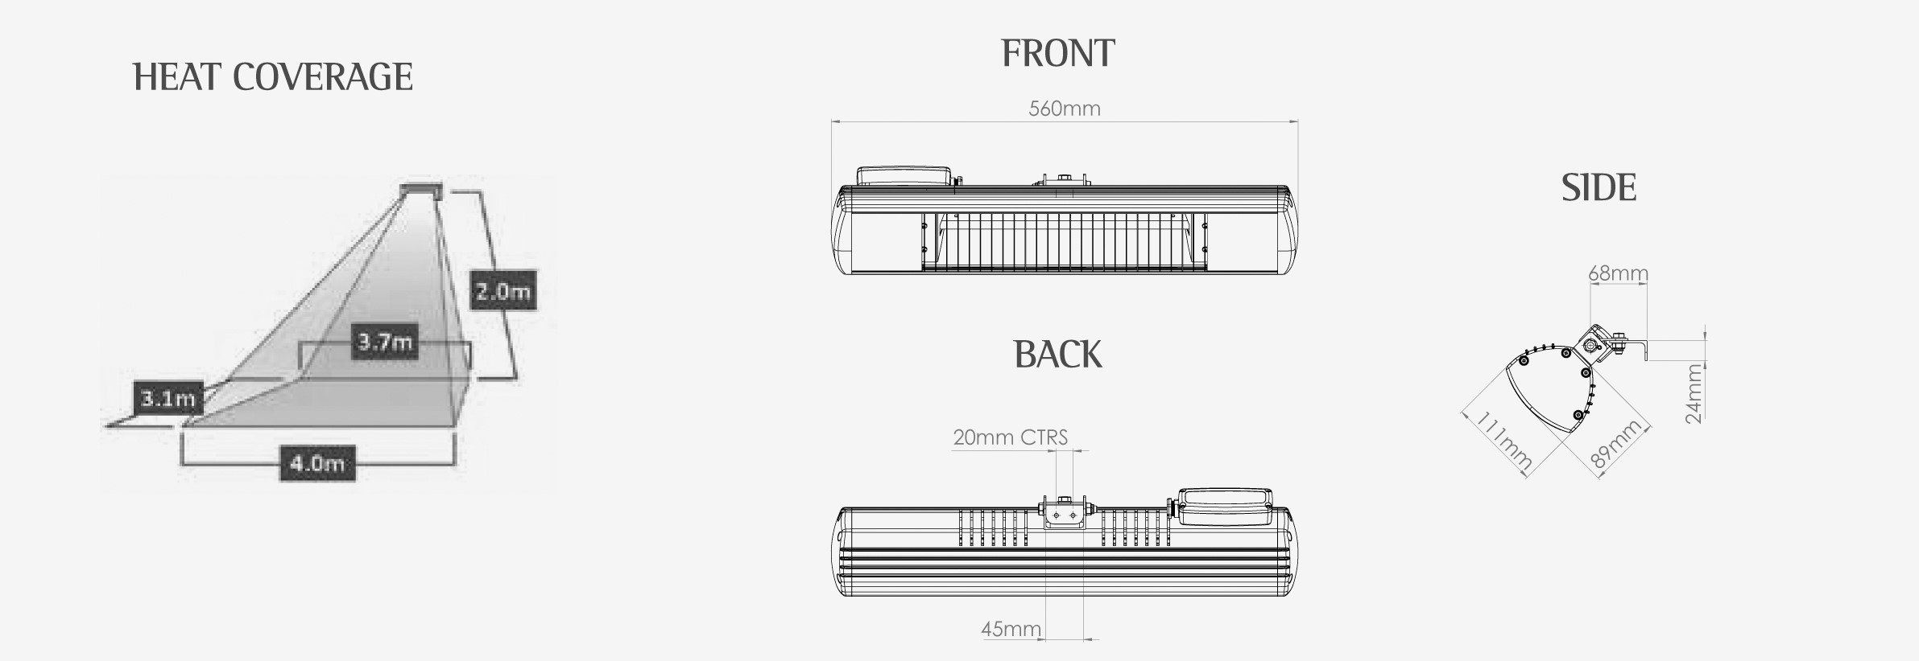

Heater Information

**OUTDOOR LIVING POD – Louvred Roof Patio Canopy**

IMAGES

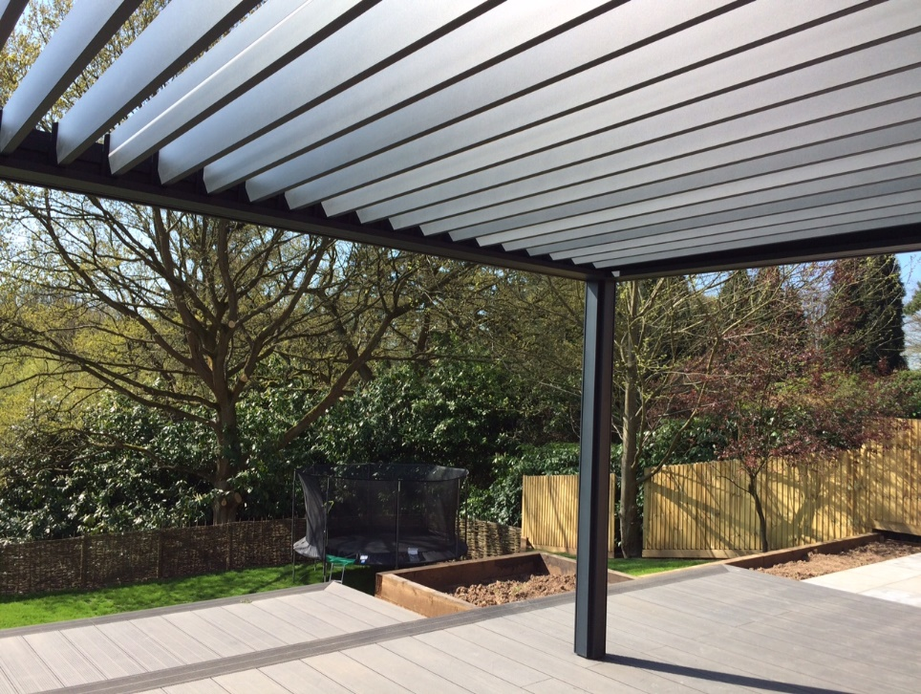

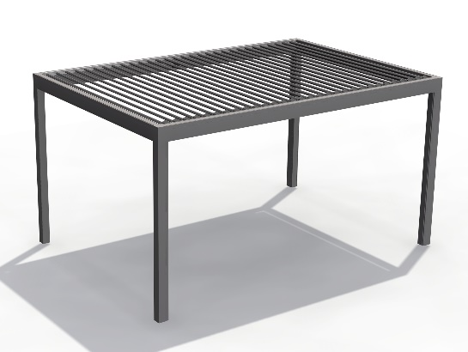

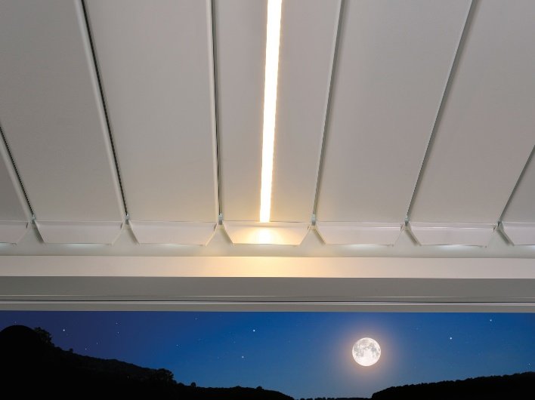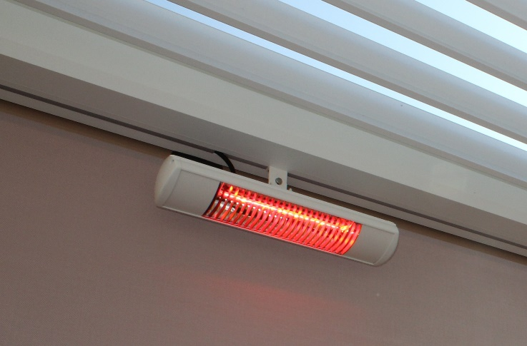

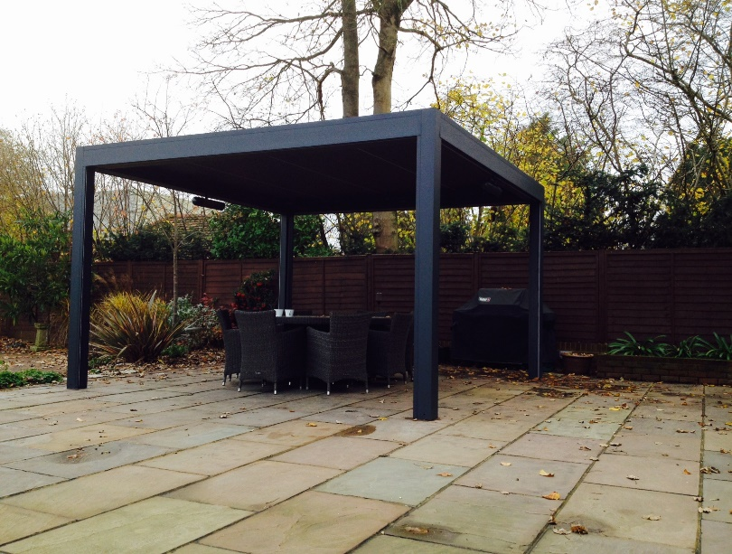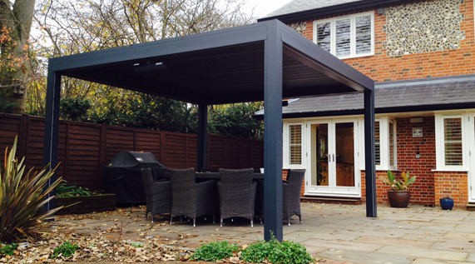

APPENDIX 4

