Design & Access statement

These roof lights are on the front roof slope of our neighbouring property . The proposed roof lights will be smaller ( 1x1m ), on the less important rear roof slope and have the central black conservation glazing bars running vertically down them to fulfil the current conservation area requirements .

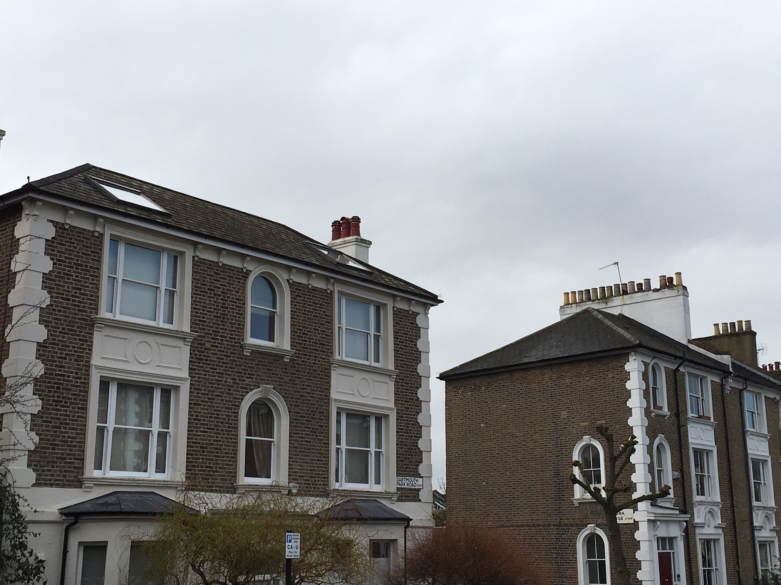
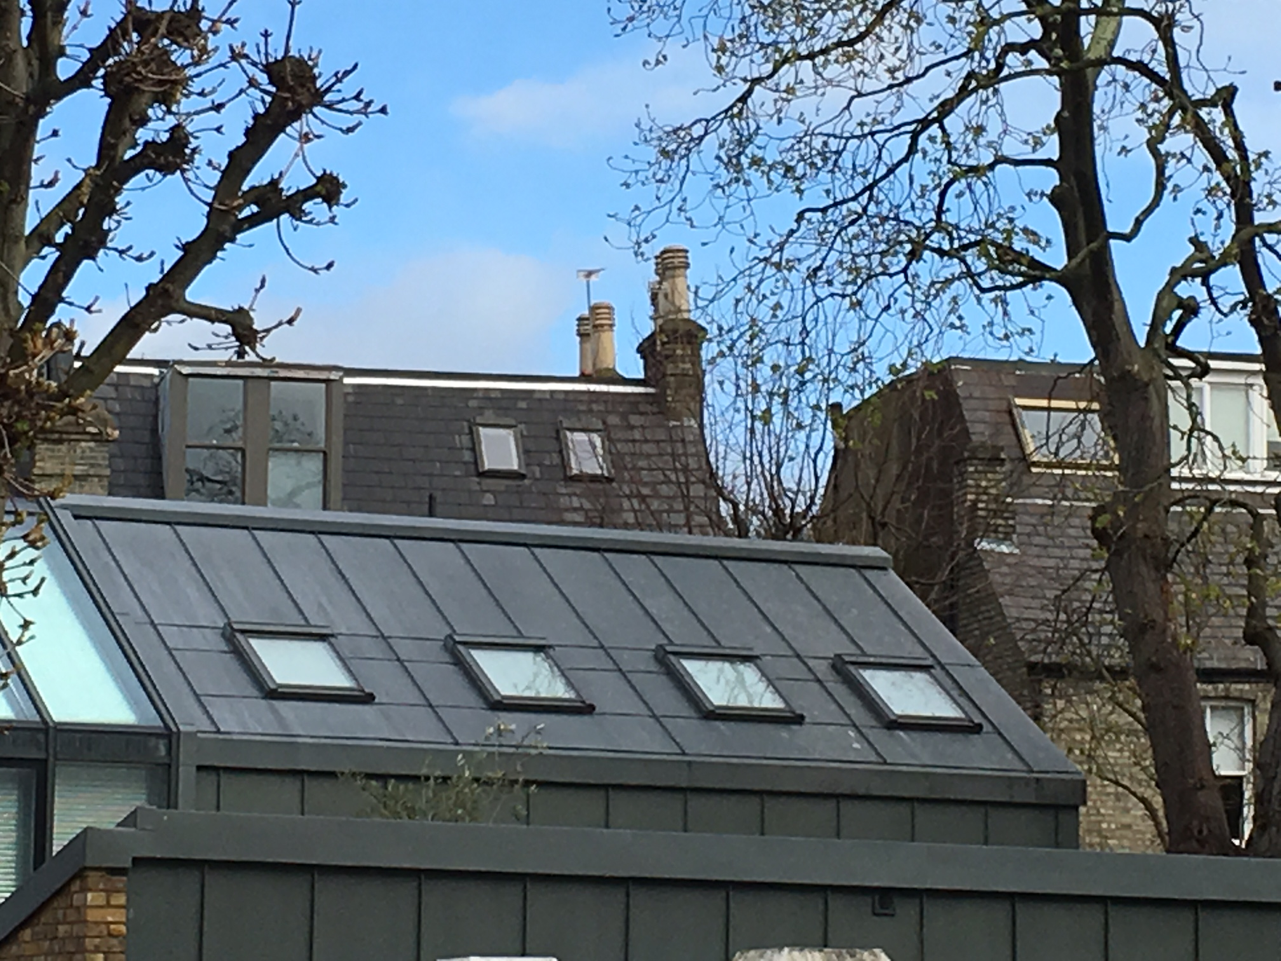

Ben Story

