Mr. Andrew Thompson
AECOM
5th Floor
City Walk
Leeds
West Yorkshire
LS11 9AR

5th Floor  City Walk  Leeds  West Yorkshire  LS11 9AR |  | Application Ref: 2016/0796/L
 |  | Please ask for: Catherine Bond
 |  | Telephone: 020 7974 2669
 |  | 31 March 2016

Dear Sir/Madam

DECISION

Planning (Listed Building and Conservation Areas) Act 1990

Listed Building Consent Granted

Address:
British Museum
Great Russell Street
London
WC1B 3DG

Proposal:
Installation of electronic access control measures on existing doors within the museum
Drawing Nos: Site Location Plan; 60304751_AC_00_L2_TS_0005; Breakglass product information; 3Egress exit button production information; Salto Systems wall reader production information; Salto Systems electronic escutcheon product information; Heritage Door Survey; Heritage Door Schedule; Design and Access Statement Heritage Statement.

The Council has considered your application and decided to grant Listed Building Consent subject to the following condition(s):

Conditions And Reasons:

1 | The works hereby permitted shall be begun not later than the end of three years from the date of this consent.  Reason: In order to comply with the provisions of Section 18 of the Planning (Listed Buildings and Conservation Areas) Act 1990.
2 | All new external and internal works and finishes and works of making good to the retained fabric, shall match the existing adjacent work with regard to the methods used and to material, colour, texture and profile, unless shown otherwise on the drawings or other documentation hereby approved or required by any condition(s) attached to this consent.  Reason: In order to safeguard the special architectural and historic interest of the building in accordance with the requirements of policy CS14 of the London Borough of Camden Local Development Framework Core Strategy and policy DP25 of the London Borough of Camden Local Development Framework Development Policies.
3 | The works hereby approved are only those specifically indicated on the drawing(s) referred to above.  Reason: In order to safeguard the special architectural and historic interest of the building in accordance with the requirements of policy CS14 of the London Borough of Camden Local Development Framework Core Strategy and policy DP25 of the London Borough of Camden Local Development Framework Development Policies.

Informative(s):

Reason for granting listed building consent:

The proposed works form part of an ongoing security upgrade to the grade I listed building. The installation of access control measures internally and externally on a number of doors throughout the museum complex will prevent unauthorised entry to back-of-house areas. The works are of a minor nature and are reversible, thereby not harming the special interest of the grade I listed building.

Public consultation was undertaken by placement of a press notice and site notice, whereby no responses were received.

Historic England was consulted, whereby a response was received on 8 March 2016 authorising the London Borough of Camden to determine this application in accordance with national and local policy guidance and on the basis of its specialist conservation advice.

The site's planning history was taken into account when coming to this decision.

Special regard has been attached to the desirability of preserving the listed building and its features of special architectural or historic interest, under s.16 of the Listed Buildings and Conservation Areas Act 1990 as amended by the Enterprise and Regulatory Reform Act (ERR) 2013.

As such, the proposal is in general accordance with policy CS14 of the London Borough of Camden Local Development Framework Core Strategy, and policy DP25 of the London Borough of Camden Local Development Framework Development Policies. The proposed development also accords with policy 7.8 of The London Plan 2015 consolidated with alterations since 2011, and paragraphs 14, 17 and 126-141 of the National Planning Policy Framework.

Your proposals may be subject to control under the Building Regulations and/or the London Buildings Acts which cover aspects including fire and emergency escape, access and facilities for people with disabilities and sound insulation between dwellings. You are advised to consult the Council's Building Control Service, 2nd Floor, 5 Pancras Square, London N1C 4AG (tel: 020-7974 6941).

You can find advice about your rights of appeal at:

http://www.planningportal.gov.uk/planning/appeals/guidance/guidancecontent

Yours faithfully
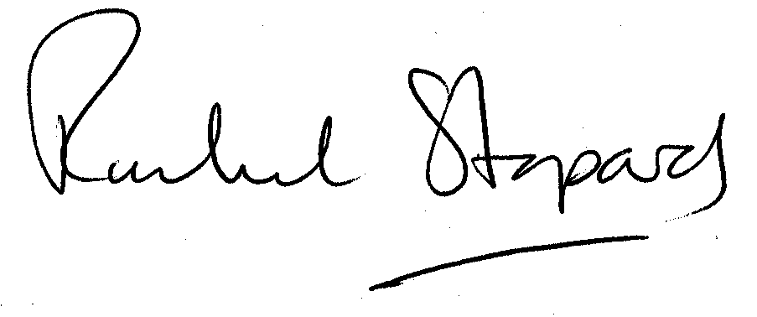
Rachel Stopard
Director of Culture & Environment

