Mr. Patrick Keetley
Patrick Keetley Architect
91c St.Johns Way
London
N19 3QU
91c St.Johns Way  London  N19 3QU |  | Application Ref: 2016/0752/P
 |  | Please ask for: Catherine Bond
 |  | Telephone: 020 7974 2669
 |  | 24 March 2016

Dear Sir/Madam

DECISION

Town and Country Planning Act 1990 (as amended)

Full Planning Permission Granted

Address:
Mary Ward House
5 Tavistock Place
London
WC1H 9SN

Proposal:
Installation of disabled access lift and associated glazed covered walkway into main lightwell
Drawing Nos: Site Location Plan; 14-10(01); 14-10(01); 14-10(01); 14-10(02); 14-10(03); 14-10(04); 14-10(05); 14-10(06); 14-10(07); 14-10(08); 14-10(09); 14-10(10); 14-10(11); 14-10(12); 14-10(13); 14-10(14); 14-10(15); 14-10(16); 14-10(18); 14-10(23); 14-10-P1; 14-10-P2; 14-10-P3; 14-10-P4; Design-Access-Justification Statement; Heritage Statement.

The Council has considered your application and decided to grant permission subject to the following condition(s):

Condition(s) and Reason(s):

1 | The development hereby permitted must be begun not later than the end of three years from the date of this permission.  Reason: In order to comply with the provisions of Section 91 of the Town and Country Planning Act 1990 (as amended).
2 | All new external work shall be carried out in materials that resemble, as closely as possible, in colour and texture those of the existing building, unless otherwise specified in the approved application.  Reason: To safeguard the appearance of the premises and the character of the immediate area in accordance with the requirements of policy CS14 of the London Borough of Camden Local Development Framework Core Strategy and policy DP24 [and DP25 if in CA] of the London Borough of Camden Local Development Framework Development Policies.
3 | The development hereby permitted shall be carried out in accordance with the following approved plans: Site Location Plan; 14-10(01); 14-10(01); 14-10(01); 14-10(02); 14-10(03); 14-10(04); 14-10(05); 14-10(06); 14-10(07); 14-10(08); 14-10(09); 14-10(10); 14-10(11); 14-10(12); 14-10(13); 14-10(14); 14-10(15); 14-10(16); 14-10(18); 14-10(23); 14-10-P1; 14-10-P2; 14-10-P3; 14-10-P4; Design-Access-Justification Statement; Heritage Statement.  Reason:  For the avoidance of doubt and in the interest of proper planning.

Informative(s):

Your proposals may be subject to control under the Building Regulations and/or the London Buildings Acts which cover aspects including fire and emergency escape, access and facilities for people with disabilities and sound insulation between dwellings. You are advised to consult the Council's Building Control Service, 2nd Floor, 5 Pancras Square, London N1C 4AG (tel: 020-7974 6941).

Noise from demolition and construction works is subject to control under the Control of Pollution Act 1974. You must carry out any building works that can be heard at the boundary of the site only between 08.00 and 18.00 hours Monday to Friday and 08.00 to 13.00 on Saturday and not at all on Sundays and Public Holidays. You are advised to consult the Council's Compliance and Enforcement team [Regulatory Services], Camden Town Hall, Argyle Street, WC1H 8EQ (Tel. No. 020 7974 4444 or on the website http://www.camden.gov.uk/ccm/content/contacts/council-contacts/environment/contact-the-environmental-health-team.en or seek prior approval under Section 61 of the Act if you anticipate any difficulty in carrying out construction other than within the hours stated above.

Reasons for granting permission:

The proposed works comprise the installation of a disabled access lift linking the basement, ground and first-floor levels of the grade I listed building, together with the construction of an associated glazed covered walkway at first-floor level in the main lightwell of the grade I listed Mary Ward House.

The building, which primarily operates as a conference and exhibition centre, with ancillary residential accommodation, does not currently provide level access throughout. The two principal entrances comprise steps to a raised ground level, although visitors can access one entrance via a ramp situated in the garden to the north. The ground floor is arranged over four different levels connected by short flights of stairs, requiring a portable ramp to be employed when necessary. However, access for wheelchair users is currently limited to the ground floor.

This application proposes to add to and improve the existing access provision. The proposed disabled access route at ground-floor level, via existing corridors in the north wing, will link the current external ramp in the rear garden to the position of the proposed lift. The lift will be accessed via an under-stair store area, which will be removed. Access at basement level will be via a short corridor accessing meeting rooms. At first-floor level the lift platform will be linked directly to the glazed covered walkway, the floor level of which will correspond with the main hall. A lift car has been selected which meets statutory requirements for disabled access, whilst having minimal impact on the plan form of the historic building due to its modest size. Notwithstanding, it is accepted that portable ramps will still be required at ground-floor level due to the constraints of the grade I listed building.

The installation of the lift and associated walkway will notably increase disabled access within the Mary Ward Centre. By locating the lift and walkway in an area of lesser significance away from principal internal spaces, and employing lightweight materials in the inner lightwell which is not visible from the public realm, the proposals will provide sizeable public benefit whilst minimising harm to the special interest of the grade I listed building and the character and appearance of the Bloomsbury Conservation Area.

Due to its location, the proposal will not harm the amenity of any adjoining residential occupiers.

A site notice and press notice were posted, but no objections were received. Bloomsbury Conservation Area Advisory was consulted, but did not comment. The site's planning history was taken into account when coming to this decision.

Special regard has been given to the desirability of preserving the listed building, under s.66 of the Listed Buildings and Conservation Areas Act 1990, and special attention has been paid to the desirability of preserving or enhancing the character or appearance of the conservation area, under s.72 of the Listed Buildings and Conservation Areas Act 1990, both as amended by the Enterprise and Regulatory Reform Act (ERR) 2013.

As such, the proposed development is in general accordance with policies CS5 and CS14 and of the London Borough of Camden Local Development Framework Core Strategy, and policies DP24, DP25 and DP26 of the London Borough of Camden Local Development Framework Development Policies. The proposed development also accords with policies 7.4, 7.6 and 7.8 of the London Plan March 2015, consolidated with alterations since 2011; and paragraphs 14, 17, 56-66, and 126-141 of the National Planning Policy Framework.

The Mayor of London introduced a Community Infrastructure Levy (CIL) to help pay for Crossrail on 1st April 2012. Any permission granted after this time which adds more than 100sqm of new floorspace or a new dwelling will need to pay this CIL. It will be collected by Camden on behalf of the Mayor of London. Camden will be sending out liability notices setting out how much CIL will need to be paid if an affected planning application is implemented and who will be liable.

The proposed charge in Camden will be £50 per sqm on all uses except affordable housing, education, healthcare, and development by charities for their charitable purposes. You will be expected to advise us when planning permissions are implemented. Please use the forms at the link below to advise who will be paying the CIL and when the development is to commence. You can also access forms to allow you to provide us with more information which can be taken into account in your CIL calculation and to apply for relief from CIL.

http://www.planningportal.gov.uk/planning/applications/howtoapply/whattosubmit/cil

We will then issue a CIL demand notice setting out what monies needs to paid when and how to pay. Failure to notify Camden of the commencement of development will result in a surcharge of £2500 or 20% being added to the CIL payment. Other surcharges may also apply for failure to assume liability and late payment. Payments will also be subject to indexation in line with the construction costs index.

Please send CIL related documents or correspondence to CIL@Camden.gov.uk

In dealing with the application, the Council has sought to work with the applicant in a positive and proactive way in accordance with paragraphs 186 and 187 of the National Planning Policy Framework.

You can find advice about your rights of appeal at:

http://www.planningportal.gov.uk/planning/appeals/guidance/guidancecontent

Yours faithfully
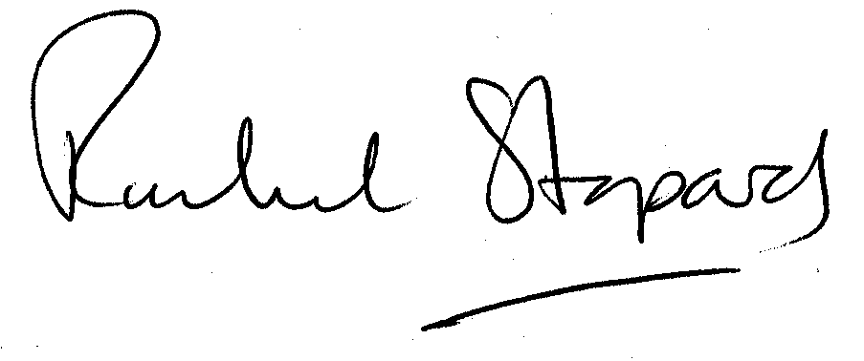
Rachel Stopard
Director of Culture & Environment

