Mr Andy Down
Archplan Architects
1 Millfield Place
London
N6 6JP
1 Millfield Place  London  N6 6JP |  | Application Ref: 2016/0403/L
 |  | Please ask for: Anna Roe
 |  | Telephone: 020 7974 1226
 |  | 21 March 2016

Dear Sir/Madam

DECISION

Planning (Listed Building and Conservation Areas) Act 1990

Listed Building Consent Granted

Address:
55 Gloucester Crescent
London
NW1 7EG

Proposal: Erection of a single storey rear extension (4m deep x 5.7m wide x 3m high).

Drawing Nos: GC/05A; GC/06A; GC/07A; CG/08A; OS Extract; Design and Access Statement; Heritage Statement.

The Council has considered your application and decided to grant Listed Building Consent subject to the following condition(s):

Conditions And Reasons:

1 | The works hereby permitted shall be begun not later than the end of three years from the date of this consent.  Reason: In order to comply with the provisions of Section 18 of the Planning (Listed Buildings and Conservation Areas) Act 1990.
2 | The works hereby approved are only those specifically indicated on the drawings referred to above.  Reason: In order to safeguard the special architectural and historic interest of the building in accordance with the requirements of policy CS14 of the London Borough of Camden Local Development Framework Core Strategy and policy DP25 of the London Borough of Camden Local Development Framework Development Policies.
3 | All new external and internal works and finishes and works of making good to the retained fabric, shall match the existing adjacent work with regard to the methods used and to material, colour, texture and profile, unless shown otherwise on the drawings or other documentation hereby approved or required by any condition(s) attached to this consent.  Reason: In order to safeguard the special architectural and historic interest of the building in accordance with the requirements of policy CS14 of the London Borough of Camden Local Development Framework Core Strategy and policy DP25 of the London Borough of Camden Local Development Framework Development Policies.

You can find advice about your rights of appeal at:

http://www.planningportal.gov.uk/planning/appeals/guidance/guidancecontent

Yours faithfully
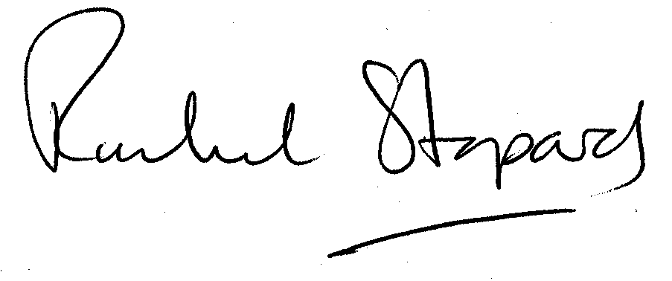
Rachel Stopard
Director of Culture & Environment

