DESIGN & ACCESS STATEMENT

SITE ADDRESS: 19 Patshull Road, London, NW5 2JX

Proposal Outline:: Anglian Home Improvements have been contracted to replace a Conservatory roof to the rear of the property. Our client has chosen a replacement roof to meet their personal requirements whilst being considerate to the natural surroundings and council guidelines.

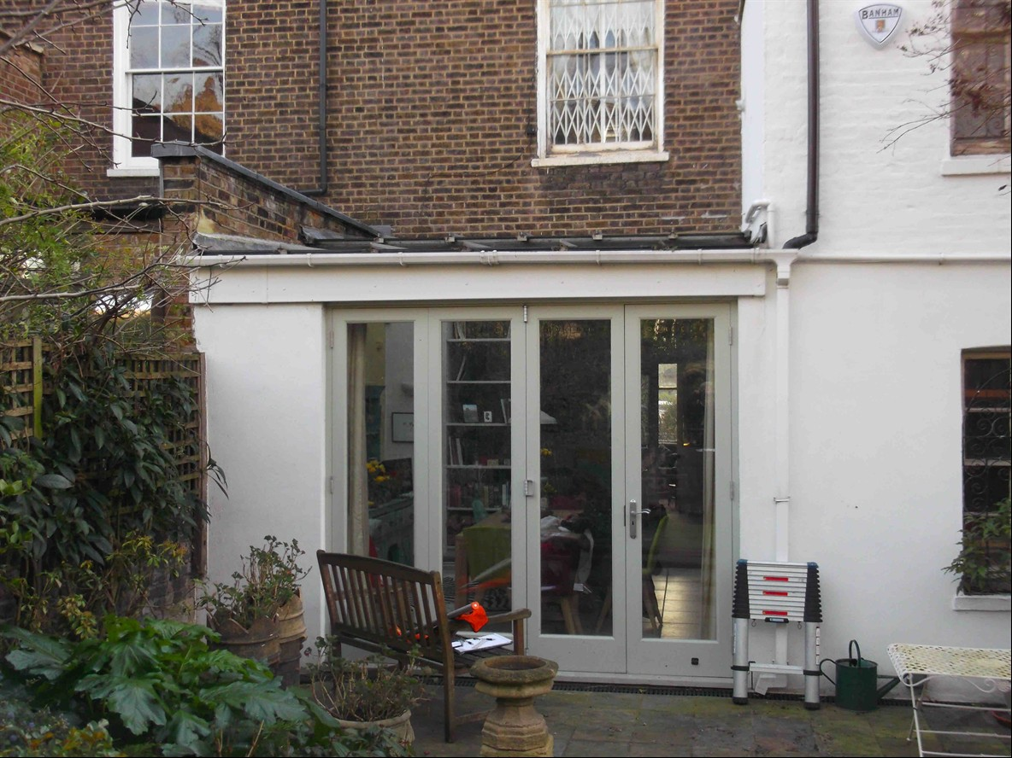

Design Principles: Our client has chosen Anthracite Grey PVCu framed roof with toughened glass sheets.

Due consideration has been given to the overall look and size of the property to give the most
aesthetically pleasing look and giving consideration to privacy without being overbearing.
All external materials used will be to match the existing property as closely as possible.

Size of proposal: The proposed roof will only project 4.5m and have a width
of 3.39m

Landscaping: Our proposal will not require the alteration of the rear garden in any form, we will not be required to remove or cut back any hedges or trees on the site. Our proposal will not affect the amenities of the site or the surrounding area and will go hardly noticed

