PLANNING, DESIGN AND ACCESS STATEMENT

Replacement of the existing mansard roof with a flush front facing elevation and formation of a new fourth floor extension to incorporate a modest 2 bedroom flat with balcony at

29 Chalton Street
London, NW1 1JD

March 2016

Statement prepared by DBPLANNERS LTD
on behalf of
Mr Ansari

Statement is copyright of
DBPLANNERS LTD
www.dbplanners.co.uk
info@dbplanners.co.uk
Tel: 01252 672425 – OUTER LONDON
Tel: 020 8933 0178 – NORTH LONDON
Registered Office - 2 Juniper Road, Cove
Farnborough, Hampshire
GU14 9XU

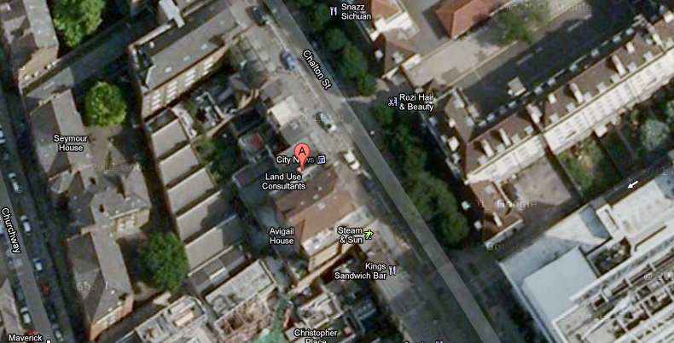

Application site marked in red ‘A’ above.

Site and Surroundings

The site houses a 5 storey mid terrace building. The building includes a mix of residential flats and ground floor commercial unit. The basement includes a front facing basement studio and a rear facing existing flat with garden terrace. The building has been extended more recently to the rear to extend the existing dwelling at first floor and above with a roof terrace enclosure.

The building sits within a wider terrace of mixed use buildings that also include intermittent commercial units on the ground floor and purpose build flats and flat conversion units.

The site is within walking distance of local shops, services, community facilities and a wide range of bus, rail and tube networks.

The site is not within a conservation area or listed or locally listed. There are no trees on site.

Local and National Planning Policy Context

LDF Core Strategy and Development Policies
CS3 Other highly accessible areas
CS5 Managing the impact of growth and development
CS6 Providing quality homes
CS7 Promoting Camden’s centres and shops
CS11 Promoting sustainable and efficient travel
CS14 Promoting high quality places and conserving our heritage
CS18 Dealing with our waste and encouraging recycling
CS19 Delivering and monitoring the Core Strategy
DP2 Making full use of Camden’s capacity for housing
DP5 Homes of different sizes
DP6 Lifetime homes and wheelchair homes
DP12 Supporting strong centres and managing the impact of food, drink, entertainment and other town centre uses
DP16 The transport implications of development
DP17 Walking, cycling and public transport
DP18 Parking standards and limiting the availability of car parking
DP24 Securing high quality design
DP26 Managing the impact of development on occupiers and neighbours
DP27 Basements and lightwells
DP30 Shopfronts

Camden Planning Guidance 2011
CPG1 - Design
CPG2 – Housing
CPG4 – Basements & lightwells
CPG5 Town Centres, retail and employment
CPG6 – Amenity
CPG7 - Transport

Revised Planning Guidance for Central London Food, Drink and Entertainment, Specialist and Retail Uses 2007

NPPF 2012

Planning Appeal Assessment
Full planning permission is sought for modifications to the front facia of the third floor from a dormer to a flush white rendered elevation and formation of a new fourth floor extension to create a new dwelling with internal access to the shared internal staircase and main front entrance at ground floor.

Key elements

Third floor
Propose external modifications to the existing flat. This includes the replacement of the existing mansard roof with a flush extension elevation to match the first and second floor presentation of the building.

Fourth floor
The new extension would include a mansard roof form with internal linkage to the existing flat access staircase. The new flat will be laid out in line with the existing third floor flat and would not result in any stacking conflict. The new flat will have a roof balcony and provide a 2 bedroom 3 person flat with 1 double bedroom and 1 single bedroom. The dwelling would be suitable for a young family occupation or couple.

The overall extensions would allow for the existing building to be used more efficiently whilst retaining its setting in the wider streetscene including the taller building it sits next to. The net benefit is the formation of one new dwelling in an area much in need of new residential development, especially entry level family accommodation.

Principle of development
The site is located within the built up area and as such the principle of new residential development is considered acceptable. The immediate area is characterised by a mix of small commercial units with residential apartments. The proposal through the modification works and new fourth floor extension works would deliver a good quality living accommodation in an energy efficient way and within a sustainable location. The proposed residential development would be in accordance with the aims and objectives of the National Planning Policy Framework.

Character & Design
The proposed development has been designed to integrate with the existing building whilst respecting the rear building line established by the adjoining property at no.25 and the recently built out extensions. The building would continue to appear subservient to much bigger building sited at no.25. Whilst the building would be set higher to the adjoining property at No.31, the development would not be read as appearing out of context or at odds with the mix building heights. Indeed the core block of buildings beyond the application site would continue to appear subservient to the taller buildings either side. However the need to build more efficient development, especially residential development should also be a material consideration and in this respect the modest changes to skylines is far outweighed by the benefits of delivering a new dwelling.

The design of the fourth floor merely seeks to replicate the presentation of the current third floor building with a new mansard roof to match the form and presentation of the one that already exists at third floor. The third floor will be made flush and in line with the front elevation extending from ground floor, first and second floor and finished in white render.

The proposed extension and new floor would not be readily visible from the road or impact the frontage character of the existing building or street scene to detrimental degree.

Residential Amenity
The proposed works would merely make modest changes to the front of the third floor and replicate development that already exists on the lower grounds. The siting, depth and general presentation of the rear extensions built out under separate permission were found to be acceptable with respect to neighbouring amenity and there is no reason to assume any different view would be adopted for the new floor, especially when it mirrors all the elements of the previously approved development albeit set at fourth floor.

Amenity space
The application site largely lacks any onsite amenity space other than an existing roof terrace and new balconies. The lack of larger onsite amenity space for the existing flats is far from uncommon for residential units located within built up city centre areas where public open space and private open space is rare and at a premium. In this instance the site is close to local shops, services and transport networks which are considered to be of a higher priority to the potential future occupants than any small onsite amenity space.

The extended flats all benefit from either a roof terrace or balcony and the new fourth floor dwelling would equally benefit from a new balcony.

Highways & Parking
The proposal does not seek to provide any onsite parking space. The overall net increase in bedrooms across the three floors would be 2 additional bedroom which would not in the applicant’s view material increase traffic pressure in the area.

The site is within the defined city centre that is served by a broad range of shops, medical services as well as local schools. The site is also well served by buses, trains and tube stations.

Notwithstanding the above, if the Council is of the opinion that a car free agreement will be required the applicant will be willing to enter into such an agreement for the new unit and the Council is requested to make contact at the earliest if such an agreement is required so it can be done during the application process if not by way of condition.

Renewable Energy
The proposed development has been designed to meet at least 10% predicted energy needs from onsite/ decentralised renewable energy technologies as well as embracing principles of sustainable design and construction.

Such measures have been detailed below

Energy efficiency
  - High levels of insulation to the floors and walls
  - Double-glazing to all windows and external doors
  - Carefully designed economic and efficient central heating system with high efficiency boilers and heating controls.
  - Low energy lighting will be used on this development.

Water Conservation
  - Low water use appliances both sanitary and kitchen to be utilised, as well as shower.

Development
  - Post extensions future occupants will be encouraged to use the local authority recycling facilities.
  - Convenient access to local public transport including bus and rail services within walking distance of the town centre.

Lifetime Homes
The Council will be mindful that the development of a fourth floor dwelling accessed via internal staircases would not be suitable for wheelchair access and the proposed development is too small to incorporate the cost of a lift, both in terms of viability and disruption to existing flat layouts.

A lifetime homes statement has been attached with the application specifying which additional measures would be possible.

Conclusion
The site is located within the existing built up area where the principle of residential development and extensions is acceptable. The proposal would result in an efficient use of land whilst providing a form and scale of development that would continue to respect the pattern of mix use development in the immediate area. The new dwelling would positively contribute to various housing needs of the local area.

The siting, scale and form of the new extension and third floor modifications would continue to integrate with the existing building and its depth and presentation would not materially harm the amenities of neighbouring properties either side in terms of daylight, amenity and privacy.

The new dwelling will provide a good living environment to meet the needs of modest family occupation.

Post development future occupants would continue to be within walking distance of local shops, services and public transport networks. The proposal would result in a sustainable form of development.

The development is based on principles of good urban design. There is no conflict with national planning policies and the relevant local plan policies.

The development would therefore be in accordance with the thrust of local planning policies and the National Planning Policy Framework.

