Planning Services Camden Town Hall Argyle Street London WC1H 8EQ

19th January 2016

**REF: 102  
93 Messina Avenue London NW6 4LG Design & Access Statement Design Process, Appearance & Access**

**Introduction**

The property is located at 93 Messina Avenue, within the London Borough Camden (LBC). The property is a terraced house.

The property is not located in a conservation area.

The proposal is for a fully screened, private roof terrace, in keeping with the style of other roof terraces in the surrounding area, with 6 foot high bamboo for the privacy of our neighbours.

The aspiration is to create a usable external seating area. Being a family house, the existing small area of lawn is used by the children for playing and there is currently no usable patio or paved seating area since the side area is north facing, dank and being 2 metres wide, too narrow for a table & chairs.

There are at least 15 roof terraces visible from our property (see attached photographs)

The front elevation is not altered.

**Statutory Context**

The following is the current statutory framework considered for the proposed application:

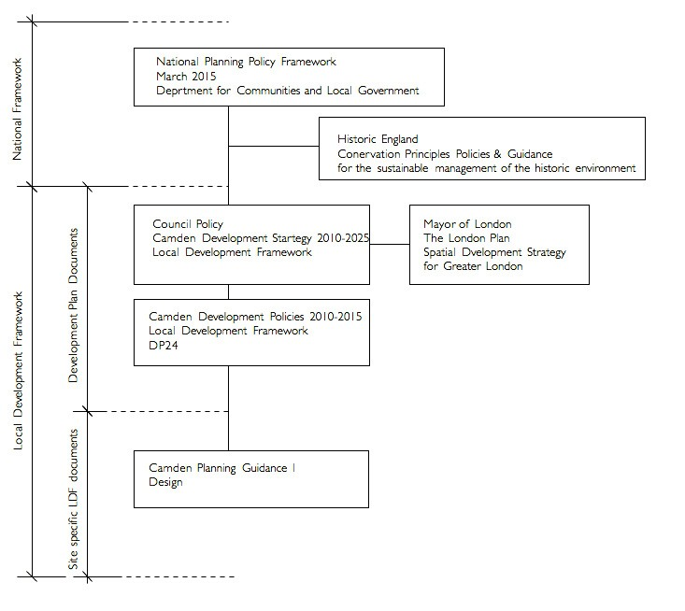

**National Framework**

Communities & Local Government Planning Policy Statement 5

Planning for the Historic Environment

Policy HE7: Policy principles guiding the determination of applications for consent relating to all heritage assets

HE7.5 Local planning authorities should take into account the desirability of new development making a positive contribution to the character and local distinctiveness of the historic environment. The consideration of design should include scale, height, massing, alignment, materials and use.

ANNEX 2: TERMINOLOGY CONSERVATION

The process of maintaining and managing change to a heritage asset in a way that sustains

and where appropriate enhances its significance.

In our view the proposed works are respectful of the local heritage and seek to celebrate and enhance the historical character.

The development seeks to enhance the local heritage by creating a contemporary new addition that responds to current needs.

**Local Development Framework**

Mayor of London The London Plan

Spatial Development Strategy for Greater London

Policy Areas Design principles

4B.1 Design principles for a compact city

The Mayor will, and boroughs should, seek to ensure that developments should:

* *maximise the potential of sites*
* *promote high quality inclusive design and create or enhance the public realm*
* *contribute to adaptation to, and mitigation of, the effects of climate change*
* *respect local context, history, built heritage, character and communities*
* *provide for or enhance a mix of uses*
* *be accessible, usable and permeable for all users*
* *be sustainable, durable and adaptable in terms of design, construction and use (see Chapter 4A)*
* *address security issues and provide safe, secure and sustainable environments (policy 4B.6)*
* *be practical and legible*
* *be attractive to look at and, where appropriate, inspire, excite and delight*
* *respect the natural environment and biodiversity, and enhance green networks and the Blue Ribbon Network*
* *address health inequalities (policy 3A.23).*

These principles should be used in assessing planning applications and in drawing up area planning frameworks and DPD policies. Design and access statements showing how they have been incorporated should be submitted with proposals to illustrate their impacts.

We would like to offer that in the spirit of the London Plan the proposed development seeks to maximize the use of the historical property.

Council Policy

## Camden Core Strategy 2010-2025 Local Development Framework

A sustainable and attractive Camden – Tackling climate change and improving and protecting Camden’s environment and quality of life

CS14 Promoting high quality places and conserving our heritage Policy

The Council will ensure that Camden’s places and buildings are attractive, safe and easy to use by:

1. *requiring development of the highest standard of design that respects local context and character;*
2. *preserving and enhancing Camden’s rich and diverse heritage assets and their settings, including conservation areas, listed buildings, archaeological remains, scheduled ancient monuments and historic parks and gardens;*

Camden’s heritage

14.9 Camden has a rich architectural heritage with many special places and buildings from throughout Camden's history (see map 6). 39 areas, covering much of the borough, are designated as conservation areas, recognising their special architectural or historic interest and their character and appearance. We have prepared conservation area statements, appraisals and management strategies that provide further guidance on the character of these areas. We will take these documents into account as material considerations when we assess applications for planning permission and conservation area consent in these areas.

14.11 We have a responsibility to preserve and, where possible, enhance our heritage of important areas and buildings. Policy DP25 in Camden Development Policies provides more detailed guidance on the Council’s approach to protecting and enriching the range of features that make up our built heritage.

In line with EH and the London Plan there is an emphasis to preserve and enhance the historical context.

It is our view that the proposal is respectful of the historical building and contributes positively to the local context and character.

The ongoing development of the historical neighborhood is as important as the preservation of the historical fabric. We believe that from the future’s perspective the proposed development will be seen as a positive contribution to the evolution of the neighborhood.

Camden Development Policies 2010-2025 Local Development Framework

DP24. Securing high quality design

24.1 Core Strategy policy CS14 – Promoting high quality places and conserving our heritage sets out the Council’s overall strategy on promoting high quality places, seeking to ensure that Camden’s places and buildings are attractive, safe, healthy and easy to use and requiring development to be of the highest standard of design that respects local context and character. Camden has a unique and rich built and natural heritage, with many areas with their own distinct character, created by a variety of elements including building style and layout, history, natural environment including open spaces and gardens, and mix of uses. We have a duty to respect these areas and buildings and, where possible, enhance them when constructing new buildings and in alterations and extensions.

Policy DP 24

Securing high quality design

The Council will require all developments, including alterations and extensions to existing buildings, to be of the highest standard of design and will expect developments to consider:

1. *character, setting, context and the form and scale of neighbouring buildings;*
2. *the character and proportions of the existing building, where alterations and extensions are proposed;*
3. *the quality of materials to be used;*
4. *the provision of visually interesting frontages at street level;*
5. *the appropriate location for building services equipment;*
6. *existing natural features, such as topography and trees;*
7. *the provision of appropriate hard and soft landscaping including boundary treatments;*
8. *the provision of appropriate amenity space; and*
9. *accessibility.*

In line with DP 24 the development will be of the highest design and standard, and meets the design criteria of creating a natural environment with open spaces and gardens, and a mix of uses.

Camden Planning Guidance 1, Design

2 Design Excellence General guidance on design

2.6 Camden is committed to excellence in design. The borough contains many special and unique places, many of which are protected by conservation area status. In accordance with draft London Plan policies

7.1–7.7, Core Strategy policy CS14 requires development schemes to improve the quality of buildings, landscaping and public spaces and we will not approve design which is inappropriate to its context or fails to improve the character of an area.

* 1. *We are working with our partners to promote design excellence and improve public buildings, landscaping and the street environment. We have established the Camden Design Initiative which seeks to encourage involvement, awareness and understanding of good design and this is promoted through the bi-annual Camden Design Awards which acknowledge high quality and innovative design. We are also a promoter of the national Civic Trust Awards which are awarded to buildings judged to have made a positive cultural, social or economic*

contribution to the local community.

* 1. *In order to achieve high quality design in the borough we require applicants to consider buildings in terms of context, height, accessibility, orientation, sitting, detailing and materials. These issues apply to all aspects of the development, including buildings and other structures (e.g. substations, refuse or cycle storage), outdoor spaces, landscaping and access points and should be considered at an early stage in the design of a development, as these elements are often difficult to change in later stages.*

Context

* 1. *Good design should:*
* *positively enhance the character, history, archaeology and nature of existing buildings on the site and other buildings immediately adjacent and in the surrounding area, and any strategic or local views. This is particularly important in conservation areas…*

Building design

* 1. *Good design should:*
* *ensure buildings do not significantly overshadow existing/proposed outdoor spaces (especially designated open spaces), amenity areas or existing or approved renewable energy facilities (such as solar panels). For further information, refer to CPG3 Sustainability Renewable energy (A shadowing exercise may be required for tall buildings or where they are near open spaces);*
* *consider the extent to which developments may overlook the windows or private garden area of another dwelling;*
* *consider views, both local and London wide, and particularly where the site is within a recognised strategic viewing corridor (as shown on the policy Proposals Map);*
* *consider the degree of openness of an area and of open spaces, including gardens including views in an out of these spaces*
* *contributions to the character of certain parts of the borough;*
* *provide visual interest for onlookers, from all aspects and distances. This will involve attention to be given to both form and detail;*
* *consider opportunities for overlooking of the street and, where appropriate, provide windows, doors and other ‘active’ features at ground floor; and*
* *incorporate external facilities such as renewable energy installations, access ramps, plant and machinery, waste storage facilities and shading devices into the design of the development. Careful consideration must be given to ensure that the facility does not harm the built environment.*

The development will be of the highest architectural standard with particular attention paid to the minimalist detailing

Materials

2.12 Materials should form an integral part of the design process and should relate to the character and appearance of the area, particularly in conservation areas or within the setting of listed buildings. The durability of materials and understanding of how they will weather should be taken into consideration. The quality of a well designed building can be easily reduced by the use of poor quality or an unsympathetic palette of materials. We will encourage re-used and recycled materials, and further guidance is contained within CPG3 Sustainability (Sustainable use of materials).

The materials will be in keeping with the design and character of the existing building, and timber based, in line with other roof terraces in the surrounding area.

*5 Roofs, terraces and balconies*

*KEY MESSAGES*

*Roof extensions fall into two categories:*

*• Alterations to the overall roof form; or*

*• Smaller alterations within the existing roof form, such as balconies*

*and terraces.*

*When proposing roof alterations and extensions, the main*

*considerations should be:*

*• The scale and visual prominence;*

*• The effect on the established townscape and architectural style;*

*• The effect on neighbouring properties*

*Roof alterations and extensions – general principles*

*5.6 Proposals to alter and extend roofs fall into two categories: those that*

*are accommodated within the existing roof form, such as dormer*

*windows and roof lights, and those which alter the overall roof form,*

*such as the construction of mansard roofs.*

*5.7 Additional storeys and roof alterations are likely to be acceptable where:*

*• There is an established form of roof addition or alteration to a terrace*

*or group of similar buildings and where continuing the pattern of*

*development would help to re-unite a group of buildings and*

*townscape;*

*34 Camden Planning Guidance | Design | Roofs, terraces and balconies*

*• Alterations are architecturally sympathetic to the age and character of*

*the building and retain the overall integrity of the roof form;*

*• There are a variety of additions or alterations to roofs which create an*

*established pattern and where further development of a similar form*

*would not cause additional harm.*

There are at least 15 roof terraces visible from the property and the design proposed would be in keeping with the character of the building, other roof terraces in the neighbourhood, and help to re-unite the group of buildings with continuity of the pattern of development along our street.

*Balconies and terraces*

*5.23 Balconies and terraces can provide valuable amenity space for flats that*

*would otherwise have little or no private exterior space. However, they*

*can also cause nuisance to neighbours. Potential problems include*

*overlooking and privacy, daylight, noise, light spillage and security.*

*5.24 Balconies and terraces should form an integral element in the design of*

*elevations. The key to whether a design is acceptable is the degree to*

*which the balcony or terrace complements the elevation upon which it is*

*to be located. Consideration should therefore be given to the following:*

*• detailed design to reduce the impact on the existing elevation;*

*• careful choice of materials and colour to match the existing elevation;*

*• possible use of setbacks to minimise overlooking – a balcony need*

*not necessarily cover the entire available roof space;*

*• possible use of screens or planting to prevent overlooking of*

*habitable rooms or nearby gardens, without reducing daylight and*

*sunlight or outlook; and*

*• need to avoid creating climbing opportunities for burglars.*

*Roof Level*

*5.25 A terrace provided at roof level should be set back behind the slope of a*

*pitched roof in accordance with Figure 7, or behind a parapet on a flat*

*roof. A terrace should normally comply with the following criteria:*

*• The dimensions of the roof should be sufficient to accommodate a*

*terrace without adversely affecting the appearance of the roof or the*

*elevation of the property.*

*• A terrace will only normally be acceptable on the rear of properties. It*

*is normally inappropriate to set back a mansard to provide a terrace.*

*40 Camden Planning Guidance | Design | Roofs, terraces and balconies*

*• It should not result in the parapet height being altered, or, in the case*

*of valley/butterfly roofs, the infilling of the rear valley parapet by*

*brickwork or railings.*

*• Any handrails required should be well set back behind the line of the*

*roof slope, and be invisible from the ground.*

*• It should not result in overlooking of habitable rooms of adjacent*

*properties.*

*5.26 When a terrace is provided within the slope of a pitch as in Figure 7, the*

*adjacent tiles or slates should be kept unbroken above the eaves. The*

*width of the terrace should be no wider than a dormer opening. A terrace*

*may be acceptable behind an existing parapet. Where the height of the*

*parapet is less than 1.1m, a railing will be required to fulfil Building*

*Regulations.*

The front elevation is not altered. The proposal includes 6ft bamboo for a fully enclosed, private terrace to respect the privacy of the neighbours.

The aspiration is to create a usable external seating area. There is currently no usable patio or paved seating area since the side area is north facing, dank and being 2 metres wide, too narrow for a table & chairs. The small garden area is dedicated to a children’s play area for the family home.

**Conclusion**

In our opinion the proposal complies with all the requirements established in the local Development Framework and the Design Guidelines.

**Use**

The current use of residence is maintained.

**Layout**

Access from the highway remains the same.

Yours sincerely,

Dominic Poloniecki