Mr. Stephen Jeffrey
Stephen Levrant Heritage Architecture Ltd
62 British Grove
London
W4 2NL
62 British Grove  London  W4 2NL |  | Application Ref: 2015/3658/L
 |  | Please ask for: Catherine Bond
 |  | Telephone: 020 7974 2669
 |  | 10 March 2016

Dear Sir/Madam

DECISION

Planning (Listed Building and Conservation Areas) Act 1990

Listed Building Consent Granted

Address:
The Stables Market
Chalk Farm Road
London
NW1 8AH

Proposal:
Replacement external doors to Chalk Farm Building and associated works.
Drawing Nos: Site Location Plan; A-DP-01; A-DP-02; A-DP-03; A-DP-04; A-DP-05; Design, Access and Heritage Statement.

The Council has considered your application and decided to grant Listed Building Consent subject to the following condition(s):

Conditions And Reasons:

1 | The works hereby permitted shall be begun not later than the end of three years from the date of this consent.  Reason: In order to comply with the provisions of Section 18 of the Planning (Listed Buildings and Conservation Areas) Act 1990.
2 | All new work and work of making good shall be carried out to match the original work as closely as possible in materials and detailed execution.  Reason: In order to safeguard the special architectural and historic interest of the building in accordance with the requirements of policy CS14 of the London Borough of Camden Local Development Framework Core Strategy and policy DP25 of the London Borough of Camden Local Development Framework Development Policies.
3 | The works hereby approved are only those specifically indicated on the drawing(s) referred to above.  Reason: In order to safeguard the special architectural and historic interest of the building in accordance with the requirements of policy CS14 of the London Borough of Camden Local Development Framework Core Strategy and policy DP25 of the London Borough of Camden Local Development Framework Development Policies.

Informative(s):

Reasons for granting listed building consent:

The proposed works comprise the replacement of various modern door-sets of differing patterns and styles and include the rationalisation of doors in widened openings on the south elevation. The new doors will be painted timber, framed ledged and braced and hinged to open as folding double door-sets within the existing openings. Works also include the replacement of a modern part-glazed timber door-set with a traditionally detailed four-panelled painted timber door-set and a modern timber door-set and fragmentary lunette window with a traditionally detailed painted timber stable door and frame and lunette window, in original openings. A ground-floor projecting bay will be reinstated in reclaimed brick to match the original, containing a traditionally detailed stable door and lunette window. At first-floor level, modern timber stable doors will be replaced with traditionally painted timber framed, ledged and braced stable doors. At ground-floor level on the west elevation, modern plywood facings will be removed from two double-folding doorsets, which are believed to be of historic value and in which case will be restored in accordance with conservation principles. The paint colour for all proposed doors will be Obsidian Green (no.216) by Little Greene.

The proposed works will preserve the special interest of the grade II listed Chalk Farm Stable as well as improving its operation as a key market building.

A site notice and press notice were posted and the Regent's Canal Conservation Area Advisory Committee was consulted, but no objections were received.

The site's planning history was taken into account when coming to this decision.

Special regard has been attached to the desirability of preserving the listed building and its features of special architectural or historic interest, under s.16 of the Listed Buildings and Conservation Areas Act 1990 as amended by the Enterprise and Regulatory Reform Act (ERR) 2013.

As such, the proposal is in general accordance with policy CS14 of the London Borough of Camden Local Development Framework Core Strategy, and policy DP25 of the London Borough of Camden Local Development Framework Development Policies. The proposed development also accords with policy 7.8 of The London Plan 2015 consolidated with alterations since 2011, and paragraphs 14, 17 and 126-141 of the National Planning Policy Framework.

Your proposals may be subject to control under the Building Regulations and/or the London Buildings Acts which cover aspects including fire and emergency escape, access and facilities for people with disabilities and sound insulation between dwellings. You are advised to consult the Council's Building Control Service, 2nd Floor, 5 Pancras Square, London N1C 4AG (tel: 020-7974 6941).

You can find advice about your rights of appeal at:

http://www.planningportal.gov.uk/planning/appeals/guidance/guidancecontent

Yours faithfully
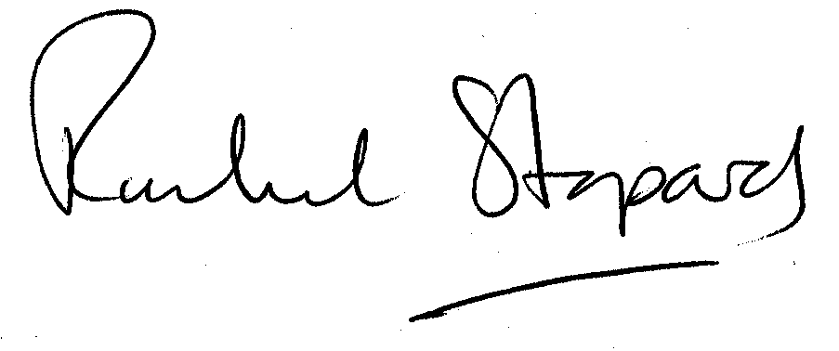
Rachel Stopard
Director of Culture & Environment

