Mr. Martin Burchett
UCL
Senate House
Malet Street
London
WC1E 7HU
UCL  Senate House  Malet Street  London  WC1E 7HU |  | Application Ref: 2016/0263/L
 |  | Please ask for: Catherine Bond
 |  | Telephone: 020 7974 2669
 |  | 10 March 2016

Dear Sir/Madam

DECISION

Planning (Listed Building and Conservation Areas) Act 1990

Listed Building Consent Granted

Address:
1 Taviton Street
London
WC1H 0BT

Proposal:
Internal refurbishment and re-configuration works to fourth-floor attic flat.
Drawing Nos: Site Location Plan; A_PL_103; A_PL_104; A_PL_301; A_PL_302; Design, Access and Heritage Statement.

The Council has considered your application and decided to grant Listed Building Consent subject to the following condition(s):

Conditions And Reasons:

1 | The works hereby permitted shall be begun not later than the end of three years from the date of this consent.  Reason: In order to comply with the provisions of Section 18 of the Planning (Listed Buildings and Conservation Areas) Act 1990.
2 | All new external and internal works and finishes and works of making good to the retained fabric, shall match the existing adjacent work with regard to the methods used and to material, colour, texture and profile, unless shown otherwise on the drawings or other documentation hereby approved or required by any condition(s) attached to this consent.  Reason: In order to safeguard the special architectural and historic interest of the building in accordance with the requirements of policy CS14 of the London Borough of Camden Local Development Framework Core Strategy and policy DP25 of the London Borough of Camden Local Development Framework Development Policies.
3 | The works hereby approved are only those specifically indicated on the drawing(s) referred to above.  Reason: In order to safeguard the special architectural and historic interest of the building in accordance with the requirements of policy CS14 of the London Borough of Camden Local Development Framework Core Strategy and policy DP25 of the London Borough of Camden Local Development Framework Development Policies.

Informative(s):

Reasons for granting listed building consent:

The proposed works comprise the re-alignment of internal partitions on the fourth floor of the grade II listed townhouse, to create two double bedrooms, a double-aspect living/dining and kitchen space, and a new bathroom. At fourth-floor level, a new front door will be installed in the existing landing space. The plan form of the existing two-bedroom flat is not historic and does not follow the established pattern found at attic level in similar 1820s terraced properties in the neighbourhood. The alterations to the plan form will help to reinforce the significance of the historic building. The works are generally of a reversible nature, and therefore will not harm this level of the property which contains minimal historic fabric. Existing service runs will be reused by the new kitchen and bathroom. The proposed works will thus preserve the special interest of the grade II listed building.

No public consultation was necessary for this application, as the proposed works affect the interior only of a grade II listed building. The site's planning history was taken into account when coming to this decision.

Special regard has been attached to the desirability of preserving the listed building and its features of special architectural or historic interest, under s.16 of the Listed Buildings and Conservation Areas Act 1990 as amended by the Enterprise and Regulatory Reform Act (ERR) 2013.

As such, the proposal is in general accordance with policy CS14 of the London Borough of Camden Local Development Framework Core Strategy, and policy DP25 of the London Borough of Camden Local Development Framework Development Policies. The proposed development also accords with policy 7.8 of The London Plan 2015 consolidated with alterations since 2011, and paragraphs 14, 17 and 126-141 of the National Planning Policy Framework.

Your proposals may be subject to control under the Building Regulations and/or the London Buildings Acts which cover aspects including fire and emergency escape, access and facilities for people with disabilities and sound insulation between dwellings. You are advised to consult the Council's Building Control Service, 2nd Floor, 5 Pancras Square, London N1C 4AG (tel: 020-7974 6941).

You can find advice about your rights of appeal at:

http://www.planningportal.gov.uk/planning/appeals/guidance/guidancecontent

Yours faithfully
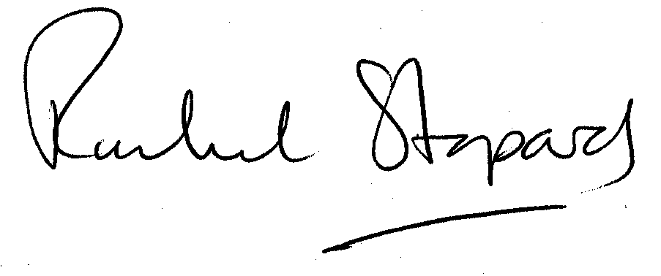
Rachel Stopard
Director of Culture & Environment

