Mr. Jack Rowe
Ridge and Partners LLP
The Cowyards
Blenheim Park
Oxford Road
Woodstock
Oxfordshire
OX20 1QR
Application Ref: 2016/0804/L
Please ask for: Catherine Bond
Telephone: 020 7974 2669
10 March 2016

Dear Sir/Madam

DECISION

Planning (Listed Building and Conservation Areas) Act 1990

Approval of Details (Listed Building) Granted

Address:
Christ Apostolic Church
Highgate Road
London
NW5 1JY

Proposal:
Discharge of condition 5 (a) (plan, section & elevation of new vent hole & flue extract), (b) (schedule of finishes for metal flue guard) & (c) (detailed plan, sections and elevations of new pipe runs) granted under reference 2014/6947/L dated 18/03/15 for installation of a new boiler.
Drawing Nos: 140041/M206; 140041/M207; 140041/M208; 140041/M209; 140041/M210; Schedule of External Finishes.

The Council has considered your application and decided to grant Approval of Details (Listed Building) subject to the following condition(s):

Conditions And Reasons:

Informative(s):

Reasons for granting listed building consent (approval of details):

This application is for discharge of conditions 5 (a), (b) and (c) of listed building consent ref 2014/6947/L dated 18/03/15. The plan, section and elevation drawings of the new vent hole and flue extract, the schedule of finishes for the metal flue guard, and the detailed plan, sections and elevations of new pipe runs show interventions using materials and finishes which are sympathetic to the historic character of the church. The proposed works will therefore preserve the special interest of the grade II listed building.

No public consultation was necessary for this approval of details application. The site's planning history was taken into account when coming to this decision.

Special regard has been attached to the desirability of preserving the listed building and its features of special architectural or historic interest, under s.16 of the Listed Buildings and Conservation Areas Act 1990 as amended by the Enterprise and Regulatory Reform Act (ERR) 2013.

As such, the proposal is in general accordance with policy CS14 of the London Borough of Camden Local Development Framework Core Strategy, and policy DP25 of the London Borough of Camden Local Development Framework Development Policies. The proposed development also accords with policy 7.8 of The London Plan 2015 consolidated with alterations since 2011, and paragraphs 14, 17 and 126-141 of the National Planning Policy Framework.

You can find advice about your rights of appeal at:

http://www.planningportal.gov.uk/planning/appeals/guidance/guidancecontent

Yours faithfully
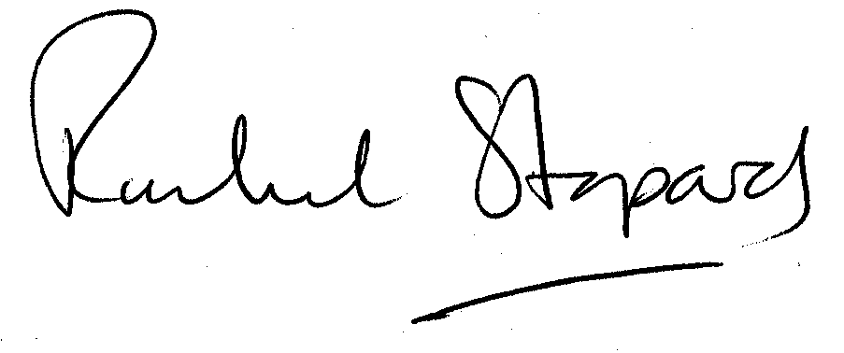
Rachel Stopard
Director of Culture & Environment

