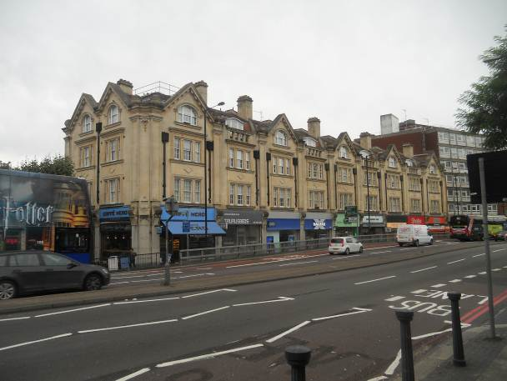 | 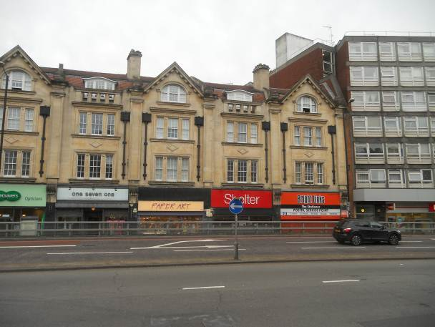
Overview of property from road | Right side frontage 171 - 175
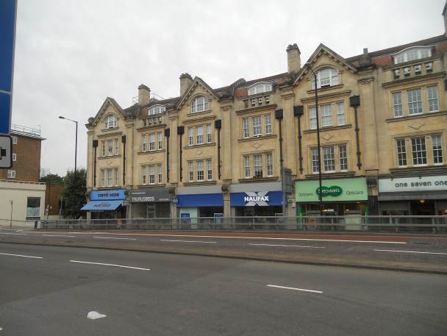 | 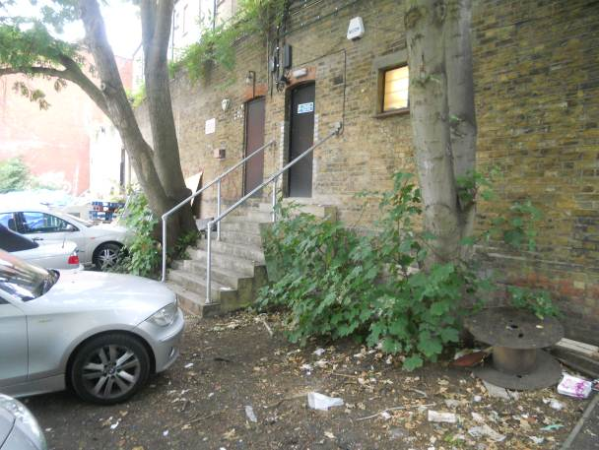
Front view left side 167 - 171 | Trees right against basement wall 171 / 171a
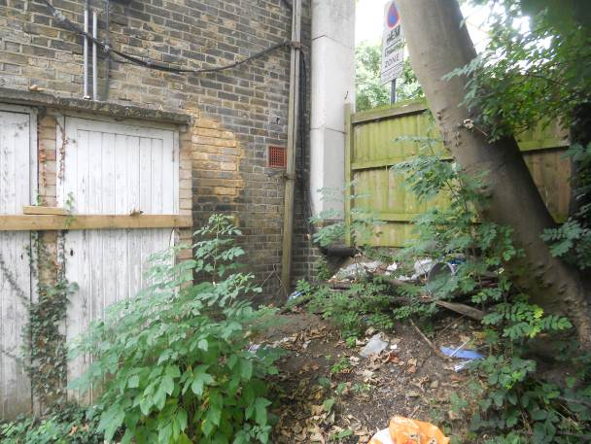 | 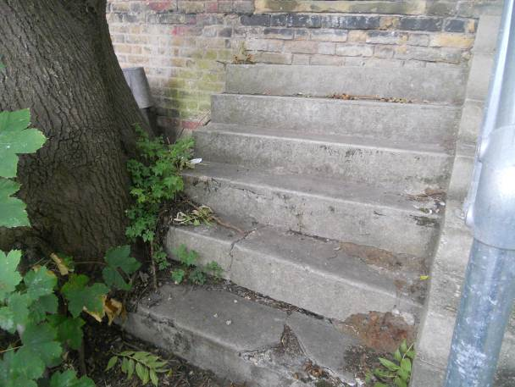
Tree close to rear corner (r/o 167) | Tree has caused damage to rear steps

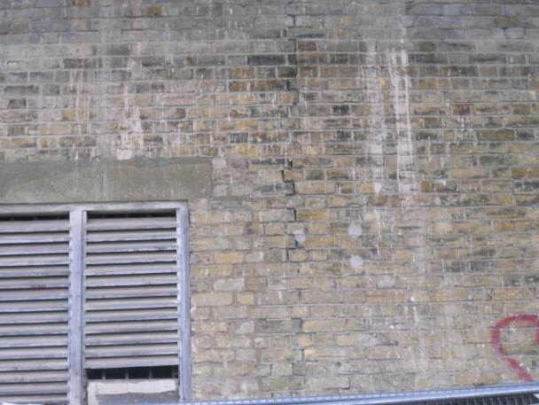 | 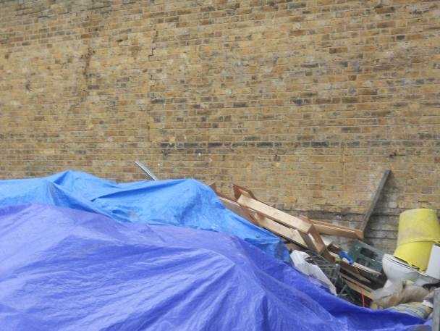
Cracking in rear basement level wall to no 173 | Cracking in rear wall plus waste issue

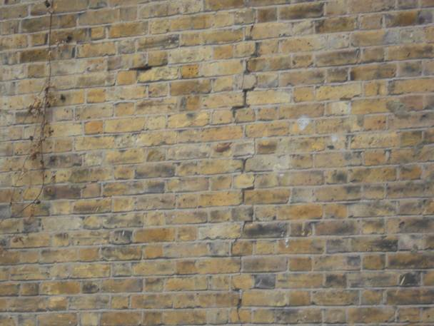 | 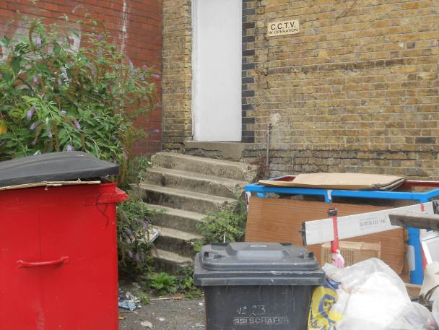
Cracking in rear basement wall | Subsided steps to rear of 175 plus waste issue
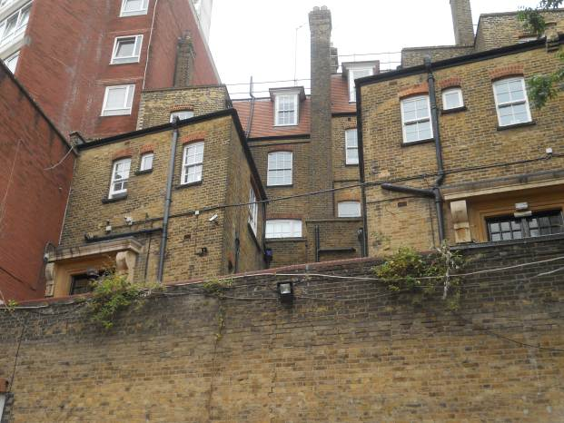 | 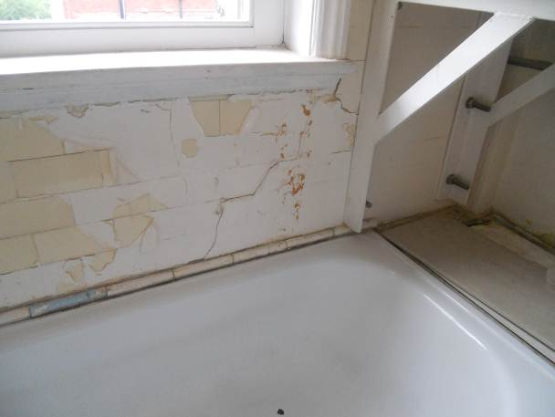
Rear view of property – note crack in basement level wall | Cracking in rear wall to shared bathroom to no 9 Fairfax Mansions
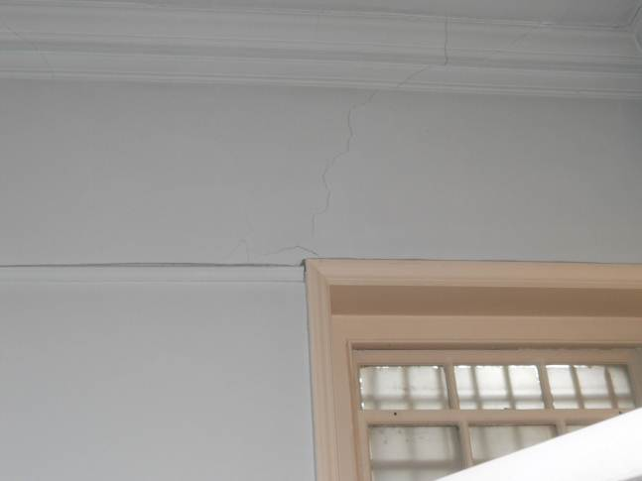 | 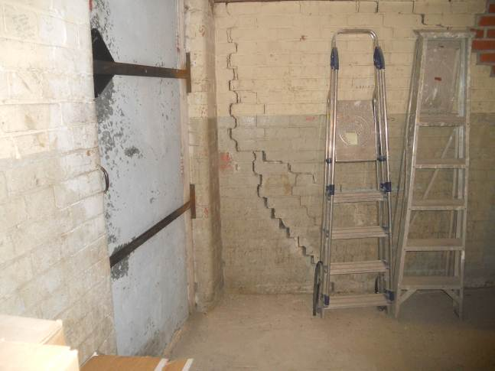
Cracking in rear ground floor wall no 171 | Cracking in basement wall to no 175

