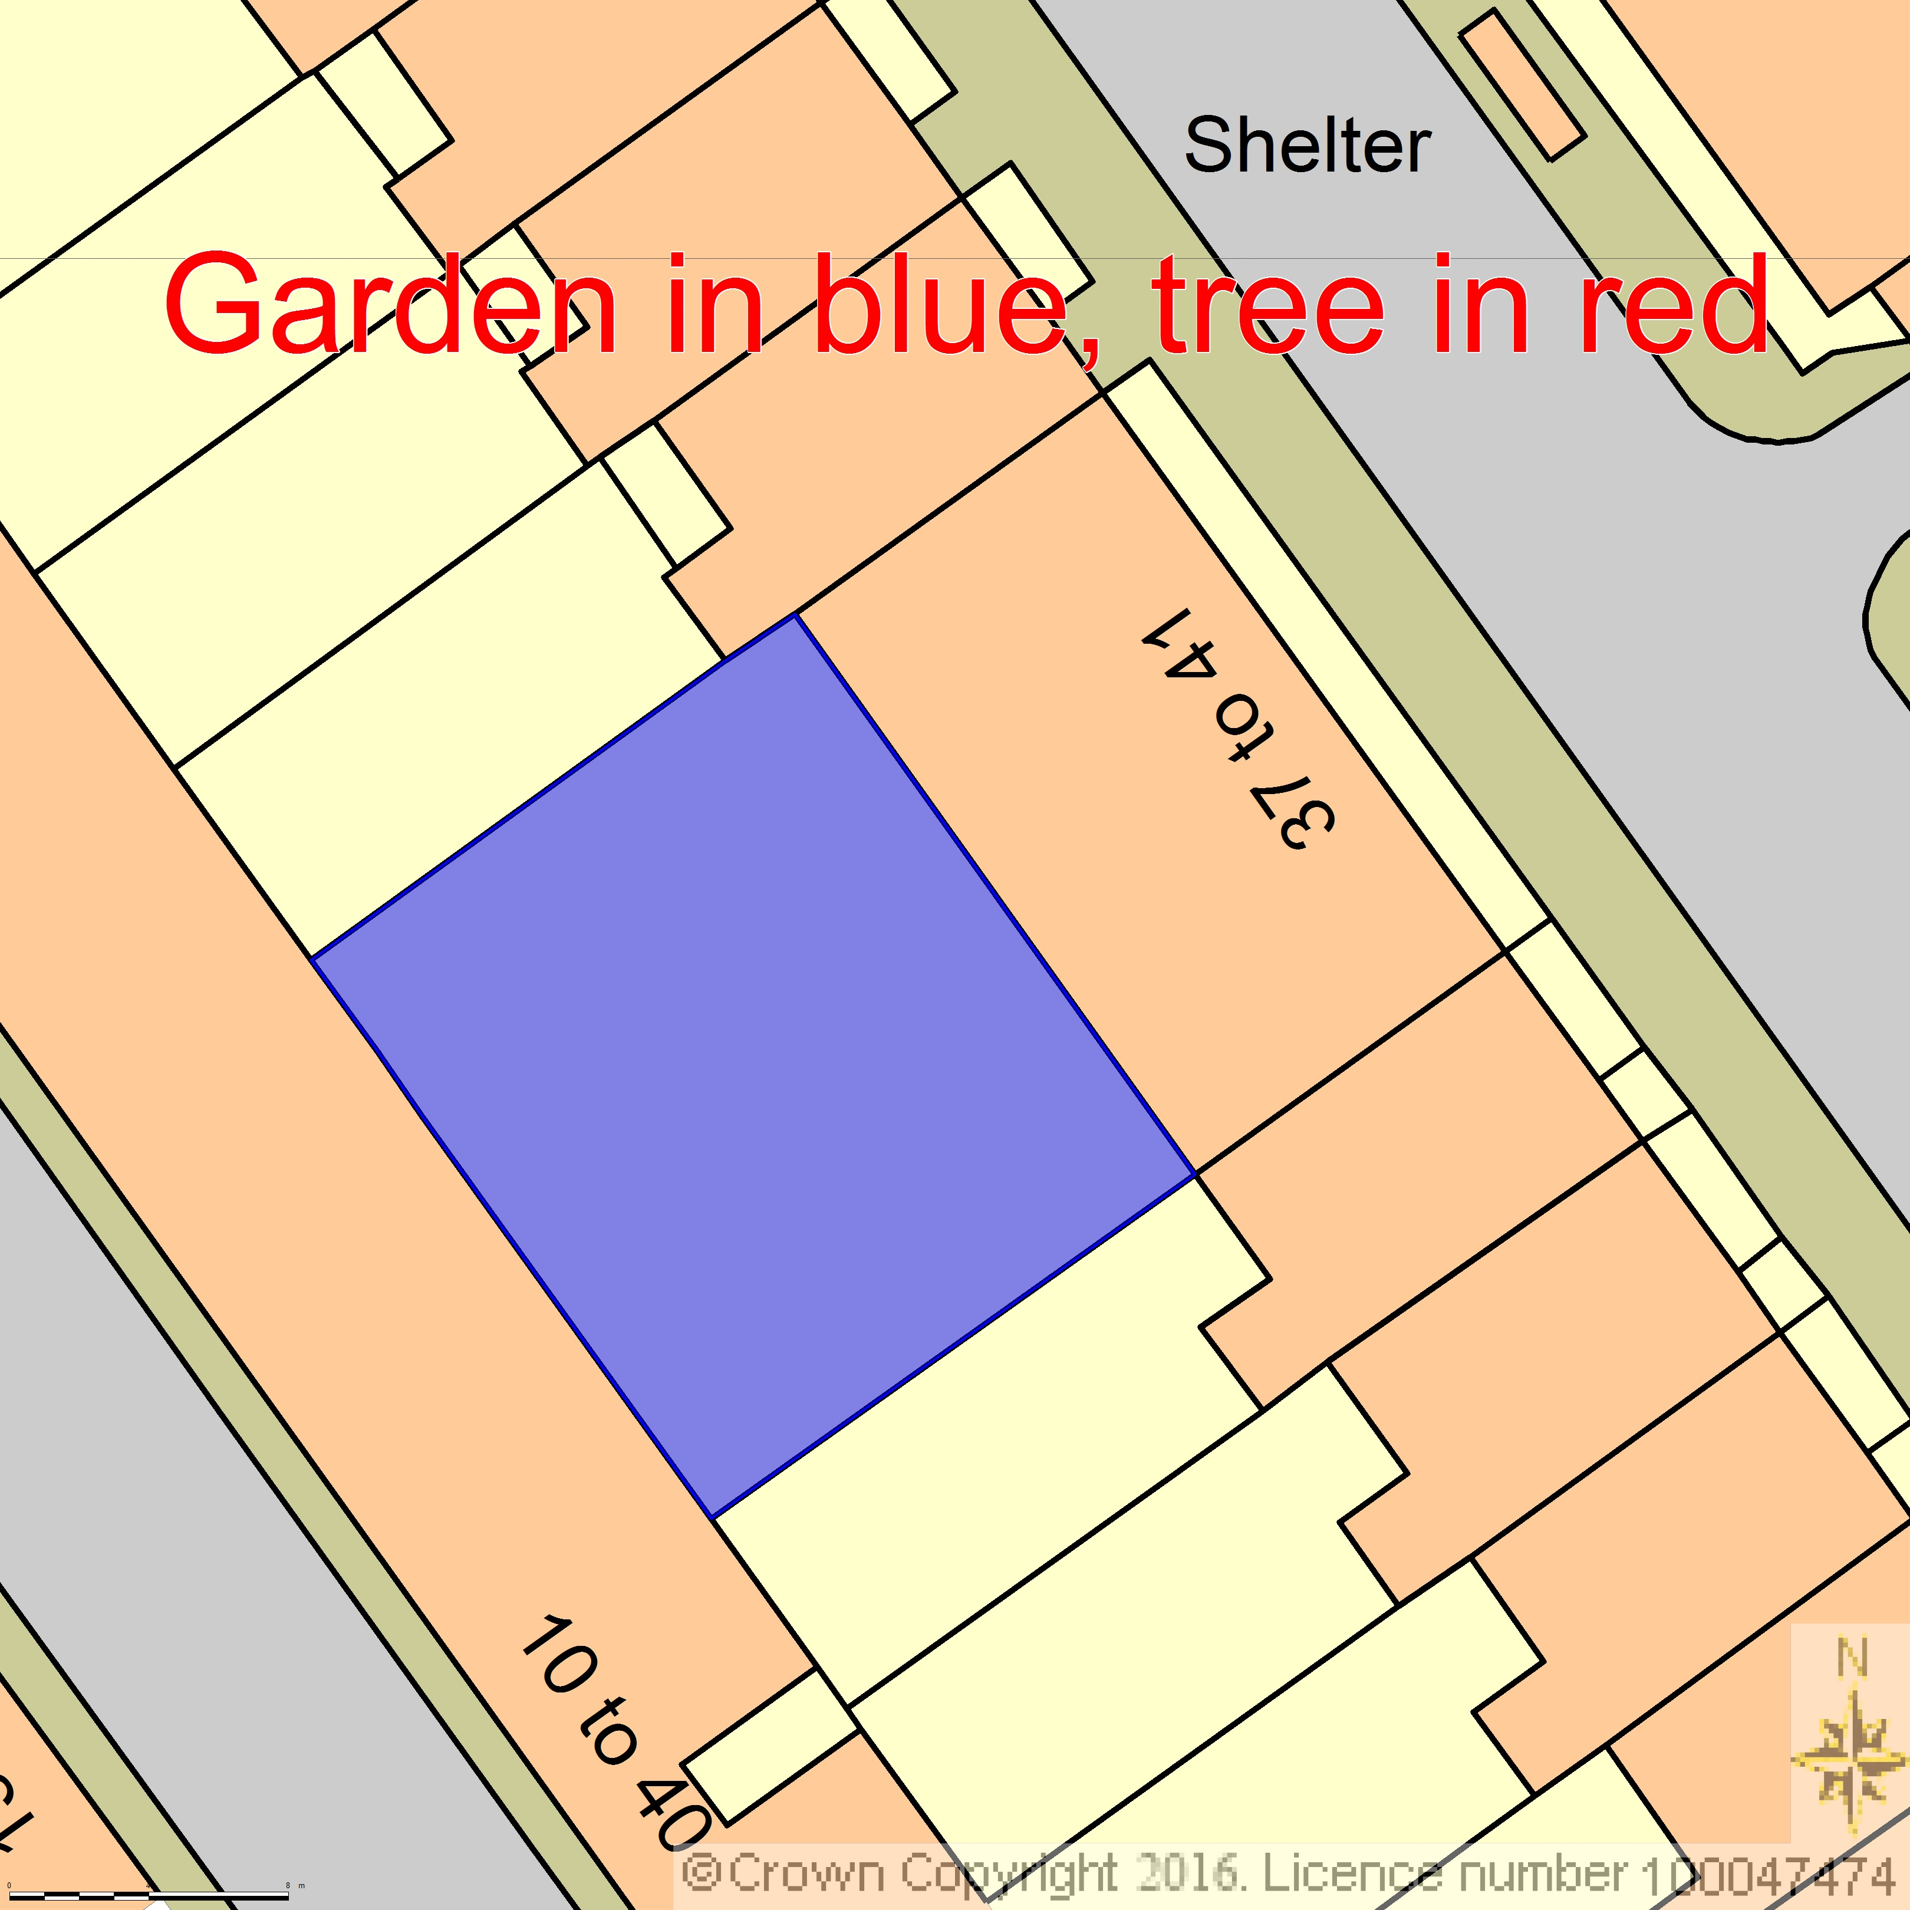
BLOCK/SITE PLAN
AREA 55m x 55m A3
SCALE 1:200
CENTRE COORDINATES: 529742, 181880


Supplied by Streetwise Maps Ltd
www.streetwise.net
Licence No: 100047474
29/07/2026 09:42:26

