**Procedure for ensuring the stability of neighbouring properties during construction of Basement**

* EDM Retro-Reflective Monitoring targets will be stuck to the neighbouring buildings/ structures.
  + Sub-Station,

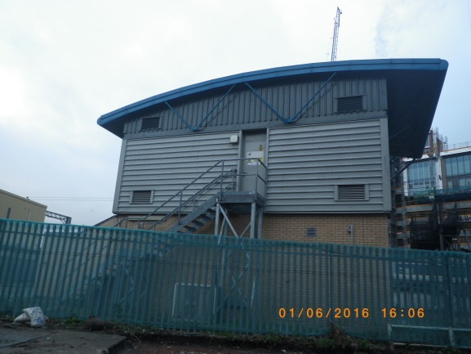

* + Bridges,

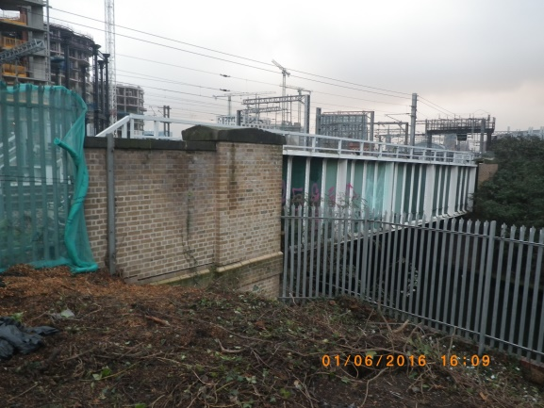

Monitoring targets

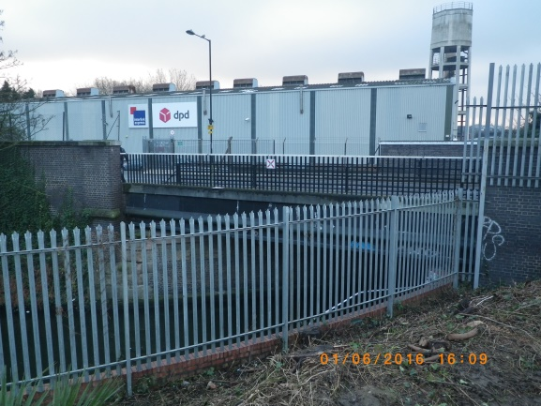

* + Building across Camley Street, (west of site)

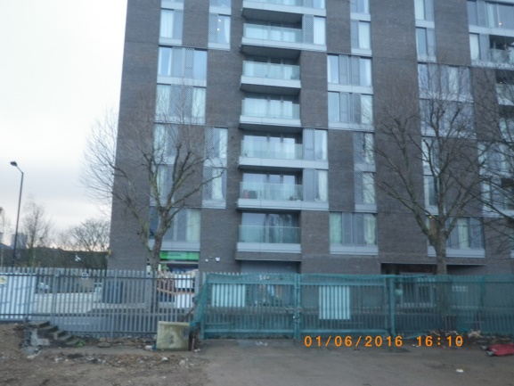

* + Tow path along the canal

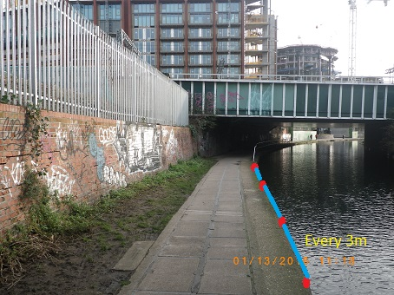

* An engineer will be designated to monitoring the targets using an EDM.
* He will record the initial co-ordinates of the targets. For the first week the targets will be monitored and recorded 3 times per day. The average will then be taken and the tolerances will then be set.
* The points will then be monitored on a weekly basis and recorded.
* The recordings will be compared with that of the previous week, if there are any discrepancies between the co-ordinates (i.e. if they fall outside the tolerances), the engineer will immediately inform the Project Manager.
* The Project Manager will then inspect the co-ordinates and inform the relevant personnel. The corrective action will be taken to ensure movement remains within the tolerance.



Regents Canal

103 Camley Street to be monitored

Bridges to be monitored

Sub- Station to be monitored

Network Rail lines