Miss Hannah Stutchbury
Boyer Planning
24 Southwark Bridge Road
London
SE1 9HF

24 Southwark Bridge Road  London  SE1 9HF |  | Application Ref: 2015/5534/P
 |  | Please ask for: Anna Roe
 |  | Telephone: 020 7974 1226
 |  | 10 February 2016

Dear Sir/Madam

DECISION

Town and Country Planning Act 1990 (as amended)

Householder Application Granted

Address:
13 Elsworthy Road
London
NW3 3DS

Proposal: Construction of a part single, part two storey side extension; a single storey rear extension; new access staircase to the rear garden and associated landscaping works including removal and replacement of two existing trees.

Drawing Nos: PA-05_08; PA-06_07; PAP-00_05; PHA-01_00; EXLP-00_01; CCL 09320A/TCP 1; CCL 09320A/IAP 1; CCL 09320A/TPP 1; CCL 09320A/PPP 1; LPP-01_00; EXA-01_01; EXA-02_01; EXA-03_01; EXA-04_01; EXA-05_01; EXA-06_01; PA-01_08; PA-02_07; PA-03_07; PA-04_07; Arboricultural Report, Crown Consultants dated 31/07/15.

The Council has considered your application and decided to grant permission subject to the following conditions:

Conditions and Reasons:

1 | The development hereby permitted must be begun not later than the end of three years from the date of this permission.  Reason: In order to comply with the provisions of Section 91 of the Town and Country Planning Act 1990 (as amended).
2 | All new external work shall be carried out in materials that resemble, as closely as possible, in colour and texture those of the existing building, unless otherwise specified in the approved application.  Reason: To safeguard the appearance of the premises and the character of the immediate area in accordance with the requirements of policy CS14 of the London Borough of Camden Local Development Framework Core Strategy and policy DP24 and DP25 of the London Borough of Camden Local Development Framework Development Policies.
3 | The development hereby permitted shall be carried out in accordance with the following approved plans: PA-05_04; PA-06_04; PAP-00_01; PHA-01_00; EXLP-00_01; CCL 09320A/TCP 1; CCL 09320A/IAP 1; CCL 09320A/TPP 1; CCL 09320A/PPP 1; LPP-01_00; EXA-01_01; EXA-02_01; EXA-03_01; EXA-04_01; EXA-05_01; EXA-06_01; PA-01_04; PA-02_04; PA-03_04; PA-04_04; Arboricultural Report, Crown Consultants dated 31/07/15.  Reason: For the avoidance of doubt and in the interest of proper planning.
4 | All work shall be carried out in accordance with the relevant recommendations of British Standard 3998: 2010. (Recommendation for Tree Work)  Reason: To ensure the preservation of the amenity value and health of the trees.
5 | Prior to the commencement of construction/demolition works on site, tree protection measures shall be installed in accordance with approved drawings and evidence of this shall be submitted to the council. The protection shall then remain in place for the duration of works on site, unless otherwise agreed in writing by the local authority.  Reason: To ensure the preservation of the amenity value and health of the trees.
Informatives:

Your proposals may be subject to control under the Building Regulations and/or the London Buildings Acts which cover aspects including fire and emergency escape, access and facilities for people with disabilities and sound insulation between dwellings. You are advised to consult the Council's Building Control Service, Camden Town Hall, Argyle Street WC1H 8EQ, (tel: 020-7974 6941).

Noise from demolition and construction works is subject to control under the Control of Pollution Act 1974. You must carry out any building works that can be heard at the boundary of the site only between 08.00 and 18.00 hours Monday to Friday and 08.00 to 13.00 on Saturday and not at all on Sundays and Public Holidays. You are advised to consult the Council's Compliance and Enforcement team [Regulatory Services], Camden Town Hall, Argyle Street, WC1H 8EQ (Tel. No. 020 7974 4444 or on the website http://www.camden.gov.uk/ccm/content/contacts/council-contacts/environment/contact-the-environmental-health-team.en or seek prior approval under Section 61 of the Act if you anticipate any difficulty in carrying out construction other than within the hours stated above.

In dealing with the application, the Council has sought to work with the applicant in a positive and proactive way in accordance with paragraphs 186 and 187 of the National Planning Policy Framework.

Yours faithfully
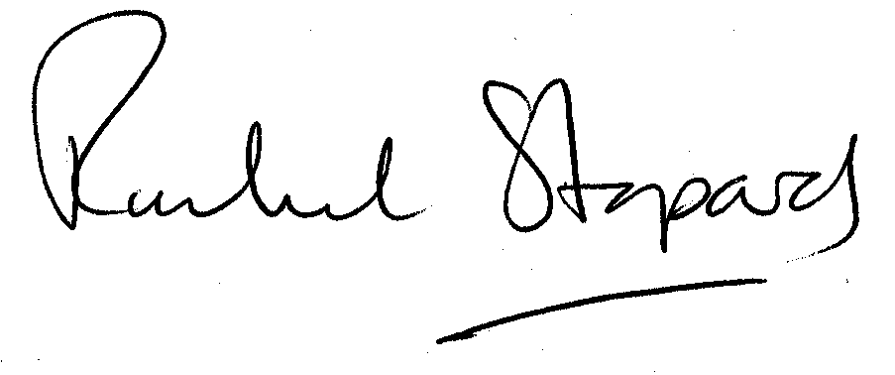
Rachel Stopard
Director of Culture & Environment

