

**HERITAGE IMPACT ASSESSMENT**

**Proposal: Planning and Listed Building Consent for Internal Remodelling and Roof Lights**

**Site: Flat 3 40A Rosslyn Hill**

**London**

**NW3 1NH**

**Prepared by**:-

Francis Caldwell BA (Hons) M Phil MRTPI

Aragon Land & Planning Ltd©

***Copyright***

***The contents of this document must not be copied or reproduced in whole or part without the prior written permission of Aragon Land and Planning Ltd***

**1.0 Introduction**

1.1 The Council have identified that they require a Heritage Impact Assessment (HIS). I am a Chartered Town Planner and Member of the Royal Town Planning Institute (RTPI) with 27 years experience. I am also a member of the Town and Country Planning Association (TCPA). I have previously written Historic Assessments which have involved listed buildings. The plans have been prepared by TAG Architects, a local, well established and respected practice. The plans and proposals are well explained by the plans and are well detailed and clear. This statement is to be read in conjunction with the plans. The HIS has had regard to the advice from Historic England.

1.2 The National Planning Policy Framework Policy 128 states;

**In determining applications, local planning authorities should require an applicant to describe the significance of any heritage assets affected, including any contribution made by their setting. The level of detail should be proportionate to the assets’ importance and no more than is sufficient to understand the potential impact of the proposal on their significance. As a minimum the relevant historic environment record should have been consulted and the heritage assets assessed using appropriate expertise where necessary. Where a site on which development is proposed includes or has the potential to include heritage assets with archaeological interest, local planning authorities should require developers to submit an appropriate desk-based assessment and, where necessary, a field evaluation.”**

1.3 It is important to identify that the level of detail should be proportionate to the proposal.

1.4 This document details the direct impact the proposed has on a designated Heritage Asset.

1.5 This statement needs to be read in conjunction with the Design and Access Statement.

1.6 Flat 3 40A Rosslyn Hill is located in a listed building under the Planning (Listed Buildings and Conservation Areas) Act 1990. The flat is above Lloyds Bank which is Grade II* listed.

1.7 Lloyds Bank facade has the year AD 1896 and is in-keeping the surrounding facades on Rosslyn Hill.

1.8 The site is located in the Hampstead Conservation Area. The building, or rather the facade is prominent in the conservation area, however the roof and parts of the roof are difficult to view.

**2.0 NATIONAL POLICY**

* 1. National Planning Policy Framework (NPPF) Para 132, states;

**When considering the impact of a proposed development on the significance of a designated heritage asset, great weight should be given to the asset’s conservation. The more important the asset, the greater the weight should be. Significance can be harmed or lost through alterations or destruction of the heritage asset or development within its setting. As heritage assets are irreplaceable, any harm or loss should require clear and convincing justification. Substantial harm to or loss of a grade II listed building, park or garden should be exceptional. Substantial harm to or loss of designated heritage assets of the highest significance, notably scheduled monuments, protected wreck sites, battlefields, grade I and II* listed buildings, grade I and II* registered parks and garden, and World Heritage Sites, should be wholly exceptional.**

2.2 In making a decision the LPA should (para 137 of the NPPF), follow the following advice;

**Local planning authorities should look for opportunities for new development within Conservation Areas and World Heritage Sites and within the setting of heritage assets to enhance or better reveal the significance. Proposals that preserve those elements of the setting that make a positive contribution to or better reveal the significance of the asset should be treated favourably.**

2.3 National Planning Policy Framework sections 7, 9 and 12 states;

**Section 12 Conserving and enhancing the historic environment.**

**Local planning authorities should set out in their Local Plan a positive strategy for the conservation and enjoyment of the historic environment, including heritage assets most at risk through neglect, decay or other threats. In doing so they should recognise that heritage assets are an irreplaceable resource and conserve them in a manner appropriate to their significance. In developing this strategy, local planning authorities should take into account.**

2.4 Policy CS5 from Camden Core Strategy Managing the Impact of Growth and Development Policy states:

**The Council will manage the impact of growth and development in Camden. We will ensure that development meets the full range of objectives of the Core Strategy and other Local Development Framework documents with particular consideration given to:**

**a) providing uses that meet the needs of Camden’s population and contribute to the borough’s London-wide role;**

**b) providing the infrastructure and facilities needed to support Camden’s population and those who work in and visit the borough;**

**c) providing sustainable buildings and spaces of the highest quality; and**

**d) protecting and enhancing our environment and heritage and the amenity and quality of life of local communities. The Council will protect the amenity of Camden’s residents and those working in and visiting the borough by:**

**e) making sure that the impact of developments on their occupiers and neighbours is fully considered;**

**f) seeking to ensure development contributes towards strong and successful communities by balancing the needs of development with the needs and characteristics of local areas and communities; and**

**g) requiring mitigation measures where necessary.**

2.5 Policy CS14 from Camden Core Strategy Promoting High Quality Places and Conserving Our Heritage States;

**The Council will ensure that Camden’s places and buildings are attractive, safe and easy to use by:**

**a) requiring development of the highest standard of design that respects local context and character;**

**b) preserving and enhancing Camden’s rich and diverse heritage assets and their settings, including conservation areas, listed buildings, archaeological remains, scheduled ancient monuments and historic parks and gardens;**

**c) promoting high quality landscaping and works to streets and public spaces;**

**d) seeking the highest standards of access in all buildings and places and requiring schemes to be designed to be inclusive**

**and accessible;**

**e) protecting important views of St Paul’s Cathedral and the Palace of Westminster from sites inside and outside the borough and protecting important local views.**

**POLICY**

2.6 Policy DP24 Securing High Quality Design states;

**The Council will require all developments, including alterations and extensions to existing buildings, to be of the highest standard of design and will expect developments to consider:**

**a) character, setting, context and the form and scale of neighbouring buildings;**

**b) the character and proportions of the existing building, where alterations and extensions are proposed;**

**c) the quality of materials to be used;**

**d) the provision of visually interesting frontages at street level;**

**e) the appropriate location for building services equipment;**

**f) existing natural features, such as topography and trees;**

**g) the provision of appropriate hard and soft landscaping including boundary treatments;**

**h) the provision of appropriate amenity space; and**

**i) accessibility.**

2.7 The site is located within the Hampstead Conservation Area, therefore Policy DP25 Conserving Camden's heritage Conservation areas is relevant, however it is only relevant in respect of the external alterations.

**Conservation areas**

**In order to maintain the character of Camden’s conservation areas, the Council will:**

**a) take account of conservation area statements, appraisals and management plans when assessing applications within conservation areas;**

**b) only permit development within conservation areas that preserves and enhances the character and appearance of the area;**

**c) prevent the total or substantial demolition of an unlisted building that makes a positive contribution to the character or appearance of a conservation area where this harms the**

**character or appearance of the conservation area, unless exceptional circumstances are shown that outweigh the case for retention;**

**d) not permit development outside of a conservation area that causes harm to the character and appearance of that conservation area; and**

**e) preserve trees and garden spaces which contribute to the character of a conservation area and which provide a setting for Camden’s architectural heritage.**

**Listed buildings**

**To preserve or enhance the borough’s listed buildings, the Council will:**

**e) prevent the total or substantial demolition of a listed building unless exceptional circumstances are shown that outweigh the case for retention;**

**f) only grant consent for a change of use or alterations and extensions to a listed building where it considers this would not cause harm to the special interest of the building; and**

**g) not permit development that it considers would cause harm to the setting of a listed building.**

**Archaeology**

**The Council will protect remains of archaeological importance by ensuring acceptable measures are taken to preserve them and their setting, including physical preservation, where**

**appropriate.**

**Other heritage assets**

**The Council will seek to protect other heritage assets including Parks and Gardens of Special Historic Interest and London Squares.**

2.8 With reference to the site and its surrounding area The Camden Conservation Area Statement details;

**Rosslyn Hill From Willoughby Road to Downshire Hill the shopping frontage continues and the majority of the buildings are 1880s four storey terraces with a number of embellishments and designs including stone dressings, gable roofs, bay windows at first floor level. The magnificent red brick Queen Anne style block comprising Lloyds Bank and the two adjacent houses (Nos.1 & 3 Pilgrim’s Lane) were designed by Horace Field in 1896. The Police Station and Magistrates Court (now closed) end this sub-area. It is a red brick building with stone dressings by J Dixon Butler (1910-13). Between the Police Station and the Lloyds Bank is a terrace of red brick properties with shops at ground floor. These have a number of original features still intact including pilasters, dentil cornice, fascia, console brackets.**

2.9 Within the Camden Conservation Area Statement Pilgrims Lane is located within Sub Area Three: Willoughby Road/Downshire Hill and notes;

**Downshire Hill The road slopes down towards the Heath from Rosslyn Hill and is fairly broad with houses set back behind lush front gardens. Looking along the street low brick walls with piers and railings link the boundaries and create a unified streetscape. There is an abundance of quality in the buildings with 48 listed houses, mostly from the early 19th century. The majority are stuccoed and as Pevsner says “the delightful thing is the preservation of so much, yet no uniformity”. Heights vary between two and three storeys and there is a profusion of ironwork on the facades and the front boundary. Two types of roof predominate - hipped roofs with projecting eaves or parapets. Placed at the centre is St John’s Church (listed grade I) whose entrance faces the junction of Keats Grove and Downshire Hill. Built in 1818-23 as a proprietary chapel it is stuccoed. Here and there newer houses have been built, all of which fit comfortably into this relaxed setting; Nos.50&51 (listed) a pair of terraced mid 19th century stucco houses; a fine row of red brick properties with ground floor shops at No.1,2a,3a,4a; Hampstead Hill Mansions (1896) in red brick with a scrolled pediment above the entrance; the imposing side elevation of the listed Police Station on Rosslyn Hill; No.40a an 1880s red brick insertion - all reflect the increasing density of later 19th century development along the High Street and Rosslyn Hill. The Freemasons Arms terminates the Heath end of Downshire Hill. This Georgian style building with bold hipped roof and chimneys replaced a succession of earlier pubs on the site in 1936. Other distinguished modern buildings include Sir Michael Hopkins steel and glass box at No.49a Downshire Hill (1975), discreet with the ground floor set well below street level and vegetation masking the building. No.13a by MJH and Charlotte Bunney (1936) was built next to the side wing of No.13 and has a painted two storey façade and elegant roof detail that blends into the road.**

2.10 The listing (1130392) of the building describes the g11*

**Nos.1 AND 3 with railings and gates to south PILGRIMS LANE. Bank incorporating 2 terraced houses of the same development. c1895-6. By Horace Field. Edwardian Baroque style. EXTERIOR: Bank: red brick with stone dressings and quoins. Slated roof dormers, slab chimney-stacks and modillion eaves cornice with carved enriched frieze. 3 storeys, attic and basement. 8 windows to Rosslyn Hill. Entrance to bank on splayed corner. Stone doorcase with pilasters supporting an open pediment with cartouche; architraved doorway with keystone and double panelled doors. Ground floor to main frontage with 3 large round-arched windows having rusticated voussoirs; central window with cartouche. Upper floors have gauged red brick flat arches with stone keystones to flush framed sashes with exposed boxing and louvred shutters; floors above central ground floor round-arched windows have flanking narrow sashes, the 1st floor a French window with cast-iron balcony. Above entrance, a transom and mullion window and cast-iron balcony to 2nd floor. Nos 1 & 3 Pilgrims Lane: in similar style. 3 storeys, attics and semi-basements. Entrances with pilasters carrying entablature with fanlights and panelled doors. Each with 3-window segmental bays rising from basement through 1st floor. INTERIORS: a sumptuous and complete surviving banking hall. Reverse of entrance door has round-headed pediment, richly carved with cartouche, set over fluted Corinthian columns. Panelled walls, window surrounds and radiator covers, these last with decorated grilles and topped with timber ledges. Original central counter, with later security screens mounted on top. A door to side (south-east) with pediment inscribed 'waiting room'. Other interiors not inspected.**

2.11 The interior of the flat was not an element that was assessed or a reason for the listing, this is not to say it is not important, but it explains that other reasons existed for the listing of the building. The building was listed in 1974 and no amendments have been made to the listing.

**3.0 Planning History**

3.1 The building appears to have been built circa 1895-6 as a bank with two terraced houses. These are accessed separately and would have existed as accommodation for the bank.

3.2 The conversion of the houses to two flats was granted by permission 45602/11481 on the 09/11/1953. The file has been inspected and it only shows the proposed plan. At the time of preparing this statement no plan has been identified showing the original layout. Enclosed in **Annex 1** is the plan of the approved 1953 layout.

3.3 The building has an extensive planning history, although the majority relates to the display of advertisements and changes to the ground floor.

3.4 2011/6048/L was a grant of permission for alterations to Flat 1. The permission and consent was granted on the 13/01/2012. The officer noted in the report that the internal layout had undergone significant change.

**4.0 Proposal**

4.1 The building is divided into three flats and flat 3 is located on the top-floor. Lloyds Bank occupies the ground-floor of the building and will remain unaltered by the proposal.

4.2 The current condition of the flat is enclosed in **Annex 2.** The accommodation is in a moderate condition and is in considerable need of an upgrade.

4.3 The key concepts behind the proposal are to:

* remove some of the central partitioning to the flat
* Upgrade the upper roof area and remove part of the ceiling
* renovate and relocate of rooms (bathroom and kitchen)
* upgrade of the accommodation and improve insulation and efficiency of the flat.

4.4 The majority of these works are repair and upgrade. The external changes include inserting 6 new conservation style roof lights and the replacement of one existing roof light on the rear roof slopes, outlined in drawing P3.

4.5 The existing window joinery will be upgraded to double glazing, but retaining the external glazing and woodwork. In accordance with good conservation practice the window ironmongery will be overhauled and retained where possible. The external window details are of significance to the fabric of the building. There will be new thermal insulation between existing rafters to improve energy efficiency and meet environmental standards. A strong theme in the development plan is to ensure development is much more sustainable and energy efficient.

4.6 The removal of bathrooms and kitchens would not normally require listed building consent. The principle of a kitchen and bathroom in the flat is obviously accepted. Neither is the character of the units/features to be removed of such a character that they need to be retained.

4.7 The internal changes create a more open layout. It would seem likely that having less partitions would actually return the character of the flat to its former more open character as a house. The removal of these partitions are not integral to the character of the building. The new walls will be timber studwork which is appropriate for the flat and is not introducing new or alien materials. The internal changes do not harm the character of the building. The existing woodwork such as skirting's will be reused and retained, although they are not of any unique character. A lot of the fabric of the building appears as 1950's building work with very little original character.

4.8 Part of the ceiling is to be removed. This is shown on plan P1. The staircase remains in its current position. This will need a steel column and enable a more open aspect and view of the existing skylight. The ceiling is of little significance to the fabric of the flat. The skylight will need upgrading and repairs need to be treated sensitively.

4.9 The loft floor will be accessed from the main floor by a new staircase with new balustrade. The loft area is proposed to be used for storage.

4.10 The existing three water tanks located in the loft are outdated, unsafe and need to be removed. This interior change will not affect or harm the fabric of the building.

4.11 Within the existing kitchen the slope in ceiling, existing boiler and larder walls will be demolished. These are of no character to the building and look like 1980/90 additions. The hot water cupboard will also be removed to provide wardrobe space for the proposed bedroom 2.

4.12 The current WC by the entrance will be renovated. The WC will be replaced and the inclusion of a shower and sink will provide a more functional and useable bathroom. Some of these works are repairs.

4.13 The kitchen will be where bedroom 2 currently is. Its walls will be demolished to provide an open plan kitchen. The proposed kitchen design includes a centre island and a cooker, sink and base cupboard running along its Southern wall.

4.14 The kitchen will have a dining area and fireplace opposite the retained existing staircase. The existing fire places are retained. The existing doors are proposed to be re used. These are features that do add to the fabric of the building and can therefore be kept in situ.

4.15 The existing bathroom will be demolished allowing for additional storage and desk space and allowing for the kitchen space to flow into the proposed living room, currently bedroom 1.

4.16 A fireplace, shelves and cupboard space will provide more functional living in the proposed living room. The new staircase to the loft floor will be accessible from the kitchen and run above the northern wall in the living room.

4.17 The existing dining room will be converted into the master bedroom. The slope in ceiling will be demolished and existing wall altered to accommodate a bathroom. The coat room will be demolished to form the bathroom containing a WC, basin, bath tub and cupboard.

4.18 The reconfiguration will not cause greater harm to the historic floor plan. The further modifications will not harm any historic fabric. This space has already seen considerable change and the modifications will not create harm to the special interest of the listed building. Accordingly the proposal accords with DP24 and DP25 of the Camden Development Policies (LDF). The historic features of the glass rooflight, the fireplace, windows are all retained. The internal changes do not impact on the historic nature of the building.

**ANNEX 1**

**Plan of The Approved 1953 Layout**

**ANNEX 2**

**Photographs**

**2**

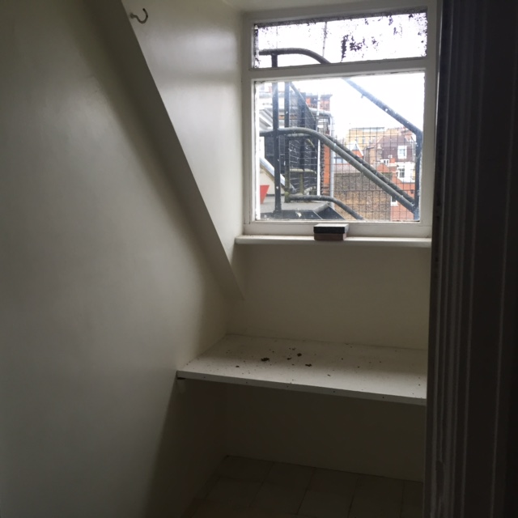

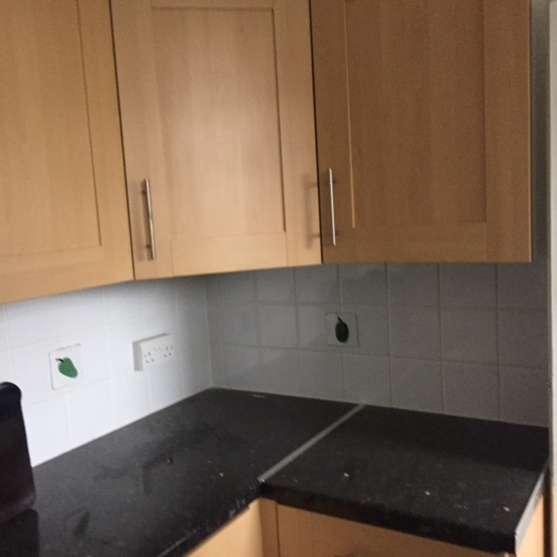

**1**

**4**

**3**

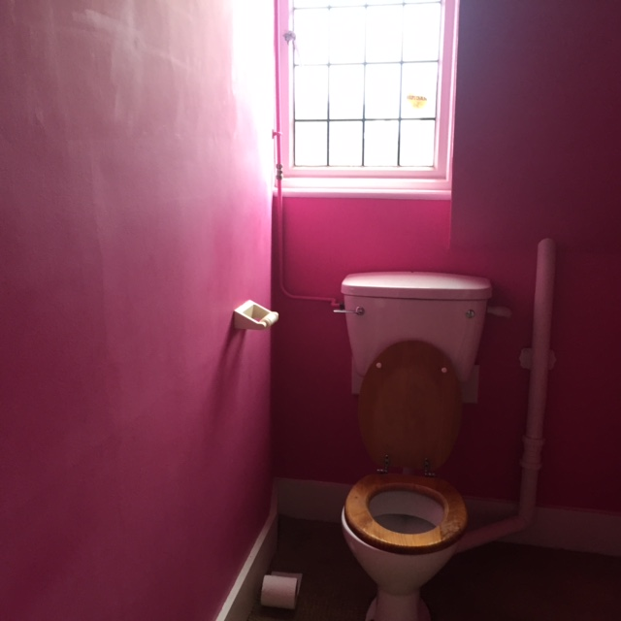

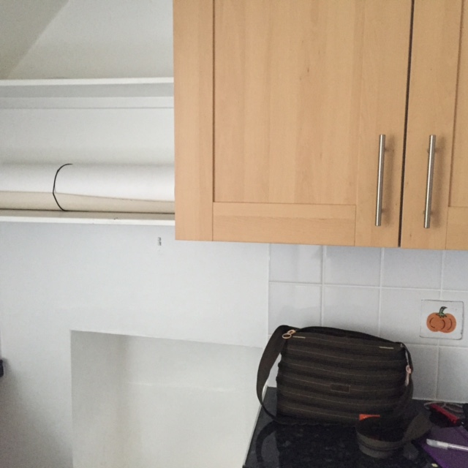

**6**

**5**

**8**

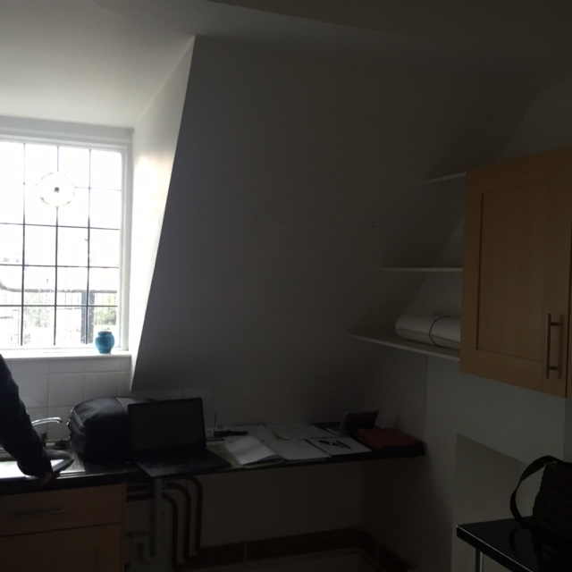

**7**

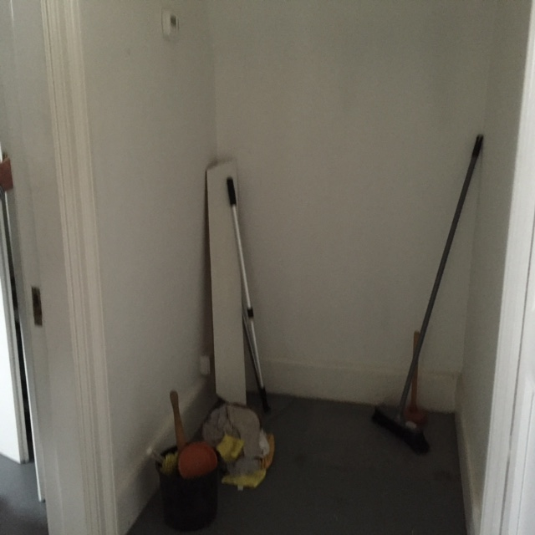

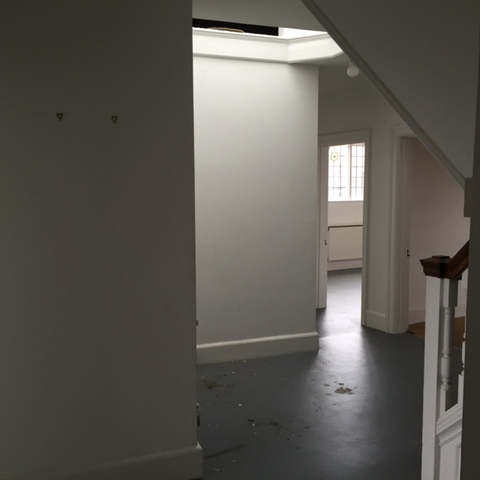

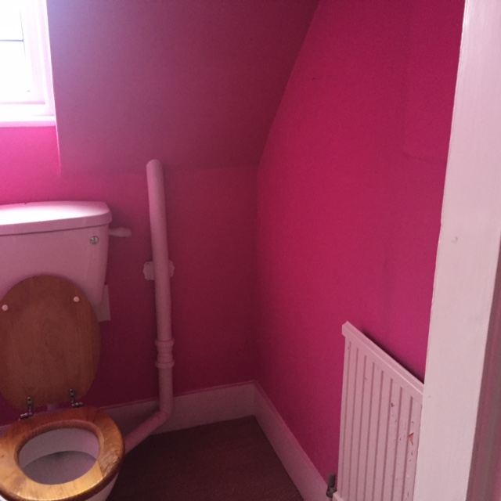

**10**

**9**

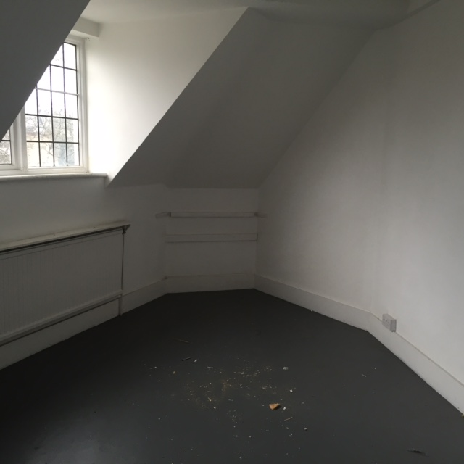

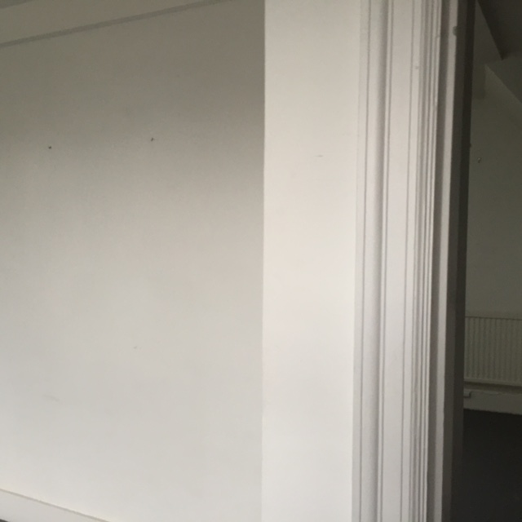

**12**

**11**

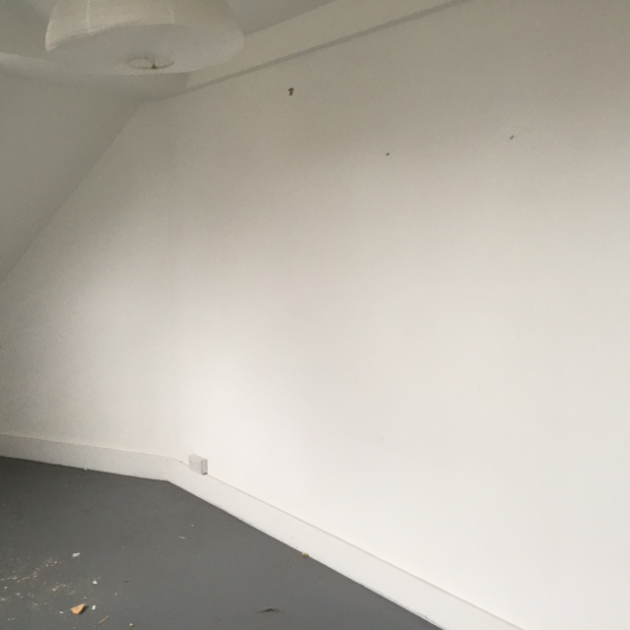

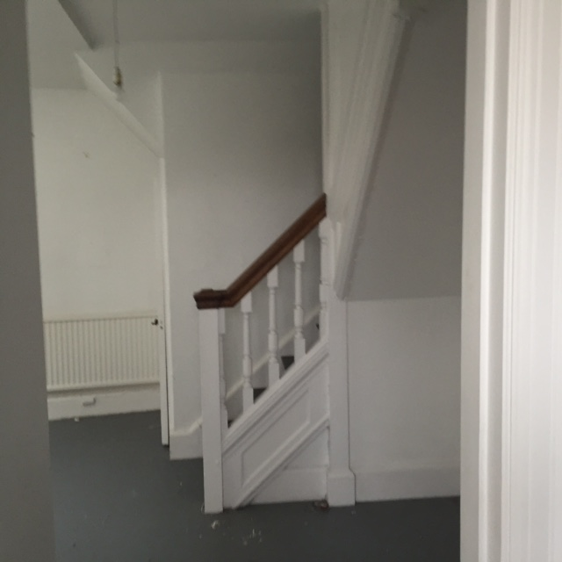

**16**

**14**

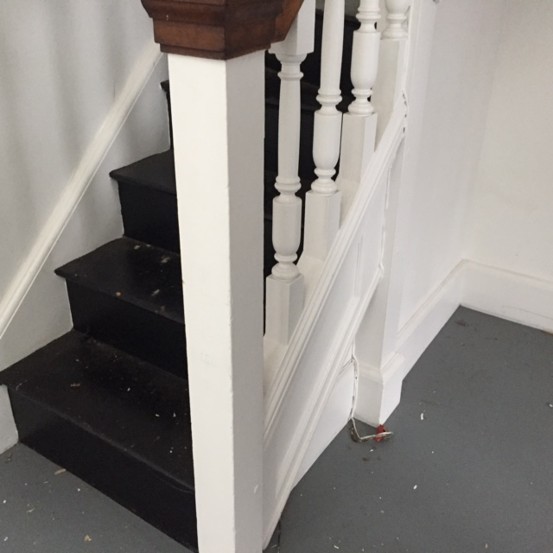

**15**

**13**

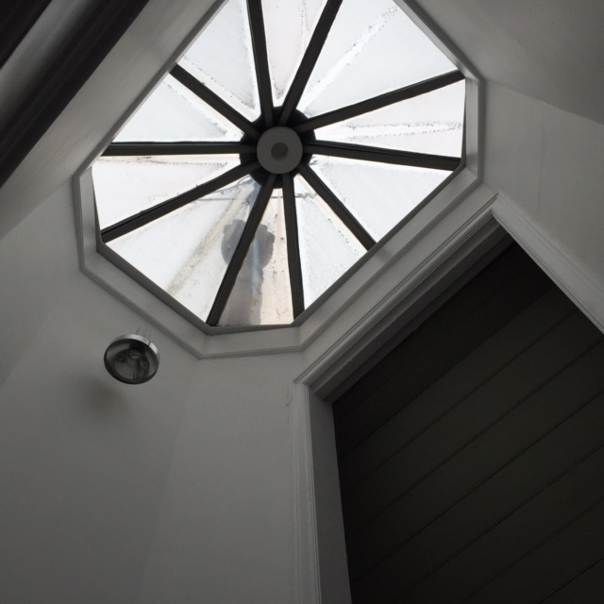

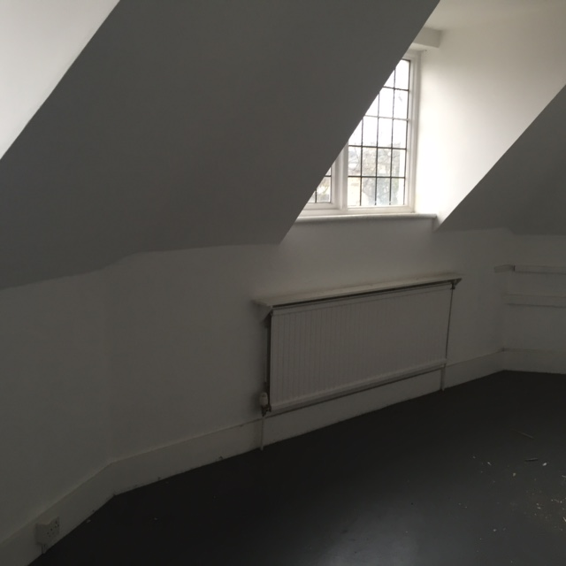

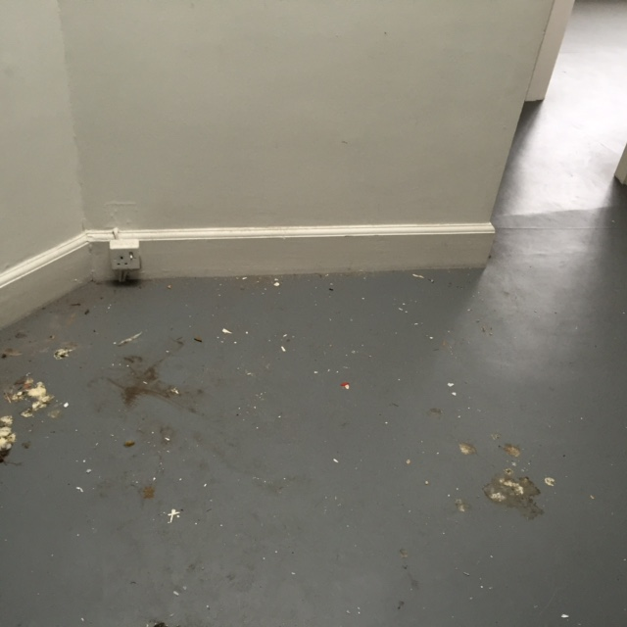

**18**

**17**

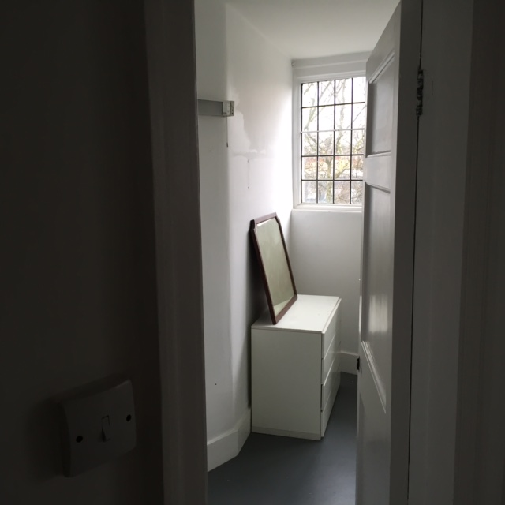

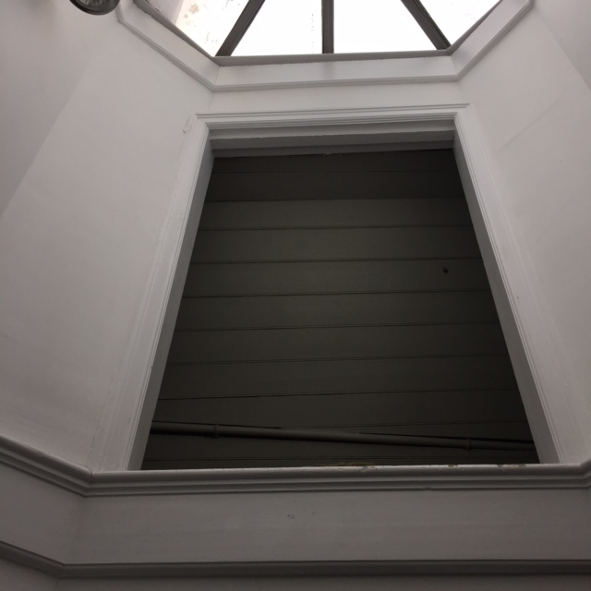

**20**

**19**

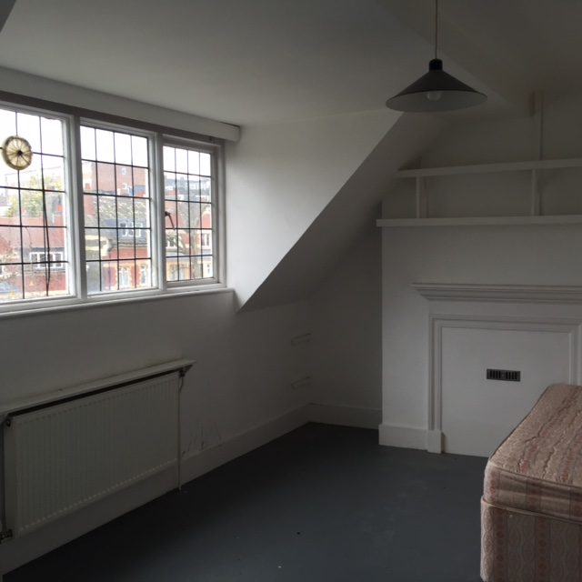

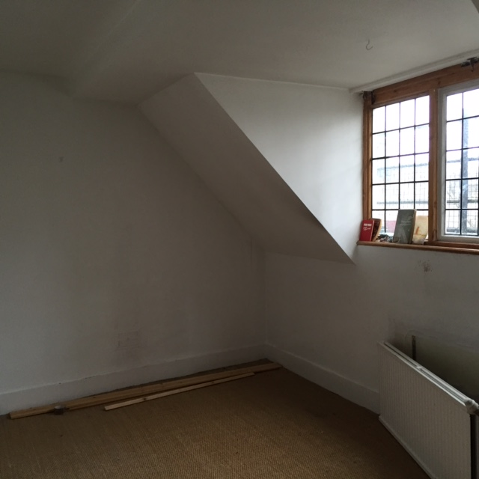

**22**

**21**

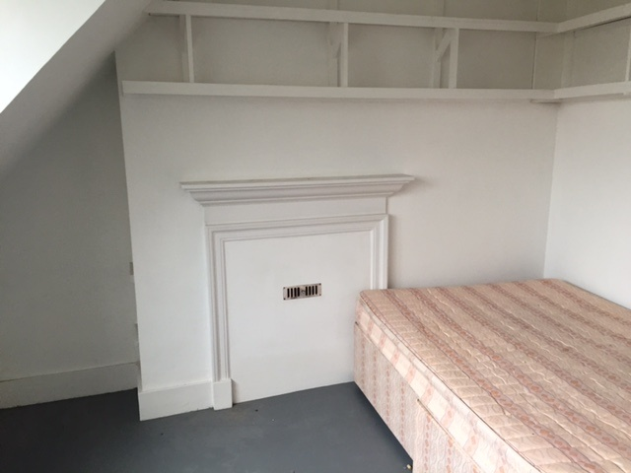

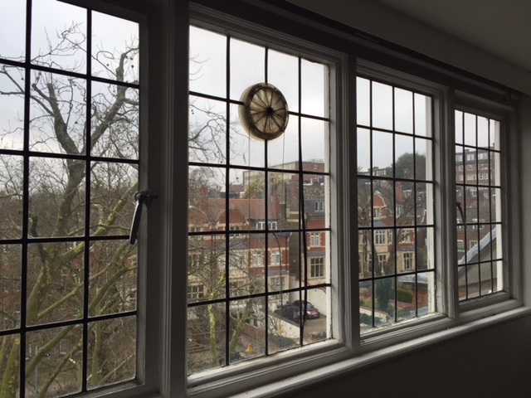

1

**24**

**23**

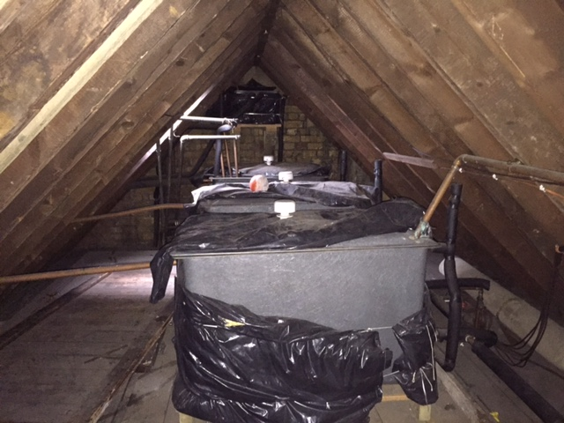

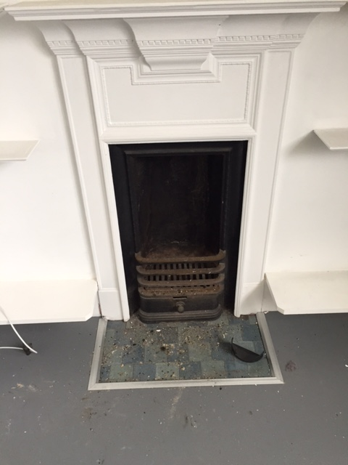

**26**

**25**

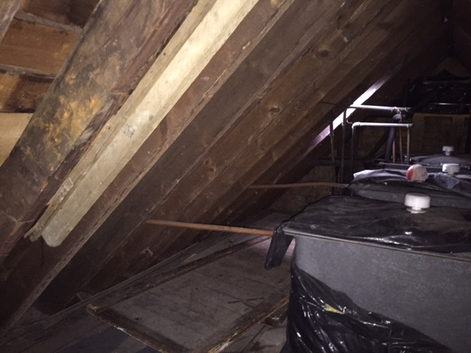

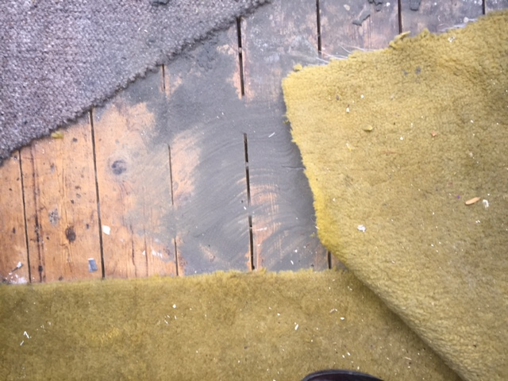

**28**

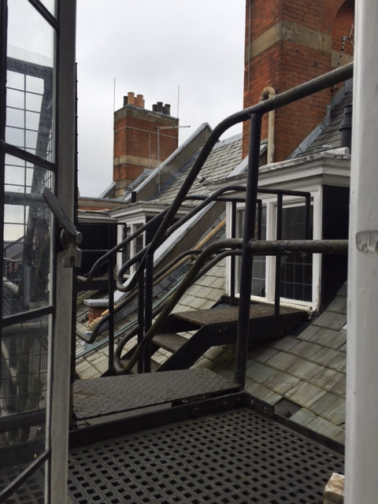

**27**

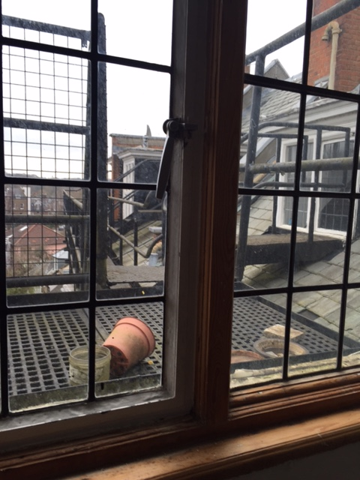

**29**

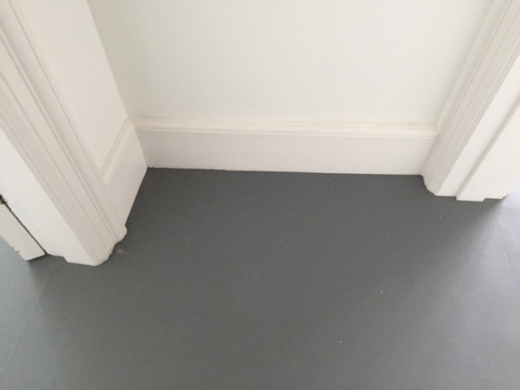

**30**

