Mr Steve Taylor
Network Rail Infrastructure Ltd
1 Eversholt Street
London
NW1 2DN
1 Eversholt Street  London  NW1 2DN |  | Application Ref: 2015/6675/P
 |  | Please ask for: James Clark
 |  | Telephone: 020 7974 2050
 |  | 9 February 2016

Dear Sir/Madam

DECISION

Town and Country Planning Act 1990 (as amended)

Full Planning Permission Granted

Address:
Land adjacent to Ampthill Community Centre
Barnby Street
London
NW1 2JP

Proposal:
Construction of a new substation
Drawing Nos: Design & Access Statement (Part 1 & 2), Lighting & Noise Impact Assessment, E100-ARP-DRG-AR-000001, E100-ARP-DRG-AR-000002, E100-ARP-DRG-AR-000003, E100-ARP-DRG-AR-000004, E100-ARP-DRG-AR-000005, E100-ARP-DRG-AR-000006, E100-ARP-DRG-AR-000007, E100-ARP-DRG-AR-000008, E100-ARP-DRG-AR-000009

The Council has considered your application and decided to grant permission subject to the following condition(s):

Condition(s) and Reason(s):

1 | The development hereby permitted must be begun not later than the end of three years from the date of this permission.  Reason: In order to comply with the provisions of Section 91 of the Town and Country Planning Act 1990 (as amended).
2 | All new external work shall be carried out in the brickwork, metalwork and ground treatment materials illustrated on Design & Access Statement 2.  Reason: To safeguard the appearance of the premises and the character of the immediate area in accordance with the requirements of policy CS14 of the London Borough of Camden Local Development Framework Core Strategy and policy DP24 of the London Borough of Camden Local Development Framework Development Policies.
3 | The development hereby permitted shall be carried out in accordance with the following approved plans Design & Access Statement (Part 1 & 2), Lighting & Noise Impact Assessment, E100-ARP-DRG-AR-000001, E100-ARP-DRG-AR-000002, E100-ARP-DRG-AR-000003, E100-ARP-DRG-AR-000004, E100-ARP-DRG-AR-000005, E100-ARP-DRG-AR-000006, E100-ARP-DRG-AR-000007, E100-ARP-DRG-AR-000008, E100-ARP-DRG-AR-000009.  Reason:For the avoidance of doubt and in the interest of proper planning.
4 | The external noise level emitted from plant, machinery or equipment at the development hereby approved shall be lower than the lowest existing background noise level by at least 10dBA as assessed according to BS4142:1997 at the nearest and/or most affected noise sensitive premises, with all machinery operating together at maximum capacity.  Reason: To ensure that the amenity of occupiers of the development site/ surrounding premises is not adversely affected by noise from mechanical installations/ equipment.

Informative(s):

Reason for granting permission

The proposed construction of a sub-station on the site is considered to be acceptable to Camden planning policy. The sub-station would replace a soon to be decommissioned sub-station on another site in the Euston area and is considered a key asset by Network rail to maintain the existing functioning railway system.

The principle of constructing a sub-station on the site is contrary to sections of the Development plan policies and the Euston Area Action plan. The site is approximately 390sqm located within the Euston Area Action Plan (ACP) and classified in section 4.3 as a designated site for a residential led mixed use scheme and therefore not conducive with the proposed Sub-station. However the proposed residential scheme is based on the presumption that structural engineering works will take place over the railway lines creating a platform for development. Considering the 20 year horizon and the unsecured nature of the proposed residential scheme it is not considered acceptable to refuse the application these grounds.

The site has historically been used as a playground for the adjacent Ampthill housing estate and appears to have been left redundant for a long period of time. A new playground area has been constructed approximately 100 metres away in closer proximity to the main housing blocks. The site is not a designated open space and policy DP15 states that the council will protect existing leisure facilities by resisting their loss unless, "- adequate alternative facilities are already available in the area, and therefore no Shortfall in provision will be created by the loss". The new playground appears to have replaced the playground previously on the site and thus accords with policy.

The proposed buildings of the sub-station would occupy approximately 223sqm of the 390sqm site located to the western half adjacent to the railway line. The buildings would be located on the western side of the site and constructed in a simple block style in an "L" shape, helping to lessen the impact on the street-scene. The proposed brickwork, metalwork and ground treatment to be used in construction are considered to provide a high quality finish that would help integration the sub-station into the prevailing character of the location.

The site is classified as contaminated land however consultation with Environmental health has confirmed that studies by the former National Radiological protection Board (NRPB) concluded that sub-stations pose no environment concern. The two major pieces of equipment generating noise in the designed substation are the transformer and the generator set. Noise and light impact assessments have been submitted with the application are considered to accord with policy DP28.

The site is adjacent an un-adopted Road managed by the housing association responsible for Ampthill estate (HASC). There are no objections to the construction of a new crossover, as it will not result in the loss of on street car parking spaces. The redundant crossover would be expected to be removed and the footway repaved. No transport conditions are imposed in relation to the development but the requirement for a drop kerb to the site would require HASC consultation.

The existing trees on the site are not protected through designation, considered poor quality and do not add to the character or overall quality of the location. Their removal is therefore considered acceptable.

25 neighbouring properties have been consulted no objections have been received at time of writing. The site's planning history and relevant appeal decisions were taken into account when coming to this decision.

As such, the proposed development would not harm the character and design of the site within its location and is considered to accord with policies CS2, CS5, CS11 and CS14 of the London Borough of Camden Local development Framework Core Strategy, and policies DP15, DP24, DP26 and DP28 of the London Borough of Camden Local Development Framework Development Policies. The proposed development also accords with policies 7.4 and 7.6 of the London Plan 2015; and paragraphs 14, 17, 56-66 of the National Planning Policy Framework.

Your proposals may be subject to control under the Building Regulations and/or the London Buildings Acts which cover aspects including fire and emergency escape, access and facilities for people with disabilities and sound insulation between dwellings. You are advised to consult the Council's Building Control Service, Camden Town Hall, Argyle Street WC1H 8EQ, (tel: 020-7974 6941).

Noise from demolition and construction works is subject to control under the Control of Pollution Act 1974. You must carry out any building works that can be heard at the boundary of the site only between 08.00 and 18.00 hours Monday to Friday and 08.00 to 13.00 on Saturday and not at all on Sundays and Public Holidays. You are advised to consult the Council's Compliance and Enforcement team [Regulatory Services], Camden Town Hall, Argyle Street, WC1H 8EQ (Tel. No. 020 7974 4444 or on the website http://www.camden.gov.uk/ccm/content/contacts/council-contacts/environment/contact-the-environmental-health-team.en or seek prior approval under Section 61 of the Act if you anticipate any difficulty in carrying out construction other than within the hours stated above.

In dealing with the application, the Council has sought to work with the applicant in a positive and proactive way in accordance with paragraphs 186 and 187 of the National Planning Policy Framework.

You can find advice about your rights of appeal at:

http://www.planningportal.gov.uk/planning/appeals/guidance/guidancecontent

Yours faithfully
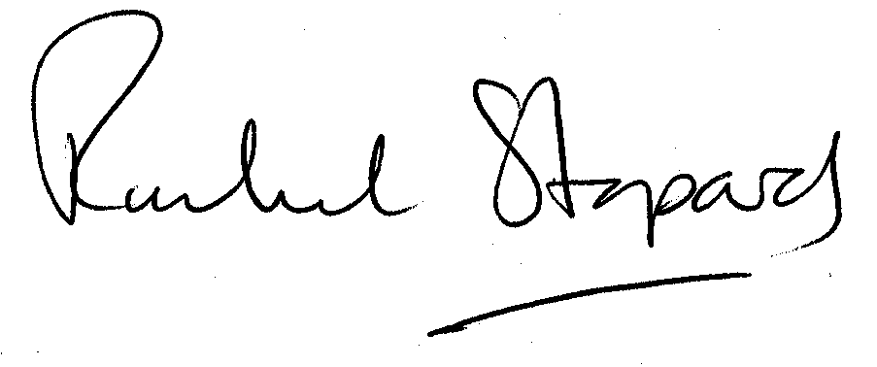
Rachel Stopard
Director of Culture & Environment

