6 AND 8, GREENLAND ROAD

List Entry Summary
This building is listed under the Planning (Listed Buildings and Conservation Areas) Act 1990 as amended for its special architectural or historic interest.
Name: 6 AND 8, GREENLAND ROAD
List entry Number: 1130408

Location
6 AND 8, GREENLAND ROAD
The building may lie within the boundary of more than one authority.
County: Greater London Authority
District: Camden
District Type: London Borough
Parish:
National Park: Not applicable to this List entry.
Grade: II
Date first listed: 14-May-1974
Date of most recent amendment: Not applicable to this List entry.

Legacy System Information
The contents of this record have been generated from a legacy data system.
Legacy System: LBS
UID: 477887

Asset Groupings
This list entry does not comprise part of an Asset Grouping. Asset Groupings are not part of the official record but are added later for information.

List entry Description

Summary of Building
Legacy Record - This information may be included in the List Entry Details.

Reasons for Designation
Legacy Record - This information may be included in the List Entry Details.

History
Legacy Record - This information may be included in the List Entry Details.

Details
CAMDEN
TQ2983NW GREENLAND ROAD 798-1/77/700 (South side) 14/05/74 Nos.6 AND 8
GV II
2 terraced houses, originally with contemporary shopfronts. Mid C19, restored c1976 as a GLC renovation scheme. Yellow stock brick with rusticated stucco ground floors. 3 storeys. 2 windows each. Square-headed doorways with fanlights and C20 doors. Recessed sashes; ground floor replacing shopfronts of which consoles remain on No.8. Upper floors architraved 4-pane. No.8, stucco cornice and blocking course; No.6, stucco parapet, cornice cut back. INTERIORS: not inspected.
Listing NGR: TQ2902483894

Selected Sources
Legacy Record - This information may be included in the List Entry Details
National Grid Reference: TQ 29025 83896

Map
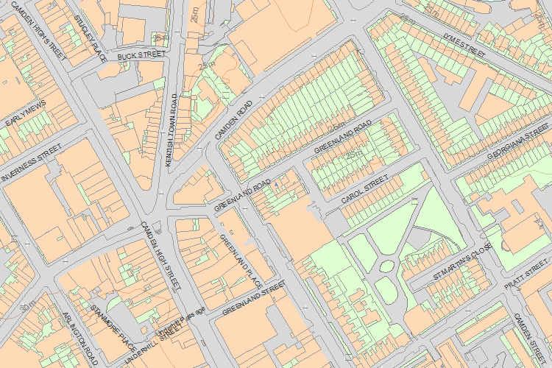© Crown Copyright and database right 2016. All rights reserved. Ordnance Survey Licence number 100024900.
© British Crown and SeaZone Solutions Limited 2016. All rights reserved. Licence number 102006.006.
The above map is for quick reference purposes only and may not be to scale. For a copy of the full scale map, please see the attached PDF - 1130408 .pdf
The PDF will be generated from our live systems and may take a few minutes to download depending on how busy our servers are. We apologise for this delay.
This copy shows the entry on 08-Feb-2016 at 10:22:48.
End of official listing

Your Contributions
Historic England is conducting a trial which allows users of the NHLE to contribute to the List. The following information about this List entry has been contributed by users of the list and does not form part of the official List entry itself.
Historic England does not check the factual accuracy of user contributions. User contributions are the opinion of the contributor and do not represent the official position of Historic England.
If you wish to report an issue with a contribution on the List please e-mail us at EnrichingTheList@historicengland.co.uk.

Email
Password
Forgotten your password?
Log in

There aren't currently any contributions
Share

- About us
- Contact us
- Jobs
- Newsletter
- Heritage Calling Blog
- Accessibility
- Terms & Conditions
- Google+

© Historic England 2015

