7210525 - Goodenough College, London House, Mecklenburgh Square, LONDON, WC1N 2AB

10.0 SITE PLAN – Mecklenburgh Square.
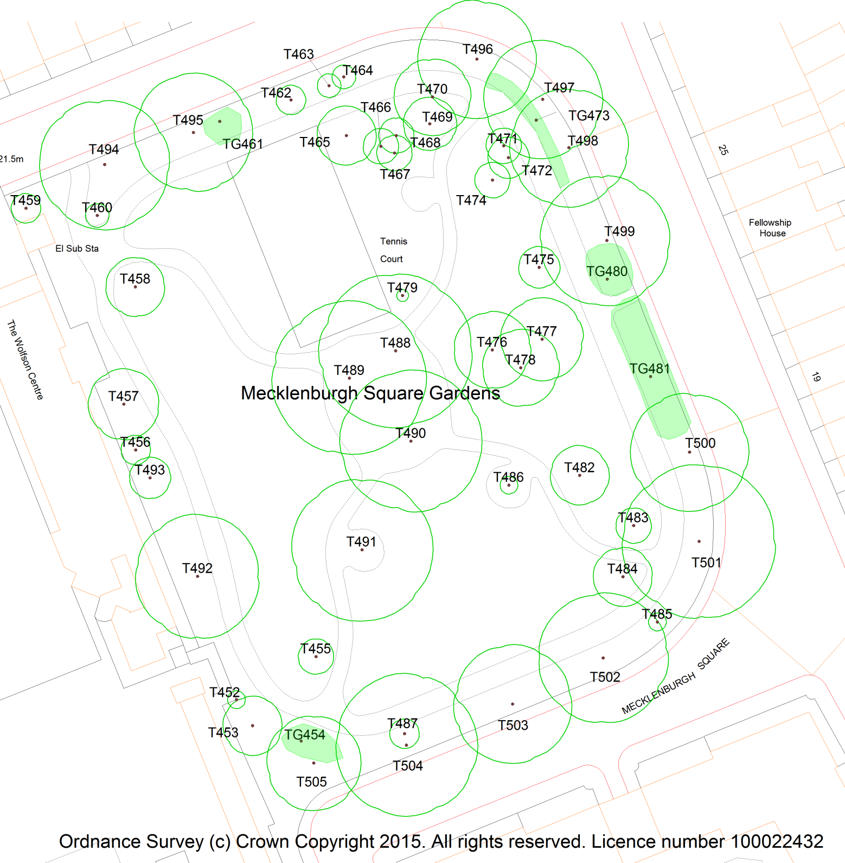
Drawn: JM | Not to scale
 | JM/150364R/sh

