D O N A L D S H E A R E R C H A R T E R E D A R C H I T E C T S
Scholars House, 4 Shottery Brook Office Park, Timothy Bridge Road, Stratford-Upon-Avon, Warwickshire CV37 9NR
Telephone: 01789 294 560, Fax: 01789 294 560, e-mail: donald@ds-architects.demon.co.uk

Our Ref: 1236BA001 | Date: 29th January 2016

Design & Access Statement

Re: Unit 3 Regis Road - Additional Accommodation

a. Physical Context

Regis Road Trading Estate lies to the West of Kentish Town Road Camden. The ground is generally flat and there are a series of varying commercial building forms and styles, housing commercial activities that range from distribution, storage, through to B1 uses Unit 3 is within a terrace of initially identical metal clad trading units in two blocks.
The character was altered with the infilling of the space between these two blocks with an atrium style fully glazed frontage building twice the height of the units that flank it. The terrace was further enhanced by the addition of a further B1 use building on unused ground at the southern end of the terrace, with again its own identity and style.

A previous application 2011/3868/P was approved on the 30th Sept 2011and implemented in 2012 / 2013 for an additional storey to unit 4.

Approval has since also been granted (although not yet implemented) for a 3 storey office building adjacent to unit 1 (approval 2013/4832/P) on the 15th of October 2013.
Approval was then sought jointly by the owners of unit 1, 2 & 3 for additional accommodation (identical to that approved in application 2011/3868/P) which was approved in October 2015 (2015/4234/P).

The present circumstances of the owner of unit 1 means that he wishes to implement the construction works as a separate stand-alone project resulting in this present application for a materially identical unit above unit 3 (already approved) to match unit 4. -

b. Planning Policy Context

The primary reference to Planning policy is in the Core Strategy.

Policy CS1
This policy identifies under para. b) that Kentish Town is an appropriate location for development as it is a highly accessible location. Regis Road Trading estate is adjacent to Kentish Town Centre and therefore is a location that meets the core strategy requirements for development in terms of location.

Policy CS1 under paras. d), e), f), g) & h) detail the requirements to ensure that best use is made of Camden’s limited land. The development proposal supports all of these objectives.
In line with this the application utilises the redundant space above units 3 in the same way as has now been successfully implemented in unit 4.

We respectfully submit that the proposed development will improve the character of the area, provide additional employment space close to both the facilities of the town centre and transport hubs and enhance the amenity of adjoining properties.

The design and form alterations have been driven by the clients desire to embrace the principles of efficiency of both energy and built form, taking full account of all life cycle costs.

The adjoining properties will be affected in no different way than the existing implemented developments within the terrace.

The proposals will not materially adversely alter the character of the area or the amenity of adjoining properties ensuring that Planning Policy supports the proposals.
Policy CS3
The applicant submits that as the application is for additional employment opportunities and therefore complies with CS3.

Policy CS8
This policy promotes a successful and inclusive Camden economy.
8.1 Highlights how Camden supports creative industries. The mixing of retail through web site film clips, with this being the only shop window brings creative filming and retail together as mutually dependent industries.
8.2 Highlights the support through the Core strategy for local employers employing local people to be retained within the borough to ensure that expansion of their premises where appropriate is supported.
8.10 Highlights the need for retention and appropriate expansion of light industrial premises the subject of this application as there has been no increase in this available floor space in recent years due to the low value of such accommodation. This dovetails with the applicants desire to remain in the borough and the fact that this application is the only viable way of retaining this business within Camden. Policies 8.11, 8.12, 8.13 and 8.14 reinforce these issues.

Policies CS9, 10, 11, 13 & 14
The application has been designed to ensure that it embraces all appropriate aspirations within these policies namely, a successful central London, sustainable credentials, high environmental standards, and high quality space respectively.

c. Involvement
We have discussed informally with the Duty Planning Officer the principle of this application, and its context with the core strategy.
.

d. Evaluation / Design Process

The recent roof extension to unit 4, the Book End unit approved to be sited adjacent to unit 1 and the previously implemented infill units created within this terrace have been evaluated to ensure that the proposed alterations use these cues to enhance the appearance of the estate as a whole and this terrace in particular.

The existing roof structure is a lightweight steel roof, which uses masonry cross walls for support. The existing structure is considered adequate to support a further level of accommodation; however the design has evolved around the client requiring the fabrication to be facilitated without any disruption to the existing units use during implementation. This means that the existing roof enclosure will remain in place throughout and be retained after completion.

e. Use

The properties are used for order processing, storage, distribution, packing and logistics for trading based companies. The properties are in part split into two levels at present with a flexible distribution of activities located on the lower level and upper levels. The proposal will keep these existing functions, but add a small reception area and enclose the staircase to the 2nd floor proposed into a fire protected shaft as at unit 4.

f. Layout

The proposed accommodation has been laid out to provide a safer and more efficient working environment, to accommodate the expanded functions of the units without needing to relocate any existing businesses. This is desirable for the companies who’s employees are local to Kentish Town, the majority walk or use public transport to get to and from work.

g. Scale

The proposals have been designed to ensure that they are no more materially visually apparent than the existing permitted infill’s of adjacent warehouse unit within this terrace. The additions have been carefully designed to ensure that they do not protrude beyond the existing urban design rhythms within the forms that make up the visual collective of the trading estate. It is also significant to note that they will be visually subservient to the new unit approved that adjoins unit 1.

h. Appearance

The proposals will enhance the appearance of the existing terrace by reinforcing the design cues, given through the implementation of recent Planning approvals, further along this terrace.
i. Landscaping

No alterations have been carried out to the surrounding landscaping.

j. Access

The existing site is accessed off Kentish Town Road adjacent to Kentish town tube and rail stations. The main shopping center for Kentish town is of course adjacent to these main transport arteries.

The functions presently accommodated on the ground floor are not proposed to alter, therefore the proposals will have the same levels of accessibility as exist at present.

Yours sincerely,
Donald Shearer

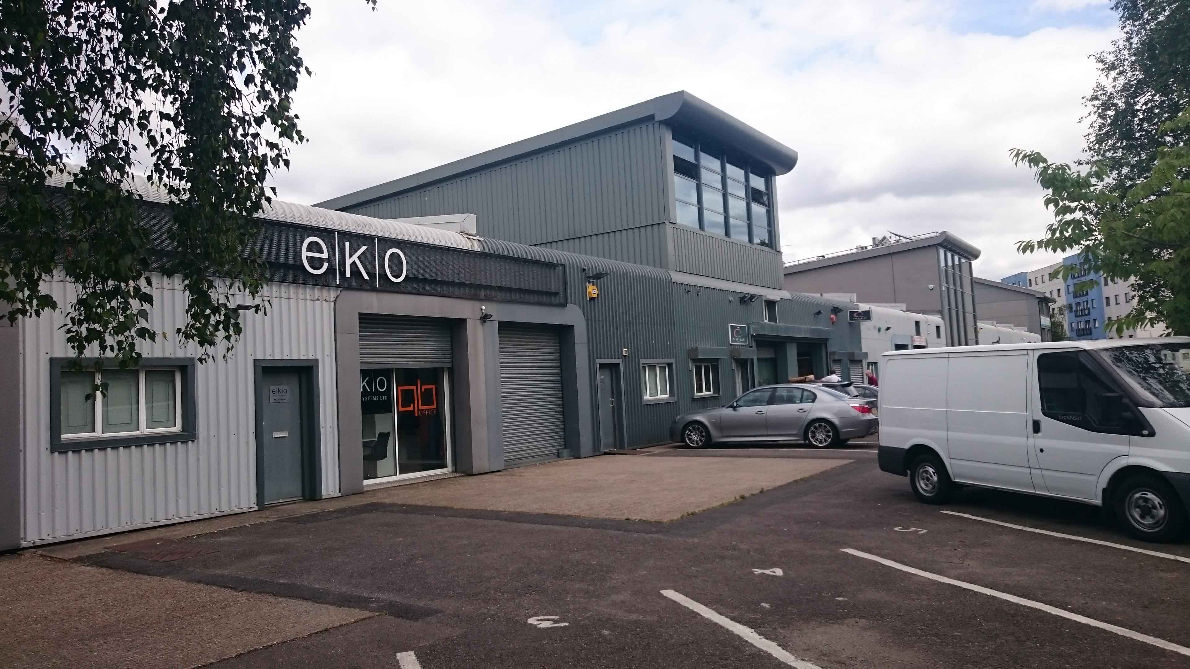

Units 3 & 4 with Unit 7a to right of photo.

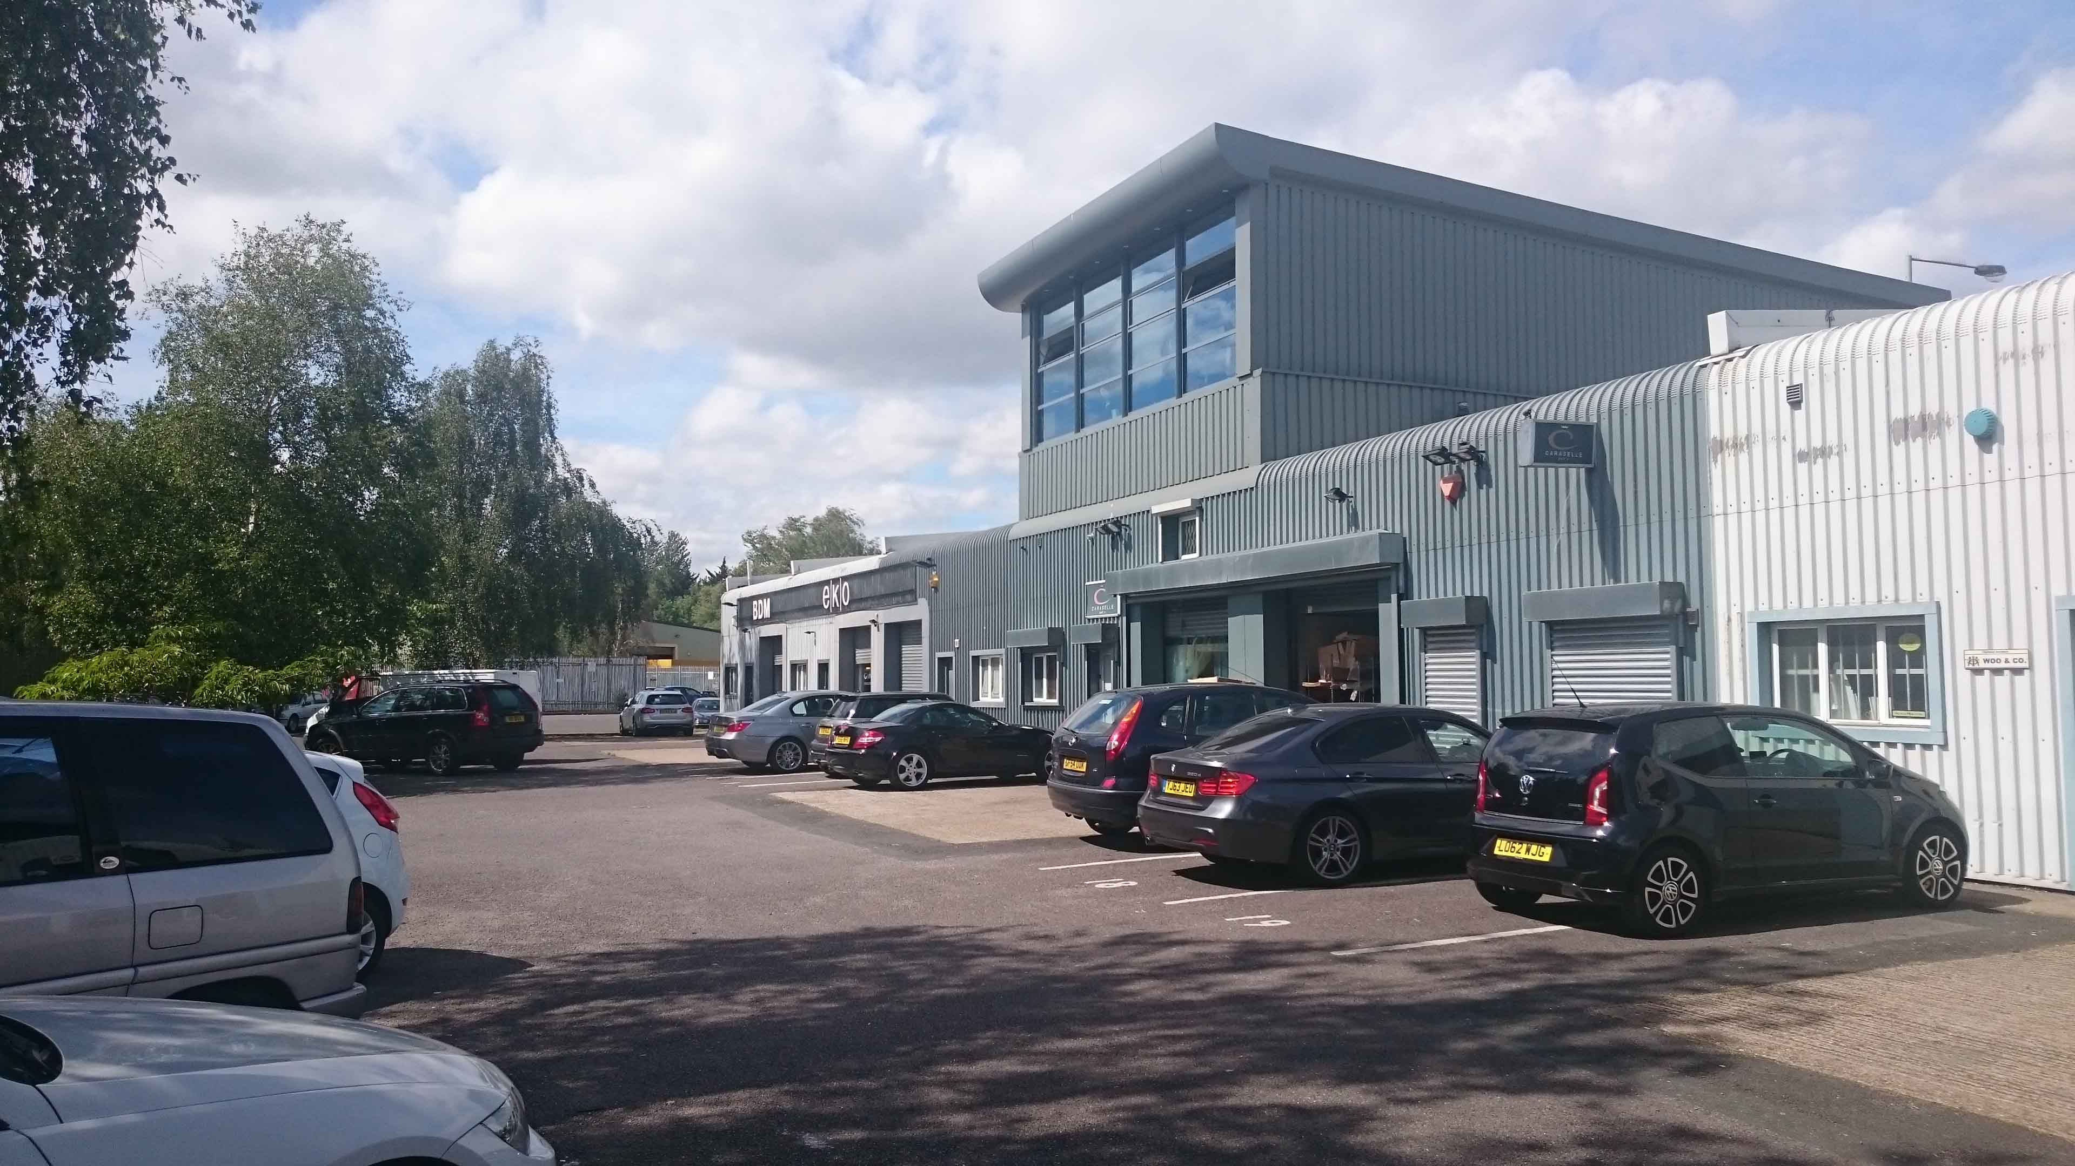

Unit 4 central with Units 5 and 6 to right and Units 1, 2 & 3 to left of photo.

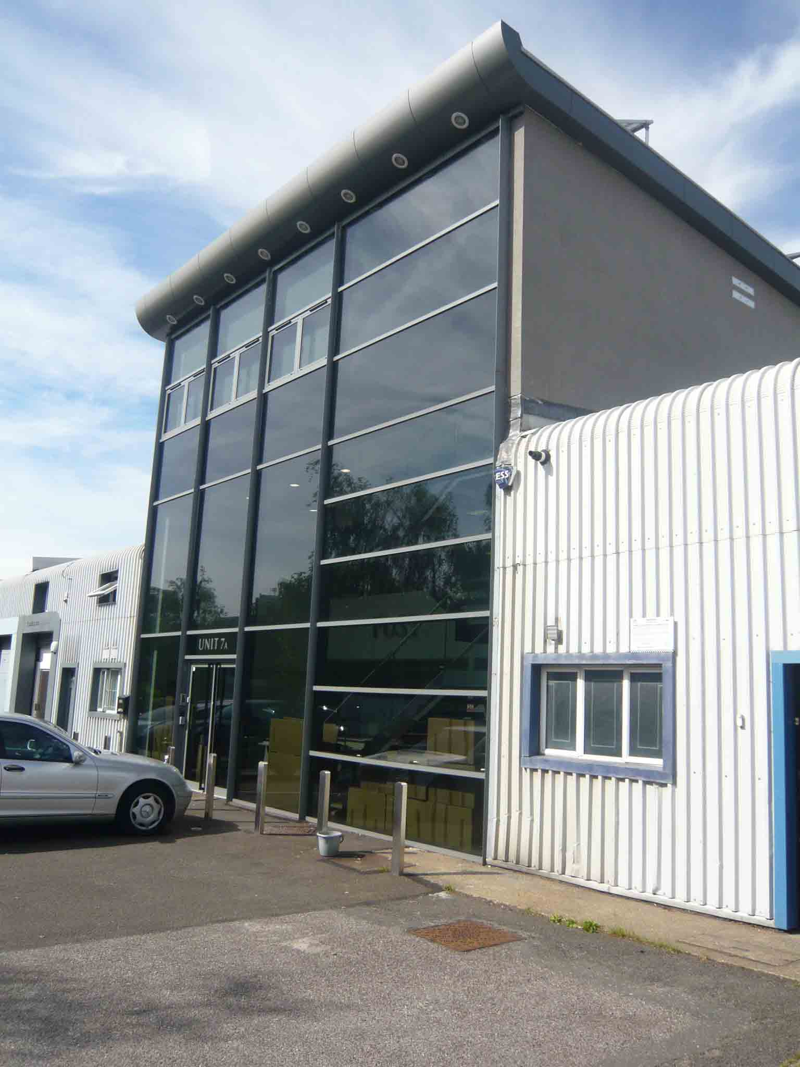

Unit 7a.
Principal: Donald M. Shearer, BSc(Arch), RIBA, ARB (Registered Architect)

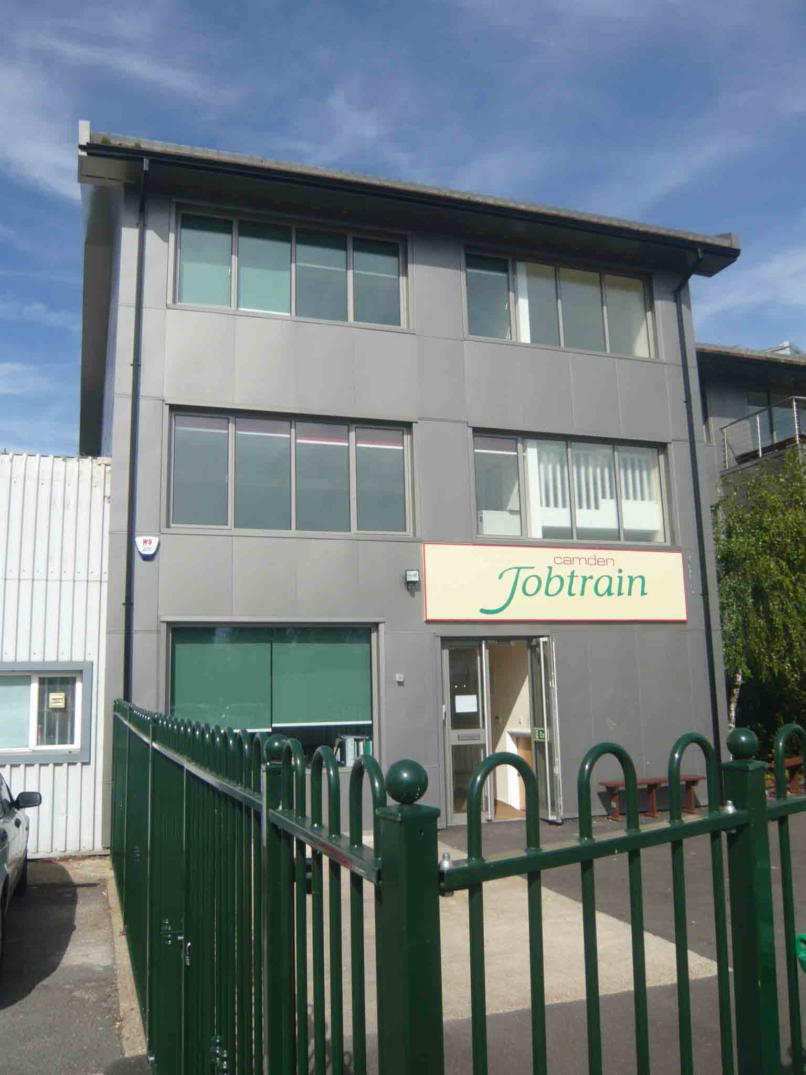

Unit 12

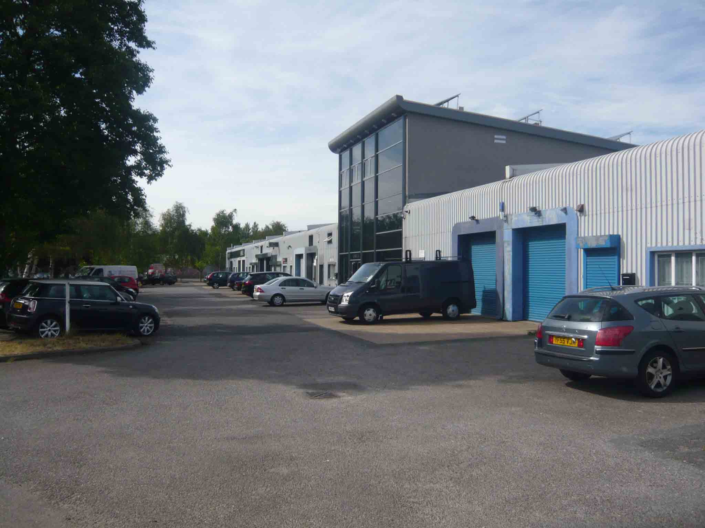

Unit 7a

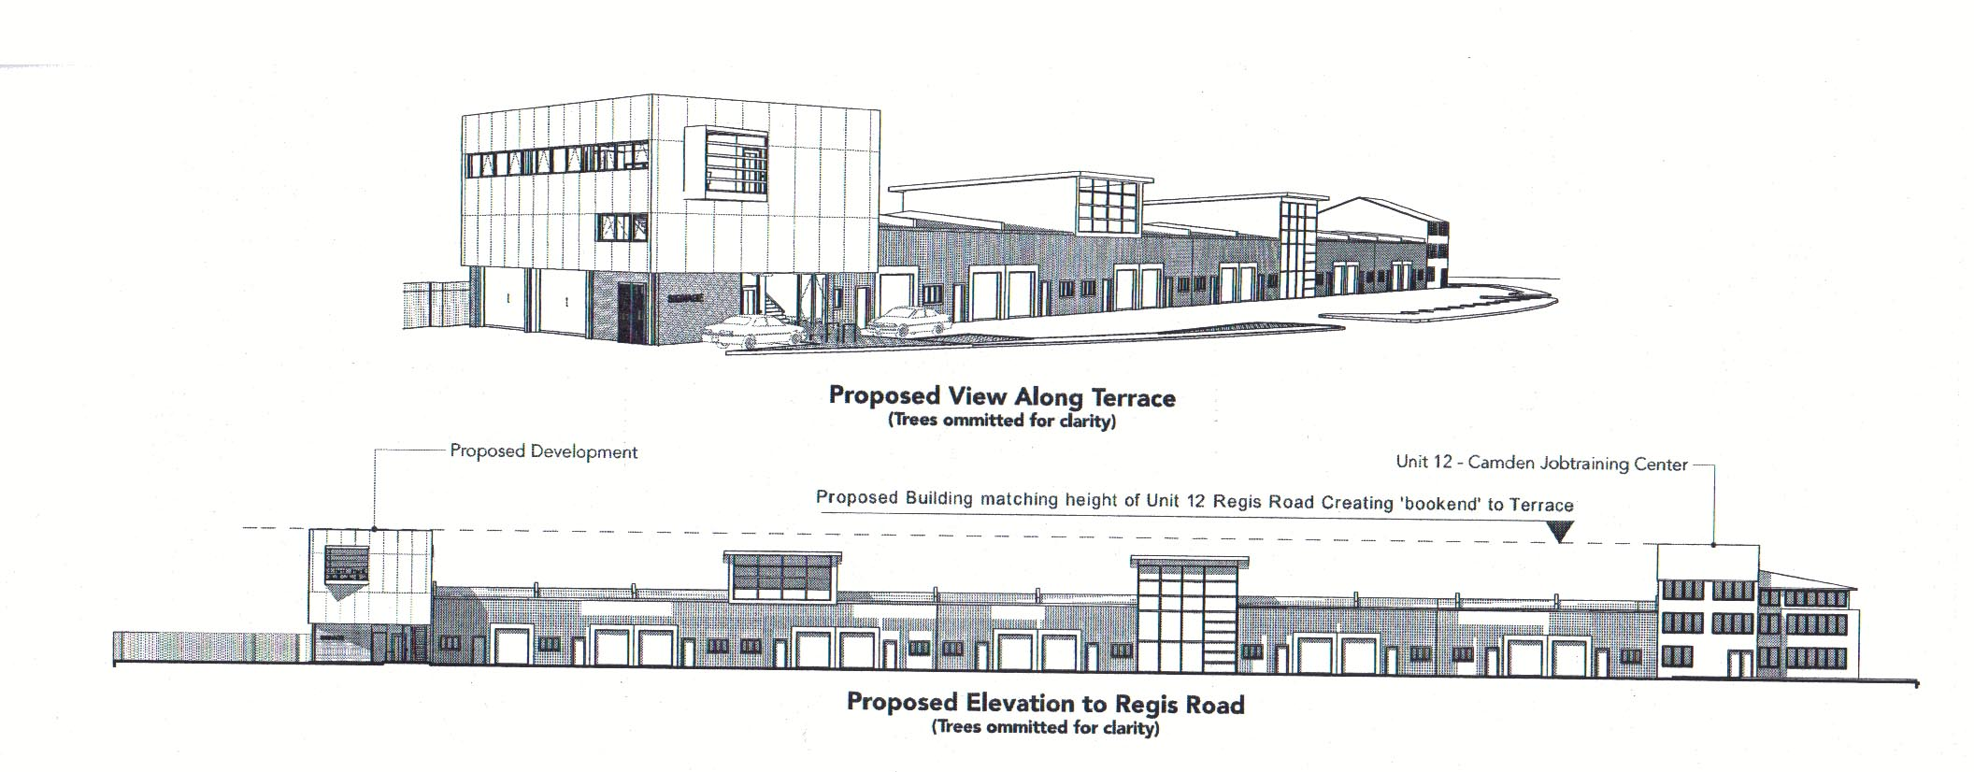

Approved unit adjacent to unit 1

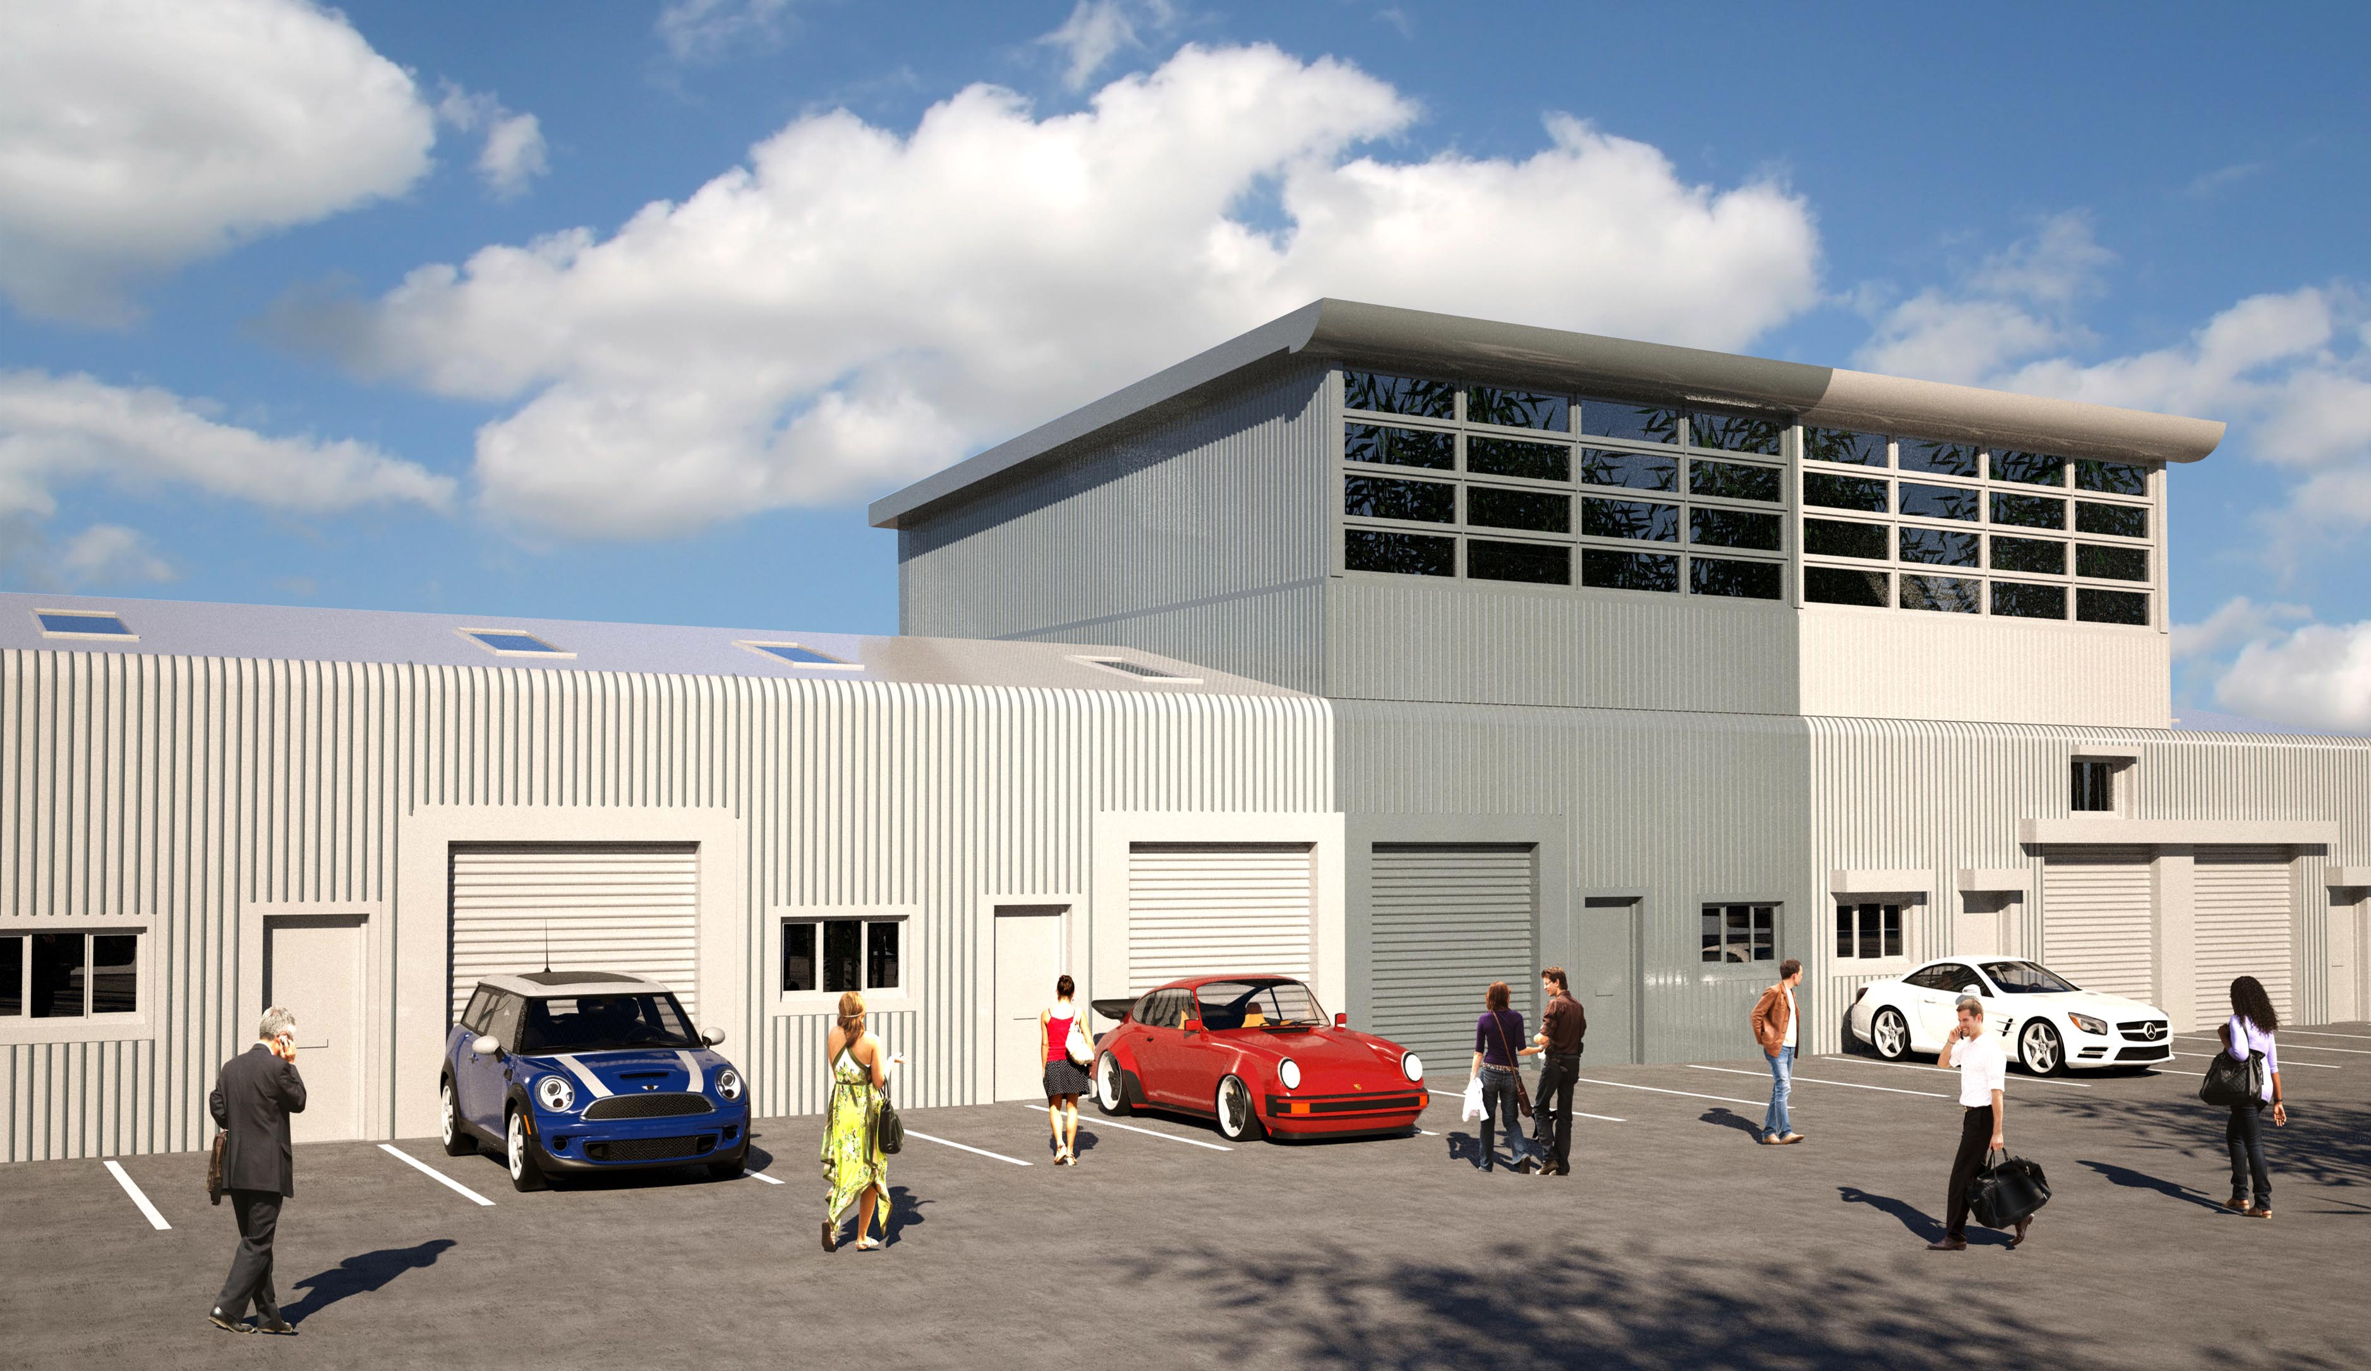

Computer generated image of the proposed Unit 3 extension (left) alongside the as existing Unit 4 extension.

