Marion Wesel-Henrion
35 Pond Street
London
NW3 2PN
35 Pond Street  London  NW3 2PN |  | Application Ref: 2015/6321/P
 |  | Please ask for: Anna Roe
 |  | Telephone: 020 7974 1226
 |  | 28 January 2016

Dear Sir/Madam

DECISION

Town and Country Planning Act 1990 (as amended)

Full Planning Permission Granted

Address:
35A Pond Street
London
NW3 2PN

Proposal:
Renewal of planning permission 2012/4824/P granted on 06/11/2012 for the continued use of basement as (Class D1) acupuncture health clinic and use of ground and first floors as (Class B1) office/studio accommodation.

Drawing Nos: Front elevation; Basement; Ground Floor; First Floor; Site Plan.

The Council has considered your application and decided to grant permission subject to the following condition(s):

Condition(s) and Reason(s):

1 | The limited period for the use shall be until 5th February 2019 or until the date that Marion Wesel-Henrion ceases to occupy 35 Pond Street, whichever is the sooner, at which date the use shall be discontinued and determined.  Reason: The Council has taken into account the special circumstances of Marion Wesel-Henrion in granting this permission and would wish to review the position at the end of this permission or if Mrs. Henrion's circumstances change earlier, with the intention that the use of the premises should revert to residential or studio office use ancillary to the main residential use of the premises.
2 | The development hereby permitted shall be carried out in accordance with the following approved plans: Front elevation; Basement; Ground Floor; First Floor; Site Plan.  Reason: For the avoidance of doubt and in the interest of proper planning.

Informative(s):

Reasons for granting permission.

Previous permissions (2004/4811/P; 2005/0215/P; 2009/3699/P and 2012/4824/P) for temporary use of part of the ground floor and the first floor as independent studio/office accommodation and the basement as an acupuncture clinic were granted taking into account the special circumstances of the applicant, Mrs Henrion, who primarily lives on the income generated from the rent paid on these units. The 2012 permission was subsequently granted given that it was ascertained that the special circumstances still remained for the same applicant. To date the situation has not altered.

Policy DP2 states that the Council will resist development that would involve the net loss of residential floor space. As the permission is for a temporary period and personal to the applicant it is considered that in the long term the proposal would not result in the loss of housing given that the site would revert back to housing if the applicant ceases to occupy the property or until the planning application expiration date whichever is the sooner as stipulated by condition 1.

The use of the basement as an acupuncture clinic is not considered to have a detrimental impact on the amenity currently enjoyed by the occupier or nearby neighbours. In addition the continued use of part of the ground floor and first floor as studio/offices is also unlikely to have an adverse effect on the amenity of nearby residential properties in terms of loss of privacy, noise and vibration.

No external or internal alterations are proposed to the building. In view of the above it is not considered that the proposal would have any detrimental effect upon the historic interest of the listed building or the character and appearance of the conservation area.

No objections were received prior to making this decision. The planning history of the site and relevant appeal decisions were taken into account when coming to this decision. Considerable importance and weight has been attached to the harm and special attention has been paid to the desirability of preserving or enhancing the character or appearance of the conservation area, under s.66 (LB's) and s.72 (CA's) of the Planning (Listed Buildings and Conservation Areas) Act 1990 as amended by the Enterprise and Regulatory Reform Act 2013.

As such, the proposed development is in general accordance with policies CS1, CS5, CS6 and CS10 of the London Borough of Camden Local Development Framework Core Strategy, and policies DP2, DP13, DP16, DP25 and DP26 of the London Borough of Camden Local Development Framework Development Policies. The proposed development also accords with policies 3.3, 3.4, 3.8, 4.2 and 4.3 of the London Plan 2015; and paragraphs 14, 17, 47-55 and 126-141 of the National Planning Policy Framework.

Your proposals may be subject to control under the Building Regulations and/or the London Buildings Acts which cover aspects including fire and emergency escape, access and facilities for people with disabilities and sound insulation between dwellings. You are advised to consult the Council's Building Control Service, Camden Town Hall, Argyle Street WC1H 8EQ, (tel: 020-7974 6941).

Noise from demolition and construction works is subject to control under the Control of Pollution Act 1974. You must carry out any building works that can be heard at the boundary of the site only between 08.00 and 18.00 hours Monday to Friday and 08.00 to 13.00 on Saturday and not at all on Sundays and Public Holidays. You are advised to consult the Council's Compliance and Enforcement team [Regulatory Services], Camden Town Hall, Argyle Street, WC1H 8EQ (Tel. No. 020 7974 4444 or on the website http://www.camden.gov.uk/ccm/content/contacts/council-contacts/environment/contact-the-environmental-health-team.en or seek prior approval under Section 61 of the Act if you anticipate any difficulty in carrying out construction other than within the hours stated above.

In dealing with the application, the Council has sought to work with the applicant in a positive and proactive way in accordance with paragraphs 186 and 187 of the National Planning Policy Framework.

You can find advice about your rights of appeal at:

http://www.planningportal.gov.uk/planning/appeals/guidance/guidancecontent

Yours faithfully
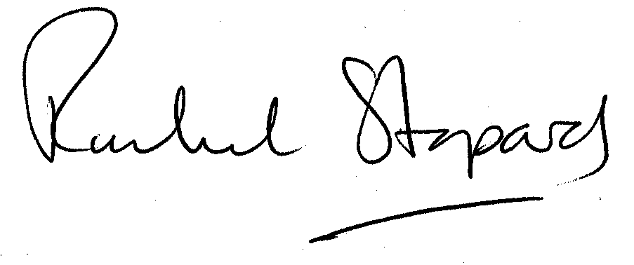
Rachel Stopard
Director of Culture & Environment

