Mr Mac McCarty
McCarty Associates
The Granary, Bishton Lane
Tidenham
Chepstow
Monmouthshire / Sir Fynwy
NP16 5LG

Application Ref: 2015/6085/L
Please ask for: Anna Roe
Telephone: 020 7974 1226
28 January 2016

Dear Sir/Madam

DECISION

Planning (Listed Building and Conservation Areas) Act 1990

Listed Building Consent Granted

Address:
57 Mornington Terrace
London
NW1 7RU

Proposal:
Construct of x2 timber pergolas, x8 roofed picnic tables in rear garden and new framed doors to the existing bin store.

Drawing Nos: MC661-100; MC661-201; EDCC 14; EDCC 15; OS Extract; Block Plan; Design and Access Statement; Heritage Statement

The Council has considered your application and decided to grant Listed Building Consent subject to the following condition(s):

Conditions and reasons:

1 | The works hereby approved are only those specifically indicated on the drawings referred to above.  Reason: In order to safeguard the special architectural and historic interest of the building in accordance with the requirements of policy CS14 of the London Borough of Camden Local Development Framework Core Strategy and policy DP25 of the London Borough of Camden Local Development Framework Development Policies.
2 | The works hereby permitted shall be begun not later than the end of three years from the date of this consent.  Reason: In order to comply with the provisions of Section 18 of the Planning (Listed Buildings and Conservation Areas) Act 1990.

Informative(s):

Reason for granting listed building consent

The proposed x2 pergolas and covered x8 picnic benches are considered to be subordinate in scale and location to the host building and are of an appropriate design by virtue of their mirroring the design and form of the existing wooden garden structures that have previously been approved at this site. The proposed pergolas and covered picnic benches would not obscure any significant architectural features or otherwise visually harm the building. The proposal is considered to preserve the building special architectural and historic interest.

The proposal to remove the existing loose fencing to the bin store and replace it with a pair of stained ledged/braced and framed doors would not result in the loss of original or otherwise historic fabric and will not affect the integrity of the building.

The proposal is thus considered not to harm to the special architectural historic interest of the listed building.

The site's planning history and relevant appeals have been taken into account when coming to this decision.

Special regard has been attached to the desirability of preserving the listed building and its features of special architectural or historic interest, under s.16 of the Listed Buildings and Conservation Areas Act 1990 as amended by the Enterprise and Regulatory Reform Act (ERR) 2013.

As such, the proposed development is in general accordance with policies CS5 and CS14 of the London Borough of Camden Local Development Framework Core Strategy and policies DP24, DP25, and DP26 of the London Borough of Camden Local Development Framework Development Policies. The proposed development also accords with policies 7.4 and 7.6 of The London Plan March 2015, consolidated with alterations since 2011 and paragraphs 14, 17, 56 68 and 126-141 of the National Planning Policy Framework.

You can find advice about your rights of appeal at:

http://www.planningportal.gov.uk/planning/appeals/guidance/guidancecontent

Yours faithfully
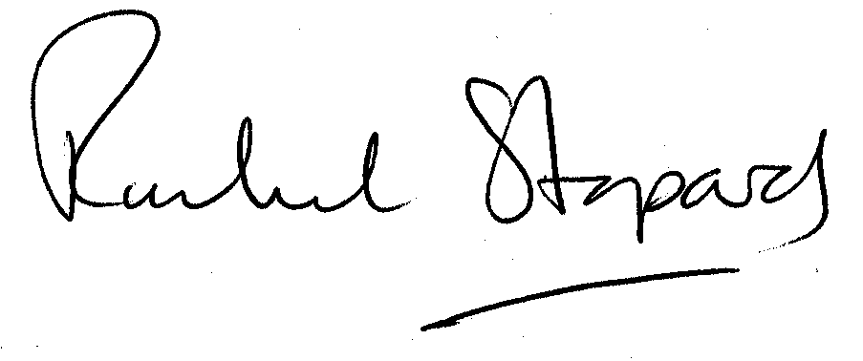
Rachel Stopard
Director of Culture & Environment

