DESIGN & ACCESS STATEMENT

SITE ADDRESS: 146A Fellows Road, London, NW3 3JH

Proposal Outline:: Anglian Home Improvements have been contracted to erect a PVCu Verandah to the rear of the property. Our client has chosen a Verandah to meet their personal requirements whilst being considerate to the natural surroundings and council guidelines.
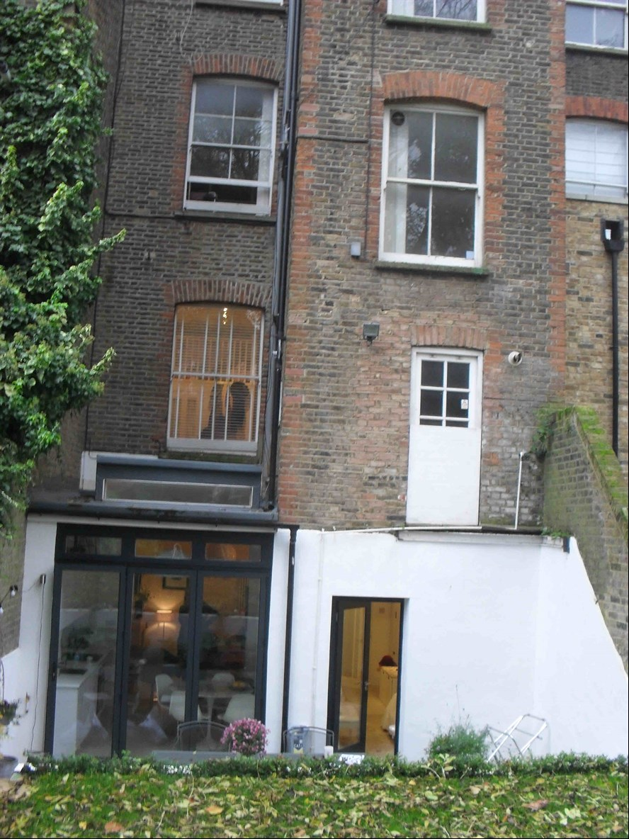

Design Principles: Our client has chosen Dual Anthracite Grey PVCu framed Verandah with aluminium posts and solarglass roof to match the existing property.

Due consideration has been given to the overall look and size of the property to give the most
aesthetically pleasing look and giving consideration to privacy without being overbearing.
All external materials used will be to match the existing property as closely as possible.
Examples of materials can be found below.
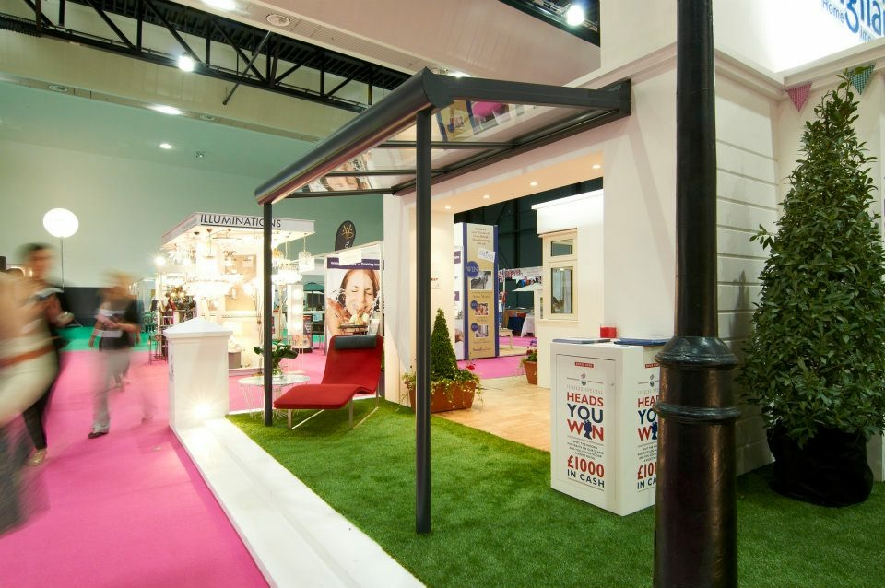
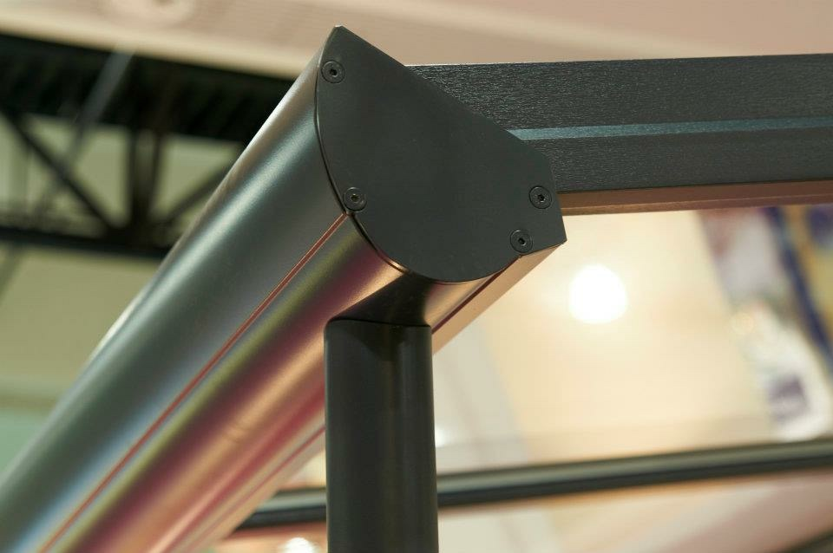

Size of proposal: The proposed unit size will only project 4.0m and have a width
of 3.0m.

Landscaping: Our proposal will not require the alteration of the rear garden in any form, we will not be required to remove or cut back any hedges or trees on the site. Our proposal will not affect the amenities of the site or the surrounding area and will go hardly noticed

