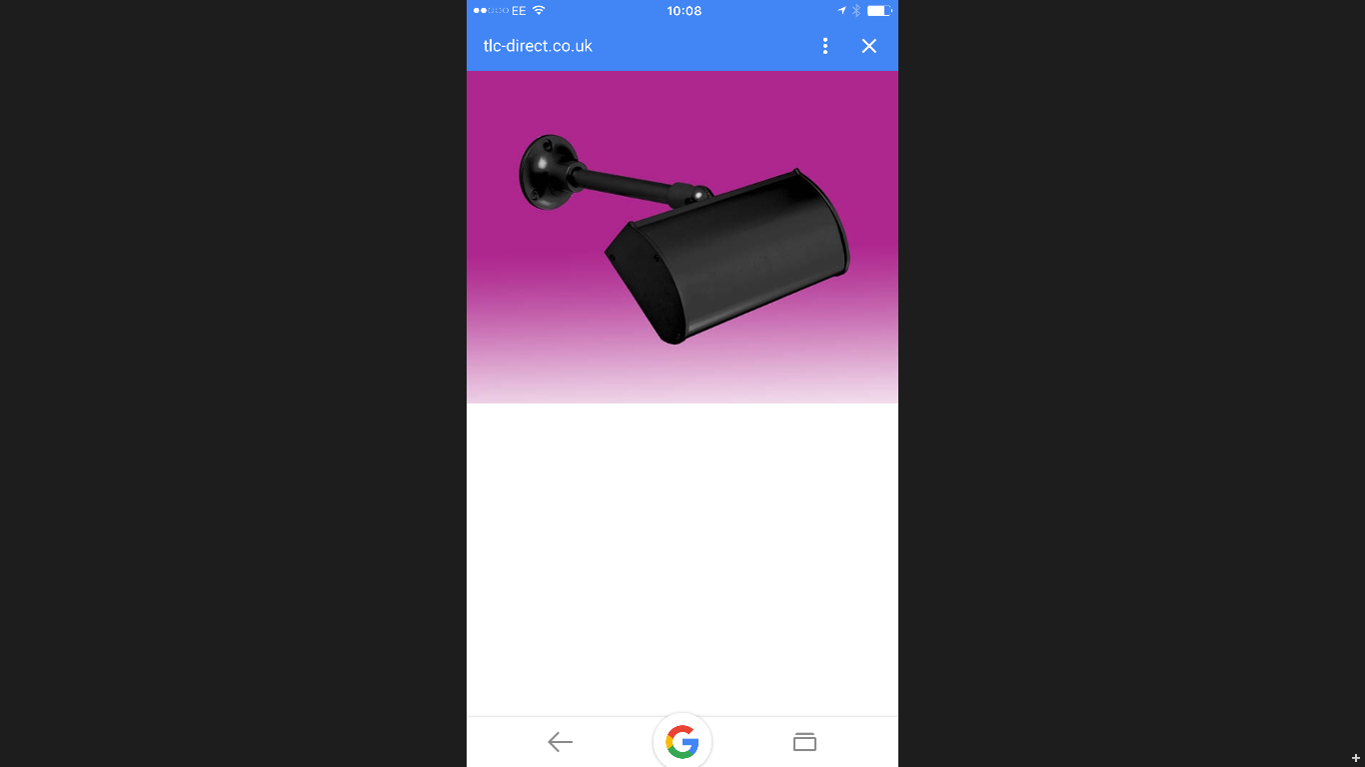

It is led which requires zero maintenance, is IP44 rated for outdoor use, low energy consumption and has a life span of 50,000 hours. It projects 340mm and is 260mm wide.