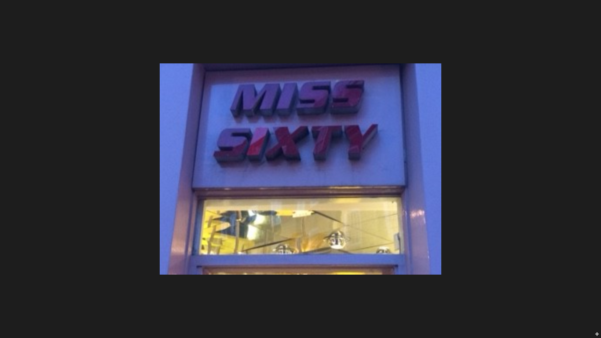

Covent jpg

Miss Sixty logo currently fitted to be replaced:

Dimensions:

H 15cm x L 88cm x D 12cm

With internal light

New sign Miss Sixty logo to be fitted:

New Dimensions:

H 15cm x L88cm x D 3cm

New external light to be fitted