- Listing
- Search the List
- List Entry
- Section Navigation
  - Minor Amendments
  - Download Designation Data
  - Non-Listed Sites

1 AND 3, FLASK WALK

List Entry Summary
This building is listed under the Planning (Listed Buildings and Conservation Areas) Act 1990 as amended for its special architectural or historic interest.
Name: 1 AND 3, FLASK WALK
List entry Number: 1322186

Location
1 AND 3, FLASK WALK
The building may lie within the boundary of more than one authority.
County: Greater London Authority
District: Camden
District Type: London Borough
Parish:
National Park: Not applicable to this List entry.
Grade: II
Date first listed: 14-May-1974
Date of most recent amendment: Not applicable to this List entry.

Legacy System Information
The contents of this record have been generated from a legacy data system.
Legacy System: LBS
UID: 477312

Asset Groupings
This list entry does not comprise part of an Asset Grouping. Asset Groupings are not part of the official record but are added later for information.

List entry Description

Summary of Building
Legacy Record - This information may be included in the List Entry Details.

Reasons for Designation
Legacy Record - This information may be included in the List Entry Details.

History
Legacy Record - This information may be included in the List Entry Details.

Details
CAMDEN
TQ2685NW FLASK WALK 798-1/26/459 (North side) 14/05/74 Nos.1 AND 3
GV II
Pair of terraced cottages with later shops. No.1: early C18, altered and refronted mid C20. Painted brick. Tiled roof with dormer; noted to retain original roof timbers. 2 storeys and attic. 2 windows plus recessed entrance bay. Early C19 wooden shopfront with C20 fascia and slightly splayed window with some original glazing bars. 1st floor has recessed sashes. Parapet. No.3: early C18, altered. Stuccoed front with 'S' tie plate; rear timber framed with weatherboarding. Slated mansard roof with dormer. 2 storeys and attic. 2 windows. Reproduction C19 wooden shopfront. 1st floor has flush framed sashes with exposed boxing. Parapet. INTERIORS: not inspected.
Listing NGR: TQ2642285753

Selected Sources
Legacy Record - This information may be included in the List Entry Details
National Grid Reference: TQ 26425 85753

Map
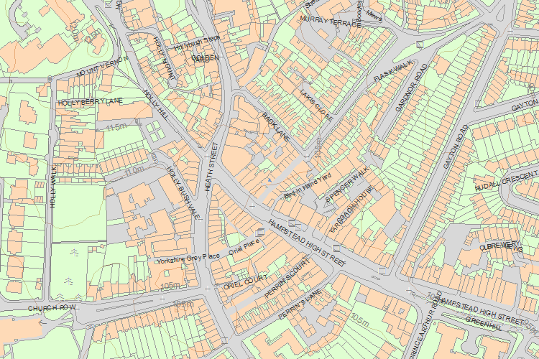© Crown Copyright and database right 2016. All rights reserved. Ordnance Survey Licence number 100024900.
© British Crown and SeaZone Solutions Limited 2016. All rights reserved. Licence number 102006.006.
The above map is for quick reference purposes only and may not be to scale. For a copy of the full scale map, please see the attached PDF - 1322186 .pdf
The PDF will be generated from our live systems and may take a few minutes to download depending on how busy our servers are. We apologise for this delay.
This copy shows the entry on 11-Jan-2016 at 02:35:10.
Share

- About us
- Contact us
- Jobs
- Newsletter
- Heritage Calling Blog
- Accessibility
- Terms & Conditions
- Google+

