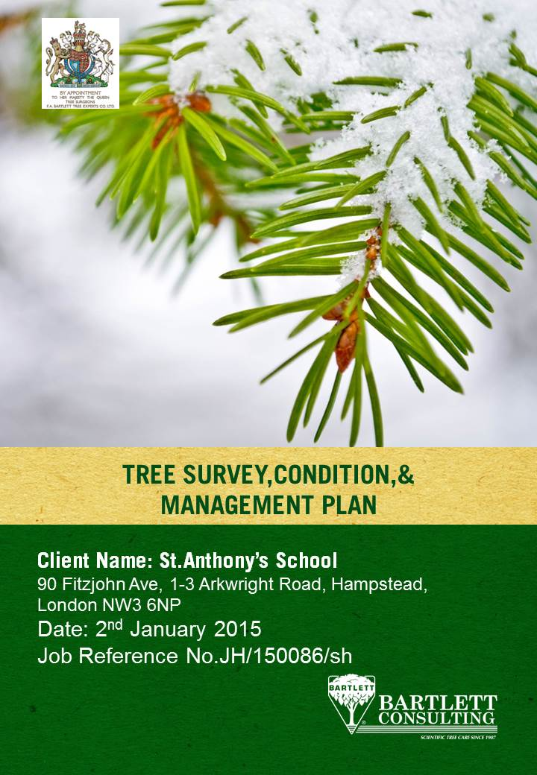

TREE SURVEY, CONDITION AND MANAGEMENT PLAN

OUR REF: JH/150086/R/sh

YOUR REF: N/A

DATE: 2nd January 2015

CLIENT: Sarah Anderson
St. Anthony’s Preparatory School

SITE ADDRESS: 90 Fitzjohn’s Avenue

1 & 3 Arkwright Road
Hampstead
London
NW3 6NP

DATE/TIME OF VISIT: 10:00 December 16th 2014

PEOPLE PRESENT: Mr. Jason C Hasaka
Mr. Steve [INSERT] St. Anthony’s School

REPORT COMPLETED BY: Mr. Jason C Hasaka

SUMMARY

An initial tree survey, including a condition report and management plan, was undertaken by Mr. Andrew Potter of Bartlett Consulting, dated April 2011. A subsequent further detailed PICUS report on Beech tree T248 was provided dated June 2011. The information contained within this current report is resultant of a standard three year resurvey to reassess the trees under the ownership of St. Anthony’s School.

A total of 10 individual trees and 01 group of trees were subject to the survey, within the three properties which constitute St. Anthony’s School: 90 Fitzjohn’s Avenue and 1 & 3 Arkwright Road.

Overall, the tree stock is considered to be of a health and vigour which is only ‘fair’, and a structural form which is ‘less than adequate’. Some trees are completely surrounded by hard surfaced areas whilst others are enclosed by built structures that are having an impact on water and oxygen availability and most of the trees have structural weaknesses and defects resulting from natural and man-made causes.

A number of management options have been recommended to help St. Anthony’s School to continue to act as responsible tree owners and to improve the arboricultural benefits of their trees for the future.

1.0 SCOPE OF REPORT

1.1 Survey Brief

To inspect the trees within the ownership of St. Anthony’s School and assess their condition, describe their features, and make suitable management recommendations in accordance with sound tree health care practices and management techniques.

The trees are located within the boundaries of three individual properties owned and managed by the School: 90 Fitzjohn’s Avenue, and 1 & 3 Arkwright Road.

1.2 Background

An initial tree survey and condition report written in 2011 by Bartlett Consulting, recommended and prioritised a number of tree management operations, including internal decay detection (PICUS) of Beech T248.

It would appear that a number of the high priority tree pruning works have since been completed, as has been the PICUS test of Beech T248 – both which will be discussed in more detail below.

It has been three years since the initial site visit and tree assessment and therefore a full re-survey of the tree stock has been commissioned so that St. Anthony’s School have an up-to-date assessment of their tree stock; its health and condition; and what risks (if any) these trees pose.

1.3 Report References

As a progressive company, we keep abreast of research data relating to arboriculture. All observations, recommendations and works are based on current industry standard reference material and extensive FA Bartlett research findings derived from the company’s own facilities at the University of Reading in England, as well as in Charlotte, North Carolina, in the USA. A selection of pertinent items is shown in Appendix 2.

All of the trees subject to the survey and contents of this report have been plotted accurately on the two Tree Location Plans referenced in Appendix 1 at the end of this report.

1.4 Report Limitations

This report is restricted to those trees shown on the attached Tree Location Plans and described in the tree survey schedule. The statements, findings, and recommendations made within the report do not take into account any effects of extreme climate and weather incidences; vandalism; changes in the natural and built environment around the trees after the date of this report; any damage whether physical, chemical or otherwise.

Bartlett Consulting cannot accept any liability in connection with the above factors nor where recommended tree management is not carried out in accordance with modern tree health care techniques, within the timelines proposed.

The trees were not climbed at the time of the tree survey. Tree dimensions were recorded using hand tools such as a diameter tape, laser range finder, and measuring tape. A “sounding hammer” and binoculars, as well as other tools were used to assess trees in more detail where necessary; and species identification, as well as age range and vigour were entered within the tree details.

All tree information and data was captured using Pear Technology tree management software; the trees were plotted using GPS on an Ordnance Survey base map using a Trimble hand-held computer. This combination of technology has resulted in the production of the two (02) Tree Location Plans found at the end of this report. The tree dimensions are accurate as captured on the day.

A basic tree risk assessment and tree health inspection were conducted on each tree identified in the “Survey Brief”. A basic assessment as described by the International Society of Arboriculture (ISA) is: a detailed visual inspection of a tree and surrounding site that may include the use of simple tools. It requires that a tree risk assessor walk completely around the tree trunk looking at the site, aboveground roots, trunk and branches.

Further guidance and tree survey methodologies followed by Bartlett Consulting include:

∙ ISA “Best Management Practice – Tree Risk Assessment” (Smiley, Matheny and Lilly 2011)
∙ F.A. Bartlett ‘Tree Risk Management’ (Smiley, Fraedrich, Hendrickson 2002)
∙ ‘Principles of Tree Hazard Assessment & Management’ (HMSO Lonsdale 1999)
∙ ‘Arboriculture’ 4th Edition (Harris, Clark and Matheny 2004)

It is important to understand that as trees are living and dynamic organisms, it is not possible to maintain them free of risk. Some level of risk must be accepted in order to experience the full range of benefits that trees provide. As such we reference the recently published document by the National Tree Safety Group (NTSG), Common sense risk management of trees (Forestry Commission 2011). This document provides guidance on trees and public safety in the UK for owners’ managers and advisors.

1.5 Carbon Sequestration Profile

Trees will have a high or low ability to take in and lock up gaseous carbon, within their structures, which is dependent on their age and species.

The 2011 report determined that “….trees T246, T248, T249 and T251 have grown beyond the stage at which they are net absorbers of CO₂ from the atmosphere. Their principal function now is as a long-term store for the carbon sequestered during their lifecycle and currently stored in their crowns, trunks and root systems.”

This statement still remains relevant today.

2.0 TREE PRESERVAITON & CONSERVATION AREA STATUS

2.1Tree Preservation Order

None of the trees subject to this report are covered by a tree preservation order.

2.2 Conservation Area

All of the trees subject to this report are within Camden Council ‘Fitzjohn and Netherall’ Conservation Area.

When dealing with trees in a Conservation Area, all trees with a stem diameter greater than 75mm are subject to the statutory protection afforded them by the Town & Country Planning Act (Tree Preservation) (England) Regulations 2012.

2.3 Tree Management Implications

The removal of dead trees and the pruning of dead wood from living trees are permitted and “exempted” works under the 2012 Regulation listed above. These works can be undertaken only after 5 working days’ notice has been given to the local planning authority.

All other tree works must first be consented by the local planning authority following the submission of a formal Section 211 Conservation Area Notification. When received by Camden Council, they can either raise ‘no objections’ to the specified works or ‘object’. If the later: either the tree works specification can be amended to reach a mutual agreement; or the local authority will make a specific tree preservation order.

Bartlett Consulting would be happy to submit the Section 211 Notification on the School’s behalf, using this report as supporting evidence, should you wish to proceed with any of the works arising from this survey.

3.0 GENERAL SITE DETAILS

3.1 Weather Conditions at Time of Survey

The weather at the time of the survey was cold but clear and dry; there was no significant breeze.

3.2 Site Location

Fitzjohn’s Avenue is a main arterial road running in a north/south direction through Hampstead – also classified as the B511. Arkwright Road forms a T-junction with Fitzjohn’s Avenue immediately outside St. Anthony’s School to the west. Both are very busy public roads.

The immediate area is a high density mixture of residential housing and public and private buildings.

3.3 Local Landscape Evaluation

Hampstead is an incredibly green London borough and the areas around Fitzjohn’s Avenue and Arkwright Road are no different. There are a number of mature street trees and the individual gardens contain large mature trees as well as smaller woody deciduous and evergreen plants.

The trees subject to this survey are an integral part of the wider landscape, and tree T248 is a prominent landscape tree with high public visibility and amenity value. Trees T249 and T251 although slightly hidden by the surrounding buildings are also of public visibility and amenity value.

The other trees subject to this report provide a level of screening, and to some extent security, between the School buildings and neighbouring properties.

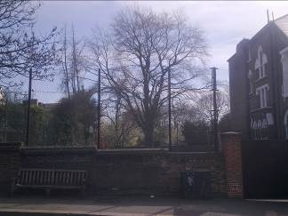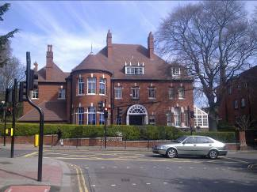
Figure 1 & 2: View of T248 from Arkwright Road; View of 90 Fitzjohn’s Avenue from Arkwright Road

3.4 Underlying Soils

Using the British Geological Survey’s ‘Geology of Britain’ viewer (www.bgs.ac.uk) it has been determined that the underlying geology is “Claygate Member – Clay, Silt, and Sand”

Using the National Soil Resources Institute’s ‘Soilscape Viewer’ (www.landis.org.uk/soilscapes/) it has been determined that the underlying soils are “acidic but base-rich loamy and clay soils”

3.5 Grounds

The grounds are a mixture of two dominating features:

90 Fitzjohn’s Avenue is all impervious hard surfacing, whilst the trees of 1 & 3 Arkwright Avenue (with the exception of T248 also in hard surfacing) are found within either open lawn or small areas of soil confined by buildings.

3.6 Slopes and Boundaries

There are slight level undulations across all the sites:

90 Fitzjohn’s Avenue has a gentle slope downwards across the site, from northeast to southwest.

1 Arkwright Road is level with the exception of the area where trees T245 – T247 are located. These trees are on a sharp downward slope from the boundary to the building in a northeast to southwest direction.

The garden of 3 Arkwright road is level.

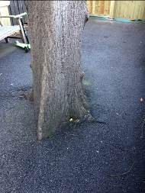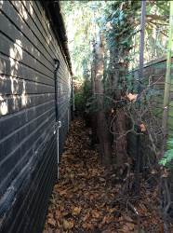

Figure 3 & 4: Lime (T249) surrounded by hard surfacing and Yew (G243) in soils between building & fencing

3.7 Assessment of Ecological Status of Site & Potential Constraints

Following our survey of the site, and analysis of climax and sub climax vegetation, we are of the opinion that the site is likely to provide a habitat for some protected species which may include birds and smaller mammals. The key areas will be within the crowns of the Beech and Yew trees, as well as the area behind the detached school building of 1 Arkwright Road.

The Wildlife and Countryside Act 1981, as amended by the Countryside and Rights of Way Act 2000, provides statutory protection to birds, bats, insects and other species that inhabit trees, hedgerows, or other associated vegetation.

These could impose significant constraints on the use, management and development of these areas, as well as the timing of tree works. The finer points of these matters are beyond Bartlett Consulting’s area of expertise and you must seek advice from an ecologist to check if any such constraints apply to this site, where we identify any such potential habitat.

3.8 Soil Tests

Soil samples were not taken.

3.9 Fluorimeter Tests

A fluorimeter test evaluates the ability of the chlorophyll in tree leaves to turn sunlight into energy (sugars). The physiological condition of a tree and, to some degree, its life expectancy can be assessed. This measure can prove scientific, non-bias measurement to assist in making tree management decisions.

Fluorimeter testing has been recommended on the following trees: Sycamore (T251); Lime (T249); Beech (T248); and Yew (G243) to fully assess their health and vigour.

The first two trees are surrounded by impervious hard surfacing, and although a visual assessment shows good bud proliferation throughout the crown, this is not a detailed and scientific assessment of their health and vigour to the level provided by a Fluorimeter.

4.0 FUNGAL, DISEASE, OR INSECT PATHOGENS

Nothing of any note or concern was identified at the time of the site visit and tree survey.

5.0 DISCUSSION AND GENERAL OVERVIEW

5.1 90 Fitzjohn’s Avenue

The two trees within this site are both enclosed by impervious hard surfacing that reduces the oxygen available in the soils for the roots and prevents water from percolating to the root system. Unless there are leaking, underground services that are being exploited by the trees, it is considered that both these trees are under some level of resulting stress.

The Lime tree (T249) is managed as a pollard and has several open wounds and decay cavities along the trunk, resulting from previous pruning operations. The regular removal of leaf area will reduce the tree’s photosynthetic capacity and in turn will reduce the available energies the tree has to close these wounds and defend against internal decay. Combined with the inhospitable surrounding environment as discussed above, the tree will be even more compromised and hard pressed to fully support itself.

The Sycamore tree (T251) has tree root damage with some visible incipient wood decay, as well as the partially included main stem union. The damage root has good wound-wood that is occluding the open cavity so the decay itself is not considered significant enough to be of current concern. Given the number of targets around the Sycamore, the included union is the primary consideration. At the moment, the tree is still young and not fully developed so it can be managed sympathetically to address this defect.

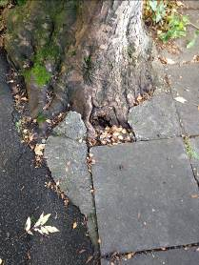

Figure 5: Image of Root Damage with Wood Decay

5.2 1 Arkwright Road

Beech (T248) is the principle and most important tree on this site.

A PICUS test was carried out in June 2011, and the conclusion was that the internal timber structure was in adequate condition, and that in the limited areas where there was some natural degradation of the woody tissue, the strength values were no lower than 71% (out of 100%). Please see PICUS image reproduced below.

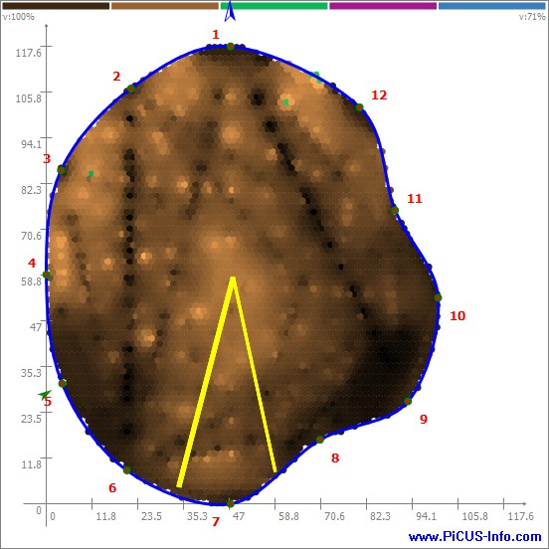

Secondary recommendations from the 2011 report included the removal of the girding root as well as removing the tarmac touching the trunk of the tree and replacing with mulch. Also the soil under the exposed tarmac was de-compacted and ameliorated.

At the time of my visit in December 2014 the girdling root was still present but the tarmac had been removed and replaced with a resin bound shingle (see photograph below). Looking through the report history it could not be confirmed is the soil amendments were completed.

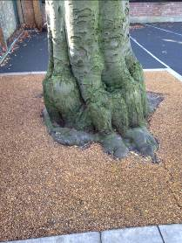

Figure 6: Image of Beech

Although the tarmac touching the trunk of the tree has been removed, over 90% of the rooting area is still enclosed by hard surfacing and it is expected that the Beech will still be experiencing the same lack of oxygen and water availability to the root system, as per the two trees above.

Given the size, stature, and importance of the tree in the landscape, as well as the high value targets that are within striking distance of the tree, a final detailed assessment using the Fluorimeter (in combination with the already completed PICUS) will give us a complete, detailed, and scientific picture of the health and structure of the tree. This will enable us to make fully informed future management recommendations.

Depending on the results of the Fluorimeter, a better specification of soil amendments and tree health care practices can be specified. A review of the recommendation to prune and remove the girdling root can also be undertaken following the Fluorimeter test, as if the tree is under stress, removal of such a large root would not be recommended.

Trees T245 – T247 are of value for their role as a screen between properties. However all have either an intrinsic structural weakness or concern resulting from damage or decay. These trees are of low public visibility and amenity value and various forms of tree management are recommended to reduce and/or remove the identified hazard and risk.

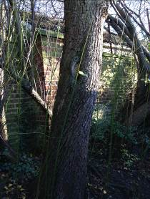

Figure 7: Image of Pear Showing Wounding & Twisting of Trunk

Yew trees G243 are of reasonable structural condition considering their growing environment and location. They will continue to be suppressed by the larger trees in the neighbouring garden. However their value as a screen will not be adversely affected by this fact. Some light pruning has been recommended to improve the form and structure of these trees and reduce the conflict with the neighbouring trees.

5.3 3 Arkwright Road

This is a residential domestic garden and property and not yet ‘converted’ to a school.

The two Cherry trees (T01 and T03) are of low value and limited safe useful life expectancy.

The nicest tree is the Birch (T02) and through some sympathetic and proactive pruning, can improve and enhance its form, structure, and safe useful life expectancy. This tree, although in a rear garden, has many positive amenity and aesthetic values and should be retained and managed positively.

5.4 Conclusions

Overall, the tree stock is considered to be of a health and vigour that is only ‘fair’, and a structural form that is ‘less than adequate’. Some trees are completely surrounded by hard surfaced areas, whilst others are enclosed by built structures that are having an impact on the water and oxygen availability. Most of the trees have structural weaknesses and defects resulting from natural and man-made causes.
Some further detailed investigations have been recommended to fully assess and understand tree health and vigour and a number of management options have been recommended as well in order to reduce and remove hazards and for the arboricultural benefit of the trees.

6.0 RECOMMENDATIONS

6.1 Fluorimeter Testing

Three trees have been recommended for Fluorimeter testing: Sycamore T251; Beech T248; and Yew G243.

This will give a scientific and detailed understanding of tree health, vigour and vitality better than the visual assessment. With this knowledge, we can understand how the growing environment is affecting tree health and make better informed management decisions and recommendations to improve and/or maintain the trees’ health.
This testing is non-invasive and gives immediate results that can be easily read and interpreted.

6.2 Pruning Works

A number of tree management options and recommendations have been specified in the table below. The pruning is described here for clarity and a fuller understanding by St. Anthony’s School as well as Camden Council should a Section 211 Notification be submitted.

All tree works unless otherwise specified to be carried out to British Standard 3998:2010

Crown Cleaning – the removal of deadwood (of all sizes) throughout the tree crown; broken and hanging branches to be removed and safely excised from the crown; stubs and ripped branches to be removed back to the branch bark collar or reduced back to substantial lateral growth; branches exhibiting any disease; branches with structural weakness such as vertical or horizontal cracking.

Formative Pruning – removal of crossing and rubbing branches to prevent further damage; removal of secondary branches with vertical growth; removal of branches growing internally; reduction in length of branches with included branch unions; reduction back to lateral growth of branches competing for apical dominance; removing selective branches to improve and increase branch spacing. This does not include major crown reduction and reshaping works.

Pollarding – heading cuts will be made out on the primary or scaffold limbs, instead of at the trunk where the primary scaffold limbs originate. The end result is a tree that retains more of the overall branching structure.

Coppicing – works should be carried out to industry standards and best practice using guides and books on the subject produced by English Nature, Forestry Commission and individual authors such as Coppiced Woodlands by Fuller & Warren; and Ecology and Management of Coppice Woodland by G.P. Buckley.

∙ When re-coppicing, all the live growth will be removed from the trees, retaining small stumps approximately 6 inches in height, and no more, above ground level.

∙ When coppicing trees for the first time, if the tree is of a species likely to re-sprout profusely and vigorously, the tree can be removed to ground level - such as Sycamore. Other species may need a stump to be retained to help encourage regrowth.

6.3.1 All of the above works are in accordance with good tree management and current Arboricultural practice and tree health care. The pruning works will not be of detriment to the health or condition of the trees; nor will the works be of detriment to the public amenity and landscape.

The tree works are to reduce and remove hazards and risk to buildings and persons within the target zone; or to improve tree health and structural condition for long-term benefit. All trees will require re-assessment within three years unless specified otherwise within the schedule below. Once the Fluorimeter testing has been completed, additional pruning may be recommended for those three trees.

Interpretations of Risk | (As per Smiley, Fraedrich & Hendrickson 2002)
Critical Risk | Failure imminent – damage to person and/or property inevitable.
High Risk | Failure likely especially during storms – damage to person and/or property likely.
Moderate Risk | Failure possible during severe storms – damage to person and/or property possible.
Low Risk | Failure unlikely – damage to person and/or property damage unlikely.
Dismantling/surgery risk | Weakened crown anchor points possible. Will require full RA prior to tree works

NB: CLIENTS MUST MAKE TREE WORKERS AWARE OF THIS STATEMENT

CAUTION: Trees with structurally weak main stem or branches may not have sufficient strength to withstand dismantling works. The weight of people climbing the tree or using the tree branches as load carrying points may increase the load to the point of tree or branch failure. Persons engaged on such works must undertake a thorough risk assessment of the tree structure before finalising a working method. Alternative work methods to consider may include the use of crane or mobile elevated platform.

Tree works recorded are to the specifications suggested in British Standard BS3998:2010 Tree Works – Recommendations. All works should be carried out by a properly and fully insured tree surgeon, approved under the Arboricultural Association’s Approved Contractor’s scheme.

TREE SURVEY, CONDITION AND MANAGEMENT REPORT

Client: St. Anthony’s School, 90 Fitzjohn’s Avenue, Hampstead NW3 6NP Report No: JH/150086/R/sh
Completed by: Jason Hasaka
Trees Tagged: Yes Weather: Cold / Still / Clear / Dry
Site: St Anthony’s School Buildings – 90 Fitzjohn’s Avenue and 1 & 3 Arkwright Road Date of Survey: December 16th 2014

Timescale for Works

ASAP – 6 months | 1 Year | 2 Years | 3-4 Years | 5 Years

Tree No. | Location | Species | DBH (mm) | Ht (m) | Crown  Spread  (m) | Age | Vig. | Condition | Works Required | Time Scale (yrs) | Life Expectancy (yrs) | Risk Factor | PRICE
T251 | Rear of 90 Fitzjohn’s Avenue building, in northeast corner | Sycamore | 595 | 12 | 7.5 | M | Good | Moderate:  ∙ Pronounced root flare and buttress especially  around north-eastern area.  ∙ Old root damage to exposed roots and root  flares around south-western area.  ∙ Some decay of exposed woody tissue but no  fruiting brackets visible.  ∙ Tree is twin stem from 1.5m above ground.  ∙ Union shows included bark along north-  eastern side of union.  ∙ Crown with asymmetrical growth habit  towards east due to competition.  ∙ Upper crown adequate structural condition.  ∙ Tree is surrounded by hard surfacing with  driveway to northwest and paving stones to  southwest and southeast. | ∙ Crown clean  ∙ Formative prune  ∙ Fluorimeter testing | Two Years  Six  Months | 20 | Moderate | £400.00  _______  £200.00  Each test. However if you have all three required in this report the cost is £350.00  for three
T249 | Along eastern flank of 90 Fitzjohn’s Avenue building, 1m from boundary wall and 2m from building | Lime | 675 | 11 | 3 | M | Fair | Moderate:  ∙ Located entirely in area of hard surfacing  with tarmac touching trunk.  ∙ Minimal root flare visible above tarmac.  ∙ Tree is an established pollard with both  knuckles and boles appearing in reasonable  condition with no large cavities or decay  visible.  ∙ Old pruning wounds occluding at  approximately 2.5m above ground level on  south-eastern side of trunk.  ∙ A decay pocket is visible at this point.  ∙ Old scaffold limb over neighbouring property  to east removed historically.  ∙ Wound is occluding but internal decay visible. | ∙ Continue to manage as pollard on 3-5  year cycle depending on rate of growth  ∙ Consider removing tarmac immediately  around base of tree. | Three years | 10 | Moderate | £400.00  _______
T248 | Southeast edge of netball court, 1 Arkwright Road building. | Beech | 840 | 13 | 10 | M | Good | Good:  ∙ Pronounced bottle butt first 0.8m of trunk  growth from ground level.  ∙ Either the result of internal decay or adaptive  growth due to confined rooting environment.  ∙ PICUS carried out previously and no internal  decay suggested through use of sounding  hammer  ∙ Heavily crown lifted in past & wounds all  closed.  ∙ Single leader tree with multiple scaffold limbs.  ∙ Adequate structural condition.  ∙ No major past pruning operations.  ∙ Tree is surrounded by hard surfacing and resin  bound shingle stone, with 2m between trunk &  wall on eastern side. | ∙ Fluorimeter testing | Six  Months | 20 | Moderate | £200.00  Each test. However if you have all three required in this report the cost is £350.00  for three
T247 | Rear of detached classroom building, northeast boundary 1 Arkwright Road building. | Laburnum | 200  130 | 8 | 6 | EM | Good | Moderate:  ∙ Twin stem from ground level.  ∙ Both stems with damage at base.  ∙ Decay and dead tissue present.  ∙ Both stems with growth habit towards west  over building  ∙ Suppressed tree due to larger trees behind.  ∙ Growing on sharp downslope approximately  2.5m between tree and building. | ∙ Option 1: coppice at ground level  ∙ | One  Year | 10 | High | £300.00
T246 | As tree T247 | Pear | 490 | 10 | 7 | EM | Good | Moderate:  ∙ Pronounced root flare and surface rooting due  to slope and general growing environment.  ∙ Natural twist in trunk.  ∙ 3 old pruning wounds approximately 170mm  across with wound wood present.  ∙ Sounding indicated some internal degradation  of wood.  ∙ Possible internal cracking corresponding to  twisting of trunk.  ∙ Single leader tree with crown in adequate  structural condition.  ∙ Broken and hanging branches. | ∙ Crown clean  ∙ Formative prune | One  Year | 10 – 20 | Moderate | £300.00
T245 | As tree T247 | Willow | 245  240 | 6 | 4 | M | Good | Moderate:  ∙ Twin stem from ground level.  ∙ Several smaller stems removed in past.  ∙ Visible and pronounced surface rooting due to  slope and growing environment.  ∙ Main stems fusing together.  ∙ Crossing branches in upper crown.  ∙ Previously lopped over building.  ∙ Crown growing through boundary fence to  east. | ∙ Option 1: coppice at ground level  ∙ | One  Year | < 10 | Moderate | £300.00
G243 | Rear of swimming pool along southeast boundary 1 Arkwright Road building. | Yew (x04)  Lawson Cypress (x01) | 260  130  130  175  175 | 6 | 4 | SM | Fair  Dead | Moderate:  ∙ Group spans 7m in length along boundary.  ∙ Tree trunks are approximately 0.5m from  both boundary fence and building.  ∙ Yew trees are both single and twin stem trees.  ∙ Suppressed with asymmetrical crown due to  competition from neighbouring garden trees.  ∙ Crossing branches within crowns.  ∙ Trees have value as low screen. | ∙ Formative prune  ∙ Remove dead tree  ∙ Fluorimeter testing | Six  Months | 20 | Low | £450.00  _______  £200.00 each test or £350.00 for three test required in report
T240 | Side of swimming pool along southwest boundary 1 Arkwright Road building. | Magnolia | 200 | 4 | 3.5 | EM | Good | Moderate:  ∙ Single stem.  ∙ Large pruning wound at base which is  occluding but decay is present.  ∙ Entire trunk growth habit is horizontal in  northwest direction.  ∙ Vertical epicormic growth from trunk.  ∙ Crown lopped over pool building. | ∙ Coppice | One  Year | 10 | Low | £200.00
T01 | Rear of 3 Arkwright Road | Wild Cherry | 265 | 4 | 4 | EM | Fair | Moderate:  ∙ Boundary wall approximately 0.5m to west.  ∙ Heavily compacted root zone from garden  entrance running immediately east of tree.  ∙ Single stem with co-dominant leaders  ∙ Reasonable union  ∙ Southern leader lopped back to boundary.  ∙ Low quality tree. | ∙ Remove | Three  Years | < 10 | Moderate | GONE
T02 | Rear of 3 Arkwright Road | Paper Birch | 205 | 6 | 5.5 | Y | Good | Moderate:  ∙ Single stem with co-dominant leaders at 1.5m  above ground level.  ∙ Included bark at union.  ∙ Multiple secondary leaders and scaffold limbs.  ∙ Very dense crown. | ∙ Formative prune  ∙ To include reduction work to establish  apical dominance and reduce leverage  on unions by 10%  ∙ Crown thin 10% | One  Year | 20 – 40 | Moderate | £300.00
T03 | Rear garden 3 Arkwright Road | Bird Cherry | 150 | 4 | 3 | Y | Good | Moderate:  ∙ Untypical root flare – difficult to describe  but resembling nursery grafting.  ∙ Tree is slightly loose in ground with visible  movement of surrounding soils.  ∙ Tree is single stem and single leader.  ∙ Crossing & rubbing branches with some  starting to grow together. | ∙ Formative prune  ∙ Monitor concentrating on basal  stability | Three  Years | 20 | Low | £100.00

Tree No – tree reference on Tree Location Plan and /or tree tags where used. Species – tree species giving English common name. DBH – the individual trunk diameter when measured at 1.5m above ground. Ht – tree height recorded in metres. Crown Spread - crown spread as average using one radial spread. Age - recorded as Y (young) recently planted; SM (semi-mature) within first 1/3 life; EM (early-mature) within middle 1/3 of life; M (mature) fully developed and grown; OM (over-mature) is exceptional age for species. Vigour – an assessment of the health physiological condition of the tree. Condition – is reference to structural observations of the tree as a whole and individual parts. Time Scale – period in which recommended management should be completed. Life Expectancy – assessment of safe useful life expectancy or estimated remaining contribution expressed in years. Risk – as per table found on Page 10 of report.

.

REPORT CLASSIFICATION: Tree Survey, Condition & Management Report

REPORT STATUS: Completed

REPORT COMPLETED BY: Mr. Jason Hasaka
Arboricultural Consultant



SIGNATURE: CONSULTANT DATE: 29.12.14

REPORT REVIEWED BY: Mr. Jason Mills
Arboricultural Consultant

SIGNATURE: 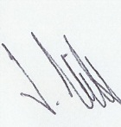 CONSULTANT DATE: 02.01.15

