Design, Heritage & Access Statement
E015847 – Costcutters, 100 Charlton Street, London, NW1 1ES

This Design and Access Statement has been prepared on behalf of Cashzone in support of an application submitted for:

The retention of an Automated Teller Machine, illuminated ATM fascia and top sign

We have consulted Circular 01/2006 in preparing the installation.
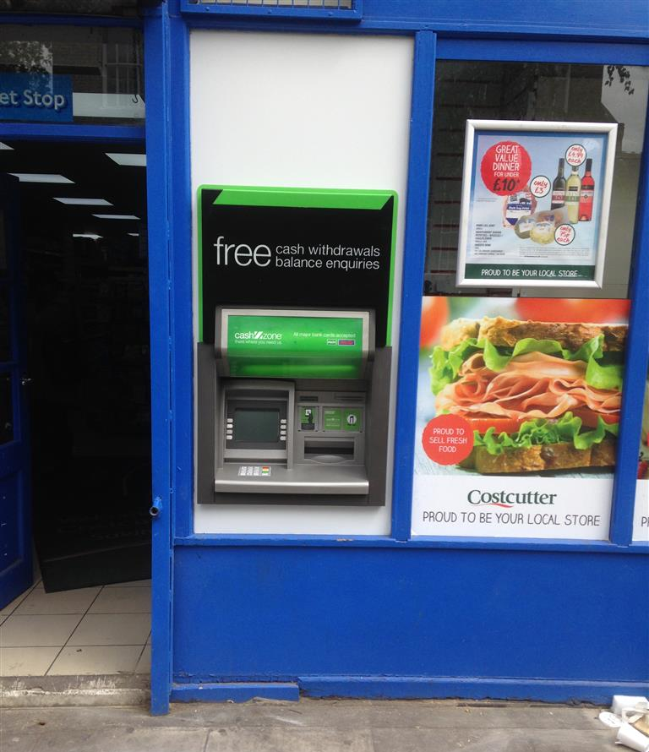

Appearance

The site is a located through an existing window of Costcutters convenience store located on Chorlton Street, London which is a grade II listed building. The immediate area is mainly commercial with nearby residential properties however we consider that the installation of this ATM is not detrimental to them. The site is not within a conservation area however the building is listed. Although an ATM is a modern feature we have tried to keep the design as sympathetic to the features of the Listed Building.

Unfortunately we have installed this ATM before we have obtained the relevant planning permissions. The receipt bin which was installed has now been removed from the revised drawings submitted in relation to this application and will be removed from the site.

Heritage statement

Our site is located within the Chamberlain house block on Charlton Street which is part of the Ossulston Estate located in Somers Town which was first listed on 13 December 1996. Chamberlain house was a pioneering interwar council housing project and is regarded by Historic England as ‘the most important inner city estate if the inter-war period’. The site compromises two neighbouring shop units on the corner of Charlton Street and Phoenix road. Originally each shop front had a low wall with large windows above, topped by a row of small windows. The masonry façade between and above each shopfront was entirely plain forming a continuous basement that projected slightly in front of the residential storeys above. It was influenced by Viennese housing models and was innovative in terms of layout and elevation. 100 Charlton Street has frontages on both streets with a door on each façade. The original frontage has changed over the recent decades, these changes include:

- The doors in the masonry façade have been blocked up
- Modern fascia’s have been fixed onto the masonry parapet above the shopfronts
- Metal shutters have been fitted to some of the windows and doors
- Several projecting signs have been fixed to the masonry façade
- Holes have been cut into the Phoenix road window to vent the plant inside.

The ATM has been installed through existing glazing to minimise design impact and a small top sign was added to avoid cluttering the façade. The ATM provides localised benefits and although a modern addition, it enhances the special interest of the building.

Use

The purpose of the installation of this Automated Teller Machine is to provide a 24 hour banking facility for the local community and visitors to the area.

Scale

N/A

Layout

The installation of the ATM has not altered the basic design of the building. We have removed an existing glazing panel. In the remaining void we have installed (a new mullion and smaller glazing panel) an external security wall (see NW0207 External security wall construction in attachments) with a laminate finish. The colour of this panel is white, which was chosen to best blend with the existing shop front design.

Amount

This is not a new structure, but the installation of an ATM in an existing shop.

Landscaping

This is not relevant as the installation does not require it.

Design Principals

The ATM is of standard design as located in many areas throughout the UK and is accepted as a necessary facility. There are a number of mandatory standards which apply, relating to the position of the ATM, it’s visibility, ambient lighting, building structure, building security features, ATM anchoring, safe strength.

Designing out Crime

We install and anchor the ATMs in accordance with National Guidelines.

Site approval by the Cash In Transit Company has been obtained. They have considered routes to and from the ATM, ensuring there is protection of their staff and of any staff or customers at the site. Paramount in their review has been the welfare of their staff and the persons they come into contact with.

The area where the ATM has been installed is a well-lit area in full view of pedestrians aiding natural surveillance.

We will supply and fit CCTV which includes 1 x dome camera, recording and monitoring equipment.

Access

The access to the site and other properties has not been affected.

In designing this application, we have taken into account the needs of able and disabled users. The ATM is set at a height that makes it accessible for all users and has space to the front for a wheel chair.
Key 5 has raised markings for blind persons to identify the centre key.

Car parking availability has been considered: Parking is available roughly 50m from the shop

