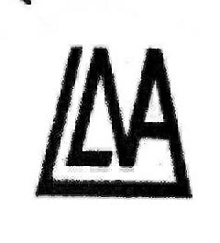
THE LINDFIELD-LANGLAND
NEIGHBOURHOOD ASSOCIATION
(incorporates Lindfield/Langland Gardens,
Langland Mansions & Arkwright Rd below Frognal)

c/o Flat 5, 15 Lindfield Gardens London NW3 6PX

14th November 2015

Dear Mr Gracie,

REF Planning Application 2015/3619/P

I write again on behalf of LLNA to comment on the new drawings which have been submitted on this application.

There is still no Design and Access Statement, demonstrating lack of consideration for neighbours and the Conservation Area context of the proposal. Although windows are now smaller and sloping with the roof, their locations are essentially unchanged. Issues of overlooking of neighbouring properties have not been carefully explored by detailing the relationship between the new windows and those that they face.

It is not acceptable for people to loose their privacy, and direct overlooking is against Camden’s core policies and on these grounds we would like to reinforce the objections made on 3rd September.

Yours sincerely

Claire Gasson for LLNA

