**Abbotswood Properties Limited**

**Basepoint, Unit 6**

**1 Winnall Valley Road**

**Winchester**

**Hants SO23 0LD**

Tel: (01962) 832794

Fax: (01962) 832501

Ms. Rachel English

London Borough of Camden

Planning Department

Town Hall

Judd Street

London

WC1H 8ND

Submitted via Planning Portal to Rachel English – 26/11/2015

Dear Ms English,

**RE: 9 & 11 MANSFIELD ROAD, LONDON, NW3 2JD**

**Application No: 2013/7934/P**

With reference to the conditional planning consent above please find below list of information we submit for the discharge of the following conditions:

* **Condition 2a.** **Details including sections of all windows, external doors,**

**chimneys and other architectural features**

* + Please refer to drawing no. 1002-PC1
* **Condition 2b.** **Detail of Facing Materials**
  + Please refer to drawing no. 1002-PC1

Please see list of proposed external materials listed below:

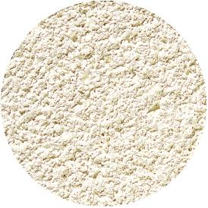External Render - K rend – Polar White

Roof Slates – 610 x 305 Natural grey slate with grey clay hip tiles

Rain Water Goods – ­­­­­­­­­­­­­­­­­­Powder coated aluminium to match render

Please note samples will be made available on site on request.

* **Condition 4. External fixings to face of building**
  + There will be no fixings to the external face of the building
* **Condition 8. Hard and Soft Landscaping** 
  + Please refer to drawing no. 1002-PC2 and 1002-PC3

We trust the information provided is satisfactory and look forward to the discharge of the relevant pre-commencement conditions to that effect.

Kind regards

Yours sincerely

**Rob Buckland**

**Architectural Technologist**

**Abbotswood Properties Ltd**

|  |
| --- |
|  |
|  |

**Enc.**