DESIGN & ACCESS STATEMENT

SITE ADDRESS: 13 Stratford Villas, London, NW1 9SJ

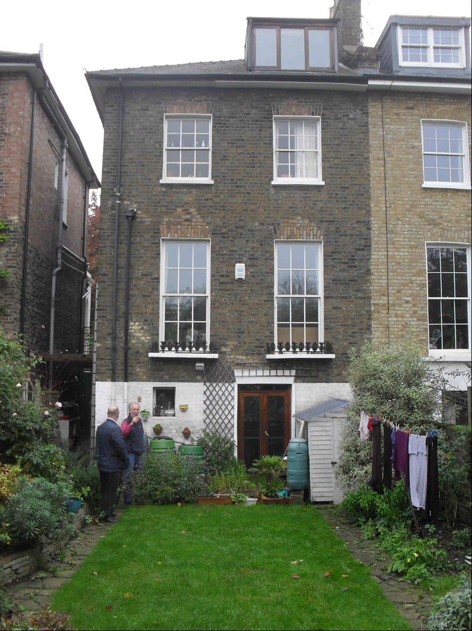
Proposal Outline:: Anglian Home Improvements have been contracted to erect a PVCu Conservatory to the rear of the property. Our client has chosen a conservatory to meet their personal requirements whilst being considerate to the natural surroundings and council guidelines.

Design Principles: Our client has chosen White PVCu framed Conservatory with a brick base and gable wall to match existing property with double glazed sealed units.

Due consideration has been given to the overall look and size of the property to give the most
aesthetically pleasing look and giving consideration to privacy without being overbearing.
All external materials used will be to match the existing property as closely as possible.

Size of proposal: The proposed unit size will only project 2.9m and have a width
of 4.5m.

Access: Access to the conservatory can be gained via internal double doors

Landscaping: Our proposal will not require the alteration of the rear garden in any form, we will not be required to remove or cut back any hedges or trees on the site. Our proposal will not affect the amenities of the site or the surrounding area and will go hardly noticed

