Design & Access Statement
E015610 – Central Food & Wine, 134 Charing Cross Road, London, WC2H 0LA

This Design and Access Statement has been prepared on behalf of Cashzone in support of an application submitted for:
The retention of an Automated Teller Machine and Illuminated sign

We have consulted Circular 01/2006 in preparing the installation.
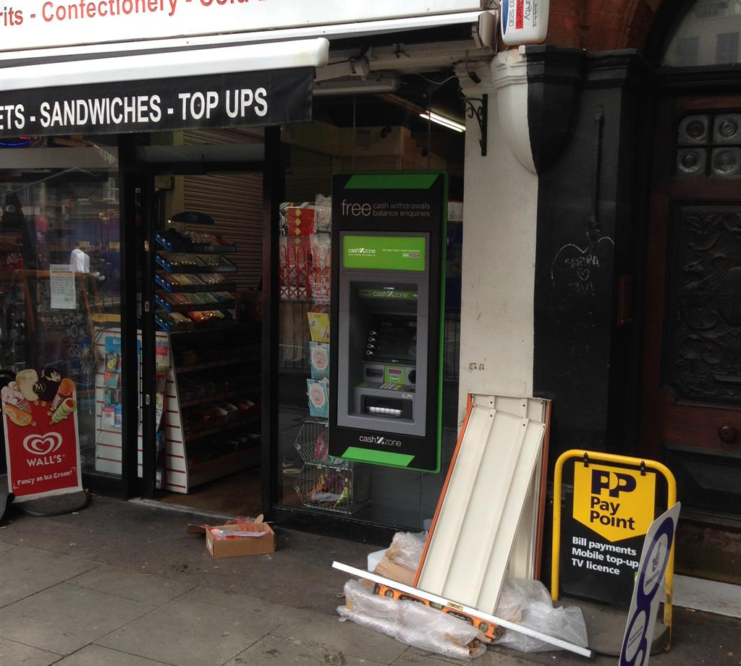

Appearance

We have installed an Automated Teller Machine (ATM) through the far right window of the Central food and Wine store located on Charing Cross Road, London. The ATM will be accessible from the road and shop entrance. The window of the store where the ATM has been installed has no special architectural or historic features.

The immediate area is mainly commercial; we consider that the installation of this ATM is not detrimental to them. The site does lie within the Denmark Street conservation area however I do not believe that it is a Listed Building.

Heritage

The Denmark Street conservation area lies within the south west of the Borough, on the borough boundary shared with the City of Westminster. Charing Cross Road forms the western boundary of the conservation area and is a major traffic route in central London. The buildings here are predominantly in commercial and retail use at ground level, so consequently this part of the area has a very busy feel. Charing Cross Road was created by the Metropolitan Board of Works from 1877 onwards by widening and demolishing the east side of Crown Street and setting the building line back by twenty feet.

There is no particular consistency of building age, type or design along this part of Charing Cross Road, although Shaldon Mansions is one of the most distinctive buildings here, and comprises shops at ground floor level with residential accommodation above. It is built of red brick with stone embellishment and a distinctive, tall stepped gable detail on the main elevation. The building heights are generally no more than 4 or 5 main storeys above tall ground floor shopfronts, commensurate with the scale and commercial nature of the road. Nos. 138 – 148 has recently been demolished as part of the Crossrail and London underground station works.

The present street pattern of St Giles High Street and Charing Cross Road has existed since at least the C12th. Camden has over 5,600 listed buildings in a variety of ages, types and architectural styles.

Use

The purpose of the installation of this Automated Teller Machine is to provide a 24 hour banking facility for the local community and visitors to the area.

Scale

N/A

Layout

The installation of the ATM has not altered the basic design of the building. We have removed an existing glazing panel. In the remaining void we have installed silicone jointed glazing with an aperture for the ATM face; we chose this design to best blend with the existing shop front. We then installed an illuminated surround sound. We consider that this would not be detrimental to the existing street scene.

Amount

This is not a new structure, but the installation of an ATM in an existing shop.

Landscaping

This is not relevant as the installation does not require it.

Design Principals

The ATM is of standard design as located in many areas throughout the UK and is accepted as a necessary facility. There are a number of mandatory standards which apply, relating to the position of the ATM, it’s visibility, ambient lighting, building structure, building security features, ATM anchoring, safe strength.

Designing out Crime

We install and anchor the ATMs in accordance with National Guidelines.

Site approval by the Cash In Transit Company has been obtained. They have considered routes to and from the ATM, ensuring there is protection of their staff and of any staff or customers at the site. Paramount in their review has been the welfare of their staff and the persons they come into contact with.

The area where the ATM has been installed is a well-lit area in full view of pedestrians aiding natural surveillance.

Access

The access to the site and other properties has not been affected.

In designing this application, we have taken into account the needs of able and disabled users. The ATM is set at a height that makes it accessible for all users and has space to the front for a wheel chair.
Key 5 has raised markings for blind persons to identify the centre key.

Car parking availability has been considered: There are parking restrictions in the area

