I have received notification that an application is to be submitted for planning permission to redevelop the above land with a new tower comprising approximately 130,000 square metres (GEA) of office space (Class B1), 2,220 square metres (GEA) of retail space, a high level restaurant and public viewing gallery. The development would comprise one building with 73 floors, rising to approximately 309.6 metres AOD subject to further consultations with the relevant bodies, including the Civil Aviation Authority. The scheme includes the enhancement of the public realm surrounding the site. This application will be accompanied by an Environmental Statement under the above regulations.

A request has been received from DP9 for a Scoping Opinion as to the information to be provided in the Environmental Statement pursuant to Regulation 13. A copy of the request for a Scoping Opinion is attached.

As you are a consultation body as defined in the regulations, I seek your views on any relevant matters which you would wish to draw to the City Corporation’s attention prior to its issuing a Scoping Opinion.

Pursuant to the Regulations, I am required to inform you that under the Environmental Information Regulations 2011, public bodies, which may or may not include yourselves, must make any environmental information in your possession available to any person who requests it. There is no obligation to undertake research or to obtain information which you do not already have, nor to make available confidential information. You may make a reasonable charge reflected in the cost of making information available requested by a developer.

I should be grateful to receive your comments within 21 days of this letter in order that they can be properly considered prior to the City Corporation issuing a Scoping Opinion.

Yours faithfully

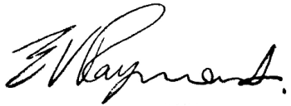

Ted Rayment  
Assistant Director (Development Management)