The Occupier  Development Control Planning Services  Town Hall, Argyle Street  London  WC1H 8EQ | Our ref: HGY/2015/3000  Contact: Neil McClellan  Office Telephone: 0208 489 3244  Mobile:  Date: 29/07/2026
Dear Sir/Madam

Town and Country Planning Act 1990

Planning application reference number HGY/2015/3000

Location: White Hart Lane Stadium, Bill Nicholson Way, 748 High Road, Tottenham, N17 0AP

Proposal: Proposed demolition and comprehensive phased redevelopment for stadium (Class D2) with hotel (Class C1), Tottenham Experience (sui generis), sports centre (Class D2); community (Class D1) and/ or offices (Class B1); housing (Class C3); and health centre (Class D1); together with associated facilities including the construction of new and altered roads, footways; public and private open spaces; landscaping and related works. Details of "appearance" and "landscape" are reserved in relation to the residential buildings and associated community and / or office building. Details of "appearance" and “scale” are reserved in relation to the sports centre building. Details of “appearance” are reserved in relation to the health centre building. The Proposal includes the demolition of 3 locally listed buildings. The proposal is EIA development. PLEASE NOTE - THIS IS A RECONSULTATION FOLLOWING THE SUBMISSION OF ADDITIONAL ENVIRONMENTAL INFORMATION.

An application for planning permission and an application for Listed Building Consent have been received by this Council for the development described above
You can view and comment on the planning application on-line via the following link: www.haringey.gov.uk/planning
Please remember to enter the HGY application reference number shown at the top of this letter.

Should you wish to view a hard copy of the application a copy is available to view at Coombes Croft Library Tottenham High Road, London, N17 8AG Tel: 020 8489 4560. The library’s opening hours are as follows: Monday to Friday: 9am-7pm, Saturday: 9am-5pm, Sunday: Closed. A copy is also available to view at the Council’s planning office by appointment. Appointments should be requested by emailing planningsupport@haringey.gov.uk.

Please send any comments by 4 December 2015 because a decision may be made on the application at any time after this date. Any comments received after this date will be considered if a decision has not yet been made. Please note that comments in respect of applications will be made available to public view and reproduction, including via the Haringey website; but acknowledgement letters are not sent out in response to comments received. If you do send in written comments, you will be advised of the committee date for this application. More advice on getting involved is given on the reverse of this letter.

Yours faithfully

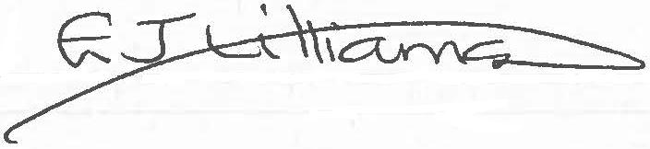

Emma Williamson,
Head of Development Management, Planning Service

