**ST1457 – McDonald’s Restaurant, Cambridge Circus – Light Well Photos November 2015**

Previous Boiler Room Vents 1

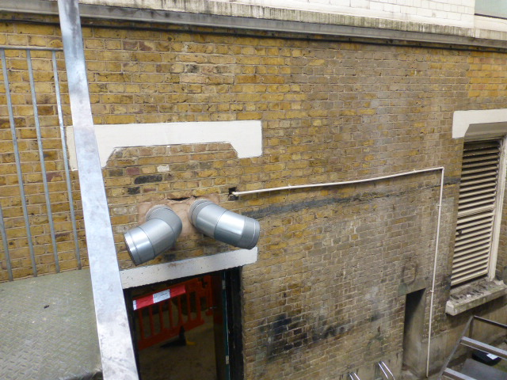

New Capped Boiler Room Vents 1

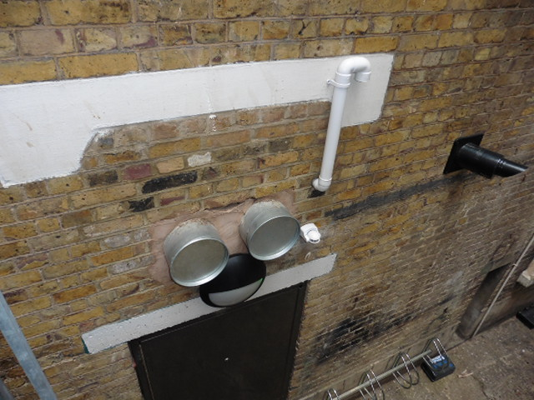

Previous Boiler Room Vents 2

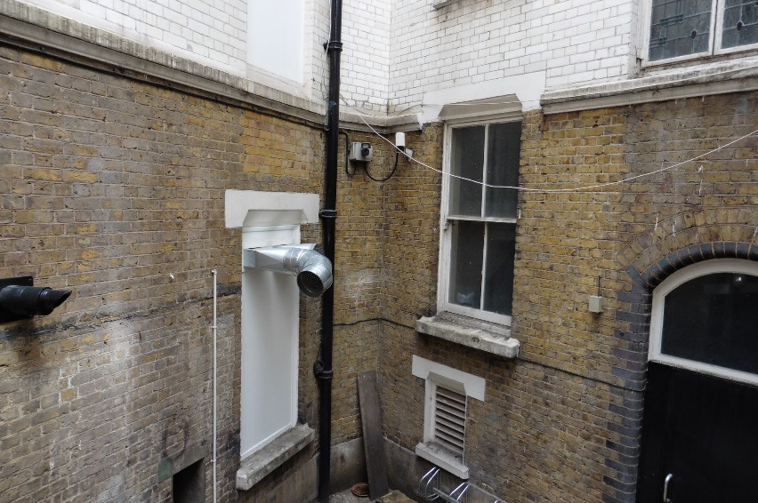

New Capped Boiler Room Vents 2

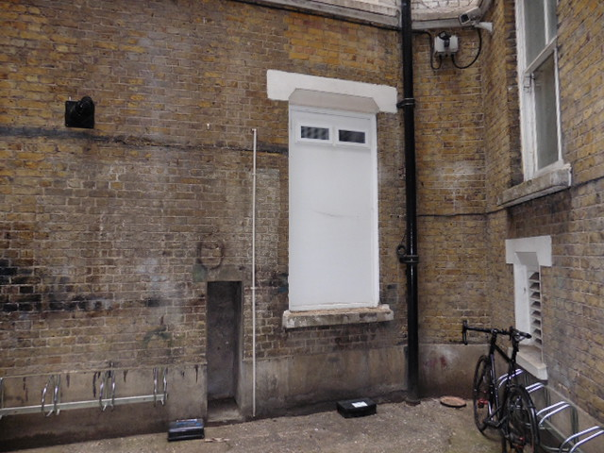

Previous W/C Exhaust

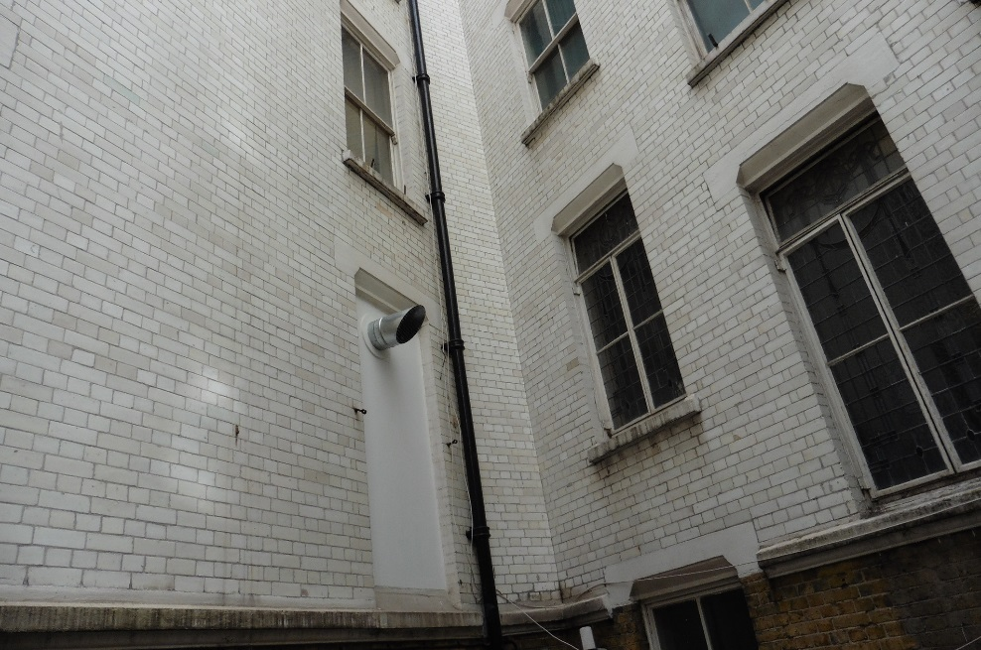

New W/C Exhaust

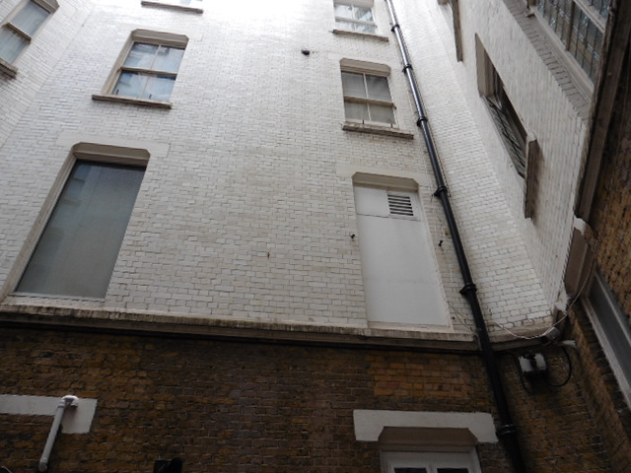

Previous Air Intake Attenuator

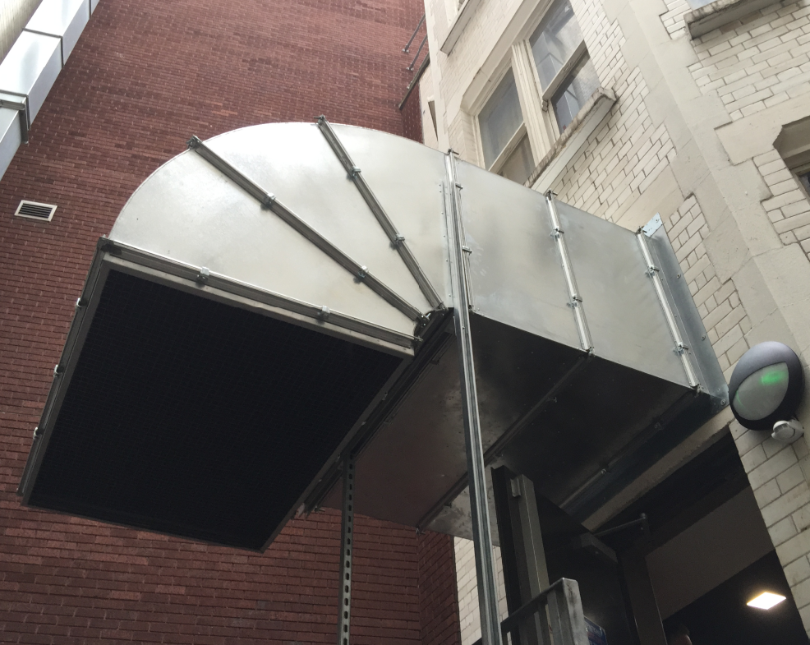

New Fresh Air Intake Attenuator 1

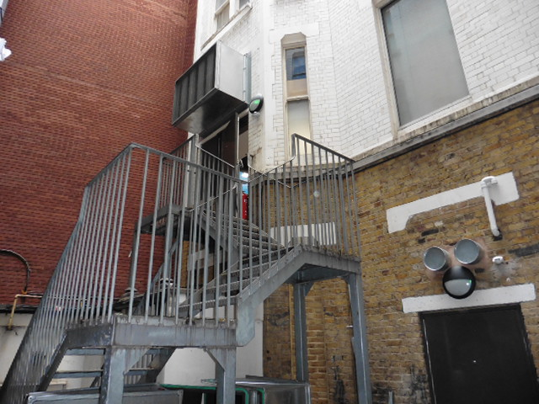

New Fresh Air Intake Attenuator 2

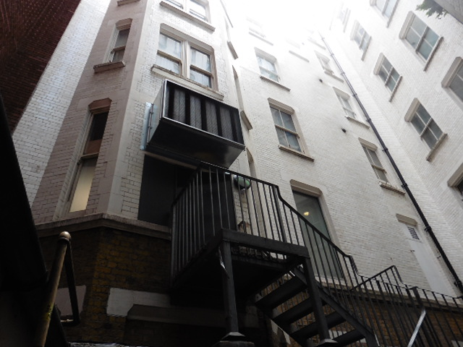

Other Plant Units in the Light well

Taken from the fire exit opposite the new Intake Attenuator

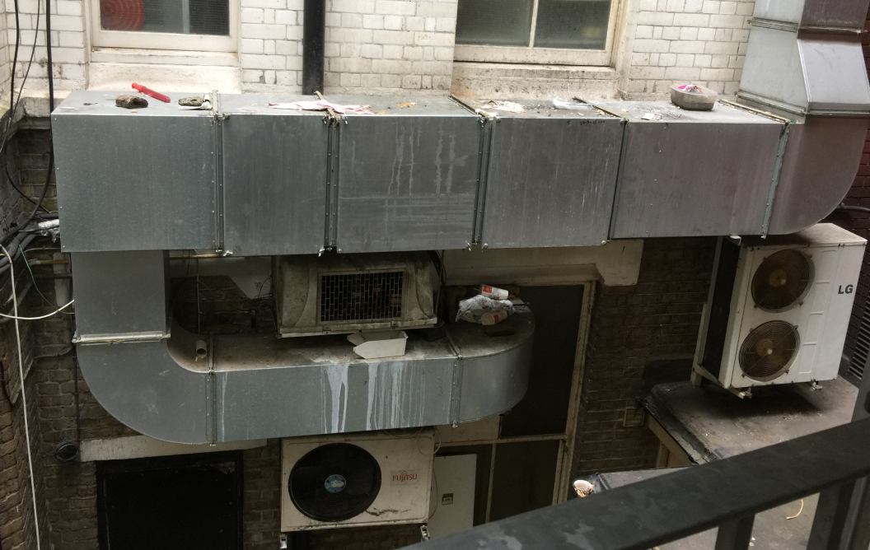

Chimney for the Air Intake for opposite unit.

