- Listing
- Search the List
- List Entry
- Section Navigation
  - Minor Amendments
  - Review Process
  - Download Designation Data
  - Non-Listed Sites

NUMBERS 51 TO 85 AND ATTACHED RAILINGS

List Entry Summary
This building is listed under the Planning (Listed Buildings and Conservation Areas) Act 1990 as amended for its special architectural or historic interest.
Name: NUMBERS 51 TO 85 AND ATTACHED RAILINGS
List entry Number: 1322177

Location
NUMBERS 51 TO 85 AND ATTACHED RAILINGS, 51 TO 85, GOWER STREET
The building may lie within the boundary of more than one authority.
County: Greater London Authority
District: Camden
District Type: London Borough
Parish:
National Park: Not applicable to this List entry.
Grade: II
Date first listed: 28-Mar-1969
Date of most recent amendment: Not applicable to this List entry.

Legacy System Information
The contents of this record have been generated from a legacy data system.
Legacy System: LBS
UID: 477394

Asset Groupings
This list entry does not comprise part of an Asset Grouping. Asset Groupings are not part of the official record but are added later for information.

List entry Description

Summary of Building
Legacy Record - This information may be included in the List Entry Details.

Reasons for Designation
Legacy Record - This information may be included in the List Entry Details.

History
Legacy Record - This information may be included in the List Entry Details.

Details
CAMDEN
TQ2982SE GOWER STREET 798-1/94/606 (West side) 28/03/69 Nos.51-85 (Odd) and attached railings
GV II
Terrace of 18 houses. Nos 51-59 built 1786; Nos 61-85, 1787. Darkened yellow stock brick. Stucco band at ground floor level and to 1st floor sills. Slated mansard roofs with dormers. 3 storeys, attics and basements. Nos 65, 67 & 73, 4 storeys. 3 windows each. Entrances with stucco surrounds with pilasters and dentil cornices; alternating round and segmental-arched doorways with fanlights and panelled doors. Gauged brick flat arches to recessed sash windows, most with original glazing bars. Ground and 1st floor windows with bracketed sills and cast-iron window guards. Nos 65 & 67 ground floor windows in segmental-arched recesses with stucco archivolts, imposts and keys. Stone dentil cornices; Nos 65, 67 & 73 cornices at 3rd floor level. Parapets. INTERIORS: not inspected. SUBSIDIARY FEATURES: attached cast-iron railings, mostly with urn finials, to areas.
Listing NGR: TQ2964382027

Selected Sources
Legacy Record - This information may be included in the List Entry Details
National Grid Reference: TQ 29680 81981

Map
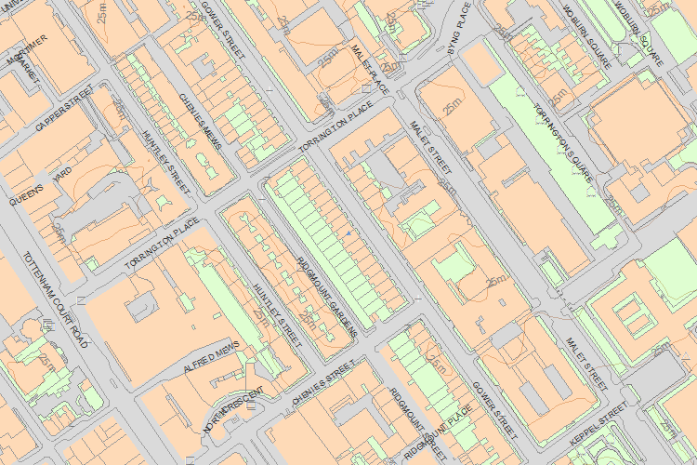© Crown Copyright and database right 2015. All rights reserved. Ordnance Survey Licence number 100024900.
© British Crown and SeaZone Solutions Limited 2015. All rights reserved. Licence number 102006.006.
The above map is for quick reference purposes only and may not be to scale. For a copy of the full scale map, please see the attached PDF - 1322177 .pdf
The PDF will be generated from our live systems and may take a few minutes to download depending on how busy our servers are. We apologise for this delay.
This copy shows the entry on 09-Nov-2015 at 12:12:55.

