# Precedent for highly visible alterations at rooftop level in the South Hampstead Conservation Area

There is significant precedent for rooftop constructions in the South Hampstead Conservation area that have been granted permission. In this document I will focus on the two most prominent, which are in the immediate vicinity of the property that we are requesting appeal of planning refusal.

## 70 Aberdare Gardens

The top floor flat has been granted permission and has constructed a beautiful roof terrace that adds beauty to the area through its ample planting and construction of high quality materials that keep it in line with the character of the Conservation Area. This property sits at the end of Aberdare Gardens at the corner of Fairhazel Gardens, and is highly visible from 3 sides, and if one looks closely while heading west up Aberdare Gardens, the fourth side of the roof terrace can easily be identified. The roof terrace if visible from 36 Fairhazel Gardens all the way to 16 Fairhazel Gardens and on Aberdare from 69 to 75, showing an acceptance of a very wide footprint of visibility.

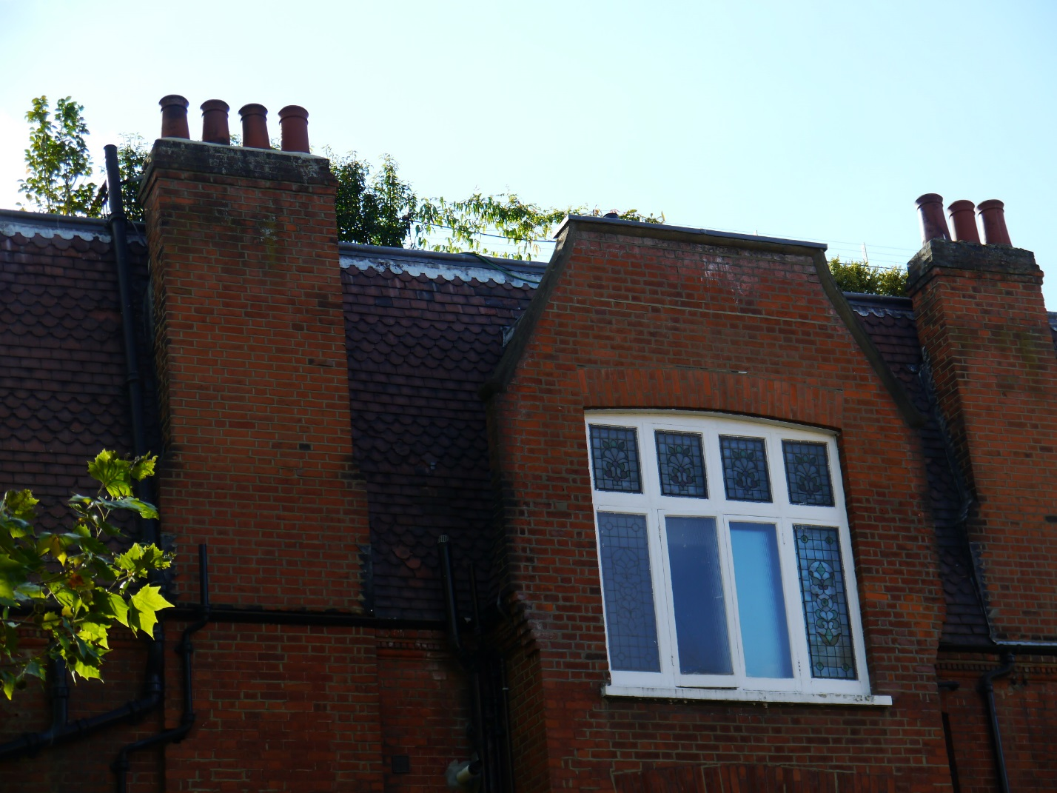

Figure - View of 70 Aberdare Gardens from 16 Fairhazel Gardens

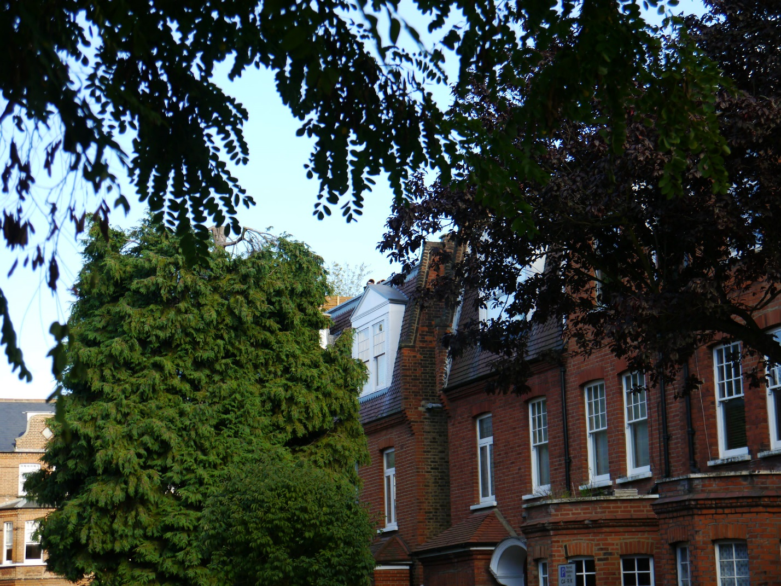

Figure - View of 70 Aberdare Gardens from 69 Aberdare Gardens

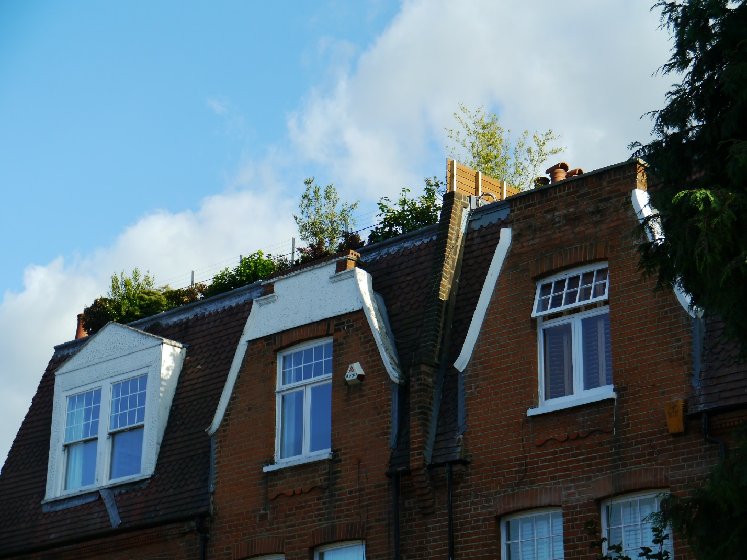

Figure - View of 70 Aberdare Gardens from 75 Aberdare Gardens

## 49 Greencroft Gardens

Similar to 70 Aberdare Gardens, 49 Greencroft is at the end of the street with only a single property of significantly lower height between it and the corner of Greencroft Gardens and Fairhazel Road. As such it has significant visual prominence due to its position, and does not have any trees in the immediate vicinity of the property to obstruct any views. On this property railing has been erected on the flat roof that is not in line with character of the Conservation Area. All four sides of the railing are readily apparent for large stretches of both Greencroft Gardens and Fairhazel Gardens. On Greencroft, this construction is visible from numbers 30 all the way through to 86 on the north side of the street, with only the occasional interruption due to a tree. It is also visible on the south side of the street, but from a smaller distance due to the angle being narrower on the same side of the street.

This construction was approved by Camden Council without need for appeal (Camden Planning Reference 2012/1376/P), and has even been cited in other successful applications to install railings at roof level (application for 35 Canfield Gardens, Camden Planning Reference 2013/0788/P).

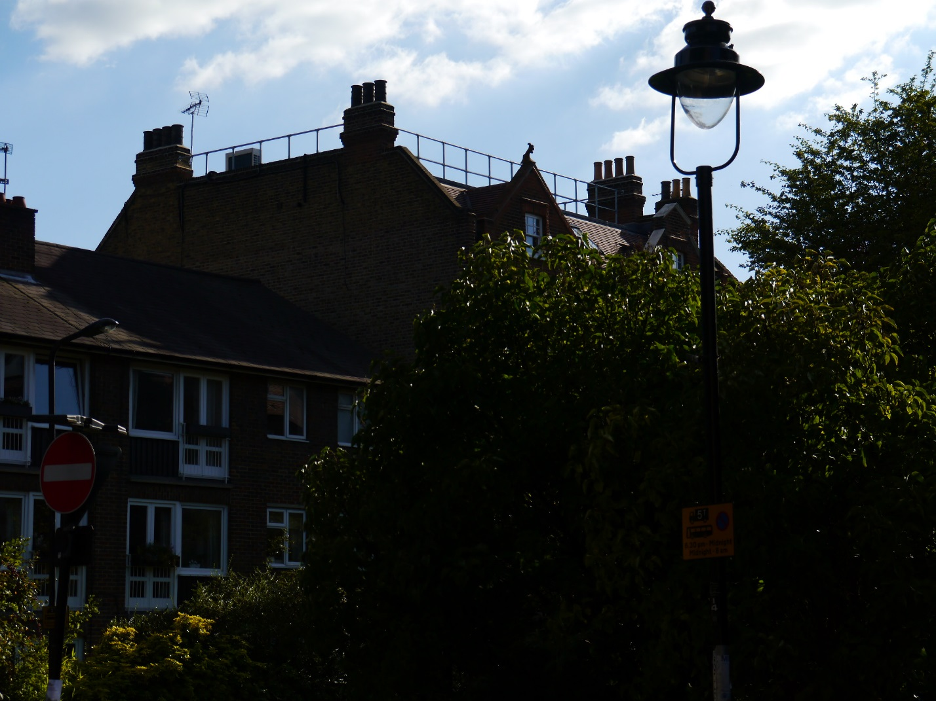

Figure - View of 49 Greencroft Gardens from NorthEast corner of Greencroft Gardens and Fairhazel Gardens

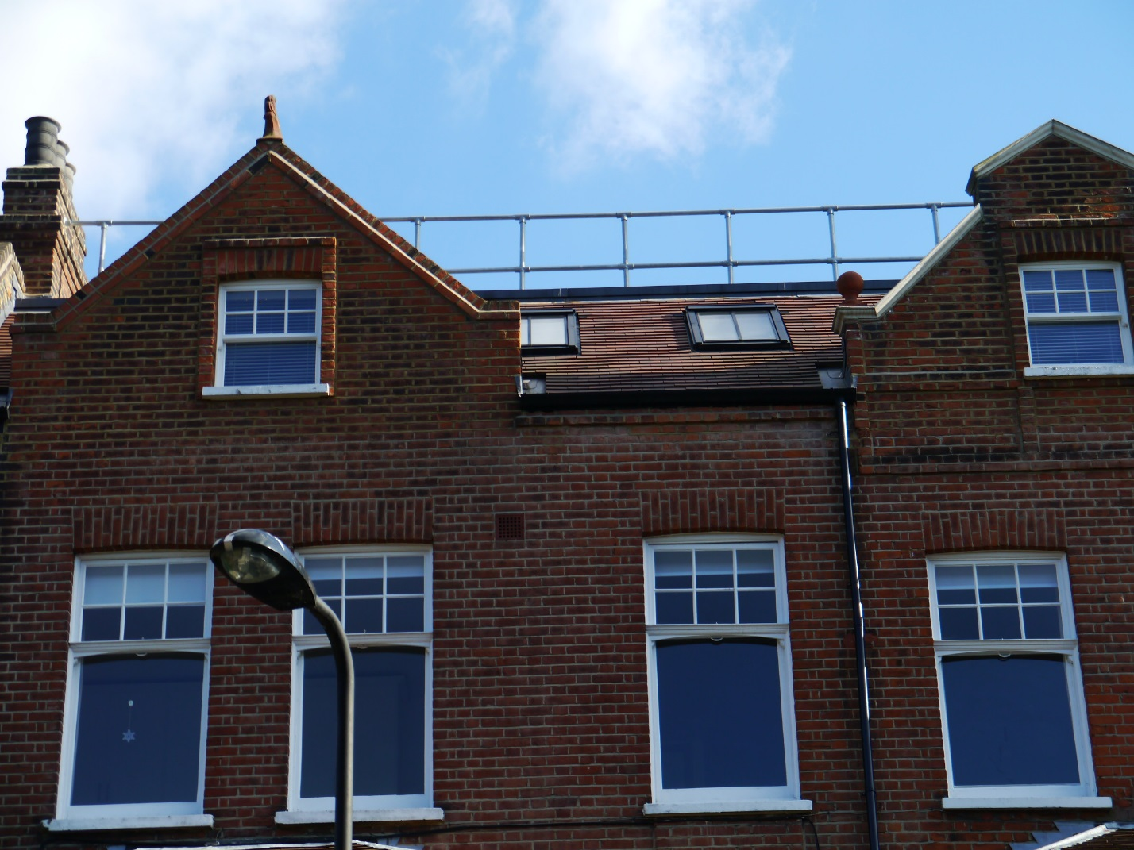

Figure - View of 49 Greencroft Gardens from 68 Greencroft Gardens

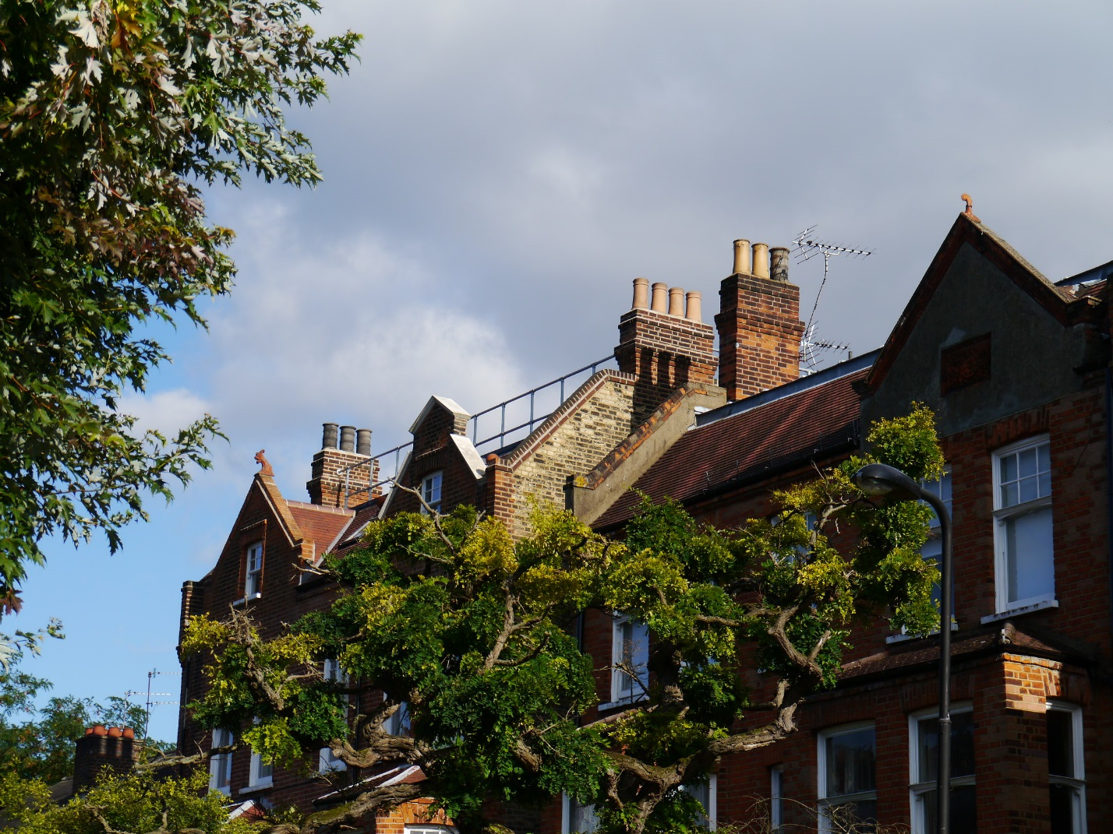

Figure - View of 49 Greencroft Gardens from 74 Greencroft Gardens

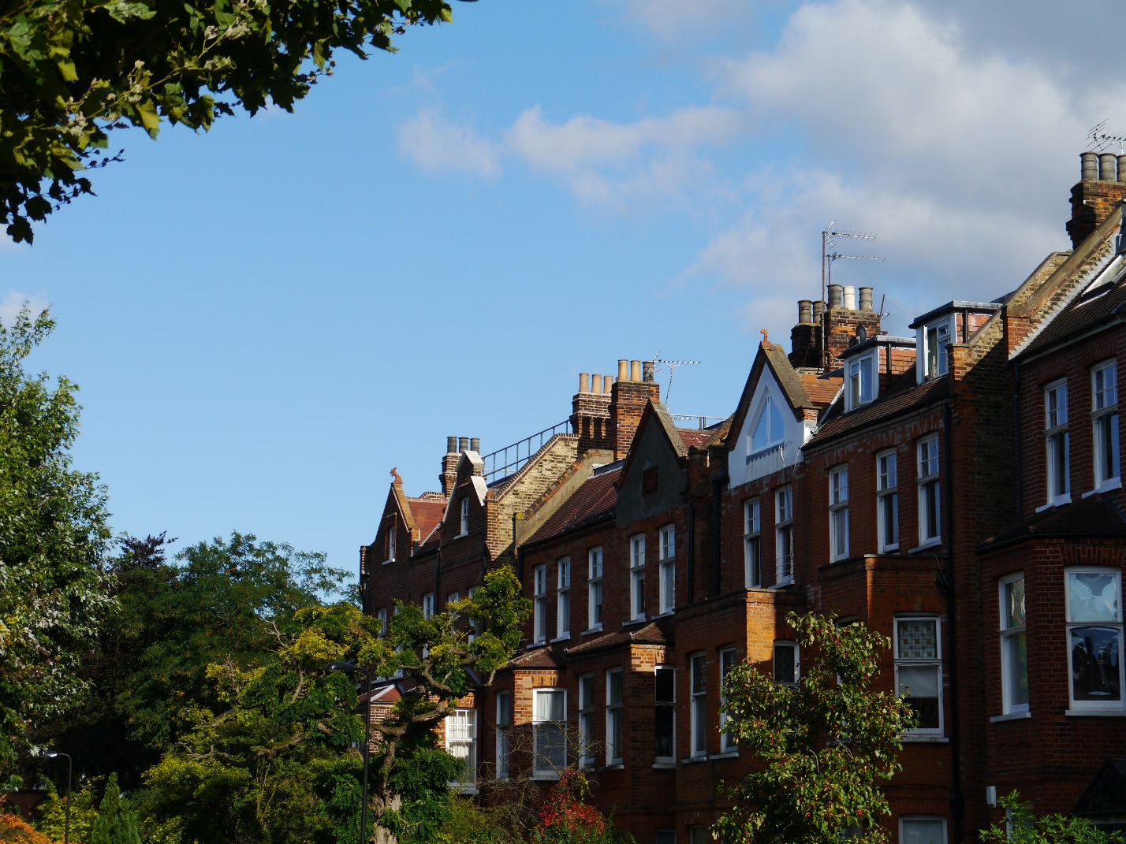

Figure - View of 49 Greencroft Gardens from 78 Greencroft Gardens

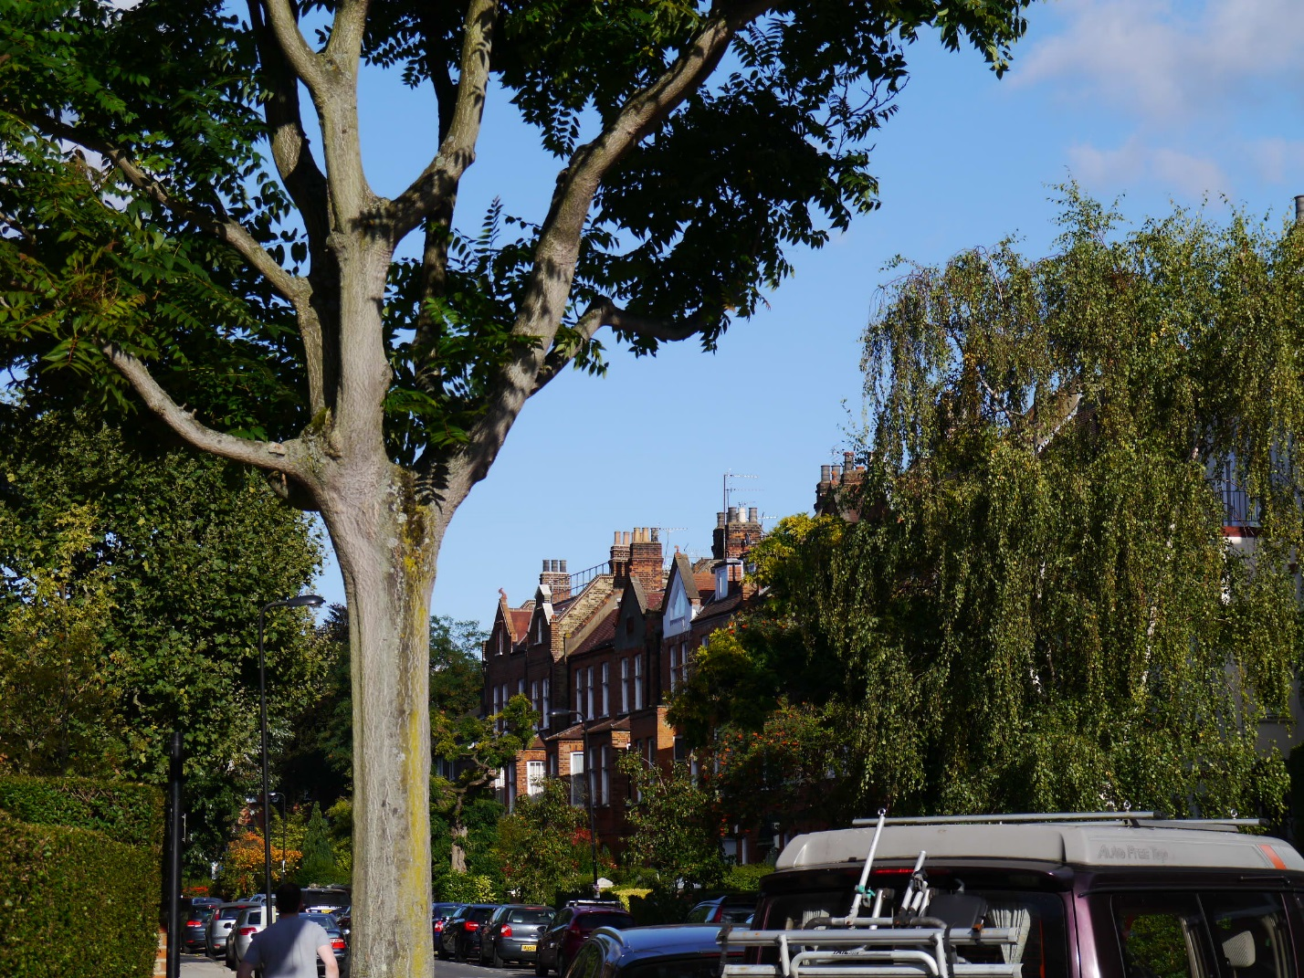

Figure - View of 49 Greencroft Gardens from 86 Greencroft Gardens

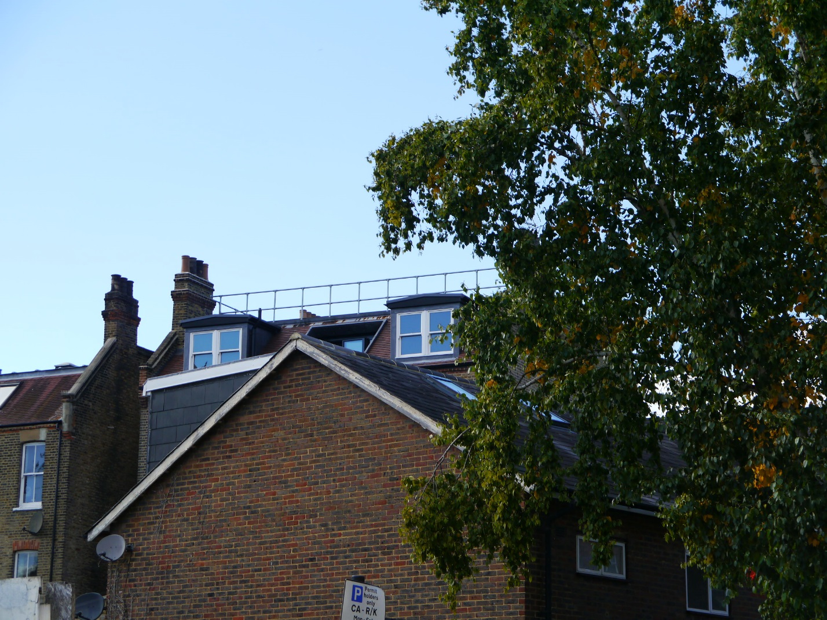

Figure - View of 49 Greencroft Gardens from 36 Fairhazel Gardens