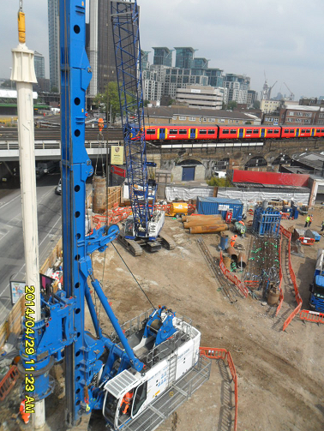

|  |  |  |  |  |  |
| --- | --- | --- | --- | --- | --- |
| **Rev.** | **Date** | **Prepared By:** | **Checked By:** | **Approved By:** | **Reason For Issue** |
| 00 | 16/04/2015 | S. Adams |  |  | For Acceptance |
|  |  |  |  |  |  |
|  |  |  |  |  |  |

Camden Lock Village/Hawley Wharf

PILING METHODOLOGY REV.00

**Index**

1. **Project overview**
2. **Site constraints**
   1. LUL running tunnels
   2. Piling works to adjacent structures
   3. Piling works adjacent to Network Rail structures
   4. Services on site and minimum clearances
   5. Bomb Damage & Unexploded Ordnance
   6. Trees
3. **Piling solution**
   1. Scope of works
   2. Piling Plant
   3. Methodology
      1. LDP Contiguous Wall, Load Bearing & Plunge Columns Bored Piles
   4. Piling Platform & Permits
   5. Backfill to piling platform
4. **Safety**
5. **Environment**
6. **Programme and Sequencing**
   1. Logistic Plan
   2. Programme Sequencing

**Appendices:**

1. Logistic Plan
2. Piling Programme
3. **Project overview**

The Camden Lock Village/Hawley Wharf development consists of 4 main sites (Areas A, B, C and D). The buildings comprise of commercial, residential, leisure, and retail together with public realm and landscaping .Piling works will be executed in the close proximity to the Regent’s canal, Chalk Farm Road, Castlehaven Road, Kentish Town Road and Hawley Road, railway viaducts and LUL tube lines.

All piles will be designed for a life of 50 years.

Condition 31 attached to the 2013 planning permission, reference 2012/4268/P reads:

***“The development of Areas A and D hereby permitted shall not commence until detailed design and method statements (in consultation with London Underground) for all foundations, basement and ground floor structures, or for any other structures below ground level, including piling (temporary and permanent), have been submitted to and approved in writing by the local planning authority in consultation with London Underground which:***

***a) provide details on all structures in Areas A and D***

***b) accommodate the location of the existing London Underground structures and tunnels accommodate ground movement arising from the construction thereof and mitigate the effects of noise and vibration arising from the adjoining operations within the structures and tunnels.***

***The development shall thereafter be carried out in all respects in accordance with the approved design and method statements, and all structures and works comprised within the development hereby permitted which are required by the approved design statements in order to procure the matters mentioned in paragraphs of this condition shall be completed, in their entirety, before any part of the building hereby permitted is occupied”***

This document sets out the method statement for the piling operations to the whole site at Camden Lock Village/Hawley Wharf in which specific sections deal with the LUL interfaces as part of a wider site wide approach. This document is supported by the design information and basement impact assessments produced by Walsh Group, and has been developed through consultation with LUL by engaging key contacts and working to specific guidelines and codes of practice.

Prior to commencing works on site, all members of the piling operations team will be fully briefed on the requirements of this document with specific reference and the communication of the actual hazards and constraints associated with the site, including the location of services, exclusion zones and environmental risks such as tree roots and watercourses.

**Site Access**

Site access is considered to be restricted, it will be necessary to carry on swept path analysis to establish the maximum length deliveries full details of the analyses can be found in our main construction management plan. Columns and pile cages might need to be spliced if necessary. In regard to the piling plant deliveries haulier visit needs to be booked in advance with Mace to minimise disruption on the highway Off-loading and delivery holding points as well as protection to public need to be considered by Mace and considered within the Mace Construction Management Plan.

1. **Site constraints**

**2.1 LUL running tunnels**

Proposed new **BLOCK D** structure will be founded in close proximity to northern line tunnels adjacent to the site – along Kentish Town Road. LUL operate a 6m vertical and 3m horizontal exclusion zone around the tunnels, where no structure is permitted, there can also be no significant change in loading to the tunnels. All piles must be installed outside the LUL exclusion zone. Therefore they should be positioned by Walsh. Any piles above this exclusion zone will need to be checked for toe level and 45deg zone of the tunnel against the top of this exclusion zone. At present the extent of the piles is located outside the exclusion to avoid exerting undue loads to the tunnels. This will need finalising and checking against relevant piles.

Proposed **BLOCK A** structure will be also founded in close proximity to northern line tunnels adjacent to the site – along the south west corner beneath Camden High Street. Mace propose to use the same methodology of construction as per block D.

**2.2 Piling works to adjacent structures**

There are number of existing structures on site i.e. The Hawley Arms building on the west of Block C where piling will need to be executed in close proximity. We have received CAD drawings but have been unable to accurately assess the clearances. This will need to be completed and verified on site before piling commences.

A party wall agreement is expected to be in place by MACE and the contiguous pile wall design for the building surcharge present in Block C.

The following are the minimum clearances needed from the centre of the pile position to the front face of existing structure for our piling rigs to allow safe construction:

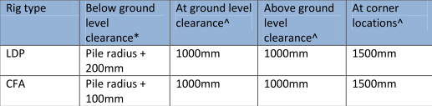

*Tab1. LDP & CFA Minimum Clearances*

Where piling close to the hoarding Mace will erect purpose made moveable barriers to prevent any debris over sailing the hoarding.

When piling near adjacent structures the settlement criteria needs to be fully understood, therefore the consulting Engineer will be critical to the process.

**2.3 Piling works adjacent to Network Rail structures**

Areas A,B &D are situated along Network Rail viaducts and block C between them. A Y-shaped Network Rail viaduct cut across the site splitting the development. Piling will therefore be executed in very close proximity to the live railway. It is envisaged that PST or sentinel cards shall not be required nor possession works, as Mace have established, that a 5m exclusion zone will be in place on each side of the viaduct. Wherever possible works will be carried out outside the 5m zone however there are instances where minimum distance available is 3.4m (NOTE: Minimum NR requirement is 3m).

The piling strategy is yet to be fully agreed with Network Rail, however this document has been produced in line with Network Rail and LUL guidance, and through many previous schemes of similar nature.

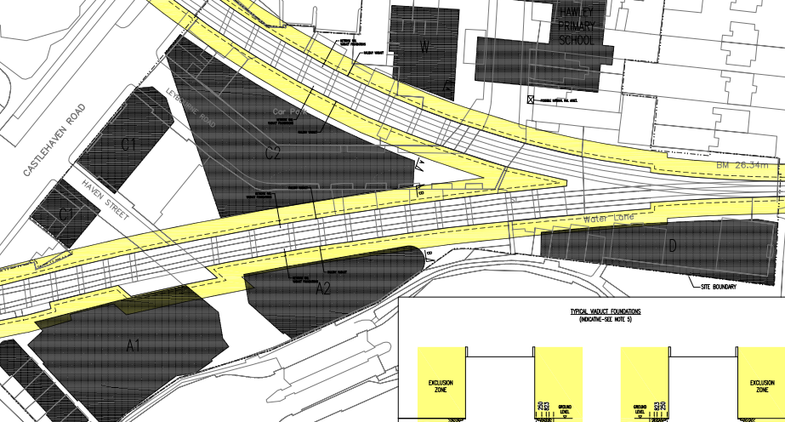

D

B

C

A

A

*Fig1. 5m Exclusion Zone Extents to Network Rail assets in relation to Mace proposed new structures*

*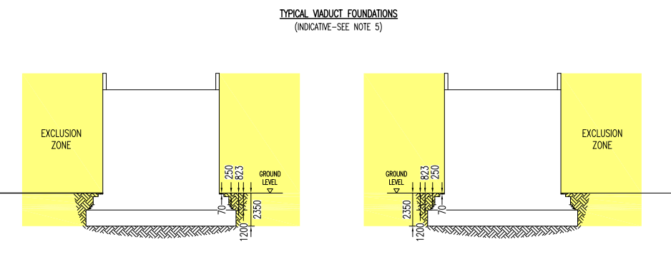Fig2. 5m zone exclusion zone established by MACE around NR asset*

The following pictures show the proximity of the Network Rail asset to the edge of the closest piles:

Not all the drawings received had coordinates so the levels of accuracy of the dimensions need to be verified on site and re-checked but the logic will be maintained.

BLOCK C

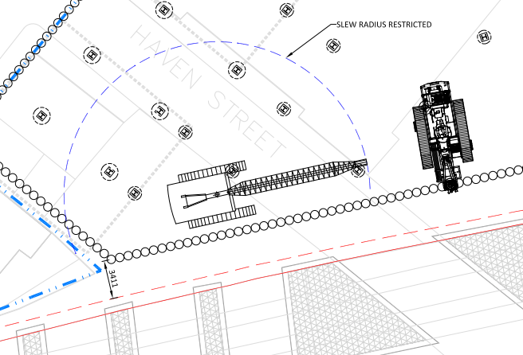

*Fig3. Interpreted minimum distance from pile to NR asset and orientation of piling machinery*

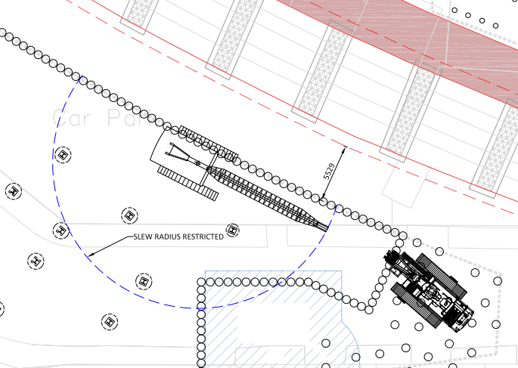

*Fig4. Interpreted minimum distance from pile to NR asset and orientation of piling machinery*

BLOCK D

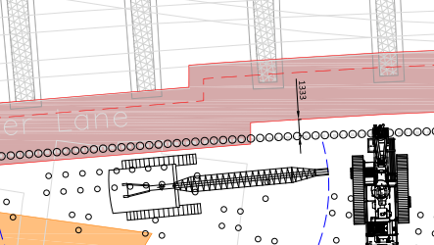

*Fig5. Interpreted minimum distance from pile to NR asset/exclusion zone and orientation of piling machinery* ***NOTE:*** *Contiguous piled wall in block A has been now removed*

BLOCK B

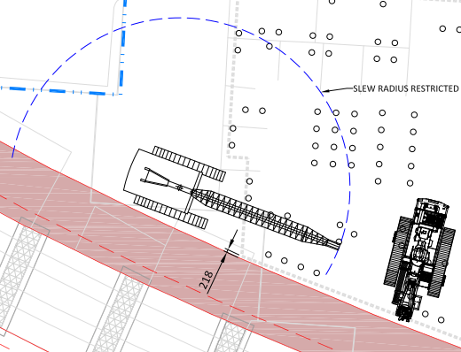

*Fig6. Interpreted minimum distance from pile to NR asset/exclusion zone and orientation of piling machinery*

BLOCK A

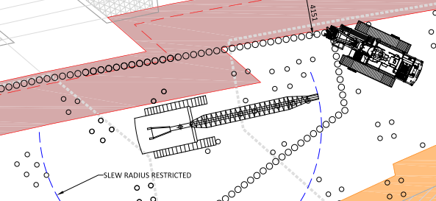

*Fig7. Interpreted minimum distance from pile to NR asset/exclusion zone and orientation of piling machinery.* ***NOTE:*** *Contiguous piled wall in block A has been now removed*

Setting up on the pile

The rig and crane will be set up on these piles in accordance with NR/L3/INI/CP0063 – Piling adjacent to the running line and therefore as shown in the drawings below. The crane will have a slew restrictors installed to manage crane movements.

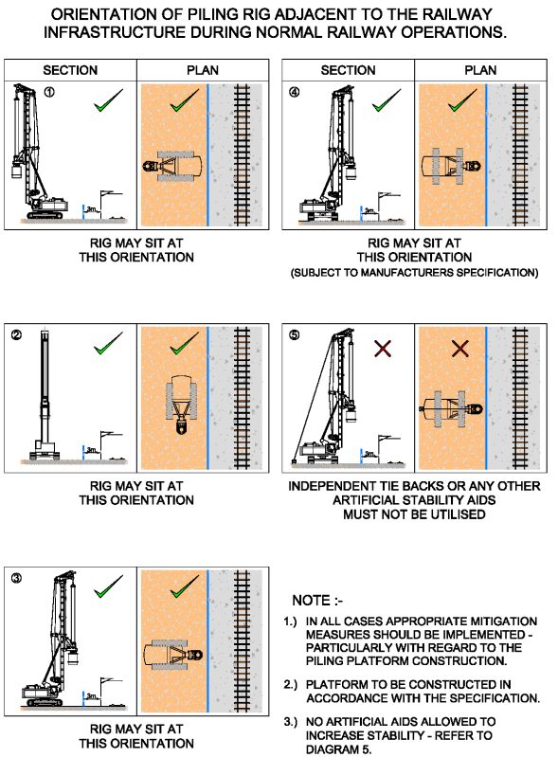

*Fig8. Orientation of piling rig adjacent to the railway during normal railway operations*

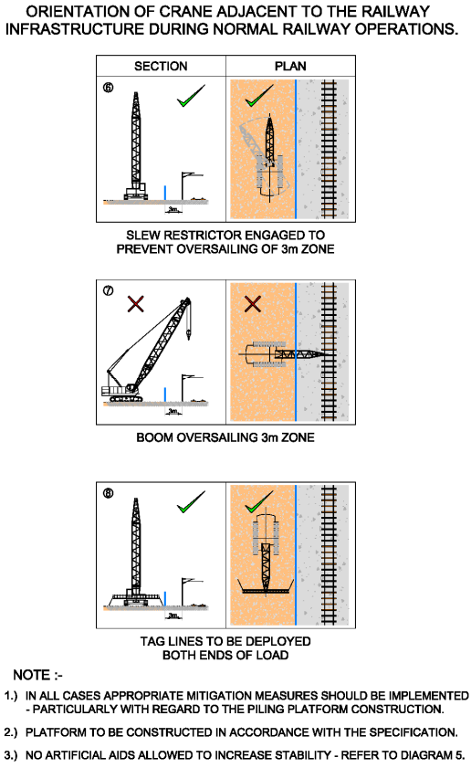

Fig9. *Orientation of crane adjacent to the railway during normal railway operations*

Arrangements shall be in place so at the end of each shift all plant is left in a safe and secure manner. Attendant jib cranes shall be stabled overnight with their jibs facing away from the railway.

The only time when the crane will deviate from this arrangement is during installation of reinforcement. The crane jibs will be slightly skewed towards the pile. The crane will be allowed to be skewed towards the Network Rail asset to achieve suitable height and maintain 3m fall clearance distance from the Network Rail asset. Slew restrictors will be fitted to ensure this slew movement is not exceeded.

The pile construction process will be carried with the following mitigation measures to ensure a collapse radius of 3m from the asset is sustained.

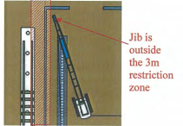

3m restricted zone

*Fig7. Sketch showing 3m clearance from NR asset during fall*

**2.4 Services on site and minimum clearances**

West of block A and south-west of Block B have the National Grid high voltage cable that requires a 5m exclusion zone. There is existing National Grid oil tank in Block C that has 1.5m exclusion zone that is being surveyed at the moment. Piles around this tank might need to be relocated.

The site will be cleared of all sewers and local drainage infrastructure during the demolition stage and prior to commencement of the piling operations. The current Thames Water sewers serving Leybourne Road and Torbay Street have been taken out of service and will be capped and sealed at the boundary in accordance with statutory requirements.

As part of the piling preparation stage the site will be scanned for any remaining uncharted services and if discovered the disconnections will be arranged as soon as possible and the works re-sequenced if required.

At the boundary, any services including sewerage, will be fully identified and marked on site record drawings and communicated to the site teams as part of works preparation, and displayed clearly in the site office.

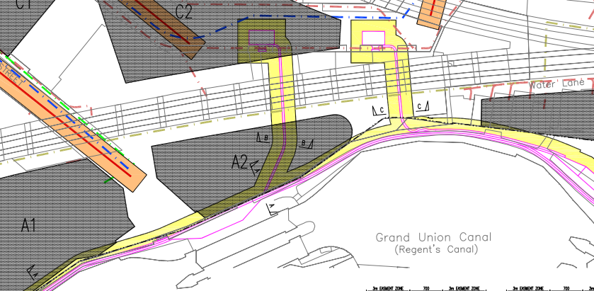

*Fig8. National Grid High Voltage Cables and oil tank extent and exclusion zones*

Please refer to below table for the minimum clearances that Mace will work to:

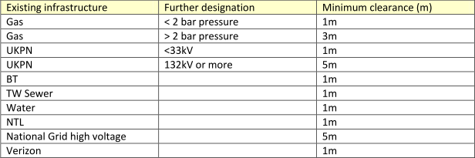

*Tab2. Minimum clearances for underground services that Mace works to*

**2.5 Bomb Damage & Unexploded Ordnance**

The site experienced some bombing during the Second World War. A detailed UXO risk assessment was undertaken and the report notes the following risk for each of the blocks.

|  |  |
| --- | --- |
| BLOCK A | a low to medium risk |
| BLOCK B | a low to medium risk |
| BLOCK C | a medium to high risk |
| BLOCK D | a low to medium risk |

It is recommended to probe each of the pile position where the risk is medium or high. A specialist contractor will be contacted to recommend any further actions in this regard.

**2.6 Trees**

BLOCK B & A sites have a number of trees where overhang branches could overhang pile positions. These branches will require to be trimmed to provide sufficient clearance for the piling plant. Similarly any tree roots must not obstruct the pile positions. We ae aware that there are a number of protected trees, and the piling programme will accord with the tree root protection strategy which has been approved under a separate planning condition.

**3.0 Piling Solution**

**3.1 Scope of works**

Mace have reviewed the options of constructing the project using either CFA or LDP method.   
LDP will be required for the large diameter bored piles/plunge columns. The contiguous wall could be constructed as CFA, but LDP seems more suitable for the site taking into account all constraints. Mace are offering the following solutions for the project. These are yet to be confirmed by design once full construction information received.

|  |  |  |  |
| --- | --- | --- | --- |
| Structure | Contiguous Wall | Bearing Piles | Plunge Columns |
| BLOCK A | N/A | *Ø750 LDP @30m (254No)*  LDP – thin wall casing seal off into the clay, bored to MACE design depth | N/A |
| BLOCK B | N/A | *Ø750 LDP @30m (116No)* LDP – thin wall casing seal off into the clay, bored to MACE design depth | N/A |
| BLOCK C | *Ø750 LDP @25m (294No)*  LDP – thin wall casing seal off into the clay, bored to MACE design depth | *Ø750 LDP @30m (29No)* LDP – thin wall casing seal off into the clay, bored to MACE design depth | *Ø1500 LDP (37No)*  *Ø1200 LDP (18No)*  LDP – thin wall casing seal off into the clay, bored to MACE design depth |
| BLOCK D | N/A | *Ø750 LDP @30m (151No)* LDP – thin wall casing seal off into the clay, bored to MACE design depth | N/A |

*Tab3. Scope of Works and Piling solutions*

*Contiguous wall:*

The option of a contiguous wall has programme advantages as it would be relatively fast to construct. The disadvantage is that with the contiguous piled wall versus the secant piled wall, it does not provide any water retention because the piles are not interlinked. However on this site, the ground water encountered in the ground boreholes is perched and comes in at a very slow rate. With this type of construction against sheet pile solution vertical loadings can be taken without larger problems, which is of benefit for the next levels of construction. The wall will also restrain better than sheet piles any horizontal loads and moments coming from the existing structures like roads and pavements.

*Bearing piles:*

Large Diameter Piles have been proposed as the best solution for the foundations on this site. With the shallow London clay levels this appears to be the most efficient solution.

*Plunge columns:*

Plunge columns have been proposed to optimise the top down construction of the basement. This technique allows accelerating the construction of the structure both ways – progressing up the framework and slabs and excavations at the same time. Mace are using this technique successfully at the moment on other projects around London.

**3.2 Piling Plant**

The piling rigs Mace propose for this project are as follows:

Soilmecs R625 LDP piling rig or similar

Kobelcos 60t, 75t or 80t crawler crane subject to weight of plunge columns

Each rig will require an excavator in attendance capable of handling spoil removal from the pile position, as well as undertaking any ancillary tasks including lifting of cages, casing, tools and casings up to 1t.

All equipment on site will be in a serviceable condition with documentary evidence of statutory controls regarding thorough examinations having been complied with. These will include:

* Examination of piling equipment and accessories
* Reports of thorough examination
* Start up checks once equipment is rigged up
* 6months report of thorough examination for all lifting accessories
* Evidence of an appropriate specific pre-contract plan inspection

All plant and equipment shall be thoroughly maintained and inspected in accordance with PUWER and LOLER regulations.

**Plant/Equipment Damage and Maintenance**

Where damage/wear occur to plant or equipment, it will be necessary for a fitter and/or welder to attend site to carry out repairs. All damaged tools/plant and associated repairs will be recorded on a fitters/welders day work sheet.

During repair works, it may be necessary to access parts of the rig/plant at height, in order to achieve this MEWP will be used. Only certificated and competent operative shall drive the MEWP and all lifting certificates for it should be inspected prior to use in addition to a visual inspection. All operatives within the cherry picker basket will wear a harness and be clipped onto the cherry picker basket at all times.

Where welders are required to repair/maintain piling tools and equipment, a designated welding area will be set up with covered screens and adequate ventilation. All gas bottles will be stored in locked cages with oxygen and propane stores separately in cages minimum 3m apart. Gas bottles will be stored in locations as agreed with MACE. Any cables/gas hoses will be placed in such way that they do not cause a trip hazard. Welding area will have signage prohibiting access of unauthorised personnel.

**3.3 Methodology**

**Location of works**

The development is located in Camden Town, London and is bounded by Kentish Town Road and private gardens to the east, The Grand Union canal to the south, Castlehaven Road to the west and Hawley Road to the North. The site is currently served by three roads, which will be ‘stopped up’, Haven Street, Leybourne Road and Torbay Street all assumed to be public highways. The site consists of 4 sites that are to be piled - Blocks A, B, C & D.

**Third Parties affected by the works**

The piling works will be carried out within close proximity to the following structures:

* Northern Line London Underground tunnels
* Neighbouring buildings at Area C
* Network Rail viaducts
* Water Canal
* Neighbouring Public Roads
* Below ground services – National Grid high voltage cable, Sewerage, oil tanks

Mace will highlight on the site logistic drawing each area, referring to the risk assessment and control measures needed in order to safely work in each area. Each area should be clearly marked on site and have physical barriers in place to prevent big machinery entrance to exclusion zones.

Mace require any protection necessary to these structures to be provided and in place in advance of the piling works, to prevent any accidental damage being caused.

Mace will take necessary steps to minimise noise and vibration throughout the works. Within the limits of our capability and in accordance with BS 5228-1:2009. It is not anticipated that significant vibration levels will be produced throughout the works. Technique employed typically results in levels less than 3mm/s at 10m. It might be practical to monitor vibrations near existing structures as a back up and a further assurance.

**Preliminary Items**

Prior to works commencing the following will have been carried out/provided by Mace. Full details on attendances can be seen in the FPS schedule of attendances submitted.

Sufficient site offices will be provided for the specialist piling contractor to allow their Site Supervisors to complete their site records whilst supervising the operations. In addition, welfare facilities will be provided including a suitable changing/drying room, with suitable lockers, and separate canteen area with power supply and means to boil water and heat food. The welfare facilities will comply with the requirements of the Construction, Health, Safety and Welfare Regulations 1996.

A full site induction will be given to all operatives by the Mace Site Supervisor, this will details safety arrangements and risks identified on site. Details of site boundaries, access/egress arrangements and welfare facilities will also be briefed at this time. A briefing register will be signed by all attendees and a copy retained by Mace.

Mace will prepare the site in advance of the piling works, designing and constructing a piling platform suitable for piling plant. This operation will include any prior obstruction removal. The piling contractor will also require assurance that the site is service clear via the issuing of an acceptable permit to dig. It is recommended that records of any obstructions encountered are kept. This would consist of the depth, time spent, location and what was removed and any damage encountered. Once the piling platform has been installed – FPS platform certificate will be signed and issued to the specialist piling contractor prior to arrival on site/move to the next site/area.

All other subcontractors working under piling operations are to be briefed on the method statement by Mace. In addition any members of other trade contractors that are in the regular contact with the works attend the Mace site induction and the daily briefings. These will include any attendant excavator operators or dumper drivers. It is vital that anyone on site whilst piling works are in operation understand that piling exclusion zones must not be entered or disturbed.

Spill kits and drip trays will be available.

**3.4.1 LDP Contiguous Wall, Load Bearing & Plunge Columns Bored Piles**

**Method & Sequence of Works**

The piles are to be constructed using LDP technique. All contiguous piles will be constructed using a temporary casing which will support upper, cohesion less strata and sealed in the top of underlying clay layer.

For a piled contiguous wall a guide wall will be constructed prior to piling. This should be a scalloped wall. The design will be carried out by the piling specialist and the installation will be carried out by an approved sub-contractor employed by Mace. The surveyor should set out the centre of all piles and the centre of the wall. To excavate the guide wall, the excavator should work away from the previously cast section and straddle the excavator over the guide wall. The shutter consists of 2 No 100mm x 50mm timbers secured parallel to each other. Cross bracing timbers to be accurately positioned from the centre line.

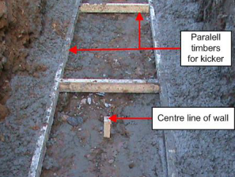

*Fig9. Cross bracing timbers of the guide wall*

The mesh reinforcement will then be trimmed to length and placed in the base of the excavation. The scalloped shutters can be positioned. After placing a check should be carried out by the setting out engineer to ensure they are within verticality and plan position tolerance and this must be recorded on the guide wall check sheet. The kicker concrete is then either placed using the excavator bucket or by direct discharge from the concrete wagon. Strength testing is not required for this concrete.

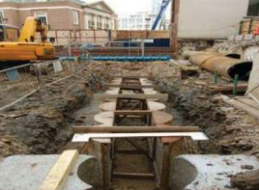

*Fig10. Scallops being placed in the trench*

The shuttering should be removed the following day and cleared from the excavation. The guide wall should be propped at intervals of every sixth scallop using 100mm x 50mm timbers. The guide wall should then be fenced off.

An as-built survey should then be carried out for plan position and verticality of the guide wall. Once checked and approved the barriers can be removed and the guide wall can be backfilled with a suitable material. There should be 7 days between the casting of the guide wall and construction of the contiguous piles. Should any out of tolerance areas be highlighted anon-conformance report should be raised immediately.

**Excavation**

Prior to excavating the pile, the kelly bar will be plumbed vertical within the required tolerance. The Frontman will check the required depth and diameter and monitor the depth as the bore is progressed using a weighted tape measure. The bore will primarily be progressed using toothed auger. Spoil will be removed periodically and spun off in a designated area set up by the rig Frontman.

Thin wall casing will be screwed in with the twist bar into the clayey material until the casing is sealed. Frontman will ensure that the plan position of the casing is as per tolerance. After a seal, the rig will bore below the casing and to required depth. The bottom of the bore will be cleaned of loose material using a cleaning bucket where required. The Frontman will note the levels of any change of strata in his notebook and this information will be included in the pile log.

**For the piles installed within/close to Network Rail 5m exclusion zone casing will be screwed in and pulled out by piling rig only.**

As built position of the pile will be recorded by the setting out engineer.

Periodically the rig will stop to allow the attendant excavator remove pile arisings and place in a stock pile. Muck away vehicles will attend site and be loaded up with pile arisings by the attendant excavator from the stock pile. All muck away vehicles will only move under Mace vehicle marshall direction.

On completion of the pile boring operation, the depth of the pile will be measured accurately using a weighted tape and recorded on the Bored Pile Record Sheet. No access will be permitted without the 1m casing to act as fall protection. Pile cover will be placed on top securing the open bore.

**Installing steel cage to pile**

Prior to installation the cage will have been inspected and signed off as correct. Any inclinometers will have been checked prior to installation.

During the insertion of the first section of cage the various pipes will be handled and guarded against damage. The next section of the cage will be lifted and placed over the lower one and joined together using a proprietary splicing system.

The cage will be lifted by the attendant service crawler crane, the trapping box section removed and the cage lowered into the bore.

Spacers fitted to the cage will be of a proprietary type constructed from plastic-coated, deformed wire. These spacers are proven to provide better performance to plastic clip-on type spacers.

Steel reinforced cages will be manufactured off site by a specialist supplier. The reinforcement cages will be CARES approved and manufactured under carefully controlled factory conditions and transported to site on 40’ flat wagons for re-assembly over the pile bore. All cages will have designed lifting points. These lifting points will be marked with paint. Lifting chains will be attached at the appropriate lifting points. The weight of the cage and the lifting points will be provided on the cage supplier’s drawing – a drawing will be supplied and approved for each cage type prior to delivery. Cage will either be delivered pre-sung with nylon strops, or within pre-slung cage stillages. The cages will be lifted from the delivery wagon and placed on the piling platform with timbers underneath.

**Installing plunge column to pile**

Once the pile has been concreted to 1-1.5m above cut-off level a plunge columns frame will be prepared and installed. Plunge frame will be attached to the crane using 4No 10t wire strops and shackles to the lifting points. Do not use 4 leg chains to lift the plunge frame. The frame will be lowered and centralised using digital setting out equipment ie laser as per company procedure. The columns will be then plunged. Column will be rotated so that the web is in the correct orientation and then centred and lowered. Once the toe of the column is below both sets of top rollers lowering of the column will be stopped. Then north and south and east and west set of top rollers will be closed within 25mm of the sides of the column. Then continue to lower the column. When the first roller mark is level with the top of the plunge frame lowering of the column will be stopped and the rollers indicated by the mark on the column closed. The column will be marked with “Close All Rollers” mark when the toe of the column passes through the toe of the plunge frame. Lowering of the column will cease when this mark is level with the top of the plunge frame. Then release the pressure on the bottom set of rollers and open each bottom set approx. 20mm. This closing and opening is a check to ensure the column is vertical and centred in the frame. When rollers fully closed against the column lowering of the column will continue slowly. At each mark made on the column the lowering will stop and rollers will be moved as required. Column will continue to be slowly lowered until the weight of it and follower is taken on the hydraulic jacks. Setting out engineer will monitor the column and check level of how far the column needs to be lowered to its correct level. Column will be plunged to its correct level in final position supported on jacks.

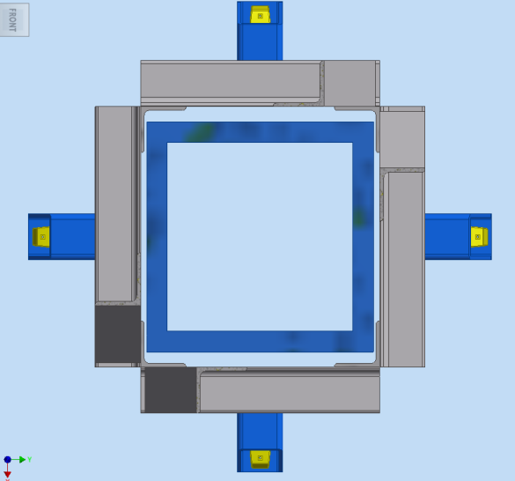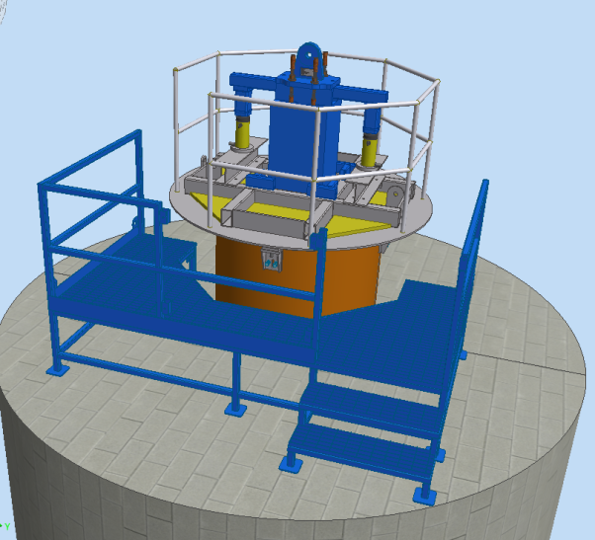

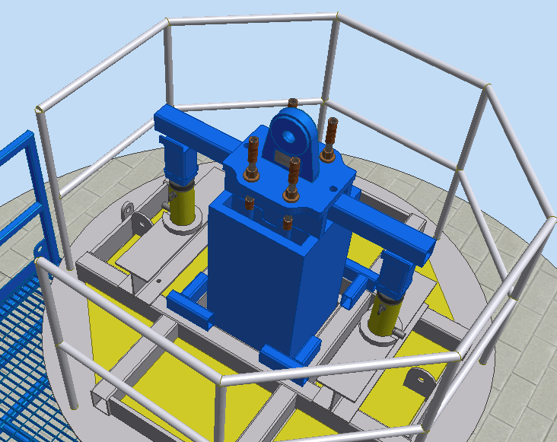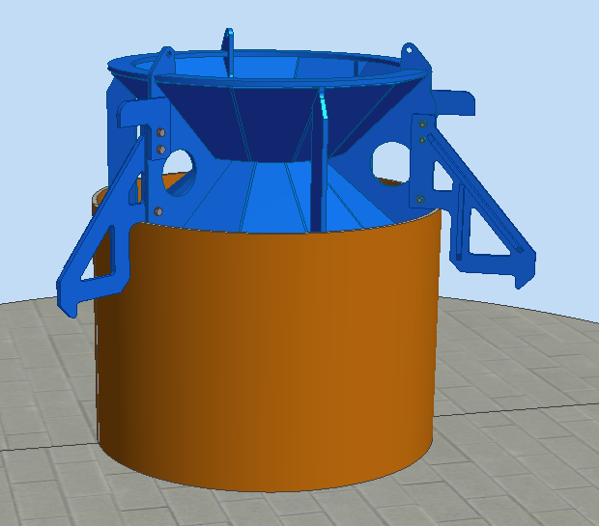

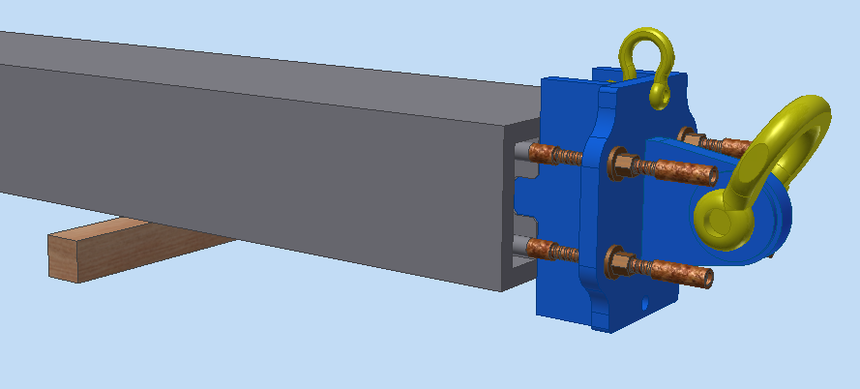

**Concreting**

All concrete used within the pile construction will be supplied from an approved supplier, accredited (eg BSi, QSRMC) as a supplier of ready mixed concrete to BS:EN 206 & BS 8500.

The Site Supervisor will order the concrete on the previous evening and confirm the following morning. Concrete will be delivered in 7.5m3 batches in 8m3 concrete trucks. When the truck enters the concrete ticket will be checked to ensure that the correct mix has been delivered. A sample will be taken to make test cubes (concrete will be sampled in accordance with the specification) then the truck will be directed to the pile position. When the truck reverses to the pile position Banksman will direct this operation.

A single sectional tremmie pipe will be used to concrete the pile. Thus ensuring the concrete is directed centrally within the stable pile bore. Concrete will be discharged from the truck directly into the tremmie hopper. Lengths of tremmie tube will be removed as required.

**Casing Extraction**

For the piles near the NR exclusion zone upon completion of the pile the casing will be extracted using the piling rig. In other areas on the site crane will be utilised for this activity where possible. Once casing extracted the pile will be covered with pile cover.

**Mobilisation/Plant Deliveries**

The main bodies of the cranes and piling rigs will be delivered to site on low loaders via an approved route designated by the haulier. It is expected that all piling equipment deliveries will be able to drive onto the site and avoid any parking on the public highway.

All service cranes will be erected and inspected by qualified fitters in accordance with manufacturer’s instructions. Prior to set up commencing a detailed lifting plan will be produced by a Competent Appointed Person, who has passed the 4 day CSCS Appointed Person Course. The lift plan, method statement and associated risk assessment will be briefed to all personnel involved in the lifting operations. Lifting operations on site will be supervised by a qualified Crane Supervisor, the Crane Operator and qualified slinger/signaller. All equipment will be certified to the LOLER 1998 Regulations and certificates will stored in the site office.

The piling tools, crane jib sections and ancillary equipment will be delivered on 40ft wagons. All deliveries will be unloaded using the site crawler crane or crane mounted on rigid wagons. Deliveries will be planned at appropriate intervals to avoid congestions on site. Delivery wagons will be fitted edge protection barriers where possible. Wide and high loads where edge protection is impossible to fit, will be pre-slung in such way that the slings can be connected to crane hooks from ground level.

**Setting Out**

The pile location will be set out using a total station and coordinate system from control stations supplied by the piling specialist.

**Quality Control and Testing**

All piles will be checked and recorded onto a Quality Assurance record.   
These will include but will not be limited to the following:

* Pile diameter
* Pile depth
* Toe level
* Verticality
* Position in plan
* Cut off level
* Cage type
* Cage level
* Concrete grade
* Concrete levels

**Concrete Testing**

All concrete will be tested in accordance with SPERW, 2007, in the absence of project specific piling specification.

**Pile Testing**

It is recommended that piles are tested both for their geotechnical capacity and for their integrity. This is yet to be developed and proposed as the design progresses.

**3.5 Piling Platform & Permits**

Piling platforms for all 4 sites shall require Category 3 design check and shall be in accordance with the requirements of Network Rail’s Technical Approval Process or the equivalent Technical Approval Process of similar bodies. Completion of the working platform certificate shall be mandatory. This certificate shall be issued in conjunction with a Form C. Installation of the platform, in line with the design, shall be undertaken by Mace.

A signed copy of the platform certificate should be kept on site all the time. There should be attached a sketch to the platform certificate showing the platform boundary so it is clear and transparent to what area it refers to. Specific bearing pressures will be provided by the specialist contractor in advance of the piling platform being designed. All piling platforms should be designed to be at least 2m greater in width and length than the theoretical working area. Physical barriers should be in place to mark the edge of the working area.

Programmed piling inspections will be in place and agreed with Mace and Network Rail as part of the piling platform maintenance and monitoring. The platform inspection sheet – TW-SF-411 is to be completed by a competent person and inspection is carried out daily. Maintenance shall include levelling and building up where thickness has been reduced. In order to mitigate the impact of unplanned excavations into the platform if required there will be a procedure in place approved by the platform designer prior to the works commencing that will allow amendments to WPP and Form C. For any reinstated areas new Platform Certificate is required to be issued.

No groundwater strikes were noted in the cable percussion boreholes during drilling, however perched water was encountered within London clay formation. Groundwater in the boreholes during monitoring is likely to be due to water seepage at the interface between the made ground and London clay formation. This was confirmed during bailing dry of a number of boreholes during monitoring visits which confirmed that the infiltration rate is very slow. With the temporary thin wall casing sealing into clay, it is unlikely that the water will be present during concreting of the piles. The risk of water gathering and disturbing piling platform appears low.

Mace will supply a full signed copy of Platform Certificate and area to which it applies in advance of mobilisation to site.

Ramps are required to access the piling platform it must not exceed 1:10.

The key piling platform specific risks and control measures that Mace will have in place are the following:

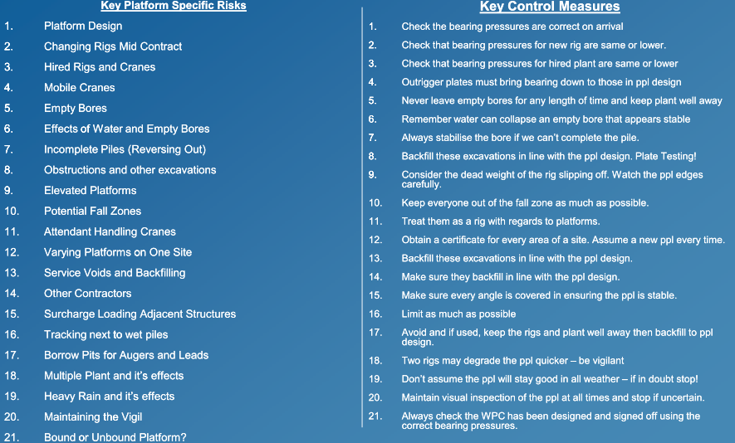

*Fig11. Key Piling Platform Specific Risks and control measures*

The following permit systems and inspection procedures will be in place to control high risk activities:

|  |  |  |
| --- | --- | --- |
| Safe System of Work | Safety Document/Permit | Issued By/Signed Off by |
| Breaking Ground | Permit to Dig | Mace |
| Working Platform Certificate | WPC | Mace |
| Hot Works | Hot Work Permit | Mace |
| Loading Test Pile | Permit to Load | Mace/Dedicated Sub-Contractor |
| Lifting Operations | Permit to Lift | Mace |

*Fig12. Permits Required in Place Prior Work*

**3.6 Backfill to piling platform**

Each pile position will be concreted to the tolerances as per specification above cut off level. Then the backfill material will be installed to the level of piling platform. It needs to be agreed what material for backfill is to be used so it is compatible with the piling platform. This will ensure there are no soft spots left in the piling platform.

**4.0 Safety**

**Safe System of Work**

All personnel will be inducted by Mace prior to commencing work on site. Induction will cover the specific hazards identified for the site. Site rules, regulations and procedures will be explained. All machine and lifting certification will be presented for inspection.

In addition, all personnel including any Mace sub-contractors working in the piling area will be inducted by Mace. A record of the induction will be made on GE – Record of HSEQ Actions form. All personnel will present CSCS or CPCS certification relevant to their trades.

On mobilisation to site the Site Supervisor will review the Works Package Plan and take actions or record comments as appropriate. Further Field inspection will be undertaken weekly or more often if the situation on site dictates. Before any work commences, Mace will prepare an FPS Platform Certificate, a GE – Permit to Dig and a GE – Permit to Hot Works which will require sign off and issue. This will include details of all known services. All plant and vehicle movements will be under the direction of the dedicate banksman.

It is essential for rig stability that all piling platforms re properly designed, constructed and maintained in accordance with FPS Guidance Notes for Piling Platforms.

The Site Supervisor will carry out safety field inspections at least once a week. Site safety will be monitored by the Project Manager/Site Supervisor and subcontractor managers.

**Exclusion Zones/Restricted Areas**

There will be exclusion zones which will be clearly defined, identified and secured. There will be physical barriers in place to prevent entrance of machinery and people.

In regards to the boring operation and augering this will be fully controlled by the rig banksman and rig driver. It will be enforced that no third parties are in the piling area. During piling no personnel must enter within 2m of the augers (min).

Our specialist piling contractor operates safe working around plant for each of the plant. A piling rig safety zones are shown below:

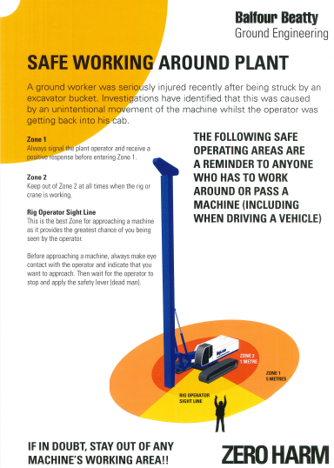

*Fig13. Safe working zone around piling rig*

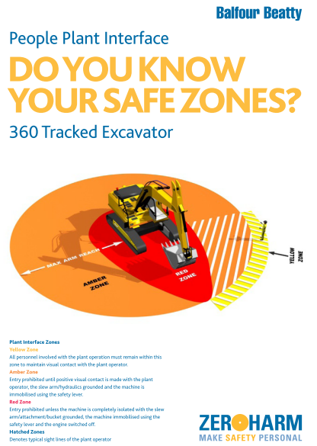

**

*Fig14. Safe working zone around excavator*

**Personal Protective Equipment**

Appropriate PPE will be worn for the task concerned at all times. Mace have minimum requirement for PPE. These must be worn at all time by both Mace staff and Mace sub-contractors.

The 5 minimum items of PPE consists of:

1. High visibility, upper body clothing with reflective tape
2. Safety helmet
3. Safety footwear that provides support to the ankle, mid-sole protection and has a covered steel toe cap. Rigger boots are not acceptable and should not be worn.
4. Hand protection
5. Eye protection – safety glasses

Additional PPE required for particular tasks being undertaken will also be worn and include but not be limited to the following: Ear protection, safety goggles, gauntlets, water proof clothing, anti-vibration gloves, face masks, disposable overalls and other as dictated by the risk assessment.

**Hazardous Substances**

Full COSHH will be provided within our Project Management Plan.

**Welfare**

Welfare arrangements and offices will be supplied by Mace. The workforce will include a trained First Aider identified by a green cross on his hard hat. First aid kits including eye wash stations will be provided and placed in convenient locations not limited to, but including the site office and stores container.

**Communication**

All site operatives will receive a daily briefing on the day’s work activities, as well as briefing of this method statement before work commences. All site operative will receive the following briefings:

* RAMS
* Lift Plans
* Permits
* QA & Environmental Plans
* Tool Box Talks
* Task Briefings

Use of mobile phones in plan is forbidden. This applies to plant that are both running and switched off. Mobile phone usage around site will be restricted to areas designated by Mace.

A site notice board in Mace office will display general and daily specific site safety information including plans of pedestrian/vehicle routes, details of first aiders and location of emergency muster point.

**Emergency Procedures**

When in need of evacuation, site personnel will exit site using the nearest gate onto the public footpath, from where will follow to the assembly point. The appointed Fire Warden will report to the Health & Safety Manager when evacuation is completed.

The notification process for incidents and emergencies shall be communicated on the site induction and site notice boards.

Portable first aid kits and eye wash facilities will be available in the site welfare and office. The name and contact details of the first aider will be communicated to all personnel before the start of the shift. All accidents, incidents and near misses are to be reported to site management immediately. In the event of medical emergency the site first aider will be notified to treat the injury within their capabilities and emergency services contacted on 999 if it is deemed necessary.

Action plan for all scenarios will be provided in our Project Management Plan.

The nearest hospital is:

**University College Hospital Accident and Emergency**

**235 Euston Road, London NW1 2BU ‎**

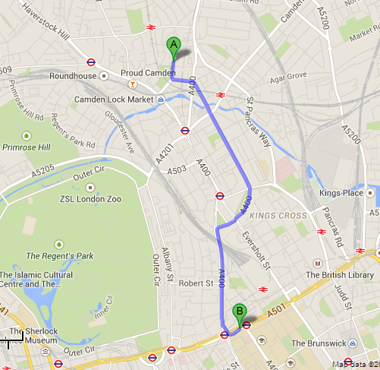

*Fig15. Map showing the route from Site to EA Hospital*

Site Address: Castlehaven Rd, London NW1 8PU, UK

**Lifting Control**

All lifts for the LDP piling operations will be analysed in a detailed Lift Plan produced by an Appointed Person, who has attended the 4 day CSCS Appointed Person Course, and submitted to Mace for approval. The lift plan, method statement and associated risk assessment will be supervised by a qualified crane supervisor, crane operator and qualified slingers. All equipment will be certified to the LOLER 1998 regulations and certificates will be stored in Mace site office. Any variations to the lift plan will result in work stopping until lift plan is amended and approved by MACE Appointed Person.

All cranes and lifting accessories shall be down-rated from their normally rated capacity to 75% of Safe Working Load.

**Change Control**

If the system of work details cannot be applied or a change to some detail or organisation is identified, the activity must be halted until an assessment has been carried out to verify that the residual risk is minimal or additional control measures identified and introduced to mitigate that risk.

Should unforeseen changes occur then the work must cease until competent person has reassessed the risk. Any employee is empowered to stop work on the grounds of health, safety, environmental or other significant matter.

**5. Environment**

Full details of the environmental controls for the piling works will be included in our Project Management Plan.

The following wastage is envisaged for the piling works:

* Bore spoil
* Excess concrete
* General office rubbish

Excess concrete will be minimised by good ordering control. Any residual concrete will be placed in a pre-determined area to allow subsequent removal from site.

All operatives will be tasked with maintaining good housekeeping on site. This will include identifying type of waste, ensuring that all waste materials are removed from the piling platform and placed in appropriate waste skips.

Any hazardous materials will be disposed of in an appropriate manner.

In the event of an environmental incident, Balfour Beatty Environmental Manager or a member of the Balfour Beatty Environmental team will be contacted and the Environmental Incident and Non-Conformance Plan will be followed.

**Contaminated land**

At present, no contaminated land is expected to be found when carrying out piling works.

Re-fuelling will be carried out in dedicated fuelling areas. All of these are to have spill kits available for containment and clean-up of any fuel spills. Drip trays or plant nappies will be used for all non-mobile plant. These should be inspected and emptied of rainwater on a periodic basis.

**Water Resources**

Water used across the site and by site cabins will be provided by Mace.

Any drains/gullies around the work and muck away area will be suitably protected to prevent ingress of construction materials. Plant will only be cleaned out onto the piling platform.

Concrete washing out will only occur in a dedicated concrete wash out area.

**6. Programme & sequencing**

**Logistic Plan**

Please refer to Appendix A)

We have included for all known to us exclusion zones and planned piling around it as per this method statement, this includes for all known to us LUL recommendations when piling adjacent to the running line.

* 1. **Programme Sequencing**

Please refer to Appendix A) of this document for our recommended piling programme for this project. Once full construction information received this can be refined and formalised.

**Conclusion**

In producing this document, Mace believe that the document provides sufficient detail to fully articulate the methodology and planned approach to delivering a safe and well organised solution, in doing so addressing the specific requirements of LUL. The principles of good planning and prestart investigation are key to eliminating potential damage, and we suggest that this proposal effectively communicates our comprehensive approach.

Appendix A

Appendix B