**SAFE SYSTEM OF WORK – ADENDUM TO CMP FOR ST PANCRAS WAY**

**FOR**

**79 CAMDEN ROAD, CAMDEN, LONDON. NW1 9EU**

**REV 00 – DATED 23 10 2015**

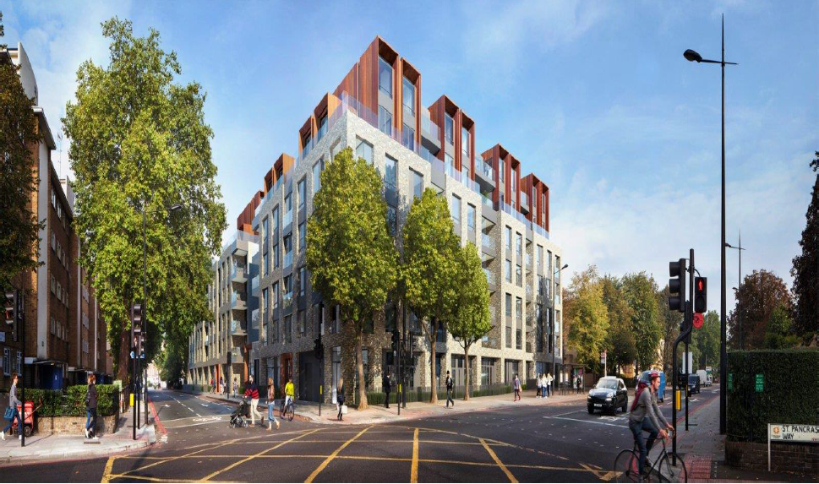

**SSoW017 Rev 04**

**OUTLINE SAFE SYSTEM OF WORK**

|  |  |  |  |  |
| --- | --- | --- | --- | --- |
| **Client** | | | Barratt London | |
| **Principal Contractor** | | | Erith Contractors | |
| **CDM Co- coordinator** | | | Trevor Chrismas | |
| Rev | | Detail | Prepared by – Date | | Authorised By - Date | |
| 0 | | Contract Document | Craig Krzyzanowski de Sloan - Project Manager  15 10 2015 | | James Hiom  Group Health & Safety Director | |
|  | |  |  | |  | |
|  | |  |  | |  | |

|  |
| --- |
|  |
|  |

**CONTENTS**

**Sections**

1. **Introduction**
2. **Review Meeting.**
3. **The Application of the Addendum when Approved.**
4. **Appendices**

**1 Introduction**

This Method Statement is specifically written to following a review of the current Chapter 8 signage for St Pancras Way, Camden, which is currently approved under the existing CMP for the Project.

The Addendum was requested following requests from local residents who would like to see the following items addressed in St Pancras Way.

* Rationalisation of the Chapter 8 Signage within St Pancras Way so as to minimalize the amount of signage that Pedestrians, Cyclists and Road Users had to absorb on the approach and when passing through the location.
* A review of the Temporary Traffic Lights currently in use to see if they can be improved to increase their usage and improve road safety for pedestrians crossing St Pancras Way due to the current Footpath Closure along the edge of the site in St Pancras Way.
* Try and Control Traffic Flow for deliveries using the Main Gate in St Pancras Way so that Traffic Stops Properly rather than trying to shoot around the Banksman using Stop/Go Boards.
* Requesting a constant 09:30 to 15:30 Temporary Lane Closure so as to provide a consistent system to Road Users each day. The current system of only closing during deliveries means the set up and taking down of the lane closure with each individual delivery causes constant changes on the road causing confusion in particular to Cyclists who are most at risk.

Limitations of this documents: - This document does not seek to change any information within the CMP other than those directly addressed within this Document. This document does not allow for additional Road or Chapter 8 signage established by other bodies carrying out works nearby. It does however attempt to clarify its own so that pedestrians, cyclists and road users, are clearly aware of what Erith’s own system is. Should additional information be received from sources of authority or from visual inspections carried out by our External Works Supervisor that indicate that this proposal has been affected then this Addendum shall be reviewed and reassessed and if necessary recompiled and re-issued for Approval to Camden Council.

**2. The Meeting**

Following the Community Liaison Meeting in September Erith were requested by local residents to carry out an independent Chapter 8 review of all the signage in St Pancras Way. This meeting took place on Monday 8th October 2015. It was attended by Local Resident Representatives; Erith Management; Hard Hat and A-Plant’s independent Chapter 8 assessor.

The **Key Points** were raised.

1. **Residents Request: The Temporary Lights are not being used or pedestrians do not realise they need to cross at the lights and walk pass them. Can they therefore be removed?**  *Erith proposed that they can now readjust the hoarding on the corner of the site next to 102 St Pancras Way so that approx. 5m of the footpath can be opened up passed the entrance way of 102 St Pancras Way.  Temporary Traffic Lights can be moved closer to the site so that they are positioned exactly next to where the footpath closure takes place. Clear Signage will be displayed indicating Temporary Crossing and the Lights will be reduced to a 3 Second Delay to change from Green to Red to encourage their use. Please find below a sketch/map below where we have tried to show this change.*

***Existing Set Up for Temporary Traffic Lights***

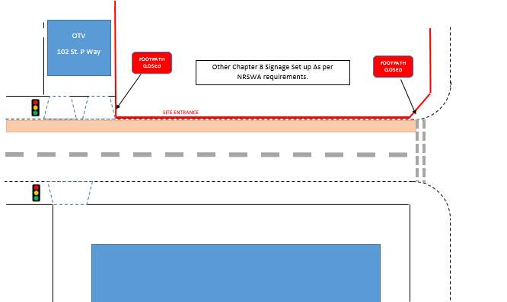

***New Proposal for Temporary Traffic Lights.***

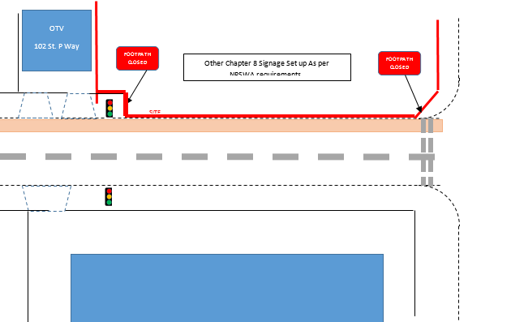

1. **Residents believe the current temporary lane closure (for when deliveries are present and removed when they leave) is causing confusion to road users, especially cyclists. They would like to see a Temporary Lane Closure consistently take place from 09:30 to 15:30 throughout so that Road Users get used to a pattern.** *Erith are happy to comply with this and if approved will put in place the following additional measures to improve the Temporary Road Closure.* 
   1. *Move substantial Conning (Double Coning) to stop cyclists weaving in and out of the current Chapter 8. This will also provide a more clearly defined Lane Closure to reduce confusion to other Road Users.*
   2. *Task Specific Signage placed further back on a Big Yellow Sign (to be designed and made by A-Plant’ indicating Temporary Lane Closure Monday to Friday from 09:30 to 15:30 – Cycle Lane is OPEN/CLOSED (open/closed sign to be amended at start and finish of Temporary Lane Closure each day – i.e. CLOSED to be bolted over the open at start of lane closure and then removed at end of day to then show ‘OPEN).*
   3. *We also appreciate that the constant putting out and taking in of signage to fit around deliveries causes a constant nuisance to road users and cyclists.*

***Please find attached a copy of the Chapter 8 Layout at the Appendices provided by A-Plant who are providing the Chapter 8 Equipment on site.***

1. **Concerns that there are other Road Works taking place by Camden at present that are in conflict with Erith’s existing Chapter 8.** *Although Erith cannot answer for Camden, we do however believe that the arrangement outlined above will overcome these issues so that no conflict of interest between Camden’s Road Works and Erith’s Temporary Lane Closures exist*.

Erith subsequently provided this information to Camden for comment and the proposals were also placed before the local residents at their next Community Liaison Meeting in October 2015 and they were back by the other Members of the meeting.

Erith agreed to submit these as the Proposed CMP Addendum.

**3. The Application of Addendum when Approved.**

Attached is a CAD Drawing of the Chapter 8 Proposal.

Once these Addendum’s are approved by Camden they will be put into action.

* Traffic Lights will be relocated to new position
* Chapter 8 Signage will be amended.
* Temporary Lane Closure will come into effect Monday to Friday between 09:30 and 15:30.
* Double Coning will be established to give a clearer demarcation of the Lane Closure
* The Advance Warning sign will be changed at the times designated to show that the Cycle Lane is Open or Closed respectively.
* Traffic Lights will be used to stop Traffic Properly for when vehicles are reversing onto or existing the sites Main Delivery Gates in St Pancras Way. This will increase both road safety and the protection of the Banksmen working to bring vehicles on and off the site.
* Traffic Lights have already been changed to a 3 second change between hitting the pedestrian button and the lights changing from Green to Red.

**Briefing accepted and delivered to work party by:**

|  |  |  |  |  |
| --- | --- | --- | --- | --- |
| **Name** | **Position** | **Method Statement No.** | **Signature** | **Date** |
| **Craig Krzyzanowski de Sloan** | **Project Manager** | **SSoW-18** |  | **23.10.15** |

**Briefing accepted by: (by signing below I confirm that I have received and understood the briefing for this task)**

|  |  |  |
| --- | --- | --- |
| Name | Signature | Date |
|  |  |  |
|  |  |  |
|  |  |  |
|  |  |  |
|  |  |  |
|  |  |  |
|  |  |  |
|  |  |  |
|  |  |  |
|  |  |  |
|  |  |  |
|  |  |  |
|  |  |  |
|  |  |  |
|  |  |  |
|  |  |  |
|  |  |  |
|  |  |  |
|  |  |  |
|  |  |  |

**APPENDICIES**

(ATTACHED)

CAD SKETCH OF NEW PROPOSED CHAPTER 8 SIGNAGE FOR ST PANCRAS WAY