Proposed Replacement of Existing French Doors
12D Bisham Gardens, Highgate, London N6 6DD

Design and Access Statement

- Description of Existing Property
12D Bisham Gardens is a Garden Flat in a terraced street located in Highgate. Pre-planning advice confirms that the property is not listed but is located within the Highgate Village Conservation Area.

The terrace is believed to have been built in the 19th Century. Most of the houses in the street are 4 storeys and Number 12 was converted into 4 flats circa 1955. The houses are constructed in London Stock brickwork with slate roofs. The rear of the property adjoins Waterlow Park and is separated at the boundary by 2m high (approx) London Stock brick wall. Consequently the rear of the property is not overlooked by any other properties

- Design Principles and Concepts
- The extent of the proposal is limited to removal of existing small side windows and associated masonry in the rear elevation to enlarge the existing opening by approximately 1m. The existing 2m wide French Windows will be replaced by new 3m wide Bi-Fold Doors (see Attachment 1).

- The new Bi-Fold Doors will be fabricated in Extruded Aluminium Alloy 6063.T6 in accordance with BS EN755-9, 2001. The finish will be in Polyester Powder Coating in accordance with BS6496. The finish will be in a light gray colour consistent with the rear sliding doors at Number 12C Bisham Gardens

- The new Bi-Fold doors will comply with current Building Regulations with respect to Safety. Security and Energy Conservation. The installation will be by a FENSA registered installer.

- The glass will double glazed toughened safety glass in accordance with BS6262. This will increase the energy efficiency compared to the existing draughty, single glazed French Windows

- The current inadequate security measures for the existing patio doors will be replaced by a high quality multi-point locking system and a hidden, inline tracking system. The main stress-bearing elements of the locking system itself including any door lock cylinders, will be formed from hardened steel and will have been tested for compliance with the relevant British standards including or equivalent to BS6375 and PAS24.

- Intended Use
The property will continue to be used as a residential property. No change of use is proposed

- Layout
No changes to the external layout are proposed. There will be no change in the footprint of the property

- Scale
This proposal is limited to minor changes in the existing doors to the rear garden/patio. The new doors will be approximately 3m wide by 2.2m high.

- Landscaping
There is no landscaping associated with this proposal

- Appearance
The proposal will preserve and enhance the appearance of the property with due regard for design within the Highgate Conservation Area. The new bi-fold doors will be similar to the existing sliding doors at 12C Bisham Gardens and 6 Bisham Gardens which were recently approved and installed under Planning Applications 2010/6423/P and 2009/3828/P

- Local context
The modification will not be visible from outside of the property. The rear garden is completely enclosed by an existing 2mm wooden fencing on either side and by a 2m high brick wall at the boundary with Waterlow Park.

- Access
The proposal makes no changes to the existing access to and from the boundary of the property. The main access to the Property will continue to be from Bisham Gardens; no changes are proposed. The Property does not have any vehicular access from the road. Parking will continue to be by Residential Parking permit in Bisham Gardens

- Highgate Conservation Area
The Applicant fully recognises that the property lies within the Highgate Conservation Area and believes that the proposed minor modification at the rear of the property will have no significant impact to the character of the Conservation Area. As noted above, the modification is at the rear of the property, consequently the modification will not affect the beneficial architectural merits of the front aspect of Bisham Gardens as described in the Plan.

Also, as noted above, the rear garden is fully enclosed and the proposed modification will not be visible from outside of the property. This will alleviate the concerns raised in the plan re “insensitive rear roof additions on the south side of the street are highly visible in long views from Waterlow Park and from Highgate West Cemetery”

Relevant extracts from Highgate Conservation Plan included below for information.

Bisham Gardens to the west of Highgate High Street, differs from other streets in the village, due to the speculative 19th century nature of its densely and uniformly developed terraces and semi-detached properties. The street sits along the contour of the hill and there are views towards St Michael’s Church to the west. It is dominated by two-storey terraced housing, influenced by Dutch architecture, constructed from red brick with stone and stucco dressings most of which have been painted white, and with slate-covered roofs. Of a repetitive design, the houses have projecting square bays, each containing two windows at ground and first-floor levels, and a third-floor gable window, in front of a mansard roof. The entrance bays have projecting brick porches originally surmounted by balconies. The houses have retained their original fenestration with small fixed lights in the upper sashes. Many front doors survive: painted timber with glazed upper panels, stained glass consisting of coloured square quarries in doors and fanlights. Several properties have original glazed tiling lining the recesses to the front entrance doors, and have retained their coalhole covers. A mixture of rooflights have been installed, together with dormers of varying proportions and materials, sometimes negatively impacting on the Conservation Area. The insensitive rear roof additions on the south side of the street are highly visible in long views from Waterlow Park and from Highgate West Cemetery.

The following buildings have been identified as positively contributing to the character or appearance of the Highgate Conservation Area. Bisham Gardens Nos. 1-23, 2-34 inclusive

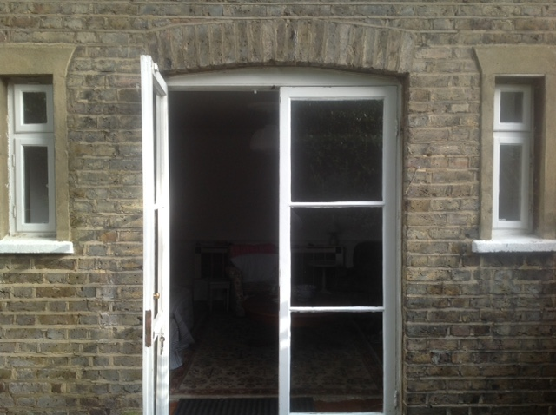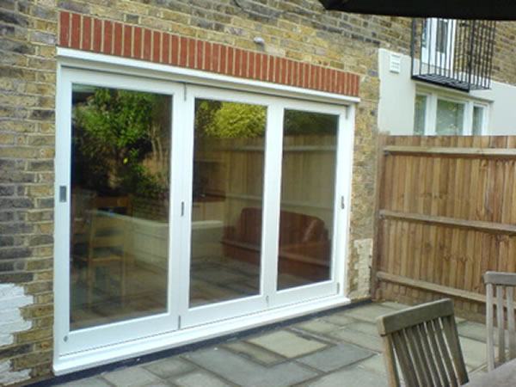
Figure 1
12D Bisham Gardens
Existing French Windows
Photograph of Existing French Windows
Visualisation of Proposed Bi-Fold Doors
(Note proposed finish will be Light Grey)
Attachment 1

