4th October 2015

Design and Access Statement

**64 Marchmont Street / LONDON / WC1N 1AB**

Applicant:

Quentin Tyler

12 Oakeshott Avenue

LONDON

N6 6NS

**1. Introduction**

**Introduction**

This statement is made in support of the application to change the use of the shop and basement at 64 Marchmont Street, London, from a skin care clinic (Sui Generis) to a coffee shop and commercial photographic gallery (A1).

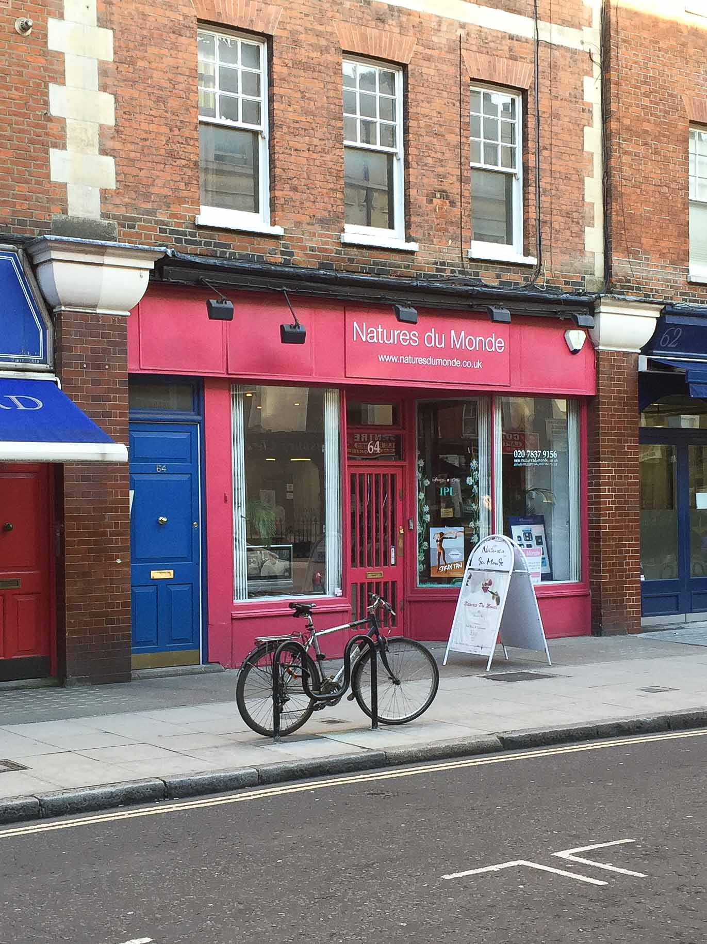

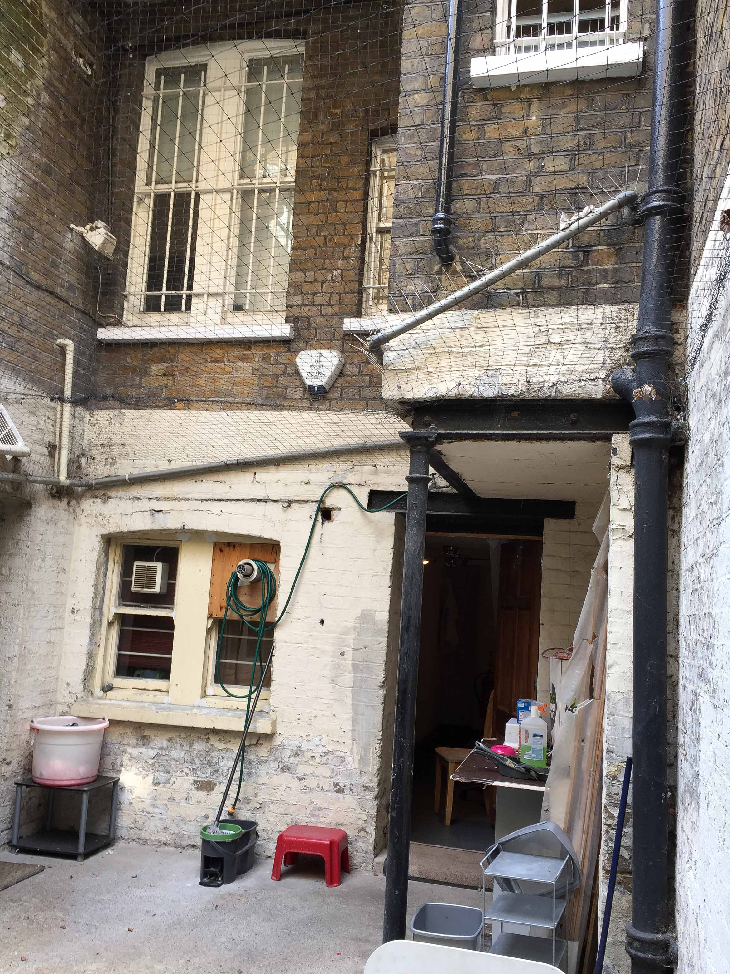

Front of Premises Rear of Premises

**2. Site and Context**

**Site Location**

The site is located on the eastern side of the busy Marchmont Street thoroughfare approximately half way between the junction with Tavistock Place and the northerly edge of the Brunswick Centre.

**Site Description**

The subject premises are not listed but the shop is located in the Bloomsbury Conservation area.

The site falls within Flood Zone 1 (low risk of flooding). As such it is not necessary to carry out a flood risk assessment for this planning application.

**Surrounding Area**

The surrounding area is largely of mixed use-ground floor commercial units with residential upper floors, characterised by Victorian terraces of four stories.

**Development History**

The subject premises have been used commercially since their construction; significantly as A1 use type but more recently under the Sui Generis classification following a retrospective application made in 2005.

**3. Description of Intended Use**

**Description of Use**

The coffee shop will serve hot and cold drinks and cold and reheated food to eat in or to take away. The idea behind serving food and drink is to both supplement the income of the gallery and contribute to its ambiance. It is not intended, however, for this to ever have the feel of a restaurant and at no point will any food be cooked on the premises.

Seating will be arranged to accommodate as much free movement around the gallery as possible on the ground floor, where it is anticipated a quarterly photographic exhibition will be installed (which will be listed in various London and specialist national entertainment guides). Additional seating will be provided at basement level where more permanent photographic imagery will also be displayed.

The basement level will also be used as venue space for the teaching of photography classes and for external hire.

**4. Description of Appearance and Design**

**Appearance of Shop Front**

The shop front is currently that of much of the original Victorian plate-glass and timber and the intention is to either keep this, or where possible, return it more accurately still to the original. The signage will be painted and not backlit.

**Design of Infill Space**

The element of the application that relates to a small infill (of not more than 6sqm) at the rear ground floor level is made for the purposes of creating an area of self-contained administrative office space. As infill, this space will not be visible from above or to the side and will not project any further than the existing building line. The exterior rear elevation of this infill space will be constructed to match the existing Victorian elevation. The bricks used will be those of Imperial London Yellow Stock and the proposed window of plate-glass and timber. The new bricks will follow the original courses and the new window will be detailed and proportioned in accordance with those that already exist on the elevation.

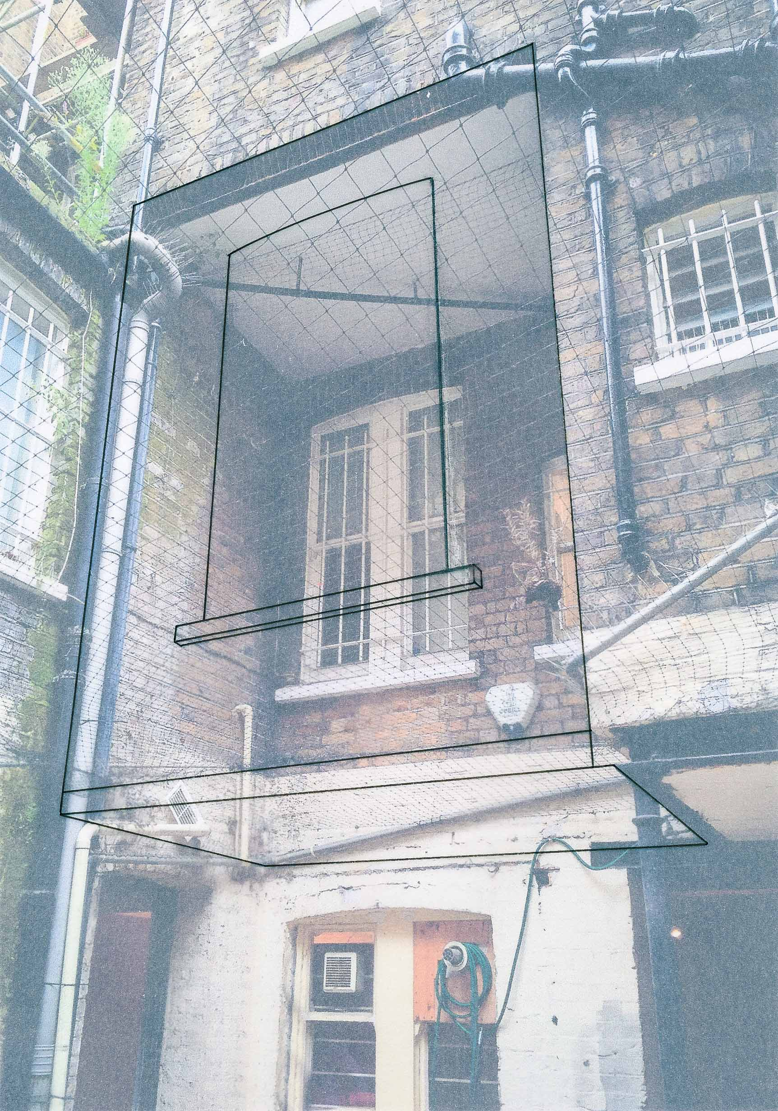

Schematic Overlay of Proposed Infill

**Design of Casement Doors**

The application also requests changing the basement level window facing the rear yard into casement doors. The doors will be sympathetically designed and proportioned in accordance with Victorian casement doors and, as such, will also be constructed from plate-glass and timber.

**5. Access and Parking**

**Access**

The existing roads and footpaths will not be affected by the proposals.

Wheelchair access will not be restricted by any steps at the entrance to the premises from the street.

**Parking and Public Transport**

There is no parking provision at the subject premises. There are metered spaces available immediately outside and there is considerable further parking provision in nearby private car parks. It is anticipated, however, that the majority of visitors will arrive by public transport. The site is located within the defined Highly Accessible Area within the Camden Core Strategy and has a PTAL rating of 6(b) (excellent). It is located some five minutes walk north of Russell Square Underground Station and there are other exceptional bus and rail links in the area, all within easy walking distance.

6. Consultations

Camden Planning Consultation

Two telephone consultations and one site visit were carried out with Camden Planning Officer, Shane O'Donnell. The site visit was made on 12.10.15.

It was advised that current Camden planning policy is favourable to the retention of, and reversion to, A1 use.

It was also advised that it would be critical for those elements of the application that relate to the rear alterations to be sympathetic to the existing character and appearance of the building.

**7. Conclusion**

Conclusion

The proposed scheme has been developed with careful consideration of the existing context and local planning policies. It is believed that the design of the development will be of very high quality, and that the design and access have been carefully considered in arriving at the submitted scheme. In summary, we feel that this proposal:

• will positively enhance the building in accordance with policy CS14.

• will add a vibrant commercial unit to the street.

• will conserve and build upon the nature of the area in accordance with policy CS14 and DP25.

• is an efficient use of the property.

• does not conflict with any relevant planning policies.