**ADDENDUM ‘A’**

**Analysis for Site: 5 Aldred Road, West Hampstead, London NW6 1AN**

**BIA Components for Audit - SECTION B Item #4**

**4. Plans, maps and/or photographs to show topography of surrounding area with any nearby water courses/water-bodies including consideration of the relevant maps in the Strategic FRA by URS (2014)**

**Figure 1:** map from the Environment Agency showing surface water flood risk for the area in question. Aldred Road (NW6 1AN) is classified as a ‘Very Low’ risk area and therefore no special consideration/measures required.

**Figure2:** an indicative map from the ‘Managing Flood Risk in Camden–The London Borough of Camden Flood Risk Management Strategy’ document showing no heavy water flows or significant potential for ponding in the Aldred Road area.

**Figure 3:** Historical map: ‘The Lost Rivers of London’ shows there are no below ground watercourses within 100m, the nearest underground river is the Westbourne approximately 200m south-east of Aldred Road. No above ground water courses exist within 500m.

**Figure 4:** Ordnance Survey Map of Aldred Road and surrounding area. The street is on a gentle slope, with approximately a 5m rise over its entire length which is around 100m. This equates to a fall of approximately 1:20. Midway along the length of the Aldred Road the site at number 5 has a comparative fall with the fall from the front to the back of the site also being approximately 1:20.

**Figures 5 & 6:** maps of superficial geological deposits and bedrock show that according to the British Geological Society the ground condition comprises of London clay with no superficial (geological) surface deposits.

**Figure 7:** map extract from Environment Agency for ground water vulnerability and aquifers shows no aquifers are present in the immediate area.

**Figure 1: Extract From Environment Agency Map For Surface Water Flood Risk © Environment Agency**

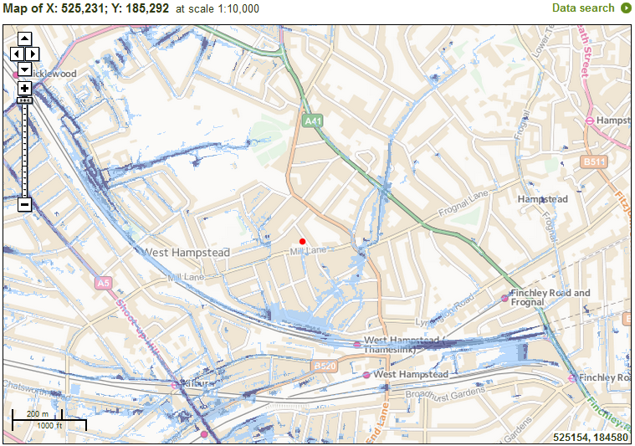

NW61AN

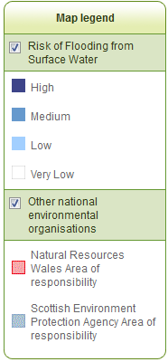

**Figure 2:**

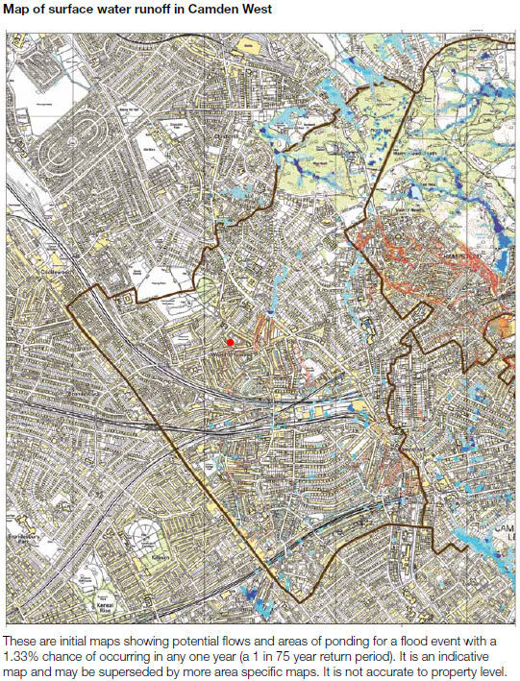

**NW61AN**



**Figure 3: Extract from ‘The Lost Rivers of London’ (Revised Edition), Nicholas Barton, Historical Publications Ltd 2009**

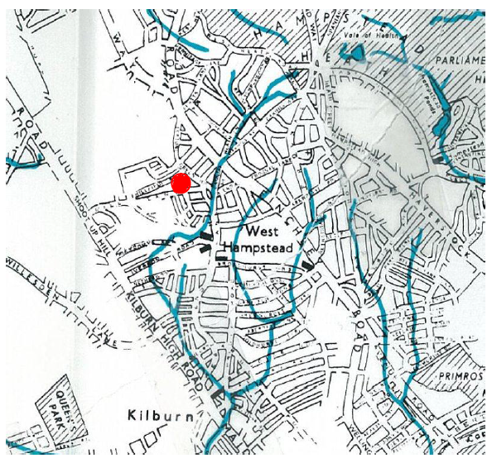

**Figure 4: Extract from 1:25,000 OS Map © Ordnance Survey**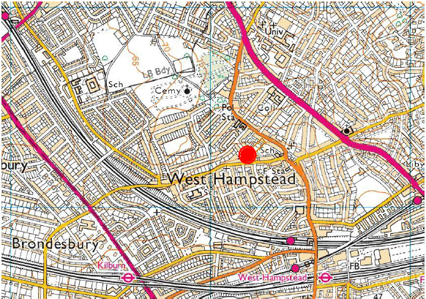

**Figure 5: Superficial Geological Deposits © British Geological Society**

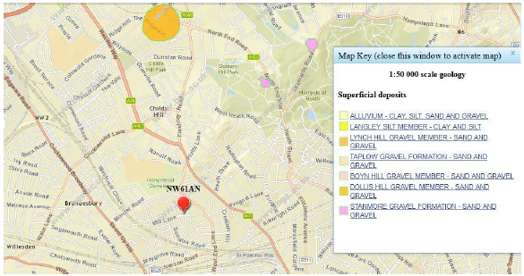

**Figure 6:** **Geological Bedrock © British Geological Society**

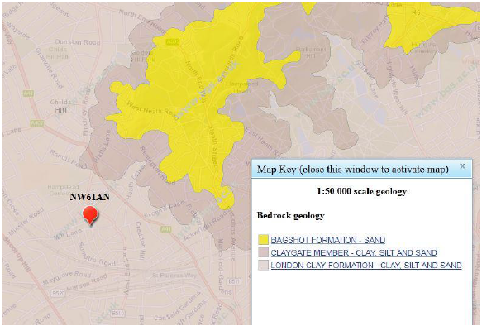

**Figure 7: Extract From Environment Agency Map For Groundwater Vulnerability / Aquifers © Environment Agency**

