ISS 60cm Mesh Dish Full specifications
- Reflector Dimensions (cm): 59 x 55
- Dish Material: Phosphated Steel
- Thickness (mm): 0.50
- Surface Treatment: Epoxy-Polyester Powder Coat
- Mounting: Wall/Pole Universal
- Mounting Material: Hot-galvanised Steel
- LNB Clamp Size (mm): 40
- Elevation (Degrees): 5-57
- Efficiency (%): 80
- F/D Ration: 0.65
- Cross Polarization: >25.0
- Gain (dBi): 35.3 - 36.1

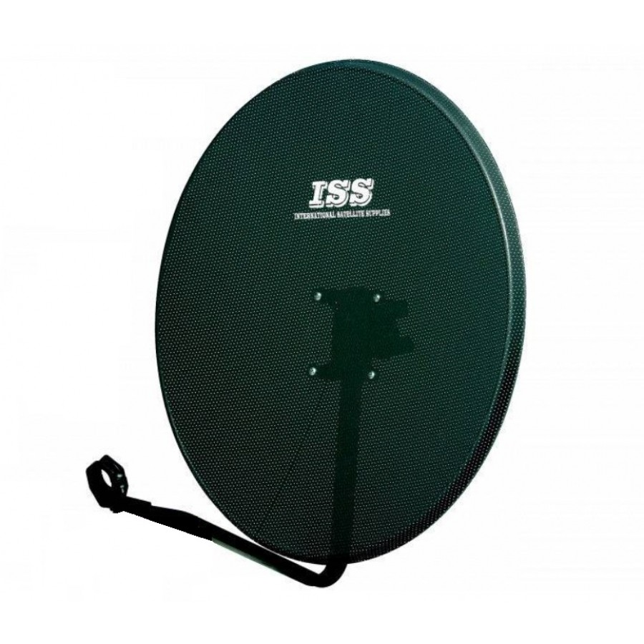

ISS INTERNATIONAL LTD. All rights reserved

http://www.issinternationalltd.com/dishes.html

