74 & 76 St Albans Road, 118, 120, 122 & 124 Croftdown Road Photos
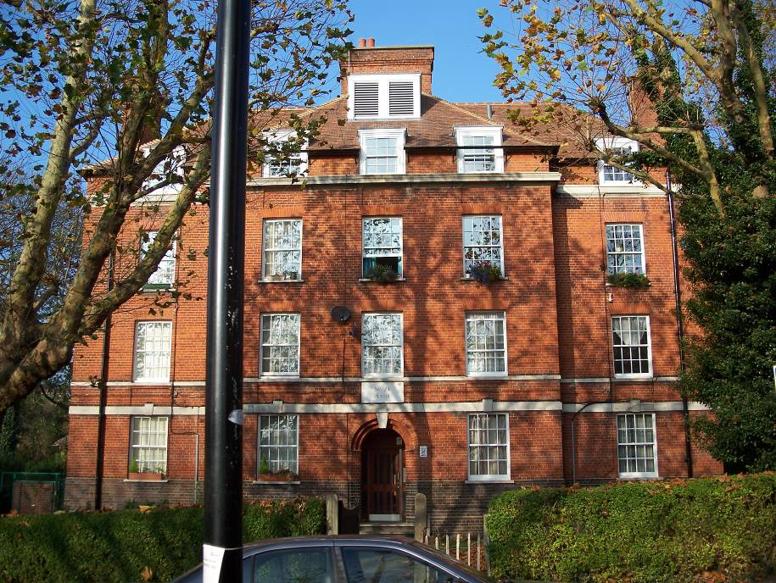
Front Elevation
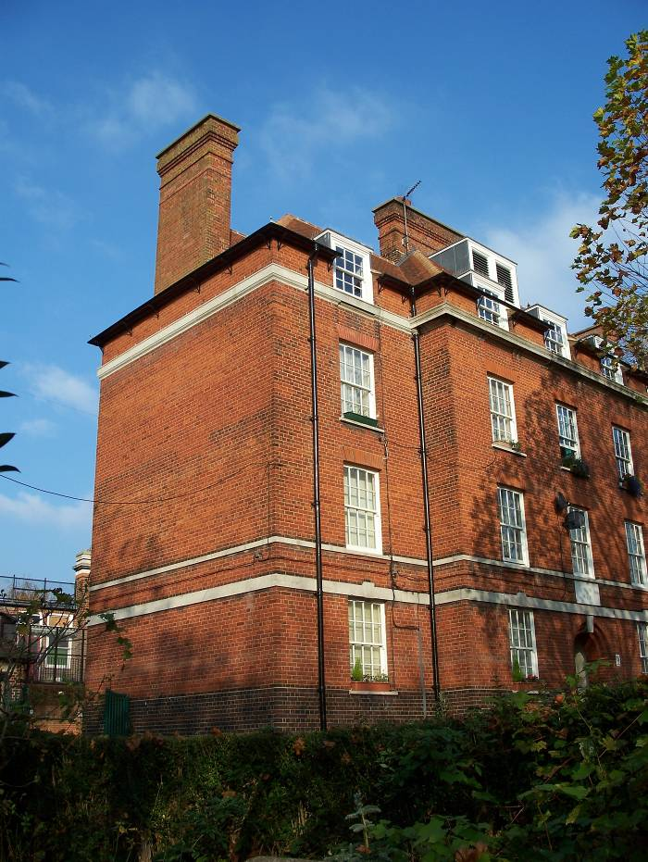
Side Elevation
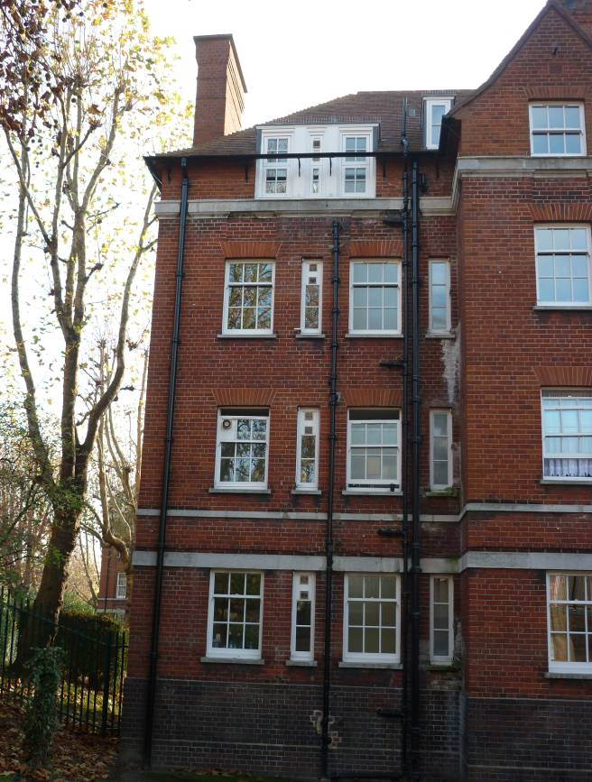
Rear Elevation (Left Hand Side)
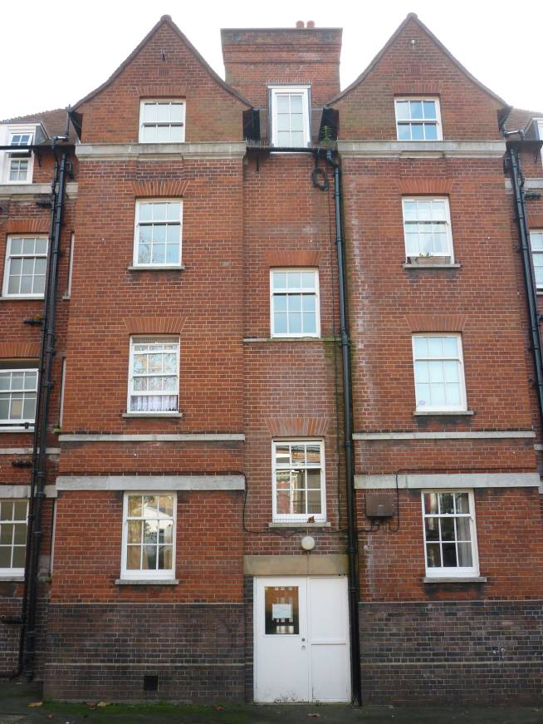
Rear Elevation (Centre)
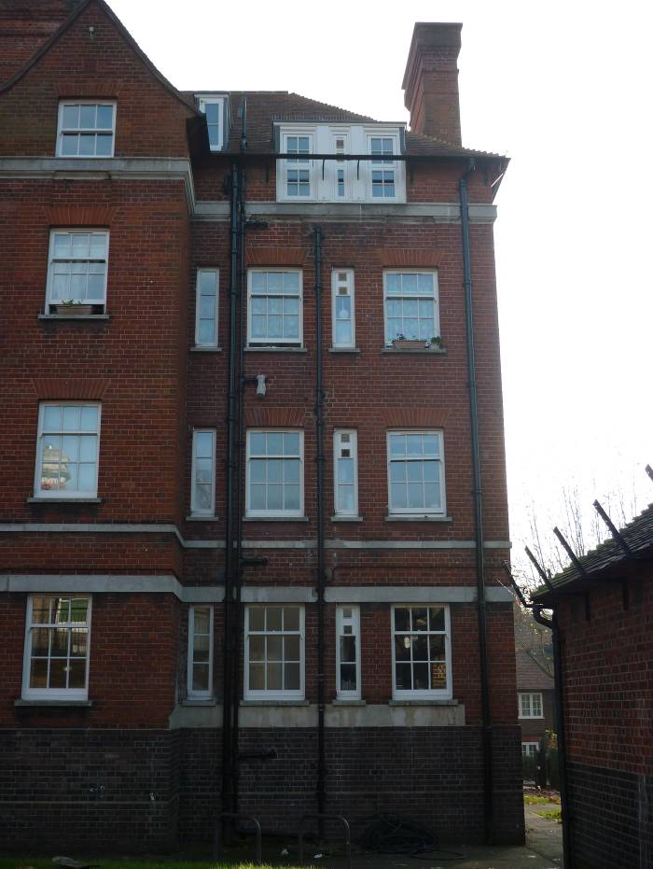
Rear Elevation (Right Hand Side)

